Task 1:

CODE: (Using if-else Statement)

const operator = prompt('Enter operator ( either +, -, \*, / or % ): ');

var number1 = parseFloat(prompt('Enter first number: '));

var number2 = parseFloat(prompt('Enter second number: '));

let result;

if (operator == '+') {result = number1 + number2;}

else if (operator == '-') {result = number1 - number2;}

else if (operator == '\*') {result = number1 \* number2;}

else if (operator == '%') {result = number1 % number2;}

else {result = number1 / number2;}

console.log(`${number1} ${operator} ${number2} = ${result}`);

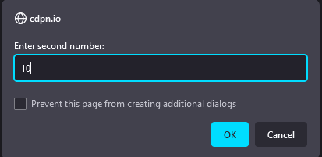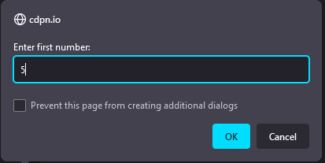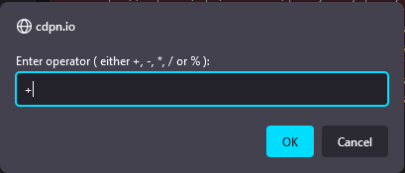

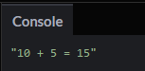

TASK NO 2

A.



B.

C.



D.

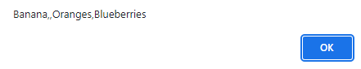

E.

TASK NO 3

var options=prompt('Your Alarm was RINGING!! Press S to Snooze and D to Dismiss !');

if(options=='S'||options=='s')

{while(options=='S'||options=='s')

{options=prompt('Your Alarm was RINGING!! Press S to Snooze and D to Dismiss !');}

alert('Wrong Input');}

else if(options=='D'||options=='d')

{alert('Good Morning & have a nice day')}

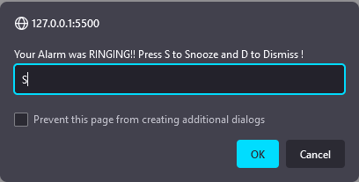else{alert('Wrong Input');}

