MARKA AI
Autonomous AI Marketing Automation Framework
v1 Architecture & Technical Document

Internal — Confidential
Last Updated: March 2026
Team: Ahmed Gamal + Yomna Hadad

Table of Contents

1. Product Overview 1
2. Team & Responsibilities 3
3. System Architecture 5
4. Agent Architecture 8
5. Tools 10
6. LLM Configuration 11
7. State Management & RAG 12
8. API Layer (FastAPI) 14
9. Frontend Layer 15
10. Repository Structure 16
11. Docker & Deployment 19
12. GitHub Rules & Workflow 21
13. Open Questions 22
Appendix A: Design Decisions Registry 24
Document Governance 25

Note: Right-click the Table of Contents and select ‘Update Field’ to refresh page numbers.

1. Product Overview

1.1 Vision
An Arabic-first AI assistant that helps Egyptian SMEs create, schedule, and publish marketing content — without needing marketing expertise or English-language tools.

1.2 The Problem
Pain Point | Current Reality | Marka AI Solution
Language | Global tools don't support Egyptian Arabic dialect | Native Arabic-first generation with dialect tuning
Complexity | SMEs need to learn marketing + tools simultaneously | AI handles strategy, timing, and content automatically
Cost | USD pricing is prohibitive for Egyptian businesses | EGP pricing, local payment methods
Time | Business owners are operators, not marketers | Fully automated — from product to published post

1.3 Business Model
Phase | Timeline | Model | Notes
Phase A (Now) | MVP — Pilot | Free / Beta | Ahmed + Yomna build, test with 3–5 SMEs
Phase B | Post-MVP | Subscription (EGP/month) | Starter: 3,000 | Growth: 12,000 | Enterprise: 40,000+
Phase C | Scale | Multi-tenant SaaS | White-label for agencies, API access

2. Team & Responsibilities

2.1 Core Team (v1)
Member | Domain | Responsibilities | Tools
Ahmed | Orchestration + Integration | Agent orchestration, Content Agent prompts, Telegram bot, Web UI, Publisher logic, API_TOKEN auth | FastAPI, LiteLLM, python-telegram-bot, React, MongoDB
Yomna | AI + RAG | RAG system (mini-RAG), Chatbot backend endpoints, embeddings + vector store logic | FastAPI, MongoDB, Qdrant, LiteLLM, sentence-transformers

2.2 Ownership Split — Visual
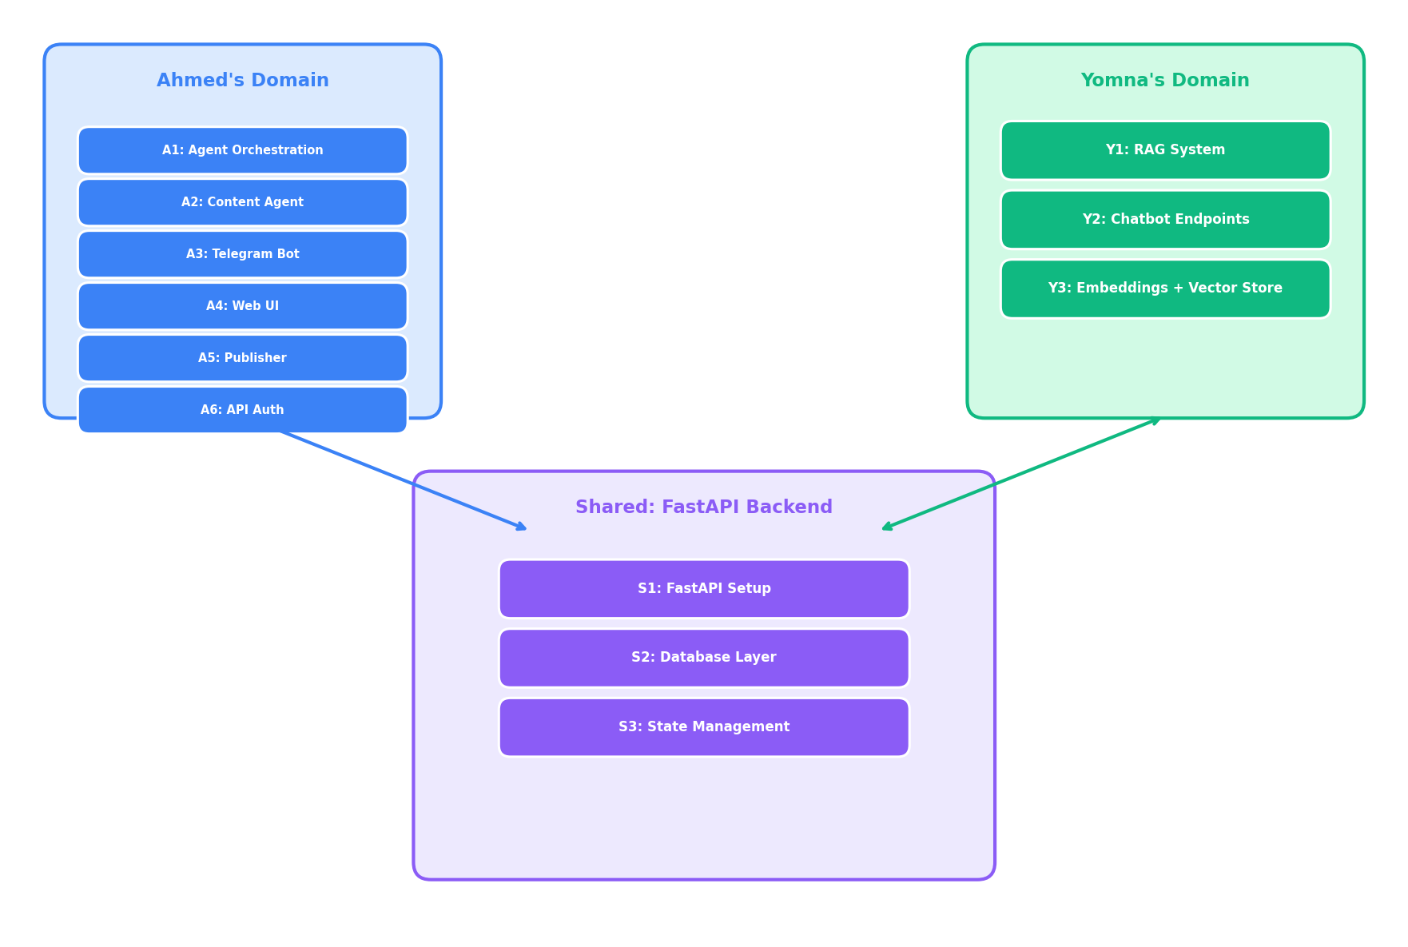
Figure 2.2: Ownership Split between Ahmed, Yomna, and Shared domains

2.3 Collaboration Workflow
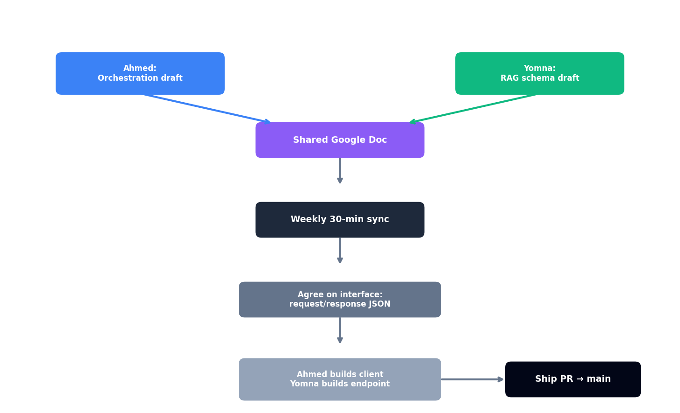
Figure 2.3: Collaboration workflow between team members

3. System Architecture

3.1 Two-Layer Architecture (v1)
Layer | Stack | Responsibilities | Owner
Frontend Layer | Telegram Bot + React (AI-generated) | User input, display results, publish actions | Ahmed
AI Layer (FastAPI) | FastAPI + MongoDB + Qdrant + LiteLLM | Agent orchestration, RAG, content generation, state management | Shared

3.2 Full Communication Flow (v1)
This is the exact request flow for a content generation session:
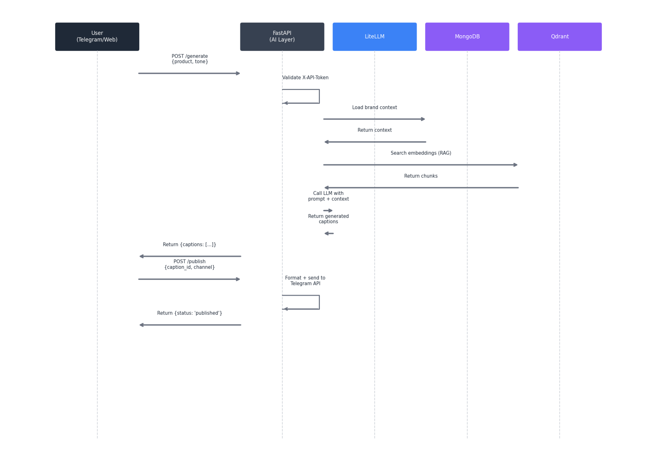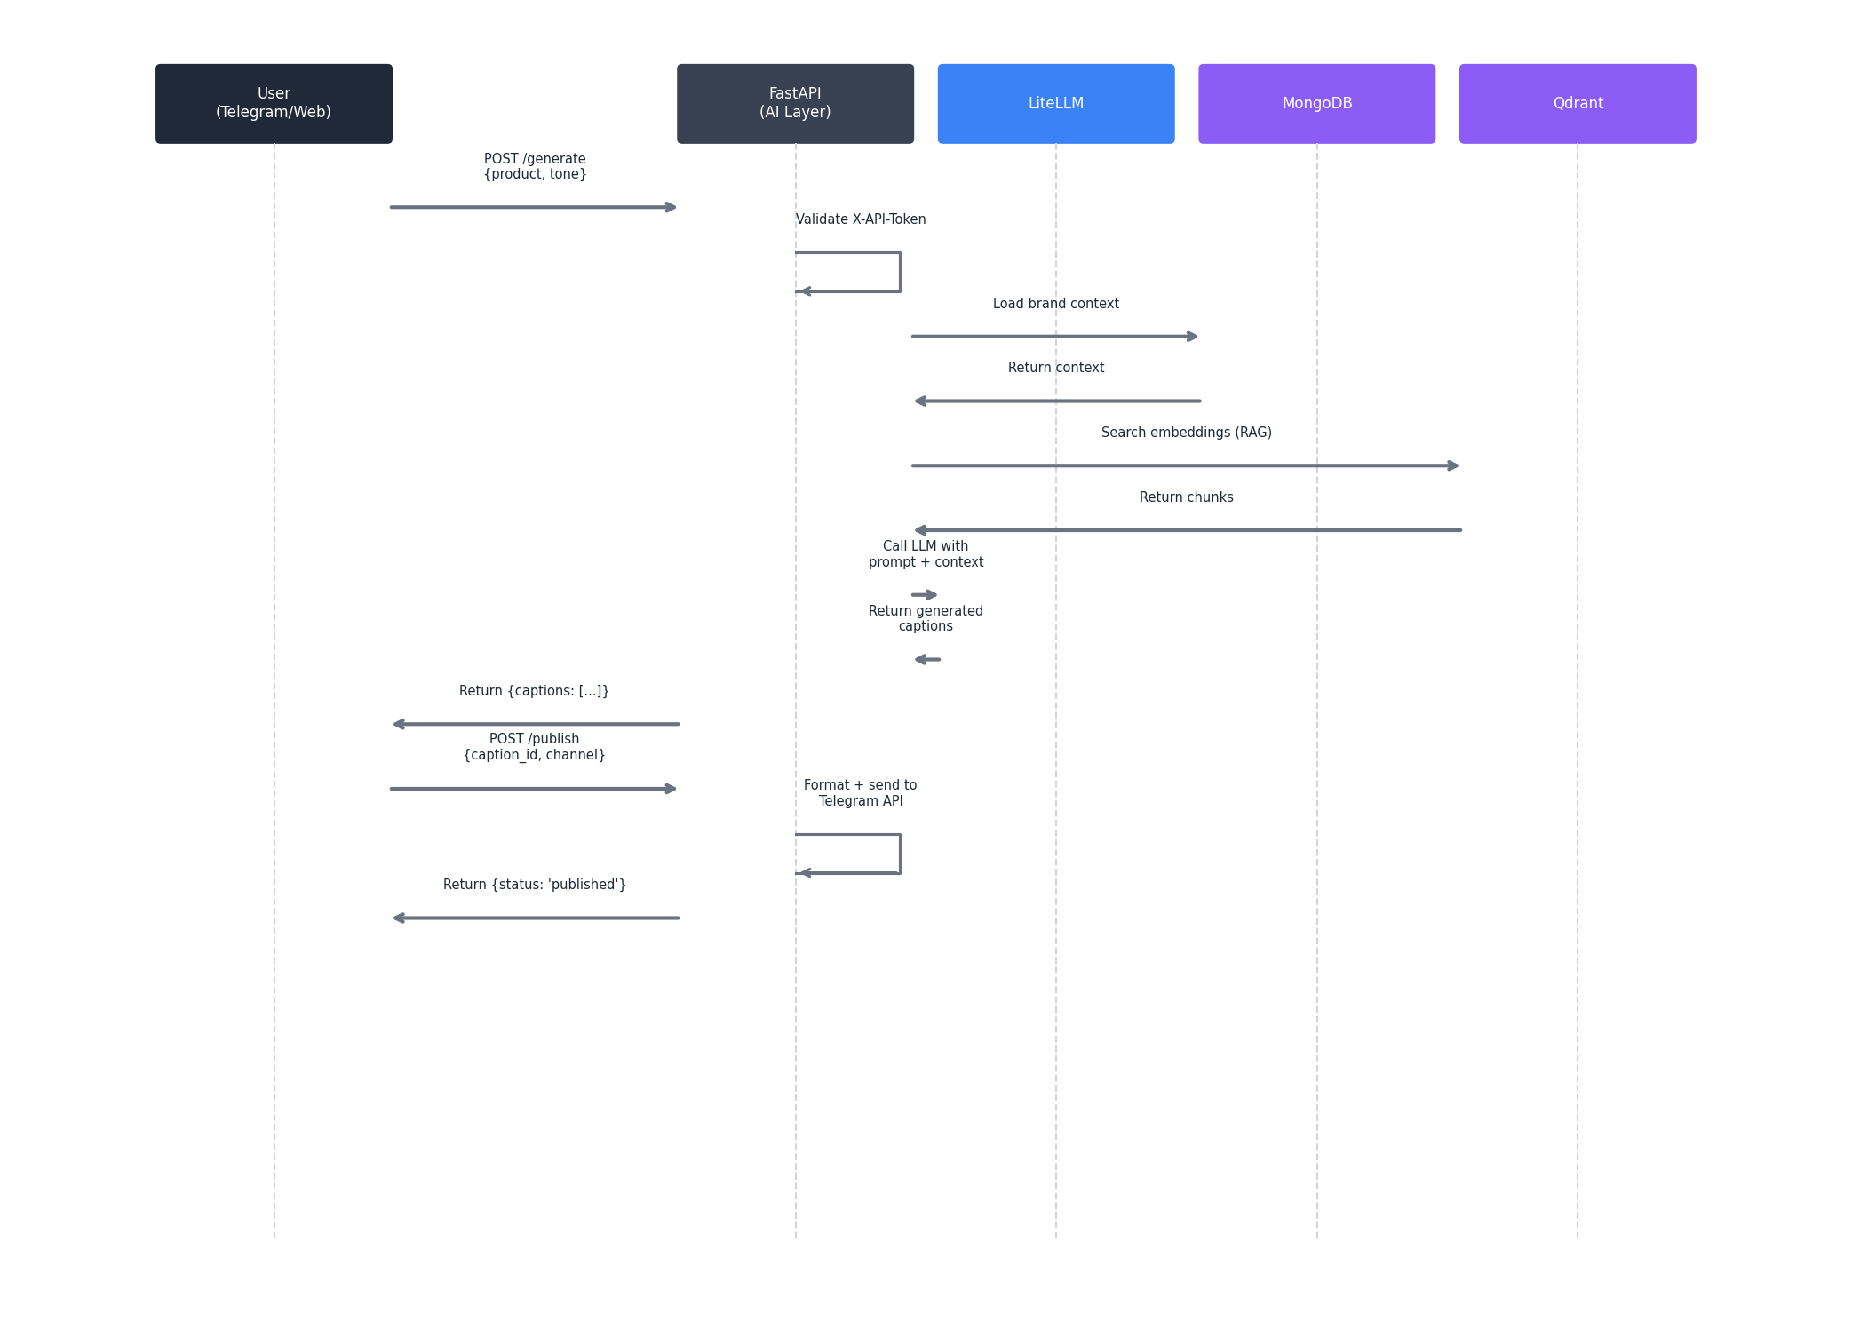
Figure 3.2: Full communication flow sequence diagram

3.3 Inter-Component Authentication
Connection | Auth Method | Details
Frontend -> FastAPI | X-API-Token header | Single token in .env, same for Telegram + Web
FastAPI -> MongoDB | Connection string in .env | No auth layer needed for single-tenant v1
FastAPI -> Qdrant | Connection string in .env | No auth layer needed for local Docker
FastAPI -> LLM Provider | API key in .env | Managed by LiteLLM
FastAPI -> Telegram API | Bot token in .env | Standard Telegram Bot API auth

3.4 Data Flow — Visual
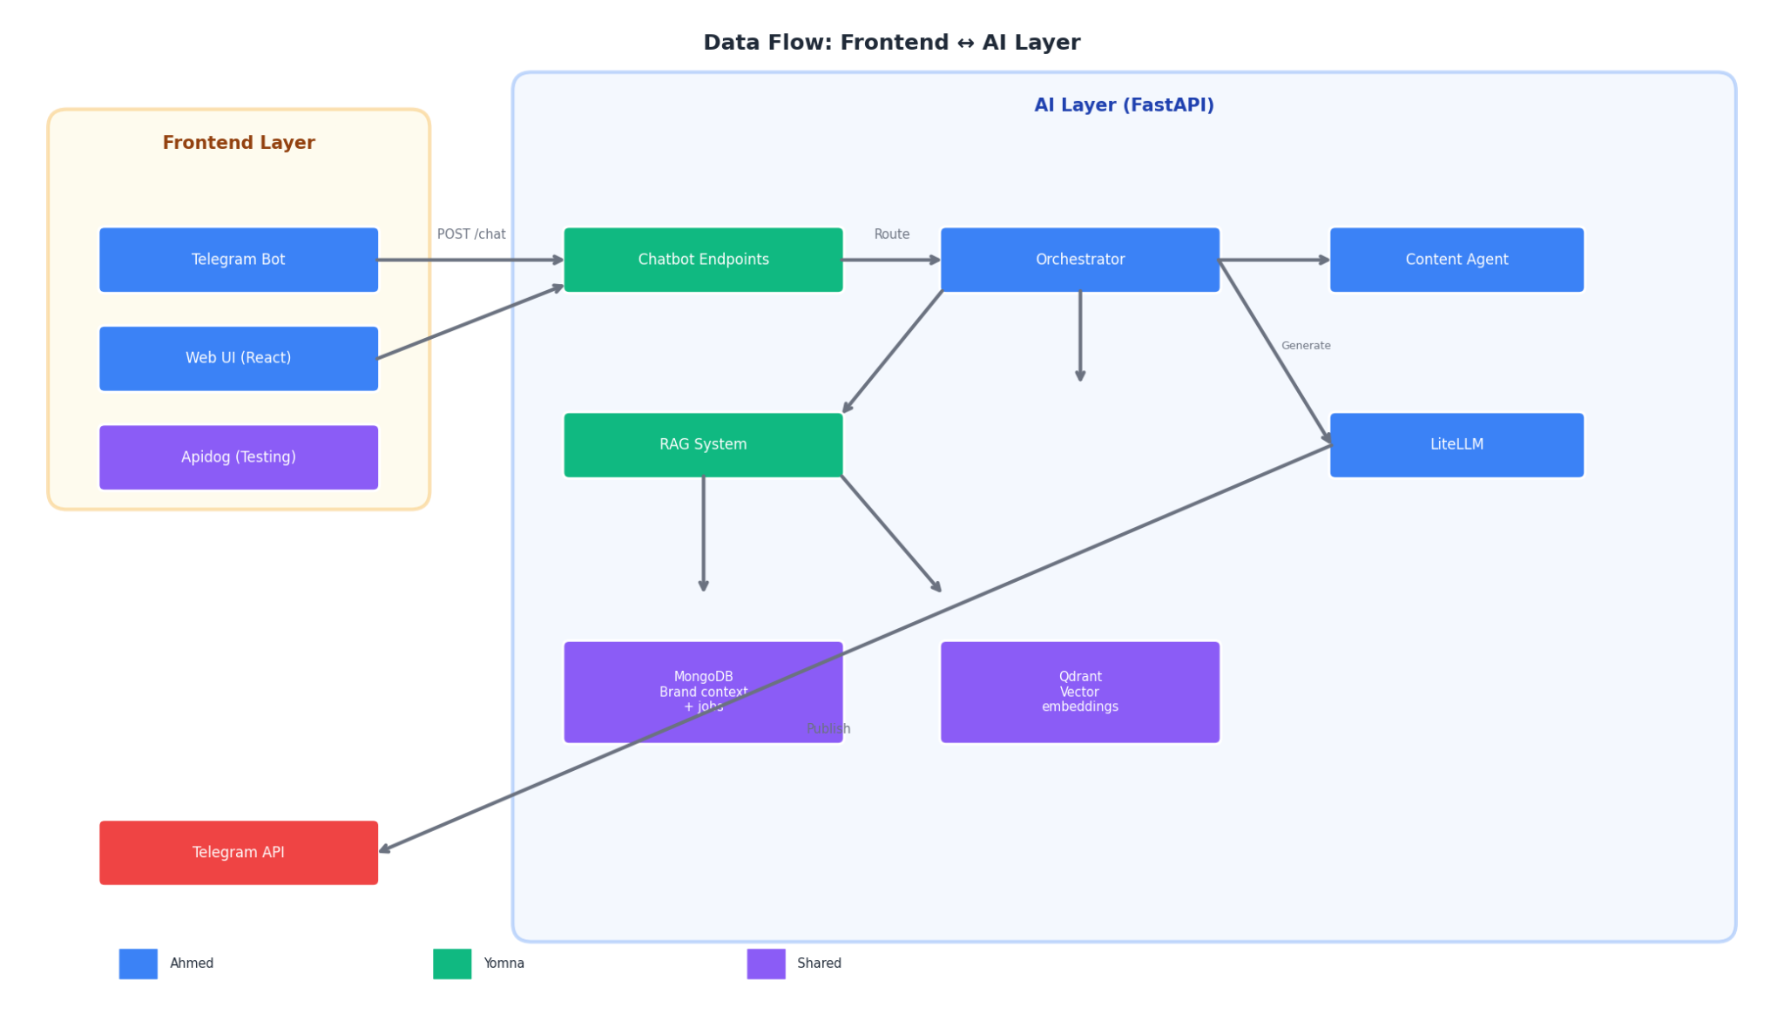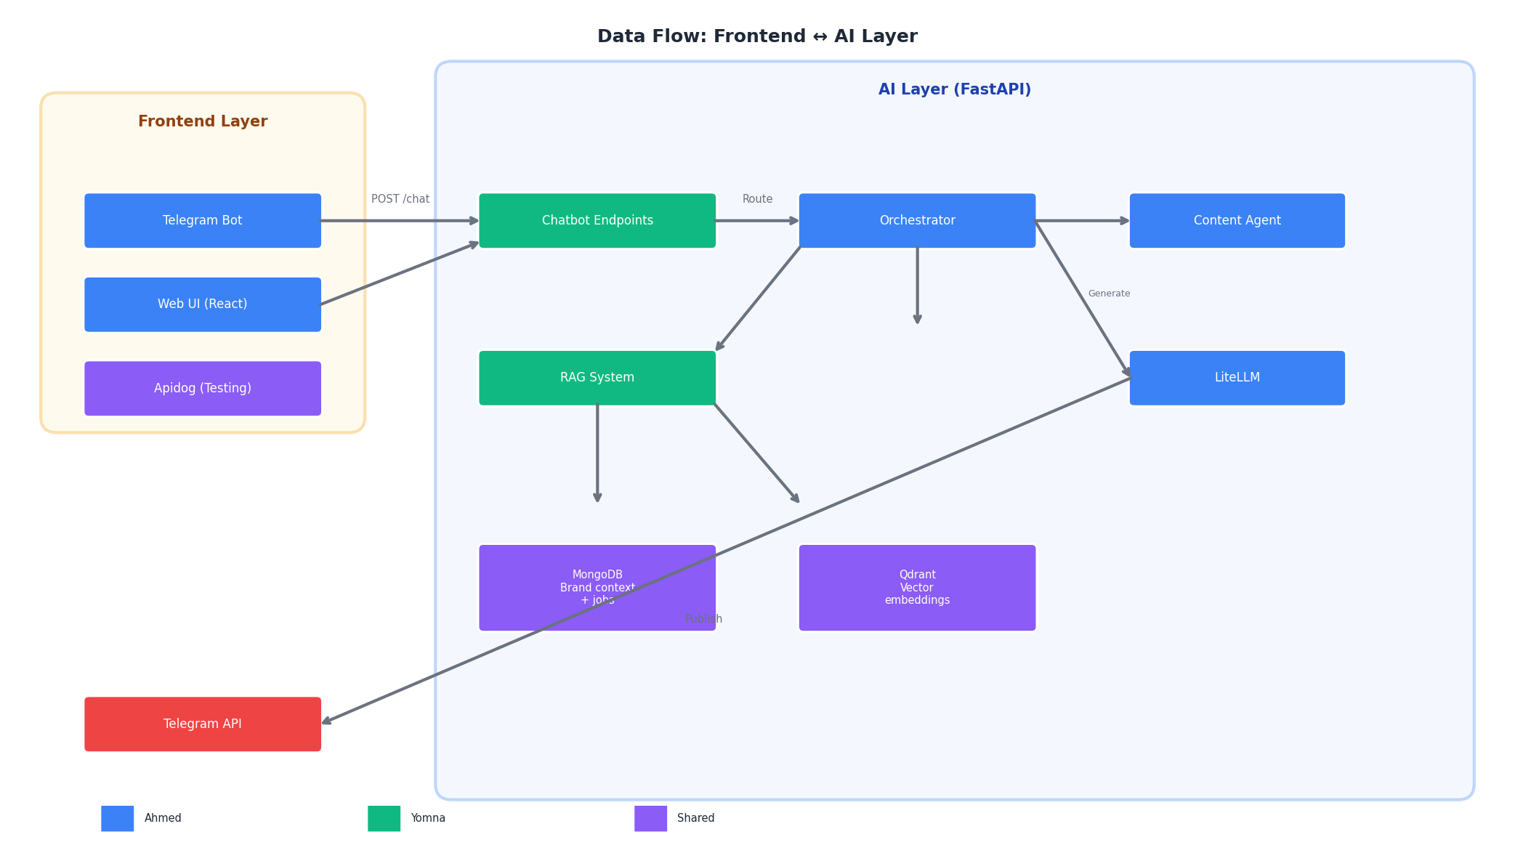
Figure 3.4: Data flow between Frontend and AI layers

4. Agent Architecture

4.1 Agent Hierarchy (v1)
Agent | Owner | Responsibility | v1 Scope
Orchestrator | Ahmed | Routes requests, manages job state, calls sub-agents | Simple if/else routing
RAG Agent | Yomna | Retrieves brand voice + product context | mini-RAG: single-product memory
Chatbot Agent | Yomna | Handles Telegram/Web intent parsing | Basic intents: /start, describe, pick, publish
Content Agent | Ahmed | Generates Arabic marketing copy | 3 caption options, Egyptian dialect tuning

4.2 Agent Communication Flow
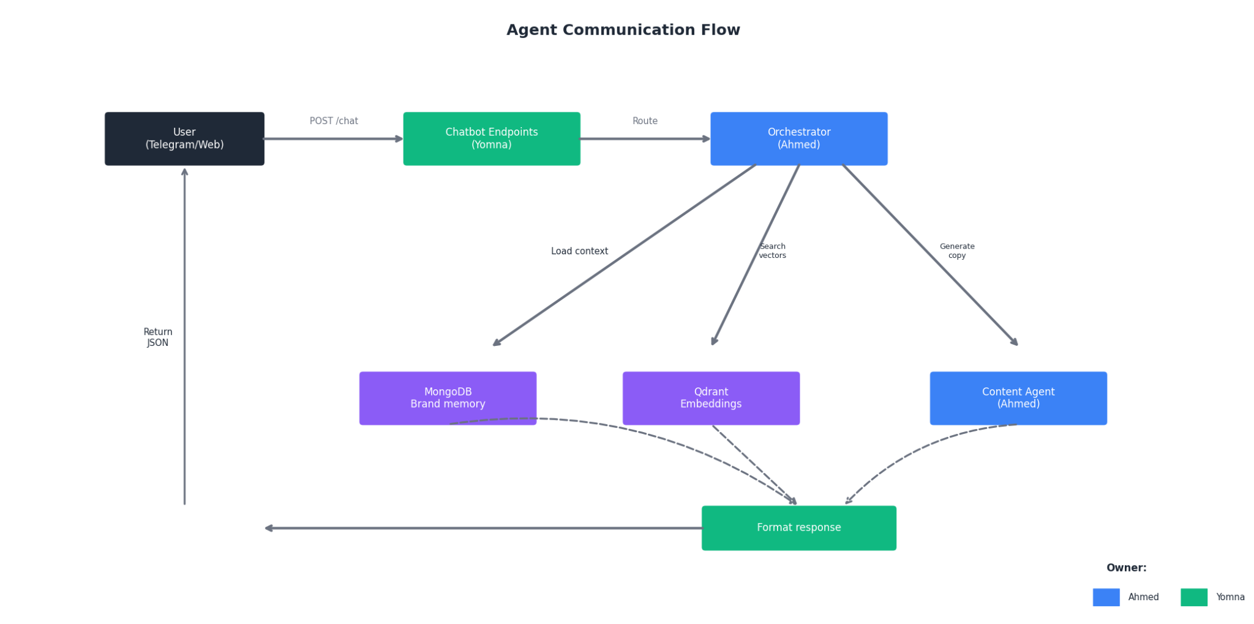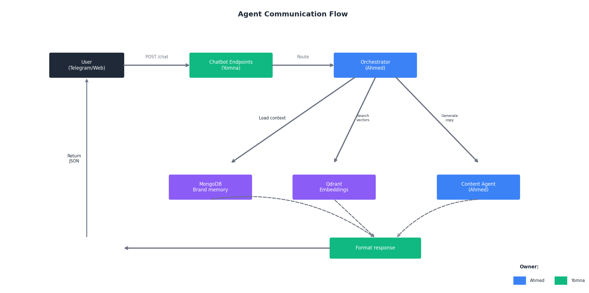
Figure 4.2: Agent communication flow through orchestrator

5. Tools

5.1 Tool Inventory (v1)
Tool | Used By | Purpose | Owner
FastAPI | Backend | API routes, middleware, request validation | Shared
MongoDB (Docker) | Backend + RAG | Structured data: brand memories, job history | Yomna + Ahmed
Qdrant (Docker) | RAG Agent | Vector embeddings for semantic search | Yomna
LiteLLM | All agents | Unified LLM interface (swap providers via config) | Shared
python-telegram-bot | Telegram Bot | Handle bot commands, send messages, media | Ahmed
Pydantic | All agents | Request/response validation, type safety | Shared
Apidog | API testing | API design, testing, documentation, mocking | Both
Docker | Deployment | Containerize FastAPI + MongoDB + Qdrant | Ahmed
GitHub | Version Control | Code hosting, PRs, basic CI | Both
Google Gemini API | LLM Provider | Primary LLM for Arabic generation + embeddings | Ahmed

6. LLM Configuration

6.1 Provider-Agnostic via LiteLLM
# ai/config.py -- Change these to switch models
ORCHESTRATOR_MODEL = "google/gemini-2.0-flash"
RAG_MODEL = "google/gemini-2.0-flash"
CONTENT_MODEL = "google/gemini-2.0-flash" # Arabic-optimized

# Embedding model -- must match QDRANT_VECTOR_SIZE
EMBEDDING_MODEL = "google/text-embedding-004" # 768 dimensions
QDRANT_VECTOR_SIZE = 768

# Rate limiting (per provider)
LLM_REQUESTS_PER_MINUTE = 30
MAX_TOKENS_PER_REQUEST = 2000

6.2 LLM Provider Strategy (Updated 2026)
Provider | Model | Pricing (per 1M tokens) | Arabic Support | Best For
Google Gemini | gemini-2.0-flash | $0.075 input / $0.30 output | Good | v1 Default — Fast, generous free tier
Mistral | mistral-small-3.1 | $0.20 input / $0.60 output | Good | v2 Fallback — Strong reasoning
Groq | llama-3.3-70b | ~$0.05 input / $0.05 output | Decent | v2 Real-time — Ultra-fast inference
OpenRouter | multiple models | Varies (300+ models) | Varies | v2 Experimentation — Unified gateway

7. State Management & RAG

7.1 Dual-Store Strategy
Store | Purpose | Owner | v2 Plan
MongoDB (Docker) | Structured data: brand memories, job history, settings, user preferences | Yomna + Ahmed | Core — add multi-tenant isolation
Qdrant (Docker) | Vector embeddings for semantic search (RAG) | Yomna | Core — add hybrid search, re-ranking

7.2 RAG Flow — Synchronous (v1)
No async tasks. No queues. Simple request -> response. (~2-5 seconds)
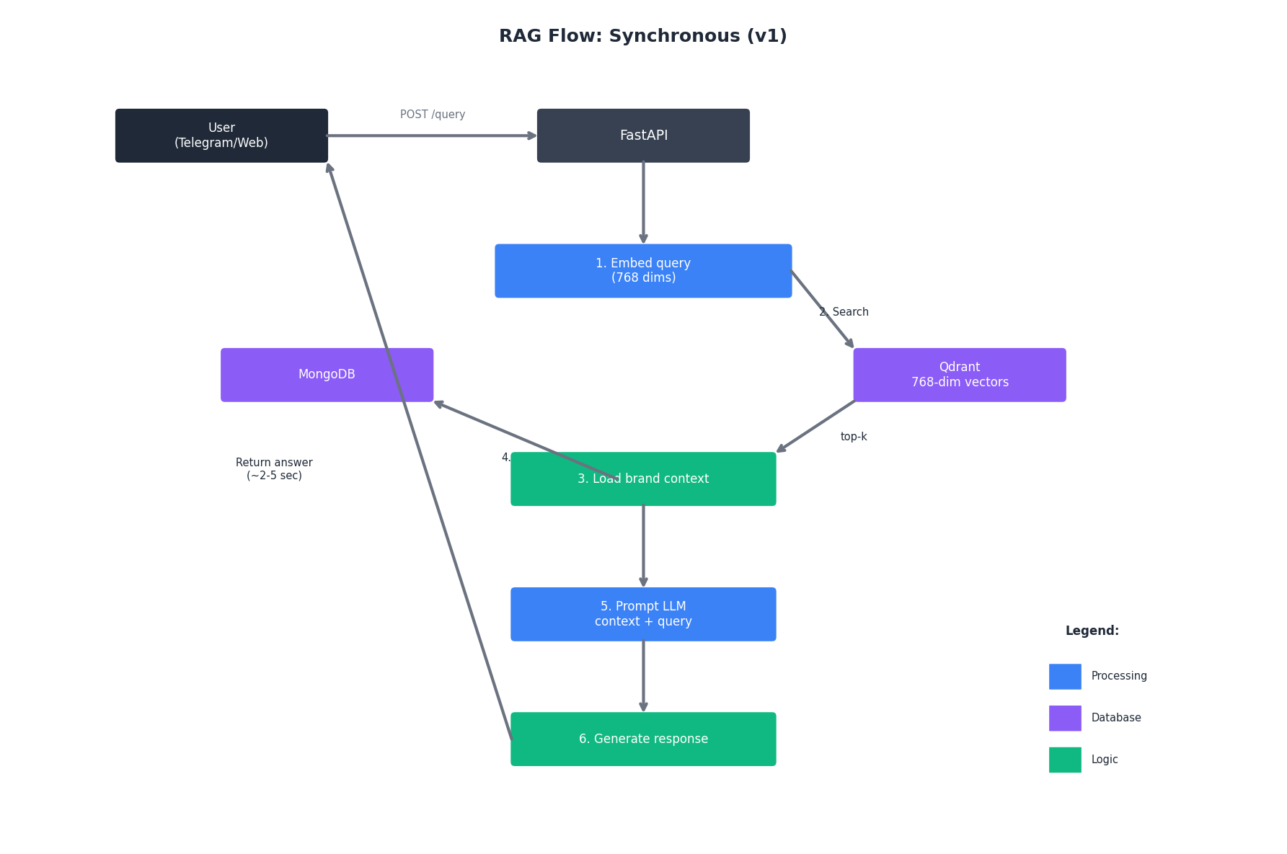
Figure 7.2: RAG synchronous flow diagram

8. API Layer (FastAPI)

8.1 FastAPI Endpoints (v1)
Endpoint | Method | Purpose | Owner
/health | GET | Health check for Docker and monitoring | Shared
/api/v1/chat | POST | Main chat endpoint (Telegram/Web) | Yomna
/api/v1/generate | POST | Content generation (captions) | Ahmed
/api/v1/publish | POST | Publish content to Telegram | Ahmed
/api/v1/rag/search | POST | RAG semantic search | Yomna
/api/v1/brand | GET/POST | Brand context management | Yomna

8.2 API Authentication
# ai/middleware/auth.py -- Ahmed owns
import os
from fastapi import HTTPException, Request

API_TOKEN = os.getenv("API_TOKEN")

async def verify_api_token(request: Request):
"""
Validate the X-API-Token header on all protected endpoints.
Uses custom header instead of Authorization: Bearer because:
1. Bearer implies OAuth/JWT, which we don't support in v1
2. Custom header is explicit -- no ambiguity
3. Simpler to implement and test
"""
token = request.headers.get("X-API-Token")
if not token or token != API_TOKEN:
raise HTTPException(
status_code=401,
detail="Invalid or missing X-API-Token header"
)
return token

9. Frontend Layer (Telegram + Web)

9.1 Telegram Bot (Primary v1 Frontend)
Command | Purpose | Owner
/start | Welcome + product description prompt | Ahmed
/new | Create new campaign | Ahmed
/generate | Generate captions for product | Ahmed
/publish | Publish selected caption | Ahmed
/help | Show available commands | Ahmed

9.2 Web UI (Secondary v1 Frontend)
Page | Purpose | Owner
/ | Landing + quick generate form | Ahmed (AI-gen)
/campaign | Campaign list + create | Ahmed (AI-gen)
/generate | Content generation form | Ahmed (AI-gen)
/settings | Brand voice configuration | Ahmed (AI-gen)

10. Repository Structure

10.1 Monorepo Structure (v1)
marka_ai/
|-- ai/ # Python -- uv manages this
| |-- pyproject.toml # uv project config
| |-- app/
| | |-- __init__.py
| | |-- main.py # FastAPI app entry
| | |-- config.py # Shared config (models, dimensions, rate limits)
| | |-- api/v1/
| | | |-- __init__.py
| | | |-- routes/
| | | | |-- chat.py # Yomna
| | | | |-- generate.py # Ahmed
| | | | |-- publish.py # Ahmed
| | | | +-- rag.py # Yomna
| | | |-- middleware/
| | | | |-- auth.py # Ahmed -- X-API-Token validation
| | | | |-- rate_limit.py # Shared -- in-memory rate limiter
| | | | +-- errors.py # Shared
| | | +-- schemas/
| | | |-- chat.py # Shared
| | | +-- generate.py # Shared
| | |-- agents/
| | | |-- orchestrator.py # Ahmed
| | | |-- rag.py # Yomna
| | | |-- content.py # Ahmed
| | | +-- chatbot.py # Yomna
| | |-- services/
| | | |-- llm_service.py # Shared -- LiteLLM wrapper + fallback
| | | |-- qdrant_service.py # Yomna -- deterministic IDs + 768-dim vectors
| | | +-- mongodb_service.py # Shared
| | |-- models/
| | | |-- brand_memory.py # Yomna
| | | +-- job_history.py # Ahmed
| | +-- state/
| | +-- job_state.py # Ahmed -- in-memory + cleanup
| |-- tests/
| |-- Dockerfile
| +-- .env.example
|
|-- bot/ # Python -- Telegram bot
| |-- main.py # Ahmed -- includes wait_for_api() health check
| |-- handlers/
| |-- requirements.txt # httpx, python-telegram-bot
| |-- Dockerfile
| +-- .env.example
|
|-- web/ # React -- AI-generated
| |-- src/
| | |-- App.tsx
| | |-- api/
| | | +-- client.ts # Ahmed -- X-API-Token auth
| | +-- components/
| |-- package.json
| +-- .env.example
|
|-- docker-compose.yml # Full stack -- health checks + depends_on
|-- .github/workflows/
| +-- ci.yml # Simple lint + test
|-- README.md # How to run locally
|-- CLAUDE.md # AI assistant guidance
+-- .env.example # Root environment template

10.2 Package Managers
Layer | Manager | Config File
AI (FastAPI) | uv | ai/pyproject.toml
Bot (Telegram) | uv or pip | bot/requirements.txt
Web (React) | npm/pnpm | web/package.json

10.3 Environment Variables
# .env.example (root)

# === Auth ===
API_TOKEN=your-api-token-here

# === LLM Provider ===
LLM_API_KEY=your-google-api-key-here
# LLM_MODEL=google/gemini-2.0-flash # Default in config.py
# EMBEDDING_MODEL=google/text-embedding-004 # Default in config.py

# === Telegram ===
TELEGRAM_BOT_TOKEN=your-telegram-bot-token-here

# === Database ===
MONGODB_URI=mongodb://localhost:27017
QDRANT_HOST=localhost
QDRANT_PORT=6333

# === Optional Fallback LLM Keys ===
# MISTRAL_API_KEY=your-mistral-key-here
# GROQ_API_KEY=your-groq-key-here

10.4 Key Config File
This is the single source of truth for all configurable constants:
# ai/app/config.py -- Shared
import os

# === Auth ===
API_TOKEN = os.getenv("API_TOKEN")

# === LLM Models (change these to switch providers) ===
ORCHESTRATOR_MODEL = os.getenv("ORCHESTRATOR_MODEL", "google/gemini-2.0-flash")
RAG_MODEL = os.getenv("RAG_MODEL", "google/gemini-2.0-flash")
CONTENT_MODEL = os.getenv("CONTENT_MODEL", "google/gemini-2.0-flash")

# === Embedding Model ===
# CRITICAL: QDRANT_VECTOR_SIZE must match the embedding model's output dimensions.
EMBEDDING_MODEL = os.getenv("EMBEDDING_MODEL", "google/text-embedding-004")
QDRANT_VECTOR_SIZE = int(os.getenv("QDRANT_VECTOR_SIZE", "768"))

# === Rate Limiting ===
LLM_REQUESTS_PER_MINUTE = int(os.getenv("LLM_REQUESTS_PER_MINUTE", "30"))
MAX_TOKENS_PER_REQUEST = int(os.getenv("MAX_TOKENS_PER_REQUEST", "2000"))
MAX_TOKENS_PER_SCAN = int(os.getenv("MAX_TOKENS_PER_SCAN", "50000"))
LLM_REQUEST_DELAY_MS = int(os.getenv("LLM_REQUEST_DELAY_MS", "200"))

# === Database ===
MONGODB_URI = os.getenv("MONGODB_URI", "mongodb://localhost:27017")
MONGODB_DB = os.getenv("MONGODB_DB", "marka_ai")
QDRANT_HOST = os.getenv("QDRANT_HOST", "localhost")
QDRANT_PORT = int(os.getenv("QDRANT_PORT", "6333"))

# === Telegram ===
TELEGRAM_BOT_TOKEN = os.getenv("TELEGRAM_BOT_TOKEN")

# === Fallback Models (ordered) ===
FALLBACK_MODELS = [
"mistral/mistral-small-3.1",
"groq/llama-3.3-70b",
]

11. Docker & Deployment

11.1 Services
Service | Port | Responsibility
fastapi | 8000 | AI Layer — FastAPI + agents
mongodb | 27017 | Structured data — brand memories, job history
qdrant | 6333 | Vector embeddings — RAG semantic search
bot | — | Telegram bot (runs as background process)
web | 5173 | React web UI (dev) / static serve (prod)

11.2 Deployment Strategy
Phase | Deployment | Notes
Phase A (Now) | Docker Compose on local machine | Ahmed + Yomna develop locally
Phase B (Post-MVP) | Docker Compose on VPS | Single server, all services
Phase C (Scale) | Kubernetes or Docker Swarm | Multi-server, horizontal scaling

11.3 Docker Compose (v1)
# docker-compose.yml
version: '3.8'

services:
mongodb:
image: mongo:7.0
container_name: marka_mongodb
ports:
- "27017:27017"
volumes:
- mongodb_data:/data/db
healthcheck:
test: ["CMD", "mongosh", "--eval", "db.adminCommand('ping')"]
interval: 10s
timeout: 5s
retries: 5
start_period: 10s

qdrant:
image: qdrant/qdrant:latest
container_name: marka_qdrant
ports:
- "6333:6333"
- "6334:6334"
volumes:
- qdrant_data:/qdrant/storage
healthcheck:
test: ["CMD-SHELL", "curl -f http://localhost:6333/healthz || exit 1"]
interval: 10s
timeout: 5s
retries: 5
start_period: 10s

fastapi:
build: ./ai
container_name: marka_api
ports:
- "8000:8000"
environment:
- MONGODB_URI=mongodb://mongodb:27017
- QDRANT_HOST=qdrant
- QDRANT_PORT=6333
- API_TOKEN=${API_TOKEN}
- LLM_API_KEY=${LLM_API_KEY}
- TELEGRAM_BOT_TOKEN=${TELEGRAM_BOT_TOKEN}
depends_on:
mongodb:
condition: service_healthy
qdrant:
condition: service_healthy
healthcheck:
test: ["CMD-SHELL", "curl -f http://localhost:8000/health || exit 1"]
interval: 10s
timeout: 5s
retries: 5
start_period: 15s
volumes:
- ./ai:/app

bot:
build: ./bot
container_name: marka_bot
environment:
- API_URL=http://fastapi:8000
- API_TOKEN=${API_TOKEN}
- TELEGRAM_BOT_TOKEN=${TELEGRAM_BOT_TOKEN}
depends_on:
fastapi:
condition: service_healthy
restart: on-failure

volumes:
mongodb_data:
qdrant_data:

11.4 Startup Sequence
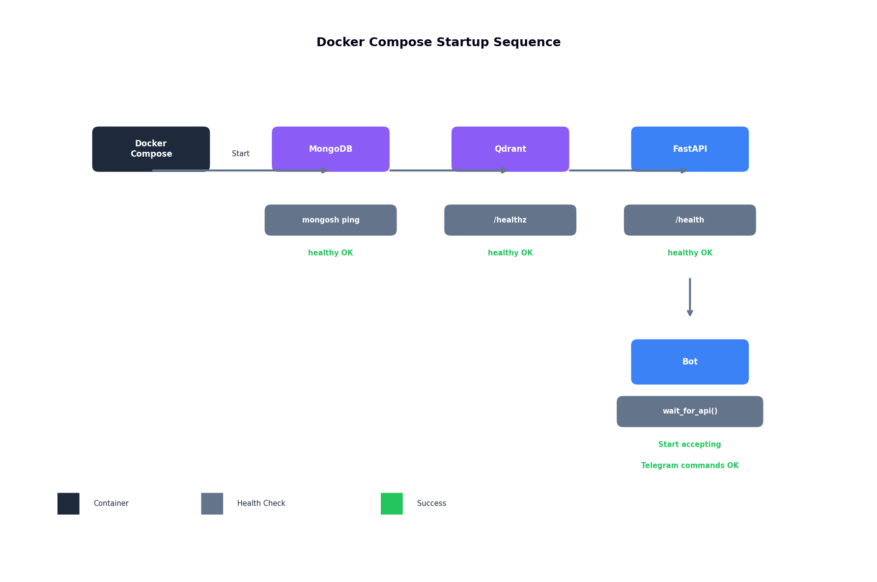
Figure 11.4: Docker Compose startup sequence with health checks

12. GitHub Rules & Workflow

12.1 Branch Strategy
Branch | Rules
main | Production. Never push directly. PR + 1 approval required.
develop | Integration branch. All features merge here first. PR + 1 approval required.
feature/ai/* | Yomna's AI layer features. Merges to develop.
feature/bot/* | Ahmed's Telegram bot features. Merges to develop.
feature/web/* | Ahmed's Web UI features. Merges to develop.
hotfix/* | Emergency fixes. Branches from main. Merges to main AND develop.

12.2 Commit Convention
feat(ai): add RAG agent with Qdrant integration
feat(bot): add /generate command handler
feat(bot): add wait_for_api() startup health check
feat(web): add campaign creation form
fix(ai): use SHA-256 for deterministic Qdrant point IDs
fix(ai): set QDRANT_VECTOR_SIZE to 768 for text-embedding-004
fix(bot): correct Telegram message formatting
fix(docker): add health checks to all services
docs: update CLAUDE.md with v1 architecture
chore: add .env.example with all required variables

12.3 PR Requirements
Requirement | Details
1 approval | From the other teammate
CI passes | Lint + test must pass
No console.log / print() | Remove debug statements before merge
Update docs | If API changes, update Apidog spec
Config consistency | If you change a model or dimension, update config.py + this document

13. Open Questions

13.1 Resolved Questions
Question | Resolution | Resolved By
Auth header: Authorization: Bearer vs X-API-Token? | Use X-API-Token custom header everywhere. Bearer implies OAuth/JWT which we don't support in v1. | Document review
Qdrant point IDs: hash() vs deterministic? | Use hashlib.sha256 truncated to 64-bit. Python's hash() is randomized via PYTHONHASHSEED. | Document review
Embedding model dimensions: 1536 vs 768? | Use 768 dimensions. Both primary and fallback models output 768 dims. | Document review
Bot startup race condition? | Three-layer protection: Docker health checks, wait_for_api() retry loop, restart: on-failure. | Document review
In-memory job state loss on restart? | Accepted for v1. MongoDB job_history is durable audit log. Add Redis in v2. | Document review

13.2 Open Questions
Question | Needed By | Details | Owner
LLM provider selection | Before first scan | Which model is best for Arabic dialect? Currently Gemini — should we test Mistral? | Ahmed
Telegram vs Web priority | Before frontend build | Should we focus 100% on Telegram for v1, or split effort? | Both
Brand voice collection | Before pilot | How do we collect brand voice from pilot SMEs? Survey? Interview? | Both
Pilot customer recruitment | Before Phase A ends | How do we find 3–5 Egyptian SMEs for pilot? | Both
Pricing for Phase B | Before v2 | Is 3,000/12,000/40,000 EGP the right tier structure? | Both
Arabic dialect tuning | Before v2 | Should we fine-tune a model or rely on prompt engineering? | Ahmed

Appendix A: Design Decisions Registry
All architectural decisions made during document review, consolidated for quick reference.
ID | Decision | Problem | Resolution
DD-001 | Auth header standardization | Section 3.3 said X-API-Token but Section 8.2 used HTTPBearer | Standardized on X-API-Token custom header everywhere
DD-002 | Deterministic Qdrant point IDs | Python's hash() is randomized via PYTHONHASHSEED | Replaced with hashlib.sha256 truncated to 64-bit integer
DD-003 | Embedding dimension alignment | Original doc specified size=1536 (OpenAI) but LLM is Google | Changed to 768 dimensions for Google text-embedding-004
DD-004 | Bot startup race condition | Bot could start before FastAPI is ready | Three-layer fix: Docker health checks, wait_for_api(), restart on-failure
DD-005 | In-memory job state documentation | JobState loses data on restart | Documented as accepted v1 limitation. MongoDB job_history is durable log

Document Governance
This document is the single source of truth for Marka AI v1 technical decisions.
Rule | Details
Any architectural change | Must be updated here and discussed with the team before implementation
Agent prompt changes | Both Ahmed and Yomna must review before merge
API schema changes | Must update Apidog spec + this document
Document updates | Either teammate can propose; both must approve
Design decisions | Must be logged in Appendix A with problem, resolution, and impacted sections
Config changes | Any change to models, dimensions, or rate limits must update config.py + this document

Last Updated: March 2026
Last Reviewed: March 2026 (5 design decisions resolved — see Appendix A)
Next Review: After Phase A (Pilot) completes

