

**CS251 – Software Engineering I**

Contents

Team 3

Document Purpose and Audience 3

System Models 3

System Decomposition 3

Class diagrams 6

Important Algorithm 7

Sequence diagrams 7

Class - Sequence Usage 9

Physical Entity-Relationship Diagram 10

User Interface Design 10

Screen 1 – XXX 11

Screen 2 – YYY 11

Screen 3 – Login Screen (example) 11

Screen 4 – Main Interface (example) 11

Ownership Report 12

# Team

|  |  |  |  |
| --- | --- | --- | --- |
| **ID** | **Name** | **Email** | **Mobile** |
| 20120007 | Ahmed Idris Elsedeek | Ahmed.idris2009@gmail.com | 01144598484 |
| 20120011 | Ahmed Elsayed Sobhy | ahmedlesnar1@gmail.com | 01123246326 |
| 20120015 | Ahmed Gamal Ahmed | ahmedfares107@gmail.com | 01112468572 |
| 20120164 | Khaled Mahmoud Youssef | khaledjoo70@yahoo.com | 01021715691 |

# 

# Document Purpose and Audience

* This document is talking about the Design of how to develop back-end API for social network something like Facebook API and this document will give a Class diagrams, System Decomposition , User Interface to describe our system and make it has reliability maintainability ,reusability and flexibility to understand it.
* Our audience are project owner, project manager, clients.

# System Models

## System Decomposition

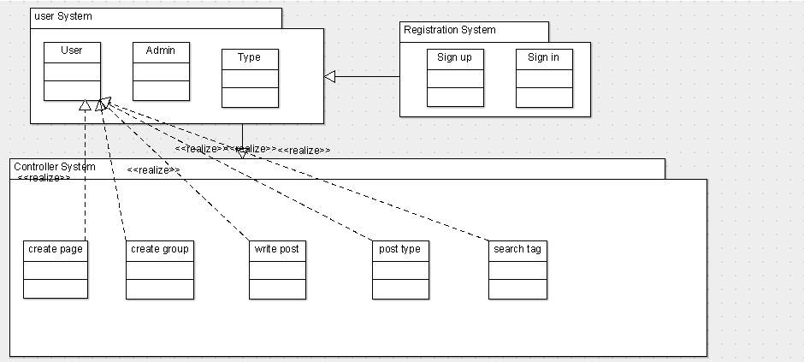

## Class diagrams

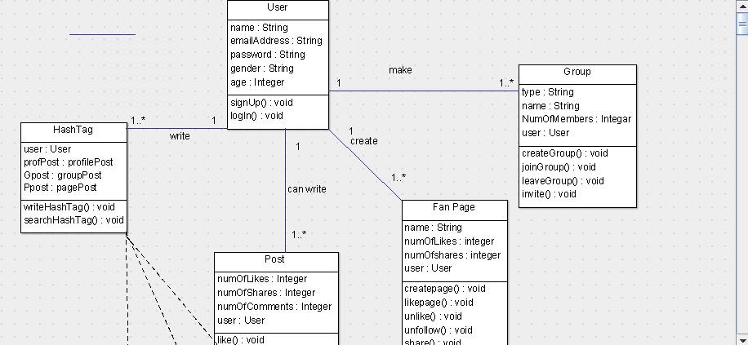

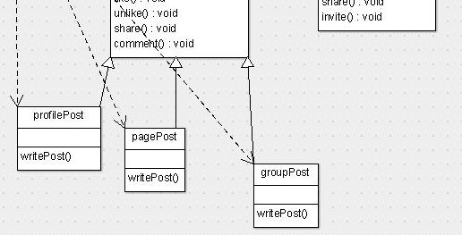

| **Class ID** | **Class Name** | **Subsystem ID** | **Description** |
| --- | --- | --- | --- |
|  |  |  |  |

## 

## Sequence diagrams

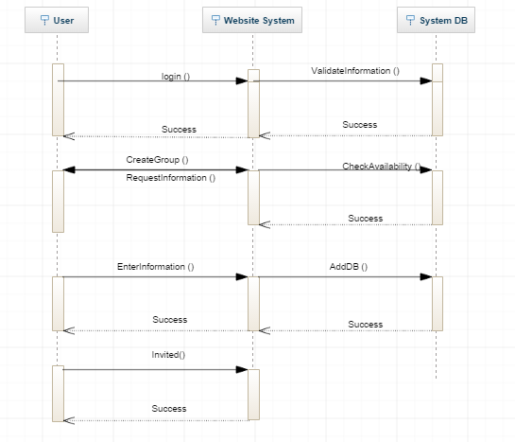

### Class - Sequence Usage

| **Class Name** | **Sequence Diagrams** | **Overall used methods** |
| --- | --- | --- |
| User | 1,5,9,13 | Login(),CreateGroup(),EnterDetails(),  Invited() |
| Website System | 2,6,10,14 | ValidateInformation(),checkAvailibiltiy(),AddInfromation() |

## 

## Physical Entity-Relationship Diagram

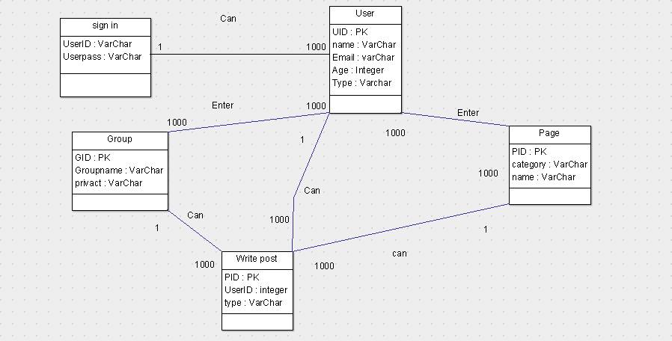

## 

## User Interface Design

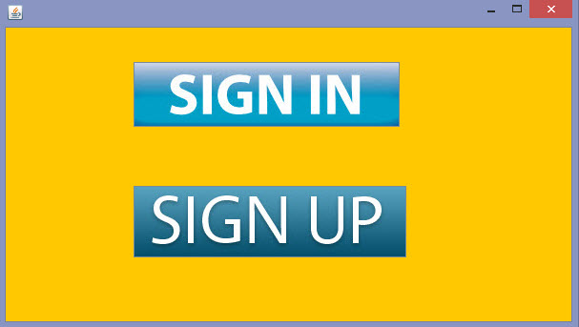

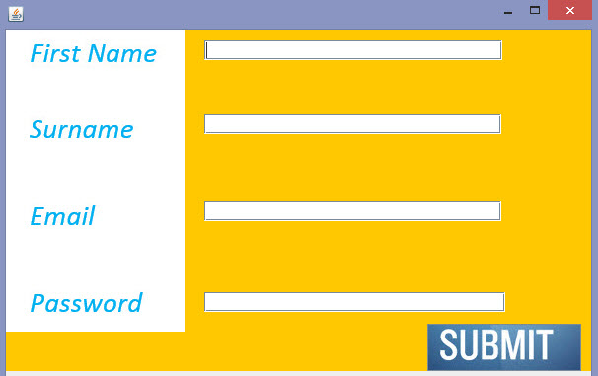

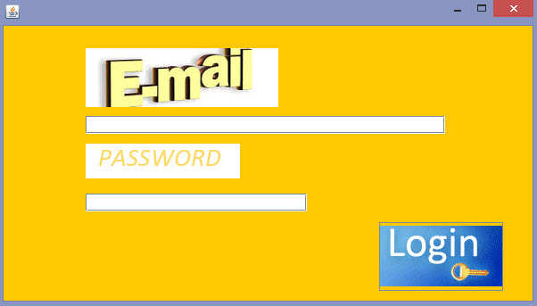

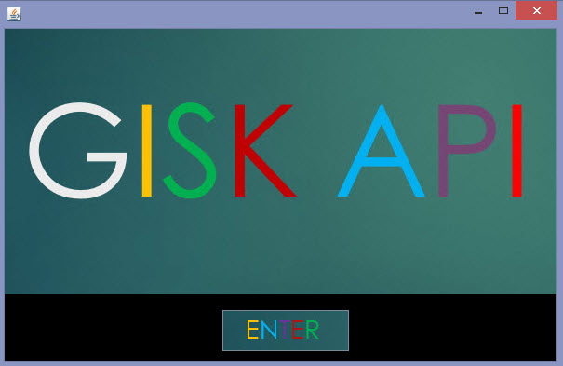

# Ownership Report

|  |  |
| --- | --- |
| **Item** | **Owners** |
| Sequence diagram | *Ahmed Idris Elsedeek Mohamed*  *20120007* |
| Physical Entity-Relationship Diagram | *Ahmed Idris Elsedeek Mohamed*  *20120011* |
| User Interface Design | *Ahmed Gamal Ahmed*  *20120015* |
| Class diagramsSystem Decomposition | *Khaled Mahmoud Youssef*  *20120164*  *Team* |