

**Course Name:** Software engineeringl

2014

**TA Name:** Mohamed Samir

**Leader Name:** Ahmed Idris Elsedeek Mohamed Elbakry

**Contact of leader:** ahmed.idris2009@gmail.com

**[Social network]**

2014

Contents

Instructions [To be removed] 1

Team 1

Document Purpose and Audience 2

Introduction 2

Software Purpose 2

Software Scope 2

Definitions, acronyms, and abbreviations 2

Requirements 2

Functional Requirements 3

Non Functional Requirements 3

System Models 3

Use Case Model 3

Use Case Tables 3

Ownership Report 4

**Policy Regarding Plagiarism:** 5

# Team

|  |  |  |  |
| --- | --- | --- | --- |
| **ID** | **Name** | **Email** | **Mobile** |
| 20120007 | Ahmed Idris Elsedeek | Ahmed.idris2009@gmail.com | 01144598484 |
| 20120011 | Ahmed Elsayed Sobhy | ahmedlesnar1@gmail.com | 01123246326 |
| 20120015 | Ahmed Gamal Ahmed | ahmedfares107@gmail.com | 01112468572 |
| 20120164 | Khaled Mahmoud Youssef | khaledjoo70@yahoo.com | 01021715691 |

# 

# Document Purpose and Audience

* This document is talking about how to develop back-end API for social network something like Facebook API and this document will give a detailed description about API and features you can have when you have our application.
* Our audience are project owner, project manager, clients.

# Introduction

## Software Purpose

* The software purpose is to develop back-end API to has a good performance and it should be easy to use and let users enjoy with the software features such as : -
* Write posts custom or public.
* Search Hash Tag to retrieve posts related to this hash tag.
* Create group public or private.
* Create Page public or private.

## And easier to connect with other people.

## Software Scope

* Develop back-end API that is able to manage interactions between users for all features they can use and to connect community projects with green and social benefits and manage interactions between users, create and manage groups and pages, manage different type of posts and retrieve current posts in specific hashtag and sort these posts according to the most important post. The target of our project is the people who wants to use any social network and can login and use it.

## 

## Definitions, acronyms, and abbreviations

# API (Application programming interface):-

# -an abbreviation of application program interface, is a set of routines, protocols, and tools for building software applications.

# -Hashtag: - is a word or an unspaced words start with the #, to form a label. It is a type of metadata tag.

# 

# Requirements

## Functional Requirements

1. **Sign up**

* To create a new account you have to sign up and you should fill in the form of these attributes name , age , email , confirm email , password , confirm password and in each of them there are some condition to check whether you typed in the right way of each of these attributes for example (password ahmed123 , confirm password ahmed12) it will check on the whole string and go on each character and compare if it’s all true and the same then this is right else then you have to retype your confirm password again to check.

1. **Sign in**

* To sign in your account you have to be signed up first and have an email account and a password account, so you first will have to fill in your email and then you email and the system will check weather this account is signed up with the right email and password so if it is true then you will sign in your account but if false you will be asked to retype both attributes and try to sign in again.

1. **Write an article or posts**

* when you are in your account and you want to write a post you first will be asked if you want the privacy to be public or custom as it will verify your choice and it will display this post depending on this privacy, when you chose public the system will display it to all the people when you chose custom the system will ask you custom for who and depending on that it will display to the custom choice.

1. **Search hashtag**

* To search for a hash tag the system will search for a word that has the same characters and display a list of these words which you can choose from.

1. **Create group or page**

* To create a group you first will have to give it its privacy public, private or admin requested so when any account wants to join this page the system will check weather public it will lit this account join if its private the system won't lit this account to join and if its admin requested the account won’t join the page until the admin accepts its request.

## Non Functional Requirements

Non-functional requirements that make an application complete are easy to leave out. The consequences of leaving these NFRs out of an application lead directly to the aforementioned maintenance problems and increased technical debt. If a single NFR is missing from an application then that application is compromised.

**1. Usability**

* Simple user interfaces that a layman can understand.

**2. Security**

* Protect the privacy of data entered into the software and restricting access to features or data to certain users.

**3. Performance**

* The performance constraints specify the timing characteristics of the software. Certain tasks or features are more time-sensitive

**4. Reliability**

* The capability of the software to maintain its performance over time. Unreliable software fails frequently, and certain tasks are more sensitive to failure.

**5. Portability**

* The ease with which software can be installed on all necessary platforms and the platforms on which it is expected to run.

**6. Flexibility**

* It is the ease with which the system can be reused, deployed, and tested.

**7. Maintenance Cost**

* The maintenance cost for such online social network must also be considered. If developing such social network requires more money than only way to gain it back is only through the advertisements or by selling user data.

**8. Availability**

* System should be available for 24hours a day.
* A system’s availability is the amount of time that it is operational and available for use.
* This is specified because some systems are designed with expected downtime for activities like database upgrades and backups.

**9. Documentation**

* It’s hard to keep complex system documentation up to date. Even if you’re able to document the initial version of your application, by the time you’ve finished, the application has changed and its documentation is outdated.

**10. Efficiency**

* Specifies how well the software utilizes scarce resources: CPU cycles, disk space, memory, bandwidth, etc.

# System Models

## Use Case Model

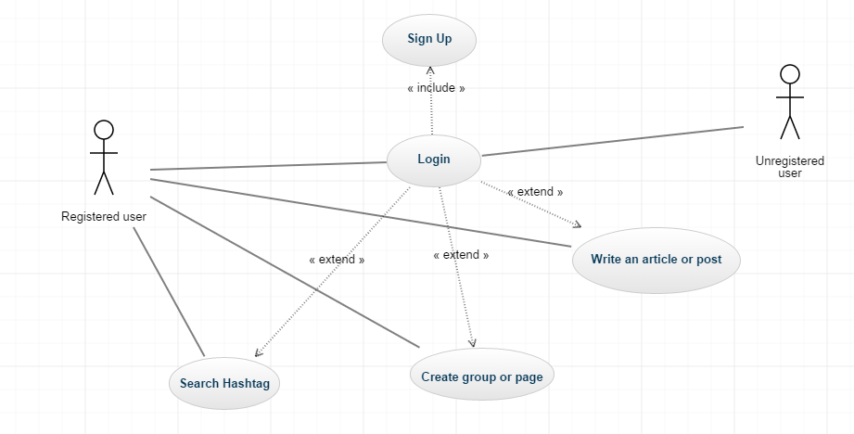

## 

## Use Case Tables

|  |  |  |
| --- | --- | --- |
| Use Case ID: | 1 | |
| Use Case Name: | Sign up | |
| Actors: | Unregistered User | |
| Pre-conditions: | -------- | |
| Post-conditions: | Login | |
| Flow of events: | **User Action** | **System Action** |
| 1- User Enter on Sign up button. |  |
|  | 2- System show up the signing up form. |
| 3- User will insert information (First name- Last name - Email – password – confirm password). |  |
|  | 4- Confirm information and add it to database website. |
| Exceptions: | ------------------------ | |
| Includes: | ------------------------ | |
| Notes and Issues: | May be new user insert the same data to another user so the new user will change (First name or Last name). | |

|  |  |  |
| --- | --- | --- |
| Use Case ID: | 2 | |
| Use Case Name: | Login | |
| Actors: | Registered User | |
| Pre-conditions: | Sign up | |
| Post-conditions: | Show timeline or write an article or create group or page or search | |
| Flow of events: | **User Action** | **System Action** |
| 1- User Enter email and Password. |  |
|  | 2- System Verify user data |
| Exceptions: | ----------------------------- | |
| Includes: | ----------------------------- | |
| Notes and Issues: | May be user enter wrong email or password | |

|  |  |  |
| --- | --- | --- |
| Use Case ID: | 3 | |
| Use Case Name: | Write an article or post | |
| Actors: | Registered User | |
| Pre-conditions: | Login | |
| Post-conditions: | Share on his / her timeline and share to his / her friends. | |
| Flow of events: | **User Action** | **System Action** |
| 1- User Enter email and Password. |  |
|  | 2- System Verify user data |
|  | 3- Enter on Write an article or post button. |  |
|  |  | 4-ready to share this article or post |
| Exceptions: | ----------------------------- | |
| Includes: | ----------------------------- | |
| Notes and Issues: | Maybe user has problem in connect to internet | |

# 

|  |  |  |
| --- | --- | --- |
| Use Case ID: | 4 | |
| Use Case Name: | Create group or page | |
| Actors: | Registered User | |
| Pre-conditions: | Login | |
| Post-conditions: | Invite people to his / her group or page | |
| Flow of events: | **User Action** | **System Action** |
| 1- User Enter email and Password. |  |
|  | 2- System Verify user data. |
|  | 3- Enter on Create group or page button. |  |
|  |  | 4-ready to Create group or page. |
|  | 5- User choose (public or private) group or page. |  |
| Exceptions: | ----------------------------- | |
| Includes: | ----------------------------- | |
| Notes and Issues: | Maybe user has problem in connect to internet | |

|  |  |  |
| --- | --- | --- |
| Use Case ID: | 5 | |
| Use Case Name: | Search Hashtag | |
| Actors: | Registered User | |
| Pre-conditions: | Login | |
| Post-conditions: | Find the result of search | |
| Flow of events: | **User Action** | **System Action** |
| 1- User Enter email and Password. |  |
|  | 2- System Verify user data. |
|  | 3- Enter on Create search button and insert the word or sentence |  |
|  |  | 4-ready to search. |
|  | 5- User will find the result (found or not found) |  |
| Exceptions: | ----------------------------- | |
| Includes: | ----------------------------- | |
| Notes and Issues: | Maybe user has problem in connect to internet | |

# Ownership Report

|  |  |
| --- | --- |
| **Item** | **Owners** |
| System Models: Use Case Model and Use Case table | *Ahmed idris alsedeek*  *20120007* |
| Functional requirements | *Ahmed Alsayed Sobhy*  *20120011* |
| Document Purpose and Audience , Software Purpose , Software Scope , Definitions, acronyms, and abbreviations | *Ahmed Gamal Ahmed*  *20120015* |
| Non-Functional requirements | Khaled Mahmoud Youssef  20120164 |