1) Install nginx and run nginx on port number 81.

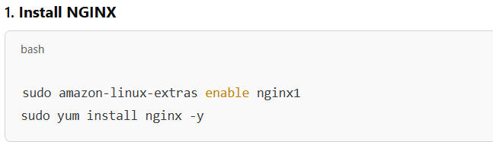

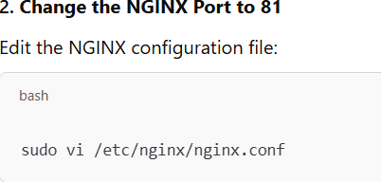

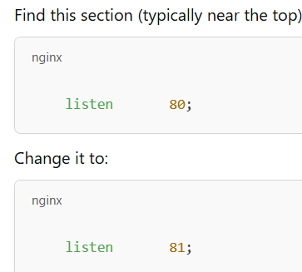

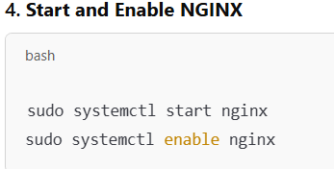

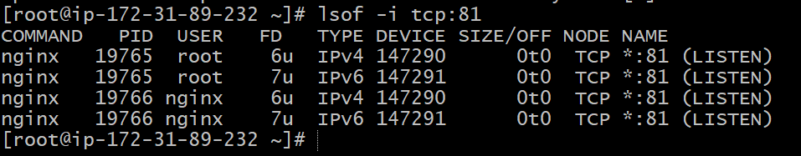

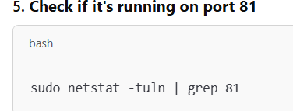

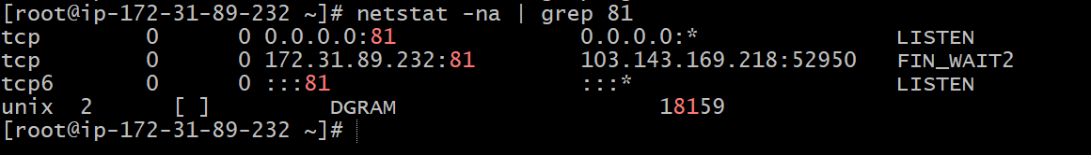

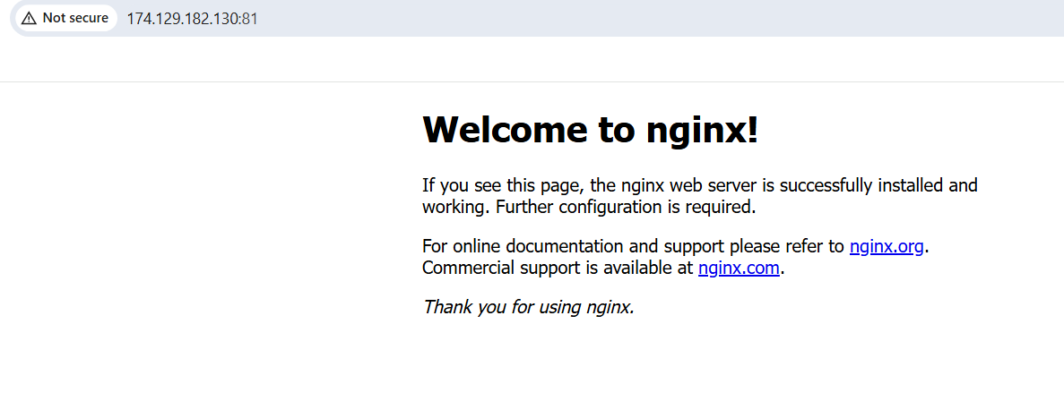

2) Deploy a sample index.html file on nginx



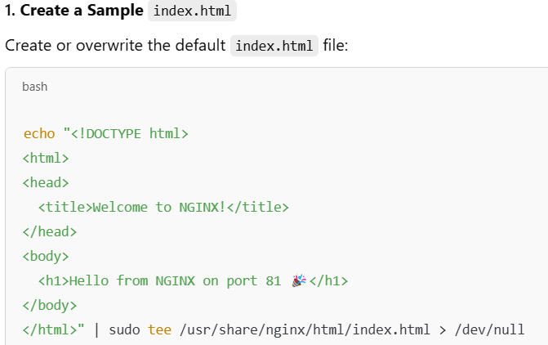

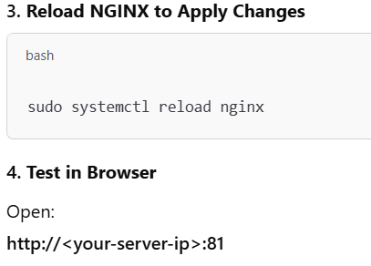

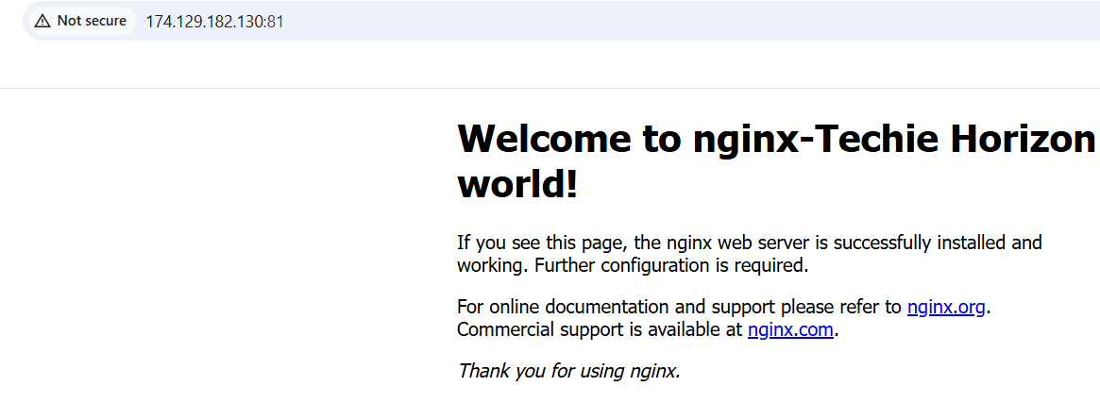

3) Install Apache and run Apache on port number 82

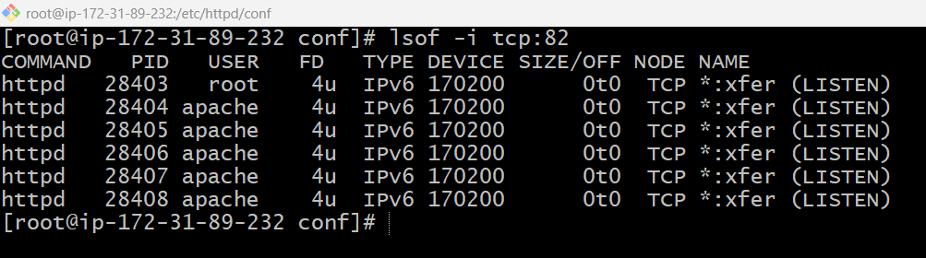

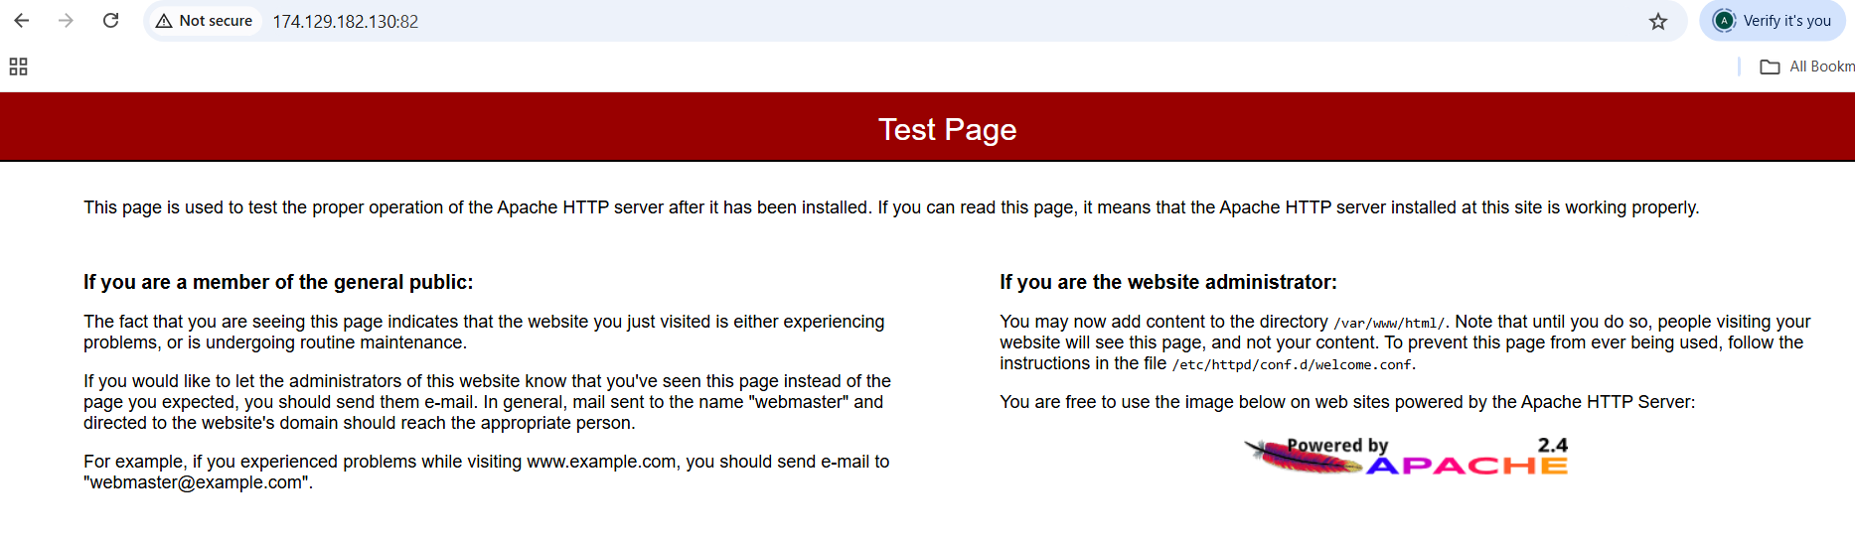

4) Deploy a sample index.html file on Apache

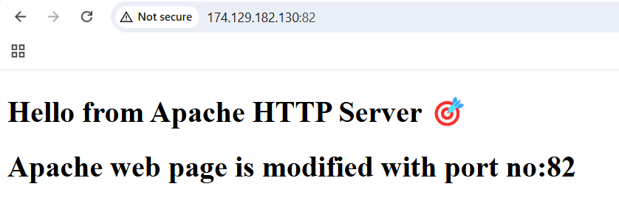

5) Install Apache tomcat on port number 8082?

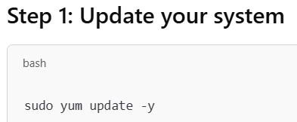

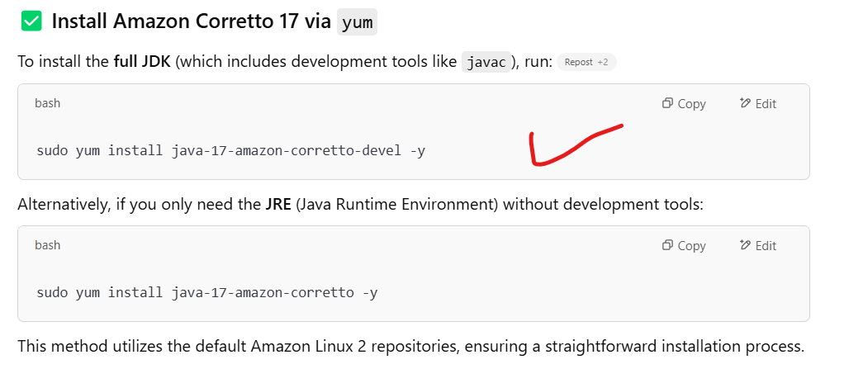

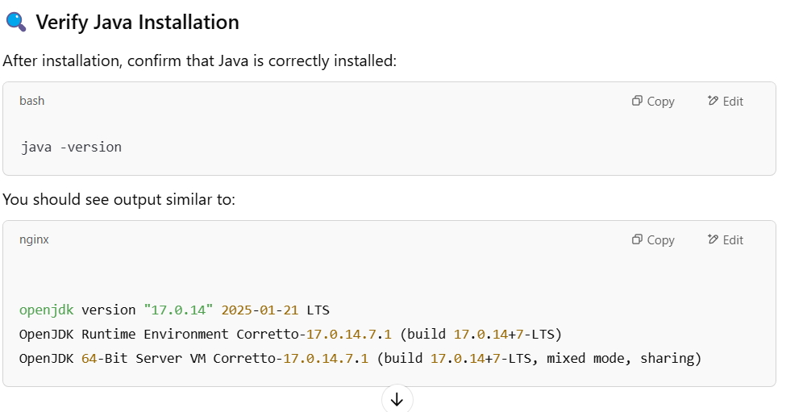

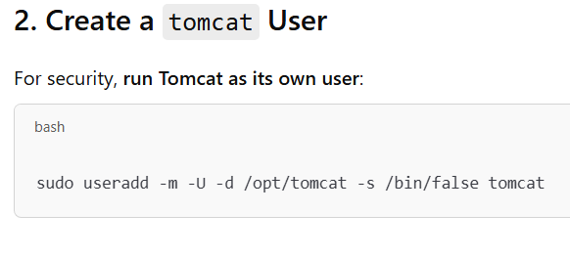

While downloading the url for tomcat from internet use

wget url…..

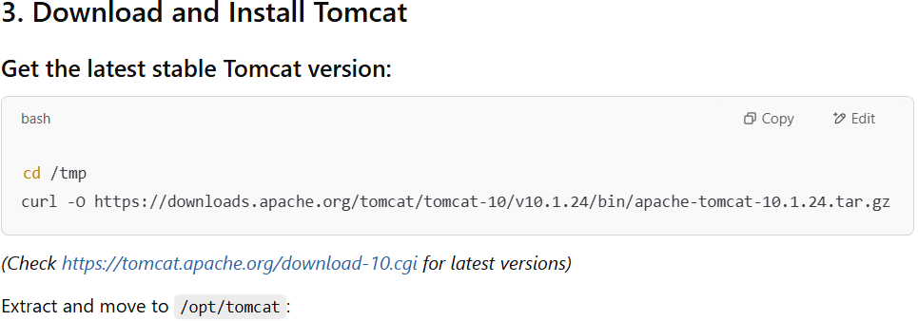

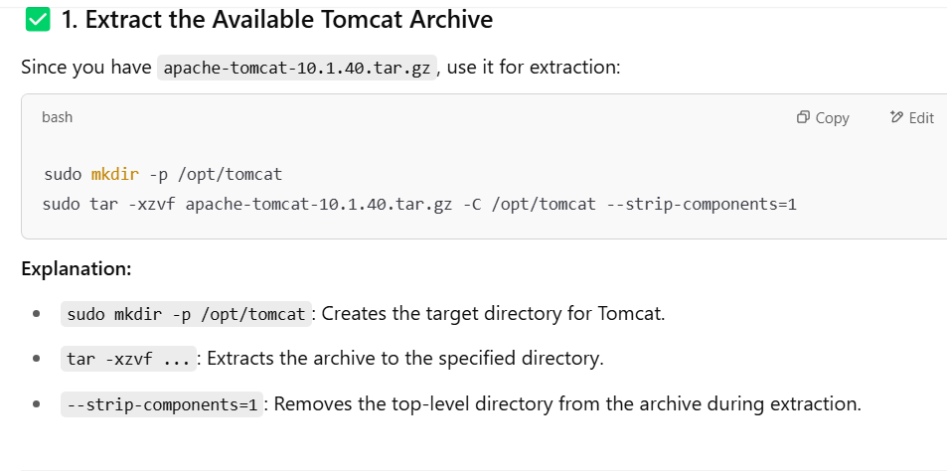

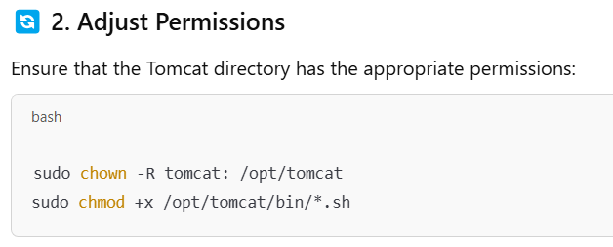

Now Tomcat running on the port no: 8082

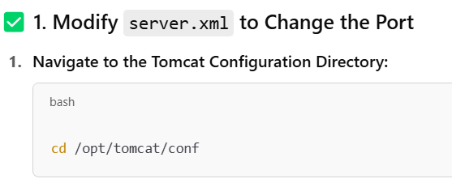

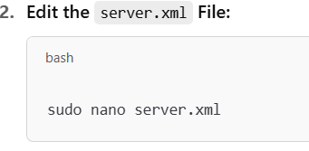

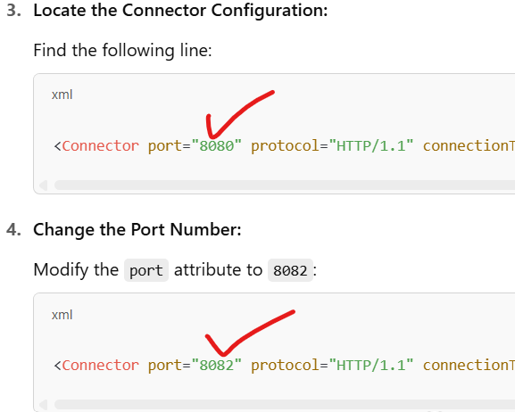

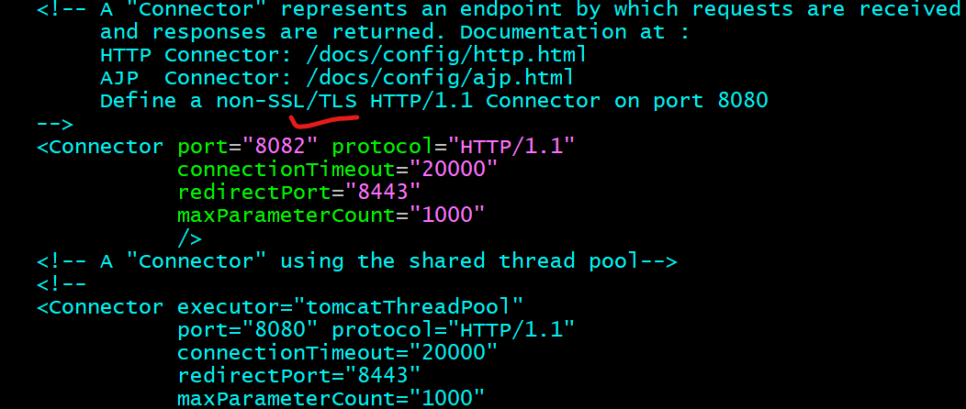

Go to ec2 Instance security group and add the port 8082 in inbound rules:

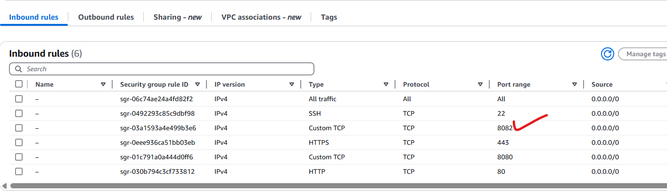

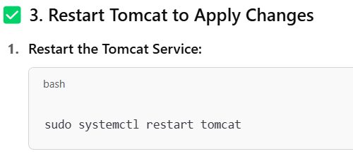

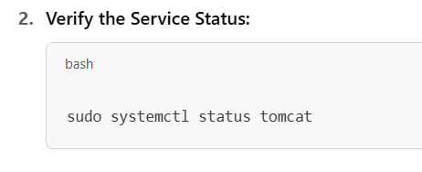

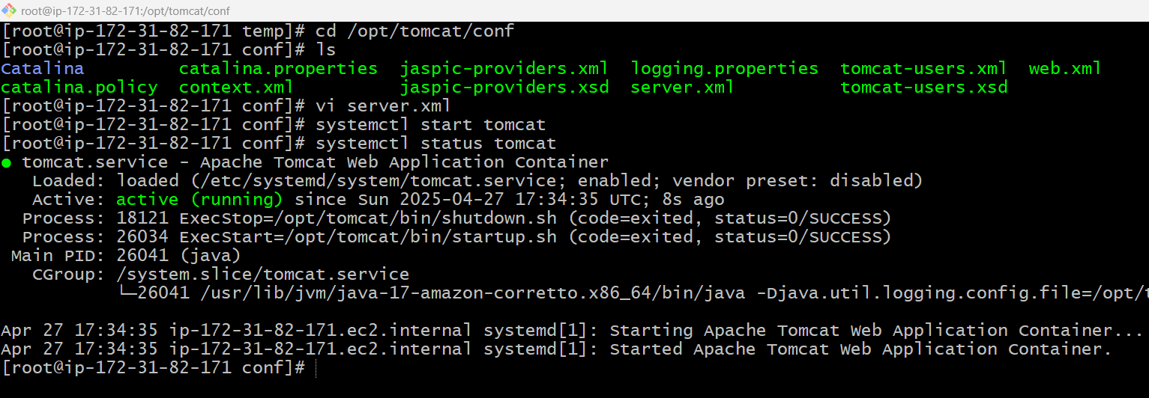

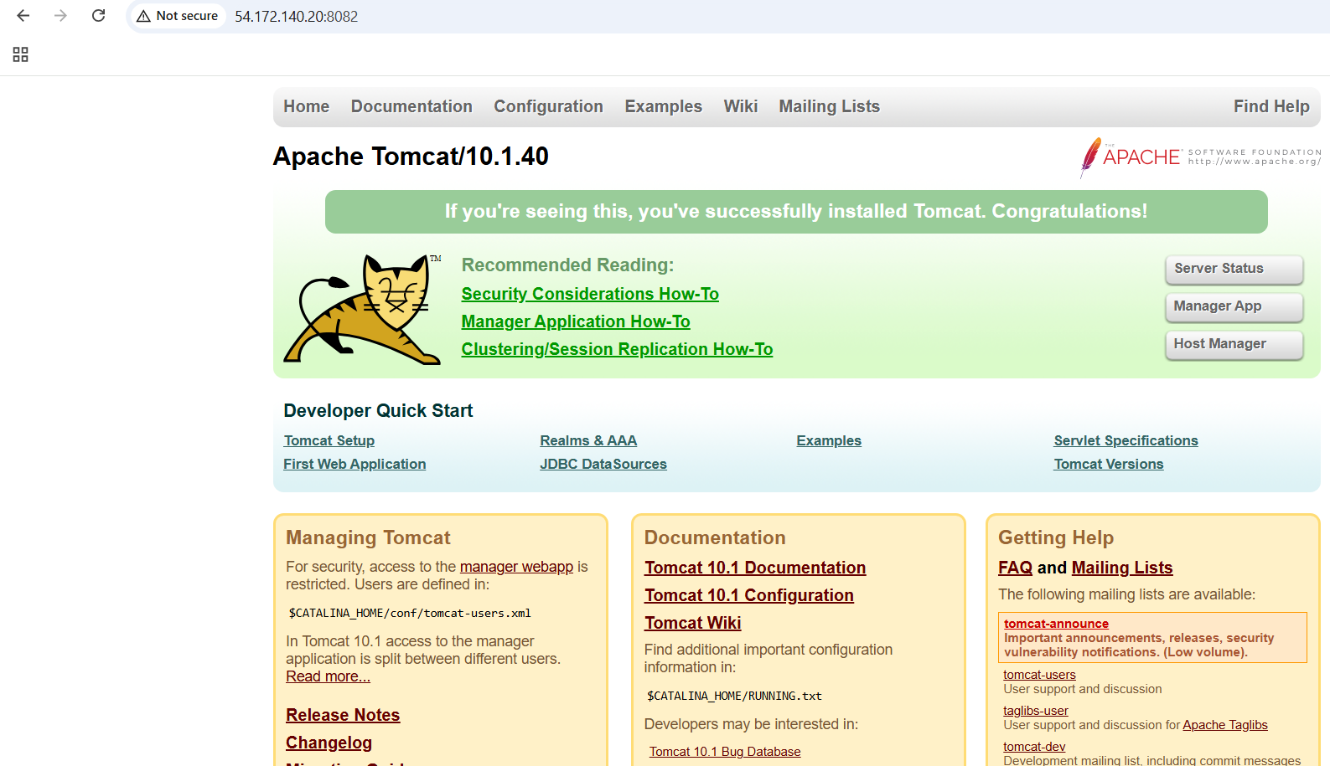

6) Deploy a sample app on webapps

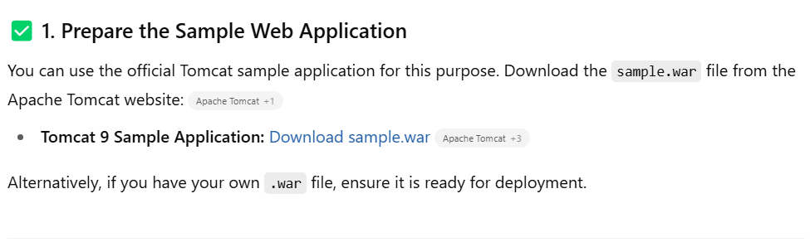

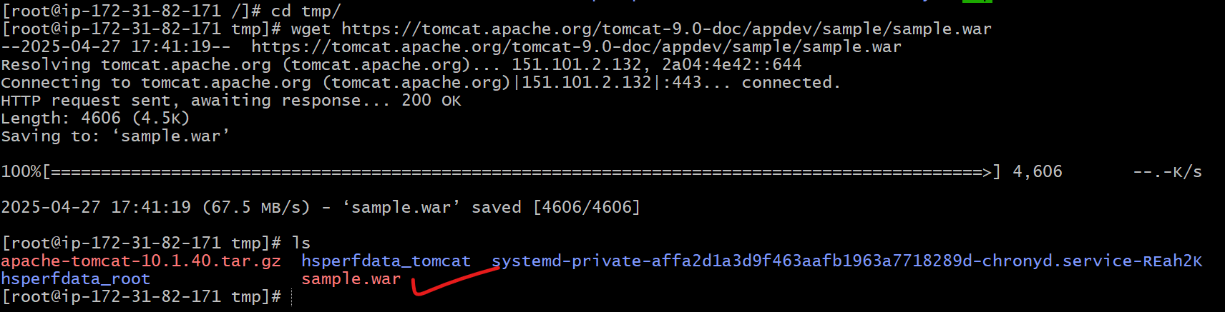

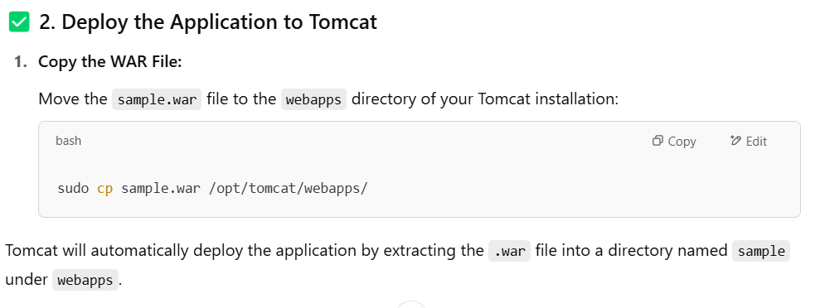

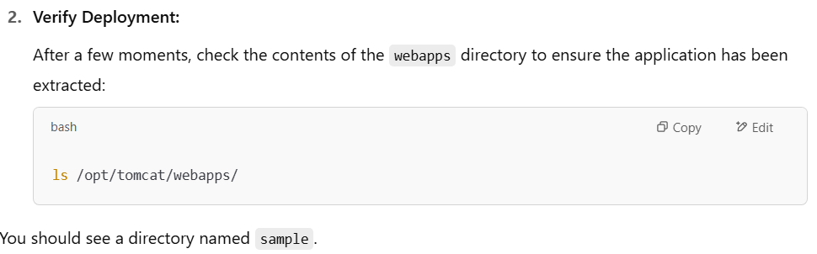

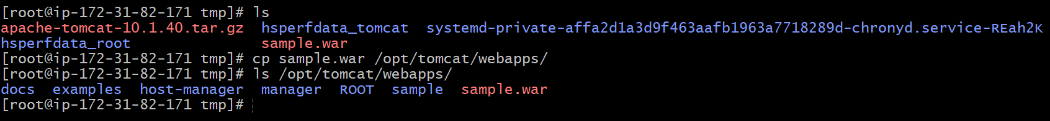

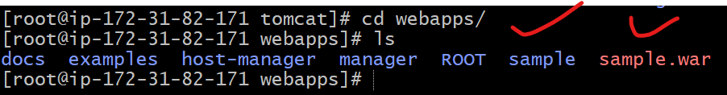

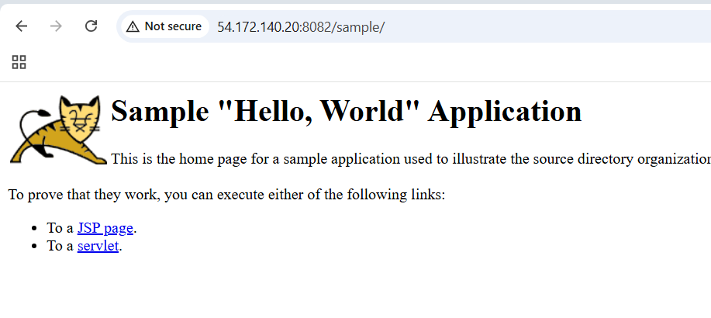

7) Create a tomcat.service file for tomcat.

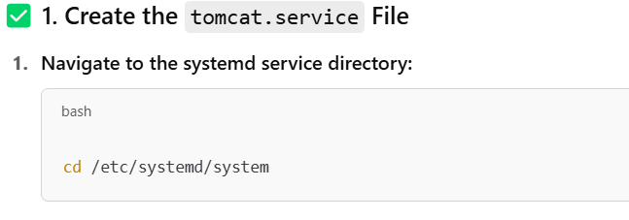



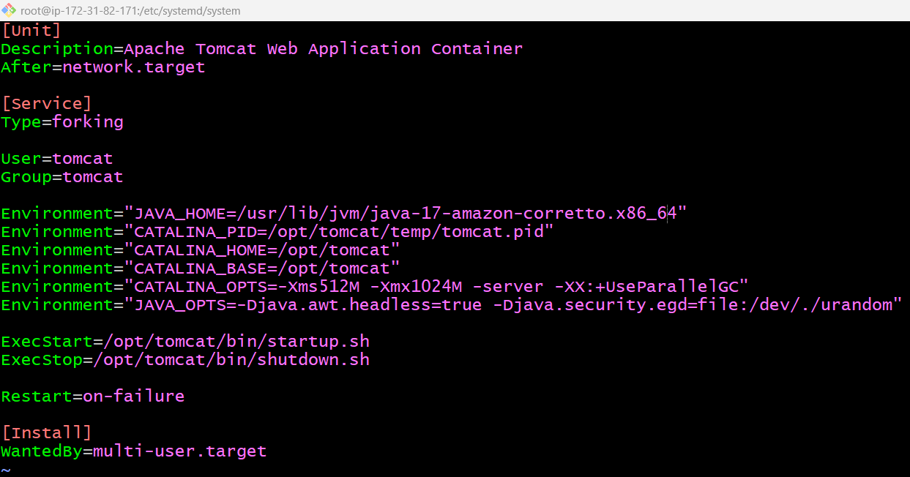

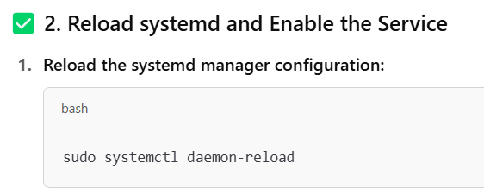

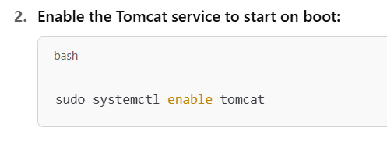

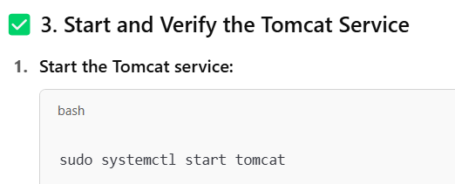

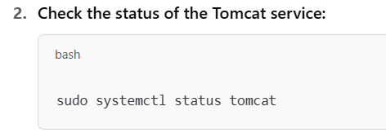

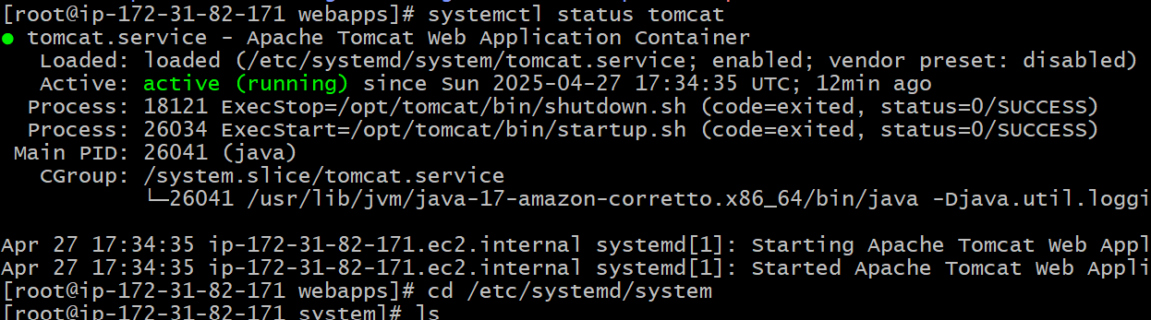

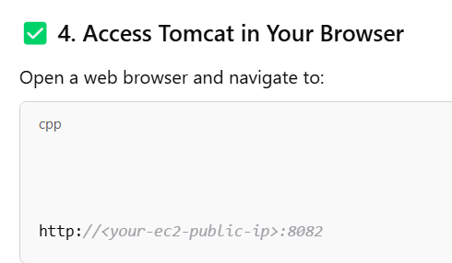

8) configure HA proxy?

**Launch 3 ec2 instances name as Server1, Server-2, HA-Proxy-Server.**

**Server1 setup:**

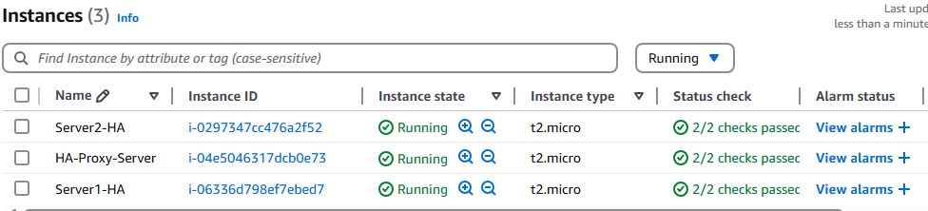

Run following command to Access the Server-1

* ssh -i your-key.pem ec2-user@Pubipaddress of Server-1 instance
* sudo -i
* yum update -y
* Yum install httpd -y
* Vi /etc/hosts
* Add HA-Proxy-Server Pubic IP Address

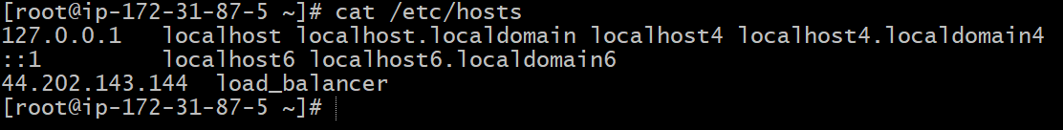

Run below command on Server-1  
ping load_balancer -c 4

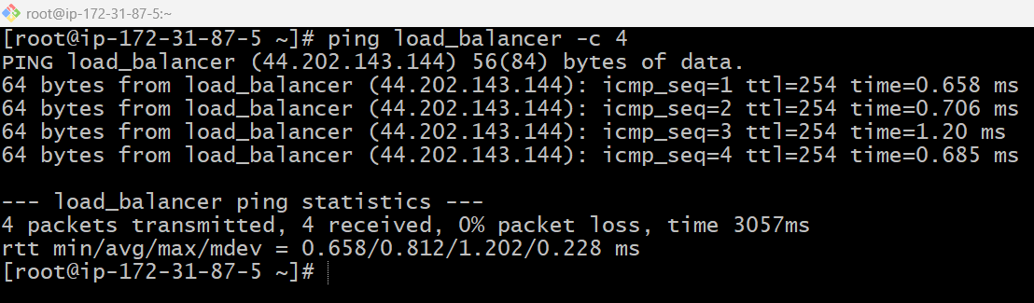

* systemctl start httpd
* systemctl status httpd

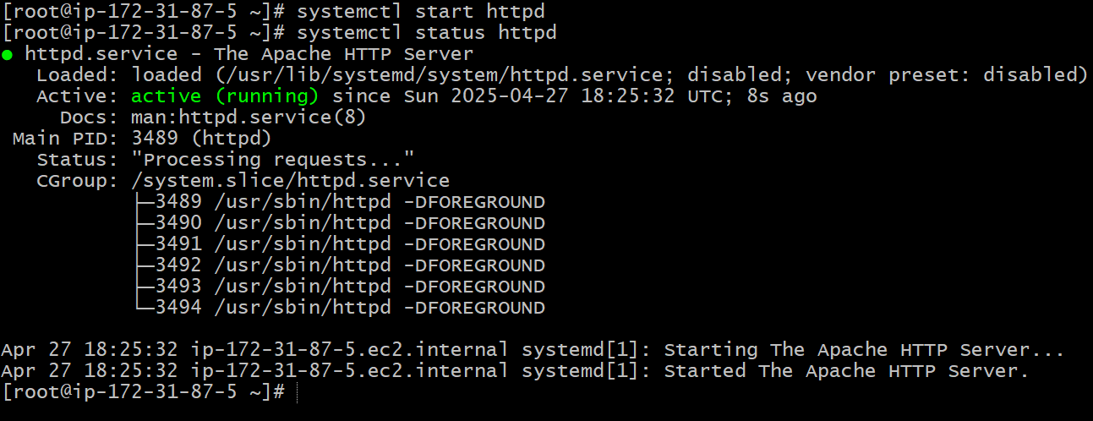

**Server2 setup**

Run following command to Access Server-2

* ssh -i your-key.pem ec2-user@Pubipaddress of Server-2 instance
* sudo -i
* yum update -y
* sudo amazon-linux-extras install nginx1 -y
* yum install nginx -y
* vi /etc/hosts
* Add HA-Proxy-Server Pubic IP Address

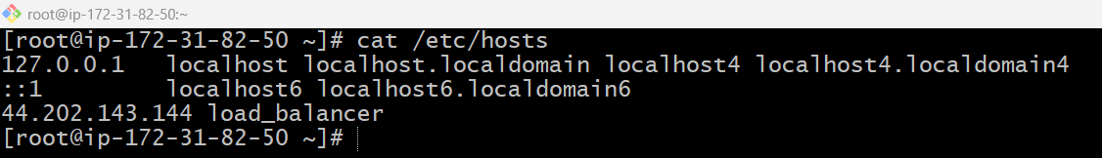

Run below command on Server-2  
ping load_balancer -c 4

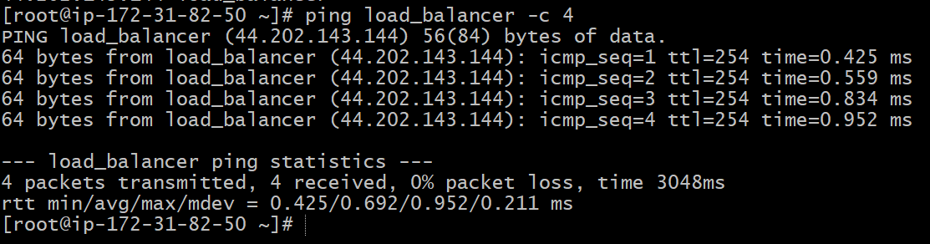

* systemctl start nginx
* systemctl status nginx

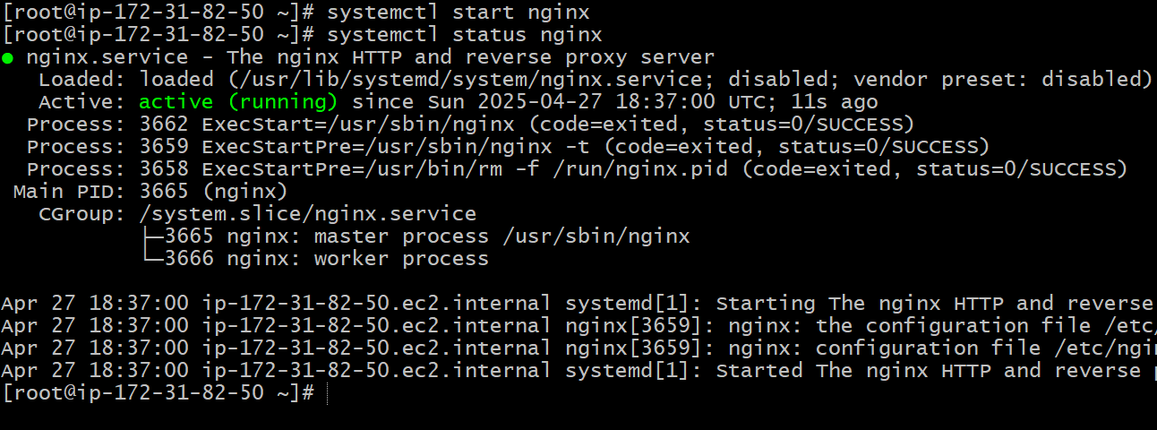

HA-Proxy-Server Steps:

Run following command to Access HA-Proy-Server

* ssh -i your-key.pem ec2-user@Pubipaddress of HA-Proxy-Server instance
* sudo -i
* yum update -y
* yum install haproxy -y
* vi /etc/hosts
* Add Server-1, Server-2 Public IP’s

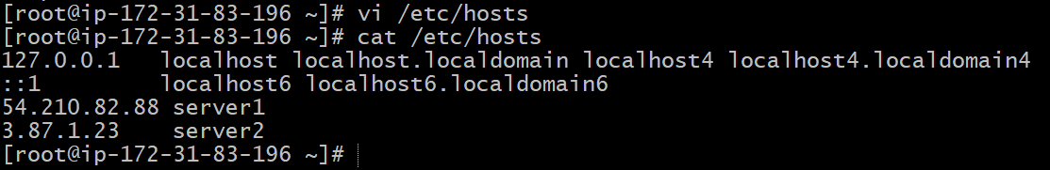

* vi /etc/haproxy/haproxy.cfg
* Add Server-1, Server-2 public IP’s

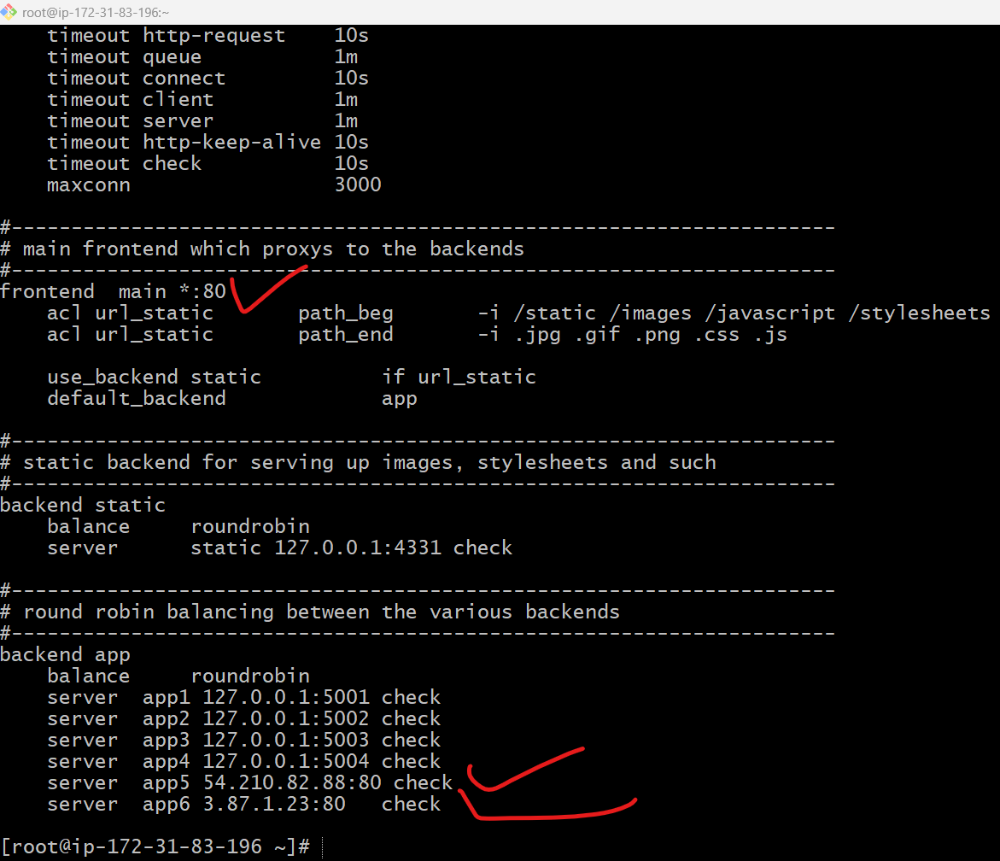

* systemctl enable haproxy
* systemctl start haproxy
* systemctl status haproxy

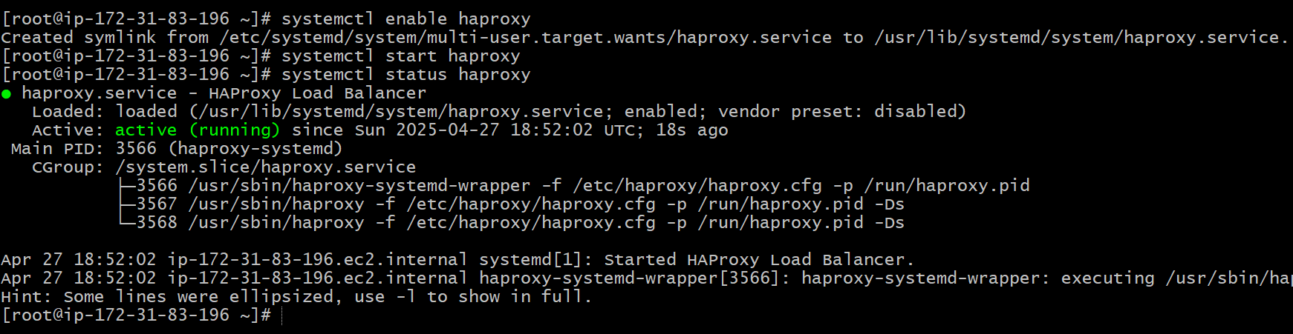

* now browse with HA-Proxy-Server PublicIP:80 it will distribute load to Server-1, Server-2

first hit

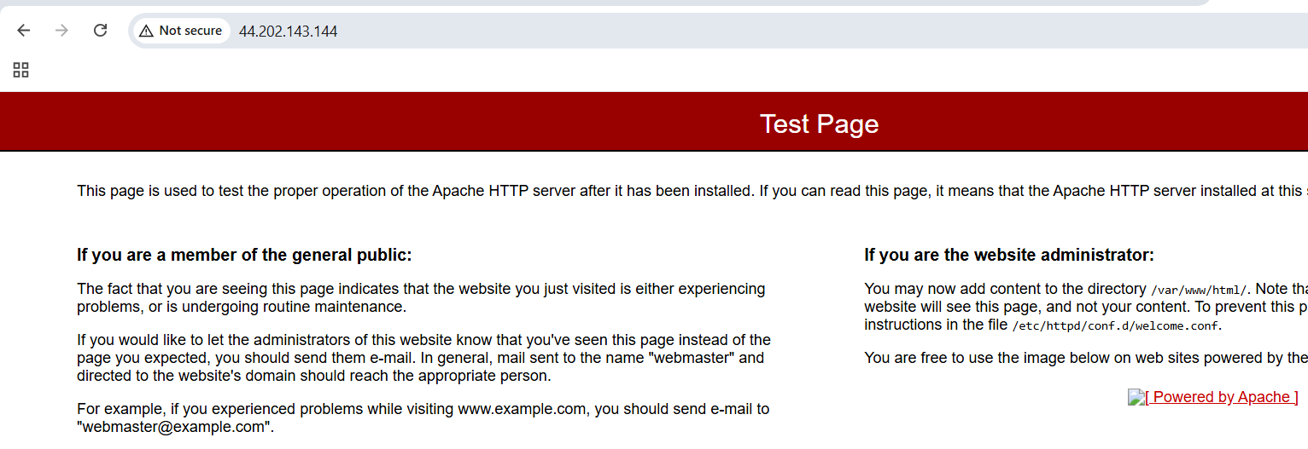

Second hit

