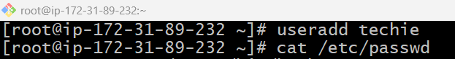1) Create user with name Techie and provide sudo access to user.



Providing the sudoer access to the user Techie and trying to install git:

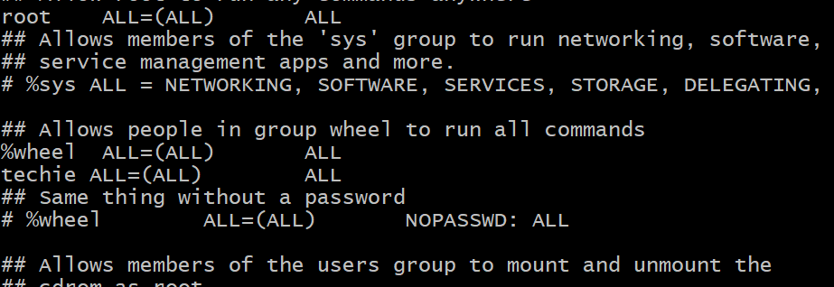



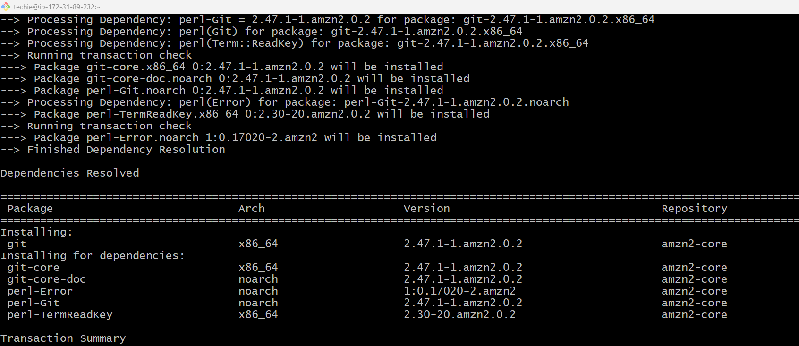

2) Navigate to the home directory.

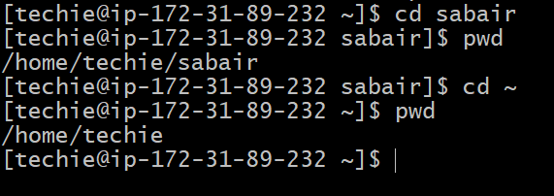

3) Create a new directory

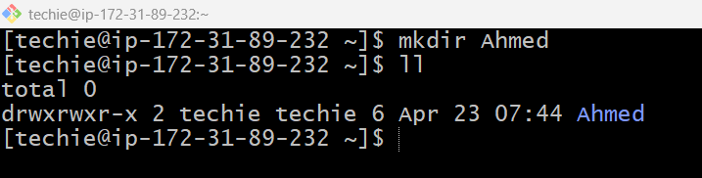

4) List the contents of a directory

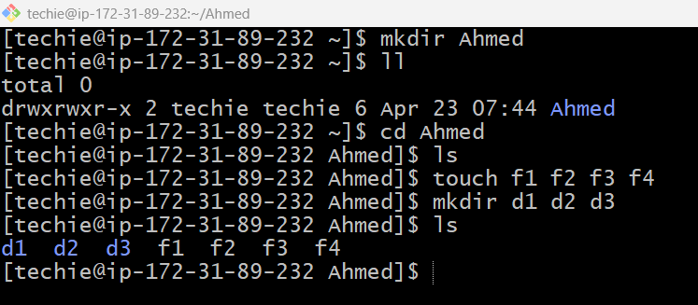

5) Change the current directory.

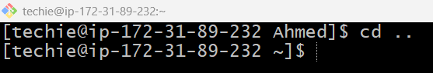

6) Create a new empty file.

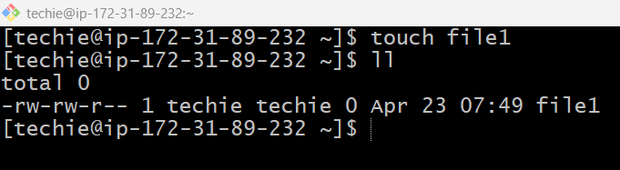

7) View the contents of a file.

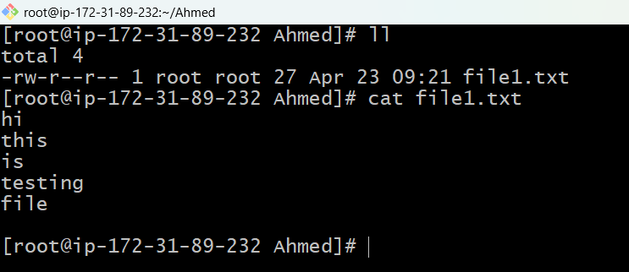

8) Copy a file to another location.

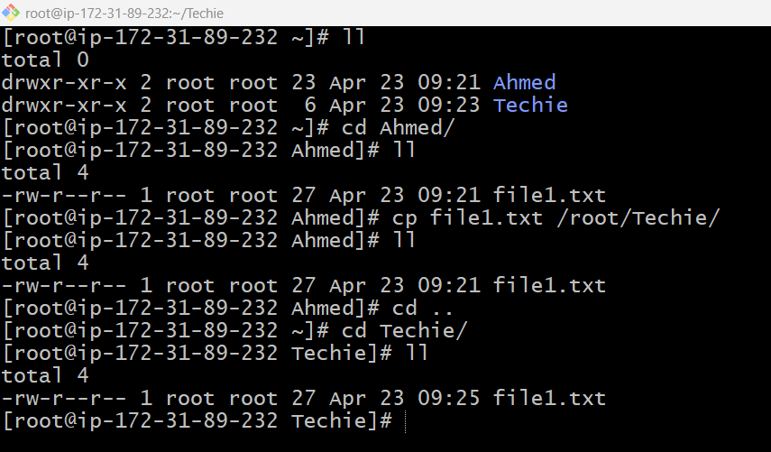

9) Move a file to another location

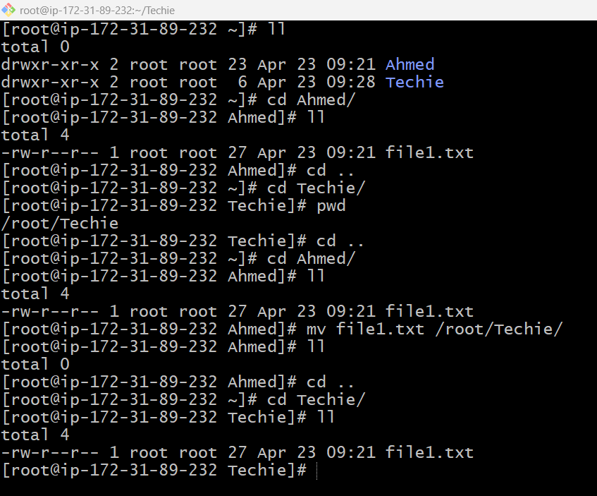

10) Rename a file

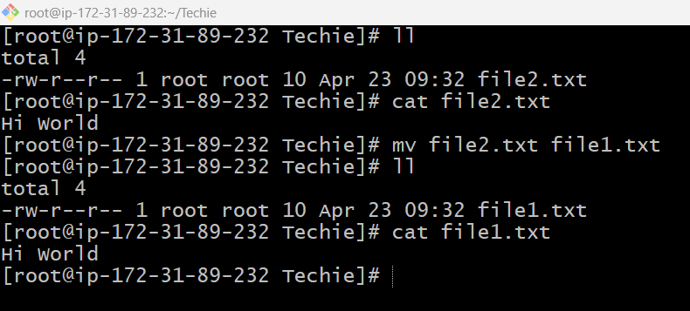

11) Delete a file

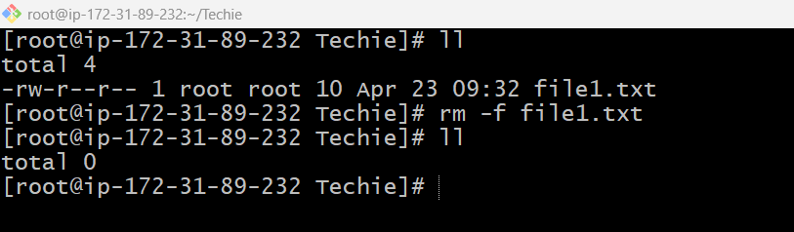

12) Grant or revoke permissions on a file or directory

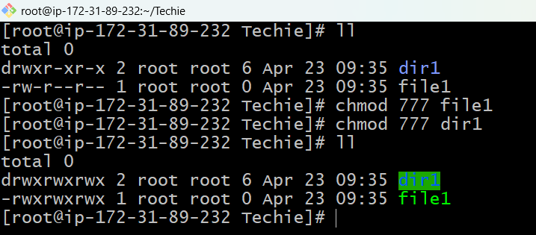

13) View the current date and time

Kill a running process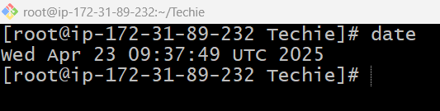

14) Check the system uptime

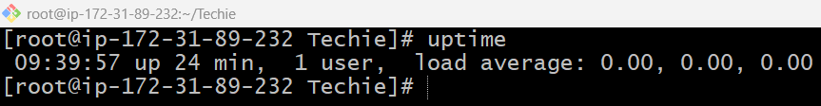

15) View the running processes

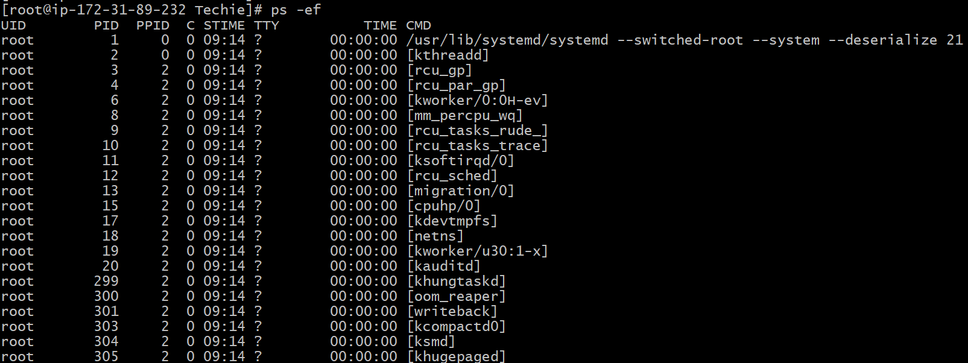

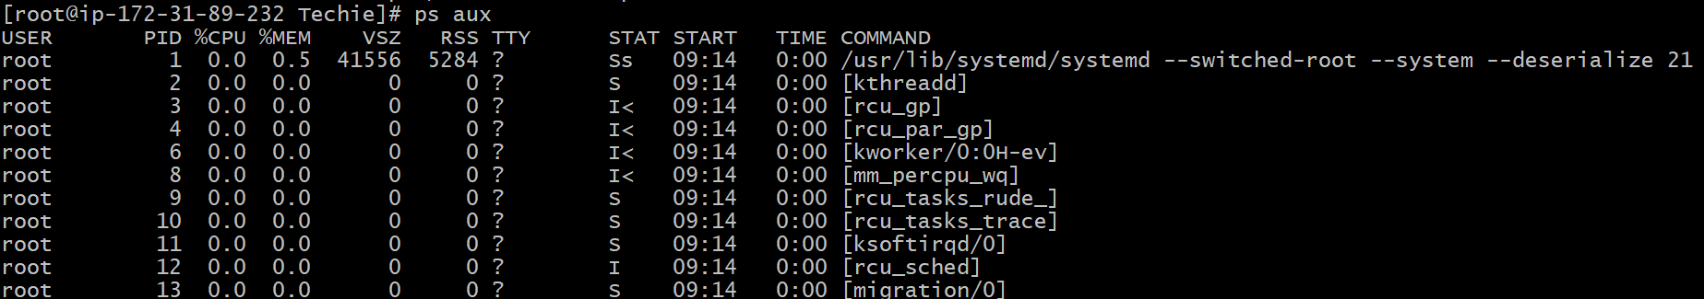

16) Kill a running process

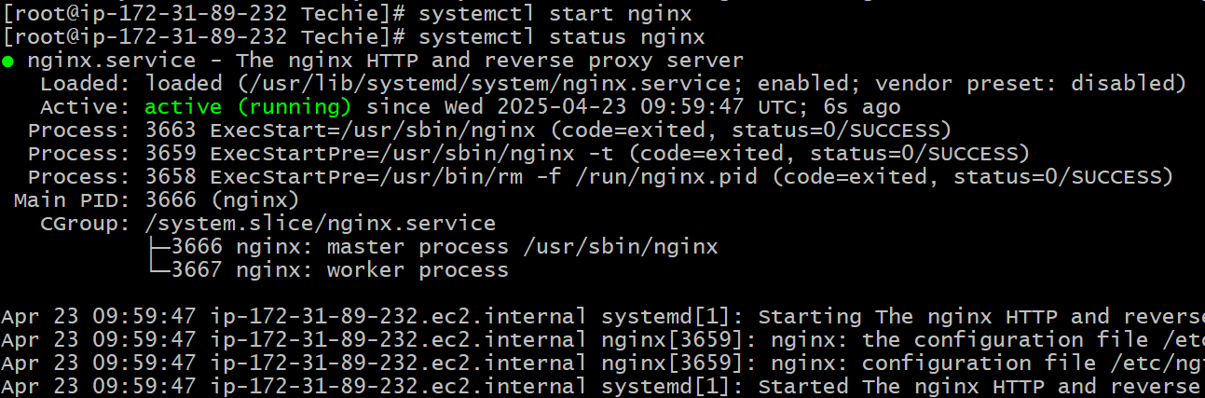

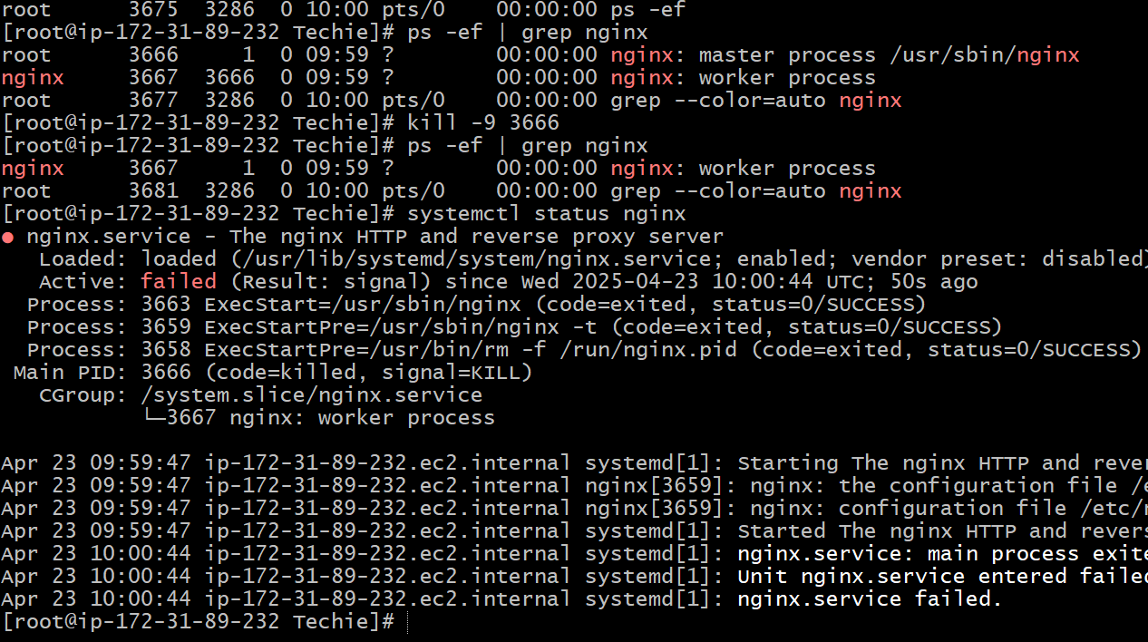

18) Update the system packages

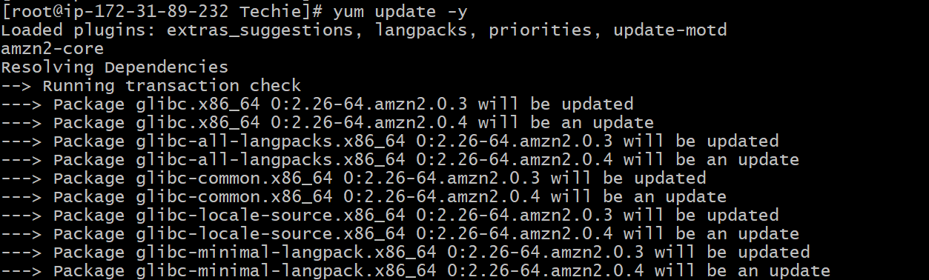

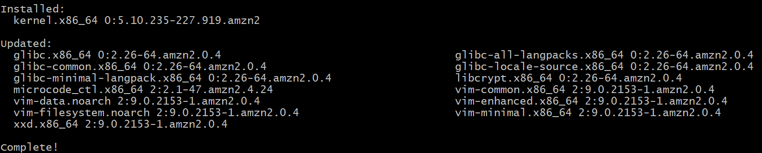

17) Install a package using the package manager (e.g., apt or yum).

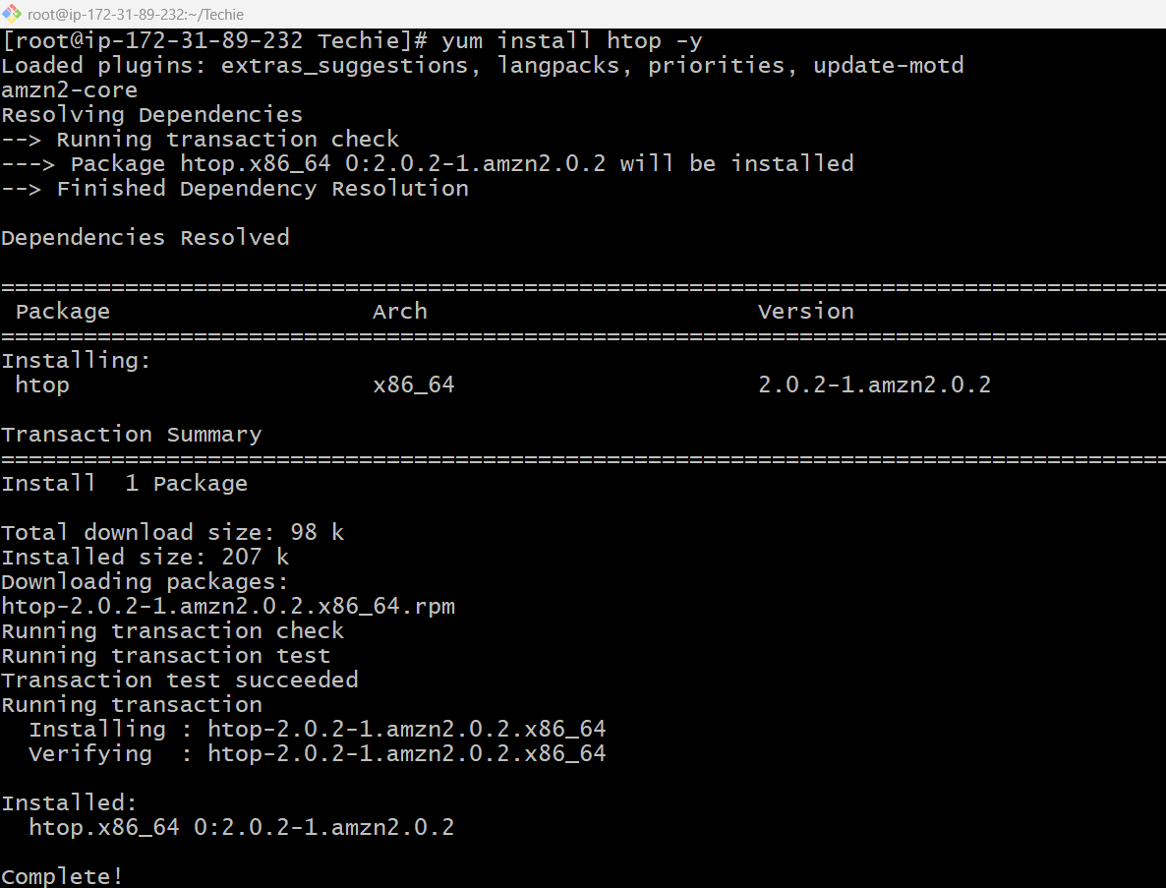



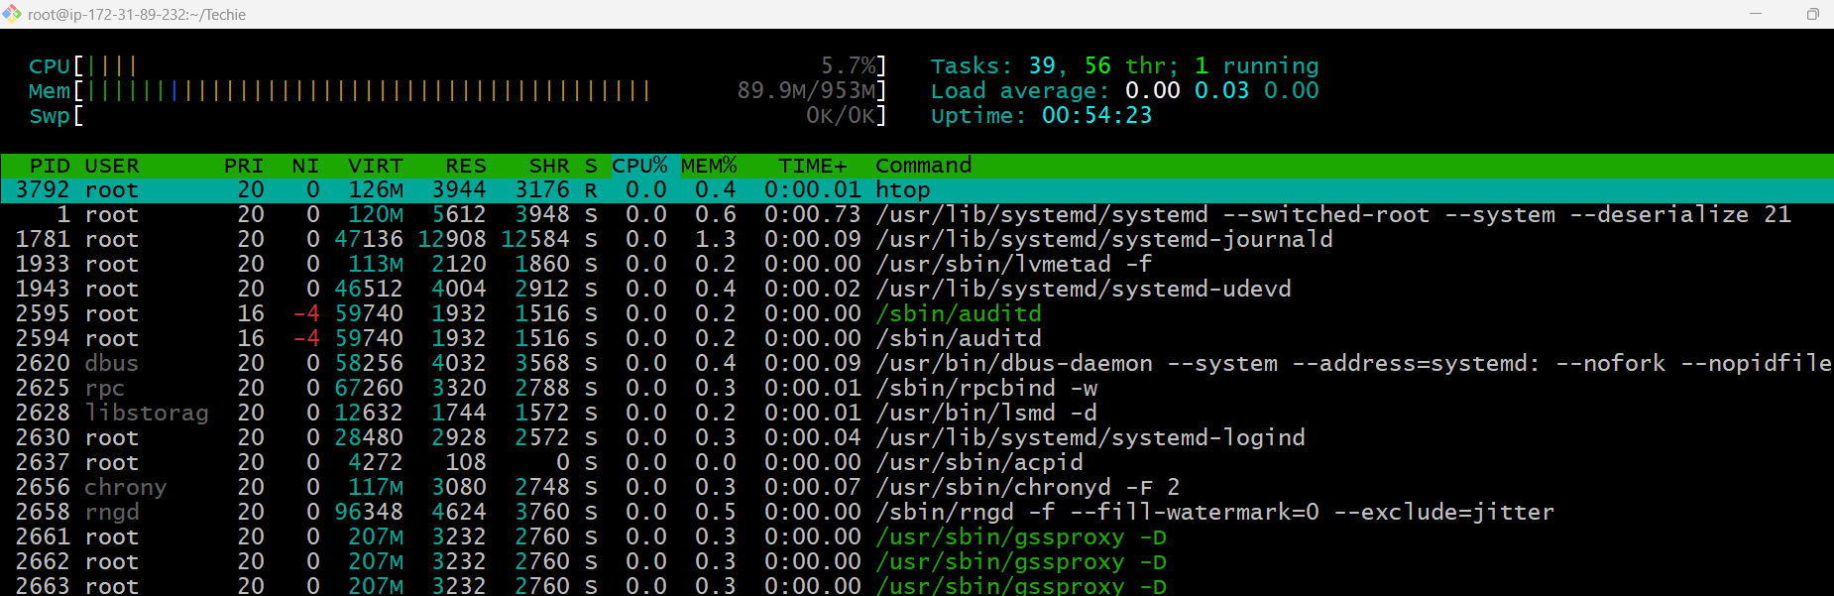

19) Create a symbolic link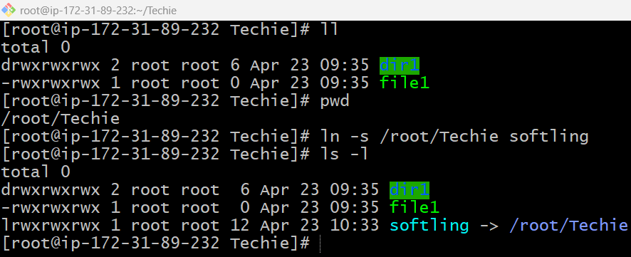

20) Remove the symbolic link (soft link)

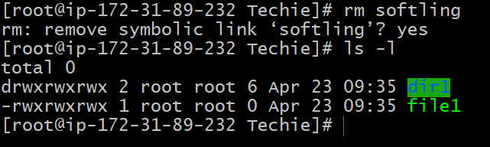

21) Search for files using the find command

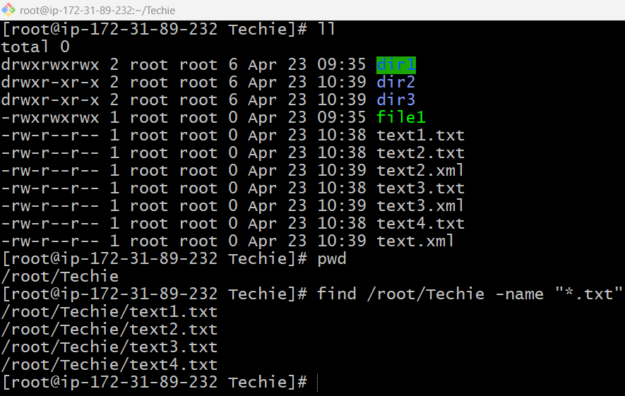

22) Compress and decompress files using tar

Compress the files:

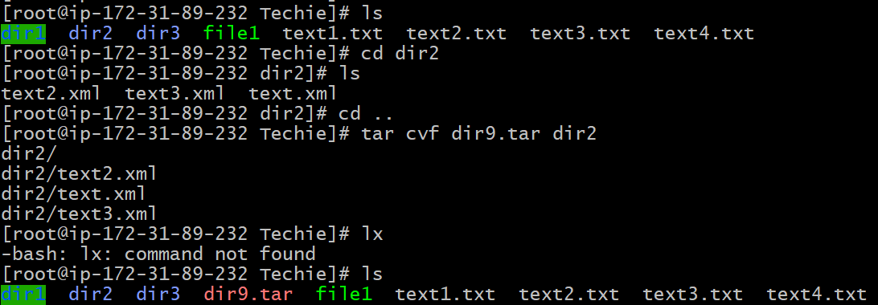

Decompress the files: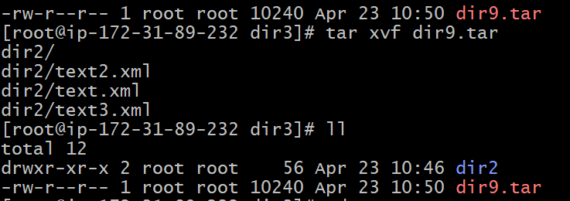

23) Monitor system resources with top or htop

Top:

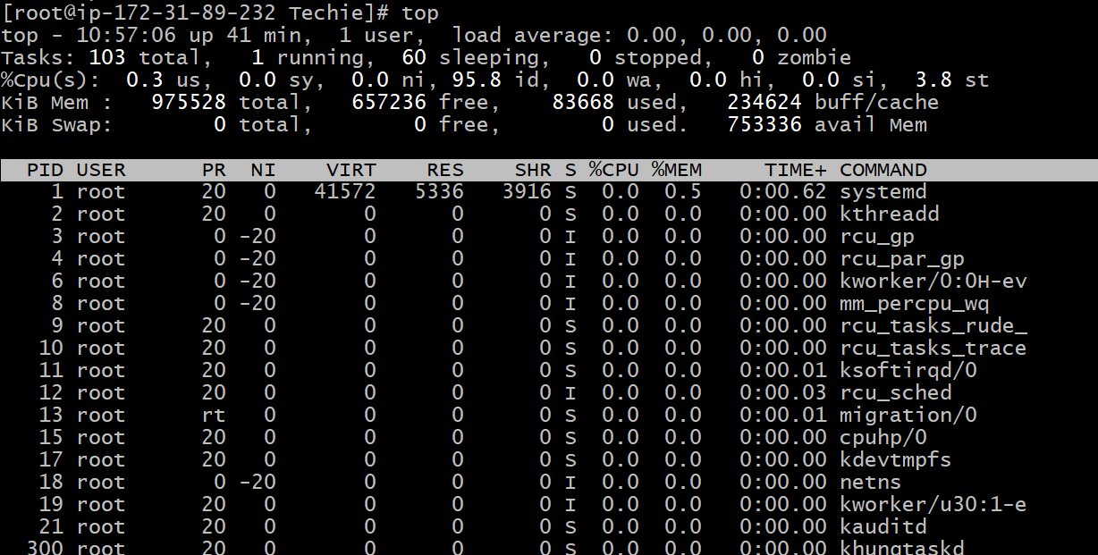

Htop:

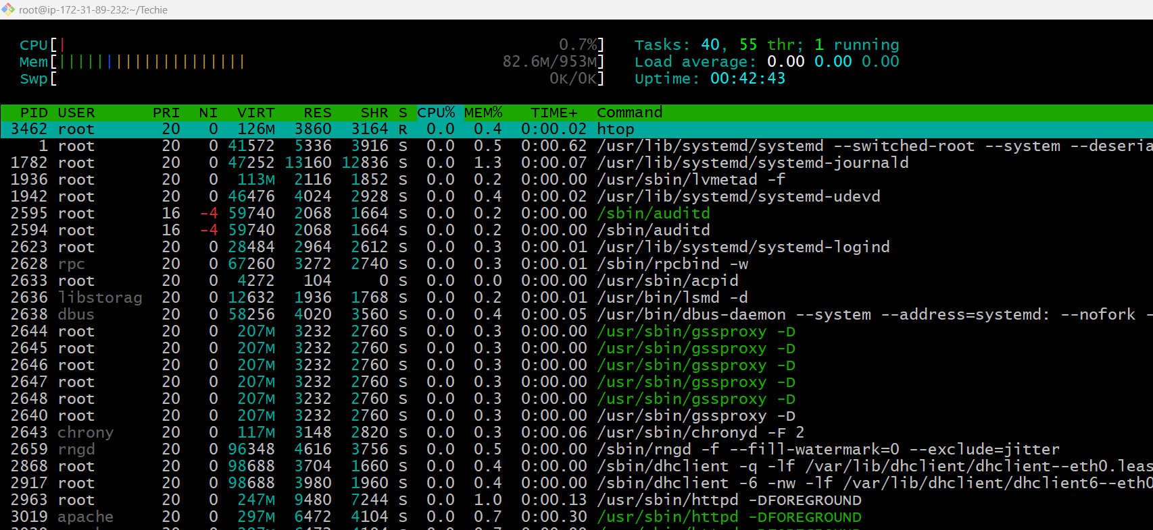

24) Create and manage user groups

i) Create a group and list the groups





ii) Add a User to a Group

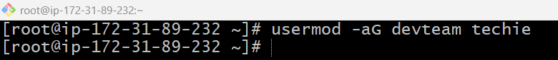

📌 The user may need to log out and log back in for the group changes to take effect.

iii) View Group Membership

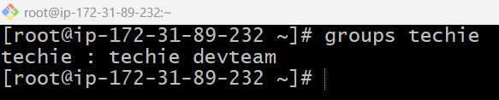

iv) Change a User's Primary Group

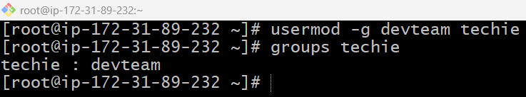

The primary group is shown as the user's default group when they create files.

v) Remove a User from a Group

Manually edit the group entry:



vi) List All Groups

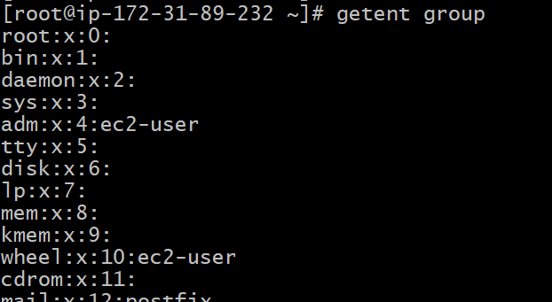

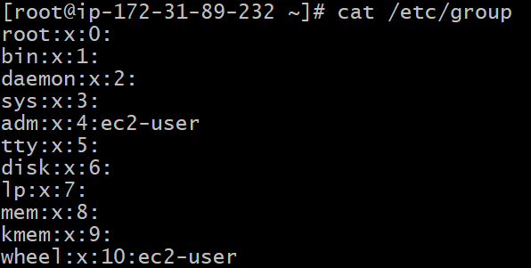

vii) Delete a Group

---- If the group **exists**, it will show something like:

devteam:x:1002:

---- If the group **doesn’t exist**, there will be **no output**.

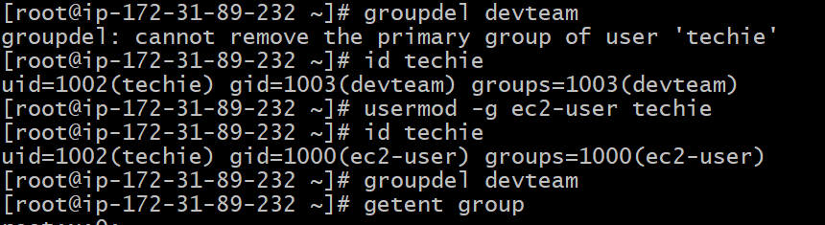



25) Set up SSH password less authentication

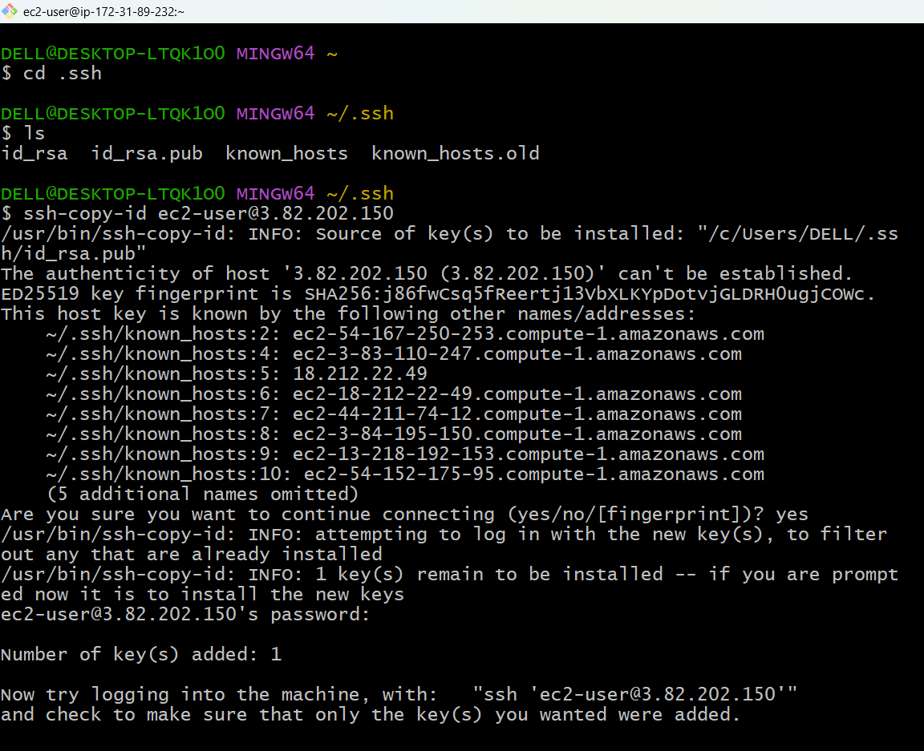

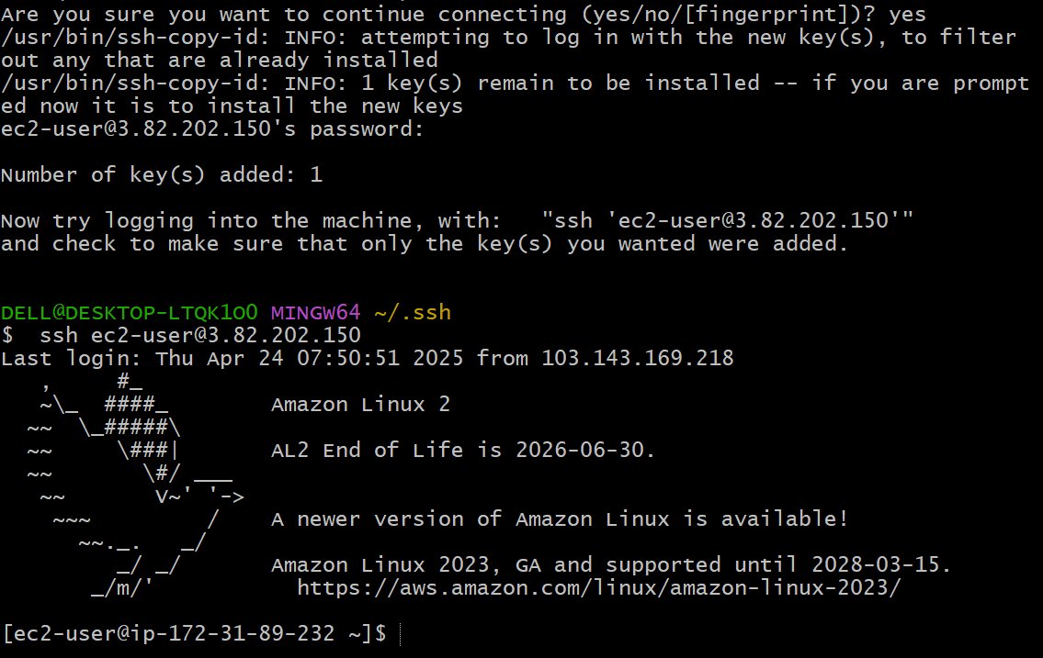

26) Monitor log files using tail or grep

Command: tail -f /var/log/messages

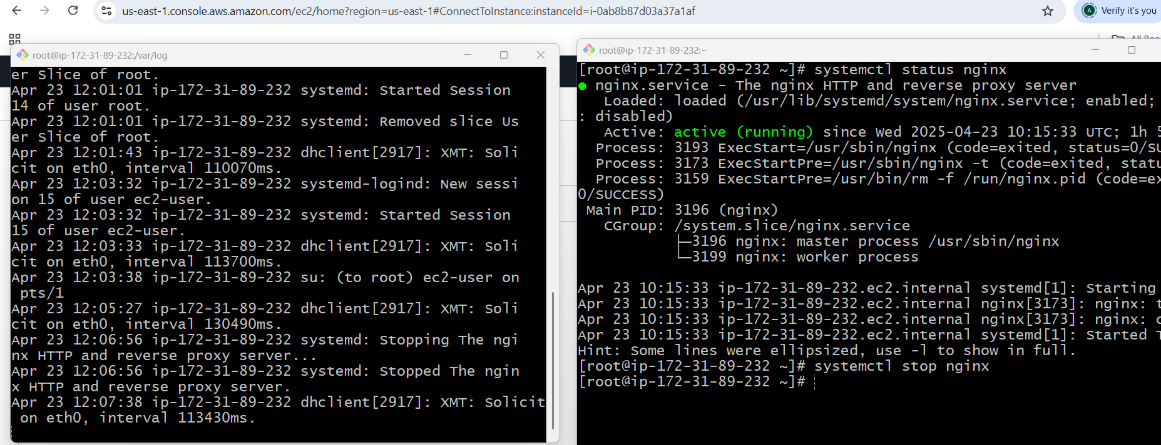

27) Set up a web server (e.g., Apache or Nginx)

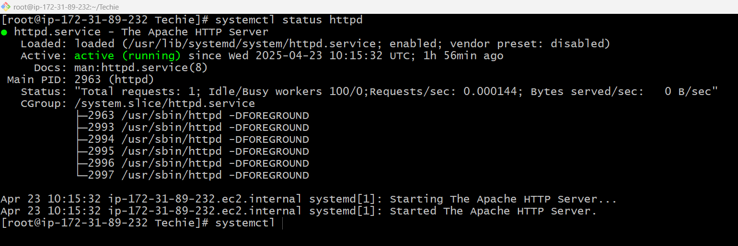

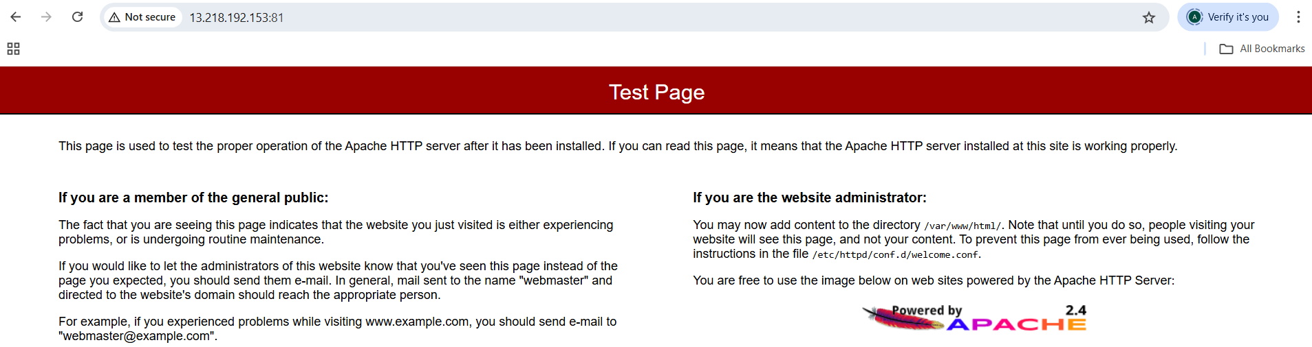

28) Configure and secure a MySQL Database

Note: Mysql not installed in Amazon Linux2, mysql work on Amazon Linux 2023

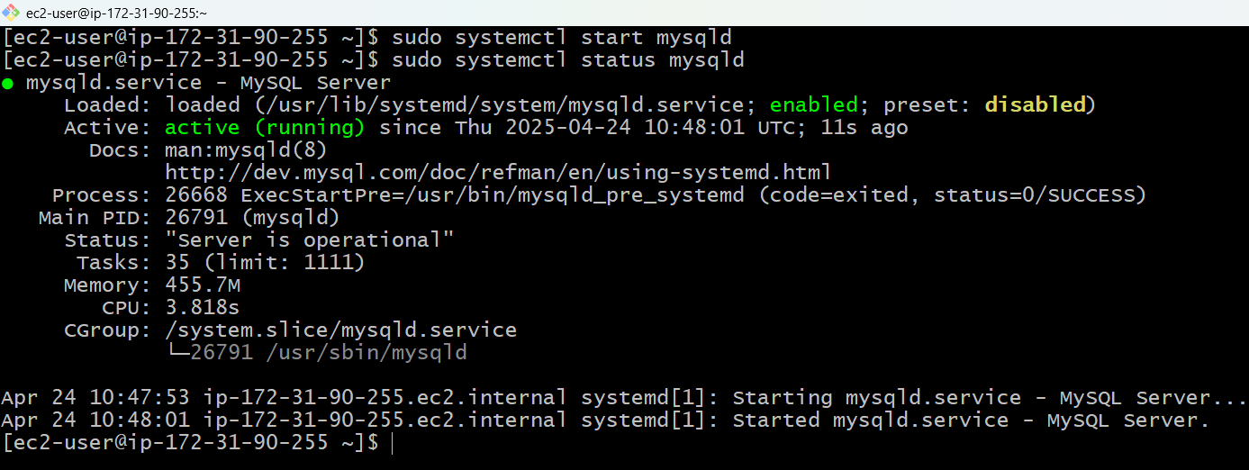

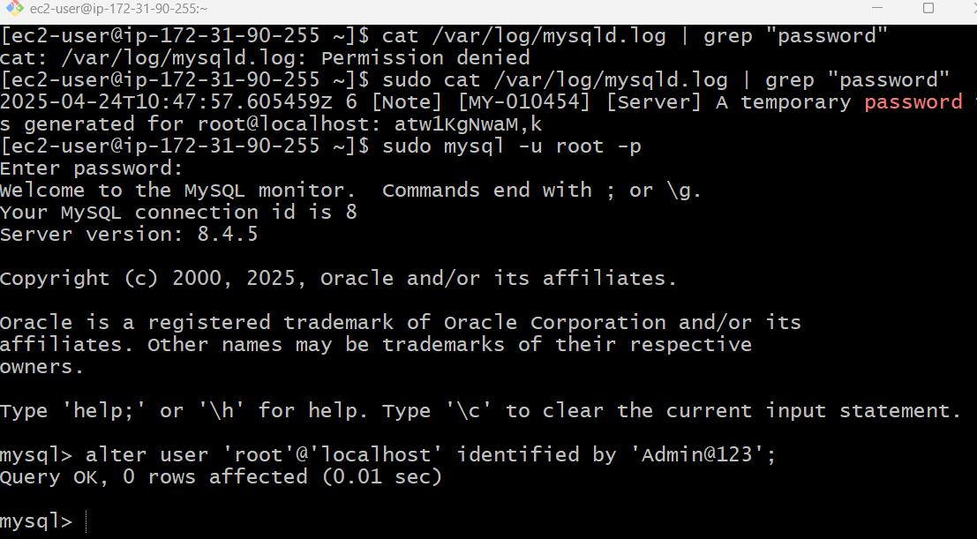

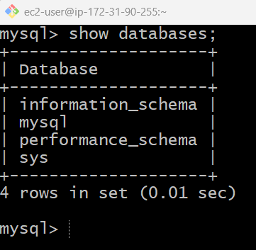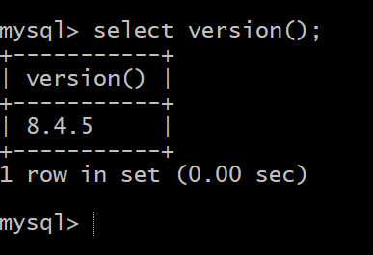

29) Set up a Application Server (e.g.,Apache Tomcat)

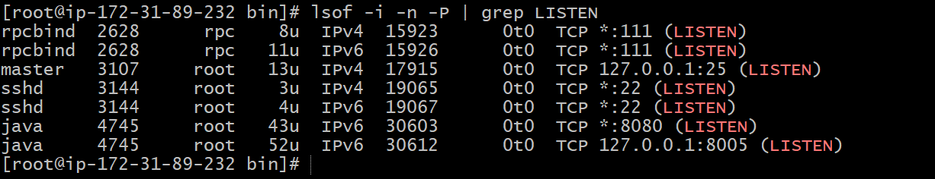

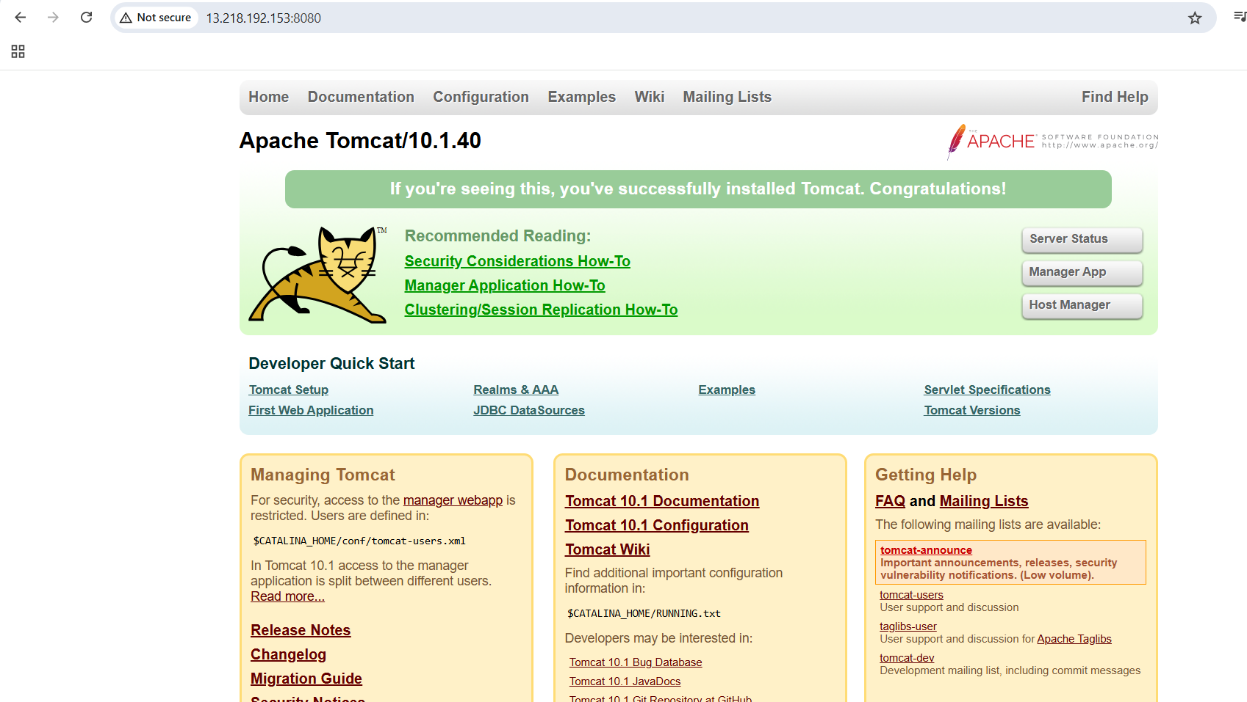

30) create a service file for Apache Tomcat.(Should execute by using systemtctl command)

31) Print specific columns from a delimited file

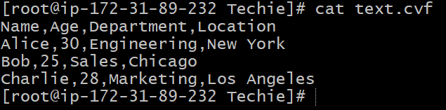

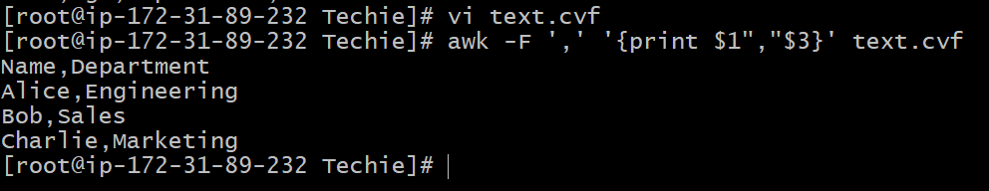

32) Filter and print lines where the Department is Sales.



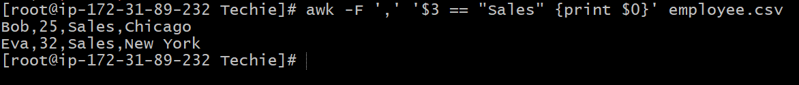

33) Calculate and print the average, sum, or other statistics of a column.

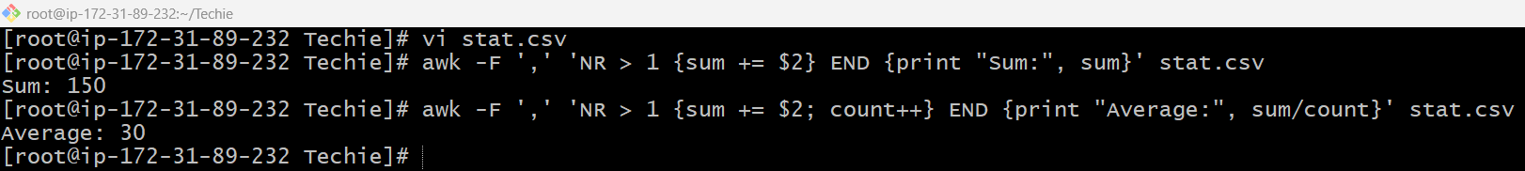

34) Perform string manipulation, such as extracting substrings or changing case

1) Extract the **first 3 letters** of the Department.

2) Convert the Location to **uppercase**.

3) Convert the Name to **lowercase**.

Output:

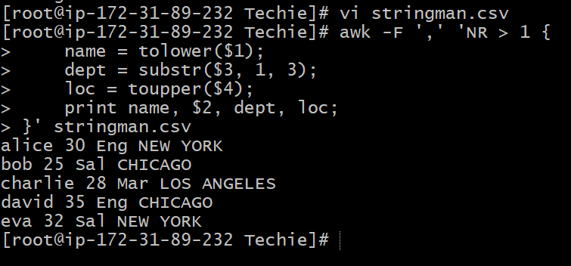

35) Count the occurrences of a specific pattern in a file

**Count how many times each department appears** in the file

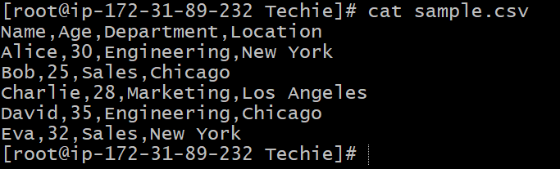

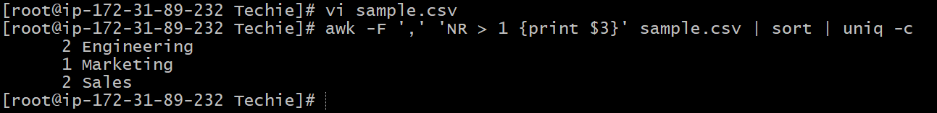

36) Sort lines based on a specific field or column

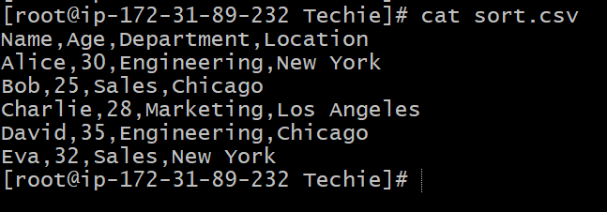

Sort the data by:

* Age (2nd column) — numerically
* Department (3rd column) — alphabetically

1) Sort by Age (column 2) numerically

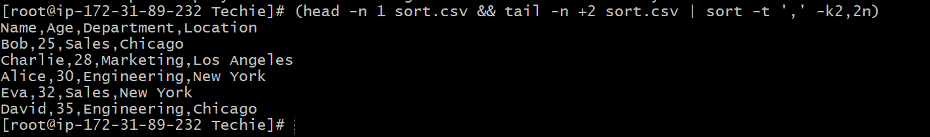

2) Sort by Department (column 3) alphabetically

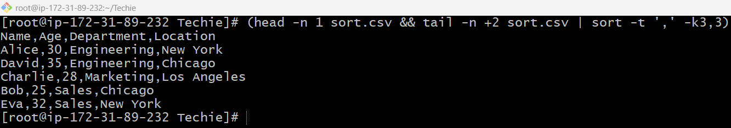

37) Merge multiple files based on a common field or column

Scenario: Merge two CSV files based on a common column

Employee.csv file:

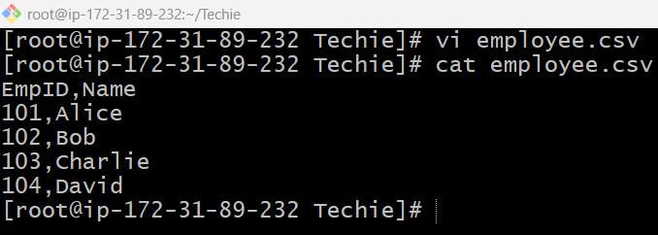

Salaries.csv file:

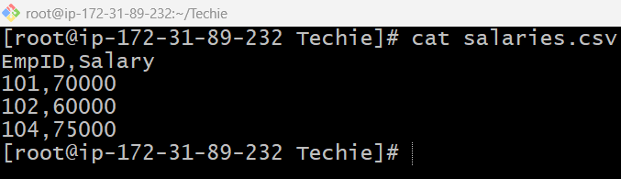

Goal: Merge files based on EmpID:

We want the result like this:

EmpID,Name,Salary

101,Alice,70000

102,Bob,60000

104,David,75000

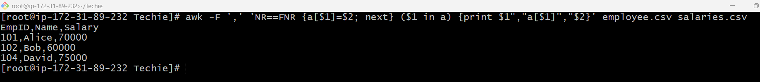

38) Substitute text in a file using search and replace

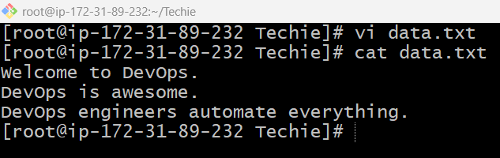

Replace **"DevOps"** with **"CloudOps"**:

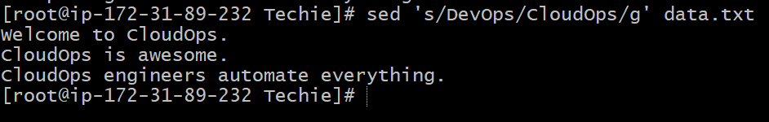

39) Delete specific lines based on a pattern or line number

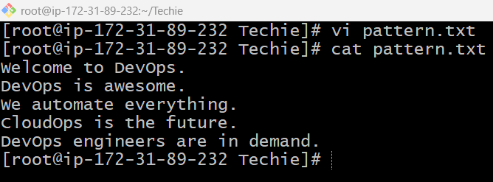

1. Delete lines **containing** the word "DevOps".
2. Delete a specific **line number** (e.g., line 3).

1. Delete lines containing a pattern ("DevOps")

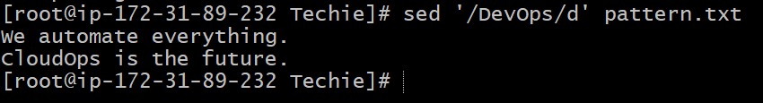

2. Delete a specific line number (e.g., line 3)

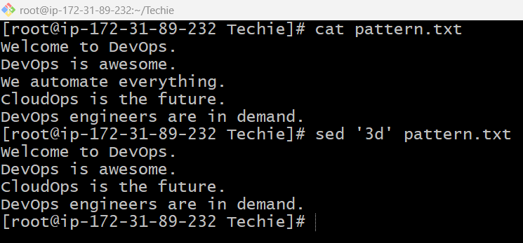

40) Append or insert text before or after a specific pattern or line

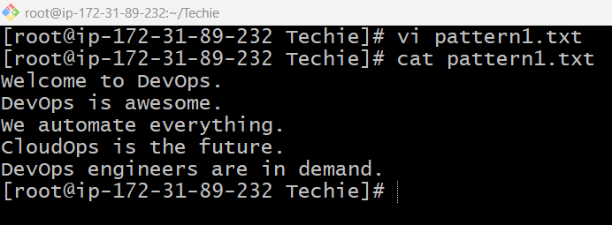

1) **Insert** a line **before** any line that contains "DevOps".

2) **Append** a line **after** a line that contains "CloudOps".

1. Insert text **before** lines matching "DevOps"

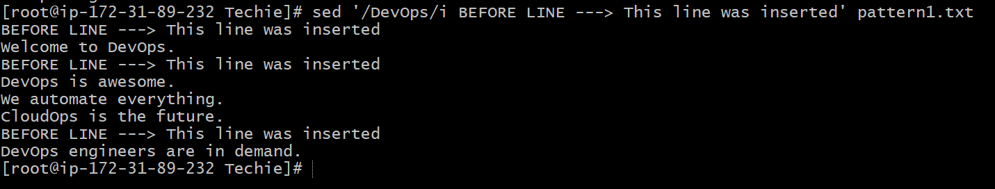

2. Append text **after** a line matching "CloudOps"

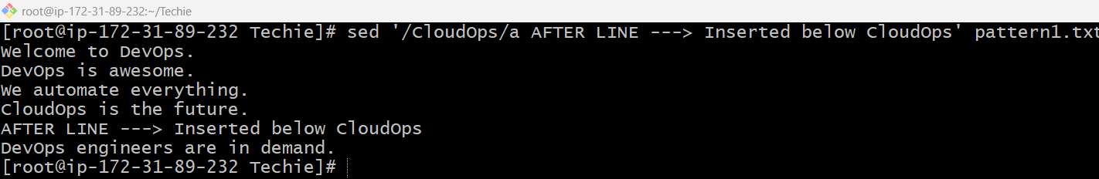

41) Print only specific lines from a file

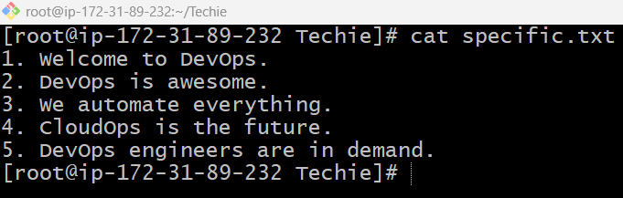

Print a **specific line number** (e.g., line 3

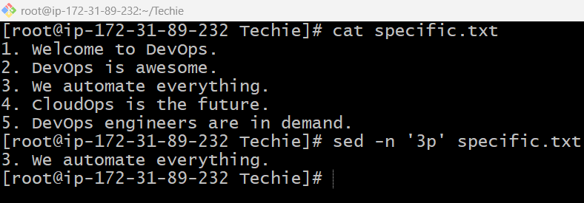

42) Copy file from linux to windows machine

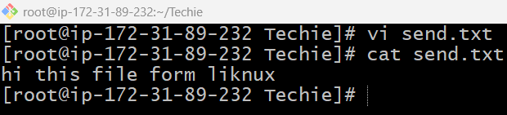

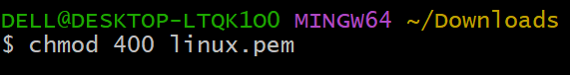



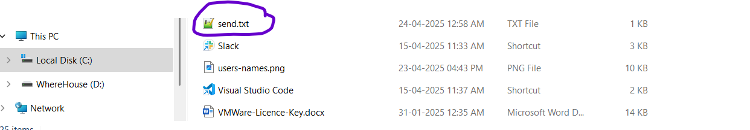

43) 5 use cases for AWK and 5 use cases for sed

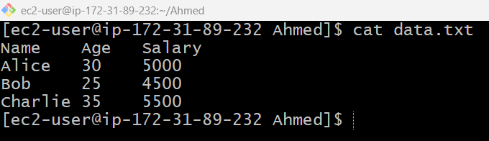

5 use cases for AWK:

1) Print specific columns (Name and Salary)

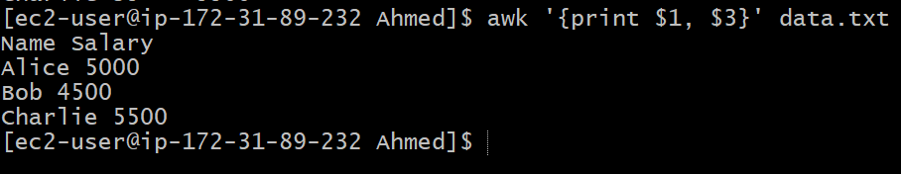

2) Print lines where Age > 30

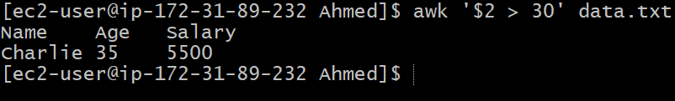

3) Calculate total salary



4) Count number of employees



5) Add new column: Bonus (10% of salary)

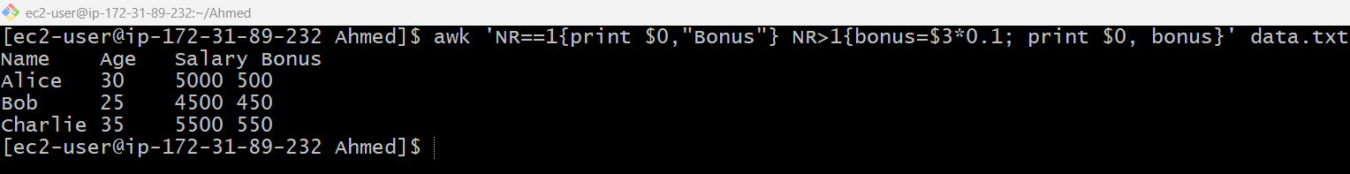

**5 sed Use Cases — With Full Examples**

Let’s use a file config.txt:

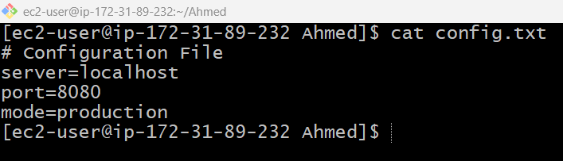

**1)** Replace 'localhost' with IP address

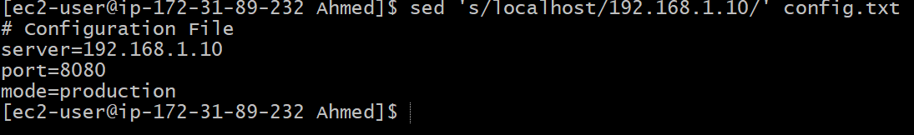

**2)** Delete comment lines (lines starting with #)

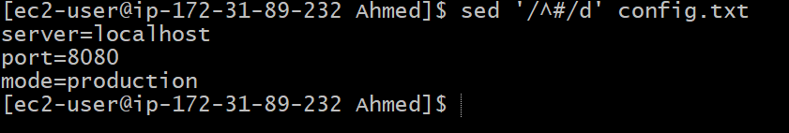

**3)** Insert a new line before 'mode'

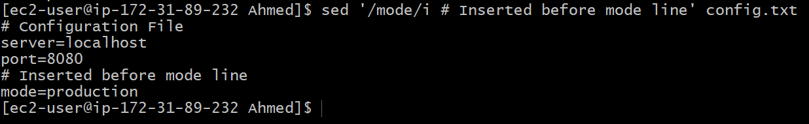

4) Append a line after 'port'

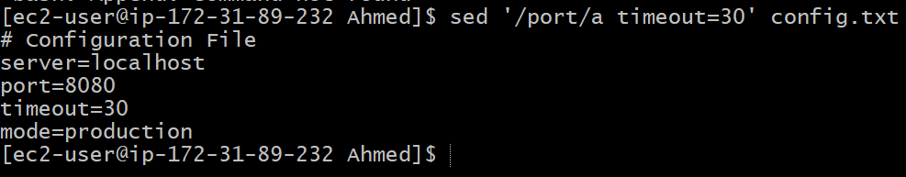

5) Edit file in-place (change port)

