**Linux Basic Commands -1**

1. **Present Working Directory**

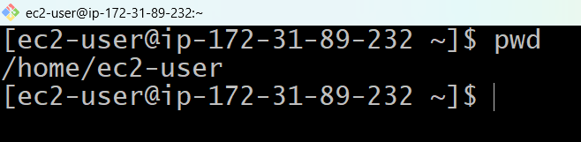

1. **Print Date**

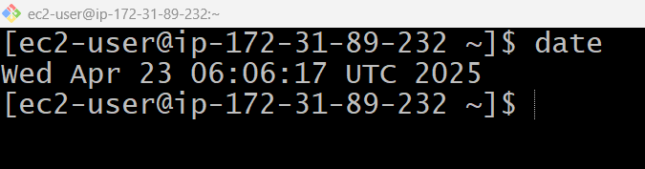

**3) Creating Hidden File**

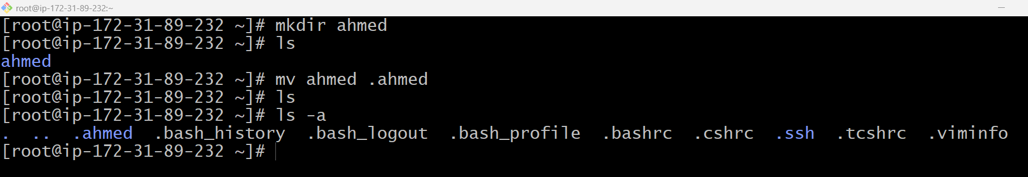

To see the hidden files

Creating a hidden file

Creating a directory



**4) Hidden to Unhidden**

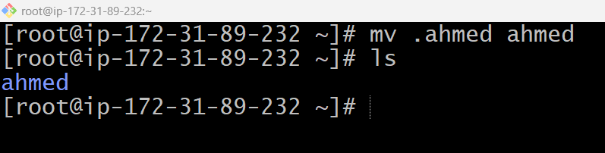

**5) Delete Directory / Removing the directory**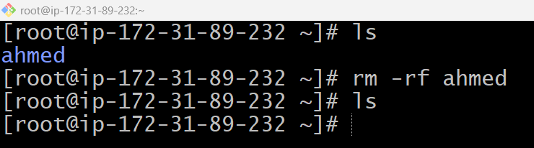

**6) Moving files/directories to another location**

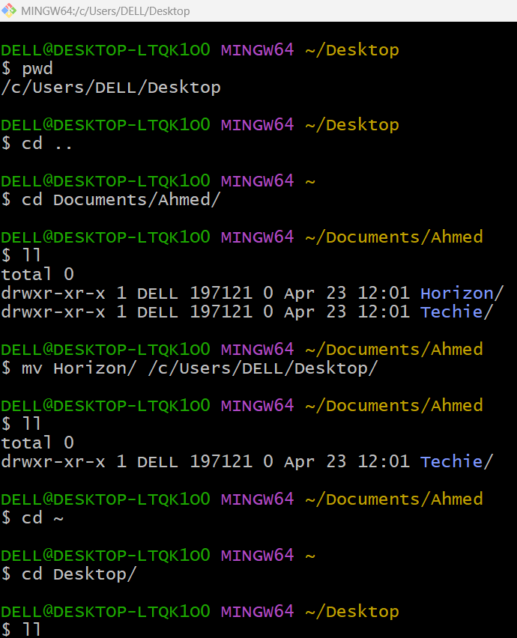



**7) copy the file/directory to another location**

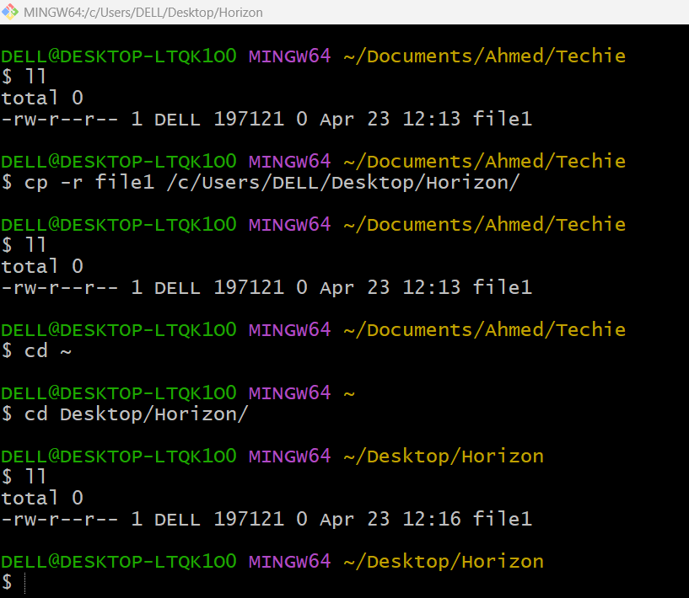



File1 is also present in destination directory

File1 is available in source directory

File1 in Techie directory

Copy file1 to another location



8) To create a file and edit the file and checking the content of the file.

