 | 
Ministry of Communications and Information Technology
Digital Egypt Pioneers Initiative - DEPI
Project Title: HR Analysis

Date of Submission: 5 April 2025
Name |  |  | signature
Prepared by
Omar Mohamed Saeed
Michael Morris Atta
Ahmed yousef Mohamed
Supervised by
Eng. | Ahmed Samir

Contents

Introduction | 3
Objectives | 3
Dataset Description | 4
Chapter 1: Data exploration and cleaning | 7
Chapter2: Analysis Questions Phase | 11
Chapter 3: Forecasting Questions Phase | 25
Chapter 4: Visualization Dashboard | 27

- Introduction: -
In this HR analytics project, we worked with two distinct datasets simulating real-world HR systems.
- The Employee Table (1,470 rows, 24 columns) covers demographic and job-related data such as department, job role, salary, gender, education, and attrition status.
- The Performance Table (6,709 rows, 15 columns) contains performance metrics like job satisfaction, environment satisfaction, training frequency, manager evaluations, and work-life balance.
Our goal is to analyze employee distribution, performance and satisfaction levels, attrition trends, and salary analysis using tools like Excel, SQL, Python, and Power BI, and to deliver actionable insights through visual dashboards.

2- Objectives: -
The main objectives of this HR analytics project are:
- Understand employee distribution across departments, job roles, education levels, age groups, and gender.
- Analyze salary trends and detect patterns based on department, job role, age, and gender.
- Explore attrition factors by examining variables such as overtime, distance from home, salary, years at company, and job satisfaction.
- Evaluate employee satisfaction, including job satisfaction, environment satisfaction, and relationship satisfaction.
- Study the impact of training and performance reviews (self-rating and manager rating) on employee retention and performance.
- Support HR decision-making by visualizing insights in interactive Power BI dashboards that highlight key workforce metrics.

3-Dataset Description

The dataset contains information about employees and their performance, including:

Column Name | Description
EmployeeID | Unique identifier for each employee
FirstName / LastName | Employee's first and last names
Gender | Employee’s gender (Male/Female)
Age | Age of the employee
Business Travel | Frequency of business travel
Department | Department where the employee works
DistanceFromHome (KM) | DescriptionDistanceFromHome (KM)
State | Employee's state of residence or work
Ethnicity | Ethnic background
Education | General education level (e.g., High School, Bachelor’s, etc.)
Education Level | Numeric representation of education level
Education Field | Field of study
Job Role | Job title or position
Marital Status | Marital status (e.g., Single, Married)
Salary | Monthly or annual salary
StockOptionLevel | Level of stock options assigned to employee
Overtime | Indicates if employee works overtime (Yes/No)
Hire Date | Date of employment start
Attrition | Whether the employee has left the company
YearsAtCompany | Total years worked in the company
YearsInMostRecentRole | Years spent in the most recent job role
YearsSinceLastPromotion | Years since last promotion
YearsWithCurrManager | Years working with current manager
PerformanceID | Unique identifier for each performance record
EmployeeID | Reference to the employee
ReviewDate | Date of the performance review
EnvironmentSatisfaction | Satisfaction with work environment (text or score)
EnviromentSatisfactionLevel | Satisfaction level in numeric form
JobSatisfaction | Job satisfaction rating
JobSatisfactionLevel | Numeric level of job satisfaction
RelationshipSatisfaction | Satisfaction with colleagues and relationships
RelationshipSatisfactionLevel | Numeric satisfaction level for relationships
TrainingOpportunitiesWithinYear | Number of training opportunities given that year
TrainingOpportunitiesTaken | Actual training sessions attended
SelfRating | Employee's self-evaluation
SelfRatingLevel | Numeric version of self-evaluation
ManagerRating | Manager’s evaluation of the employee
ManagerRatingLevel | Numeric version of manager’s rating

Data Modeling
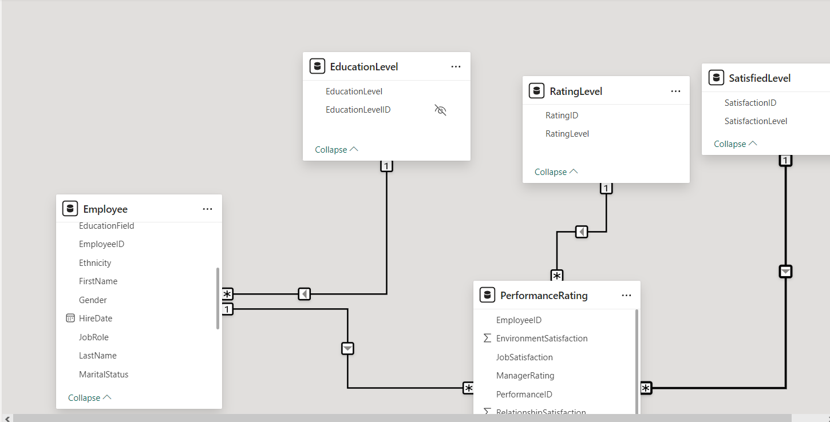

Chapter 1: Data exploration and cleaning

Employee Table:

Python Codes
Step 1: Load the Dataset
- Use Python's pandas library to load the dataset:

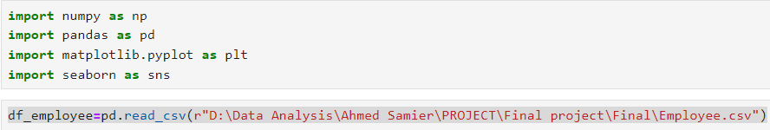

Step 2: Inspect the Dataset
- Check for missing values

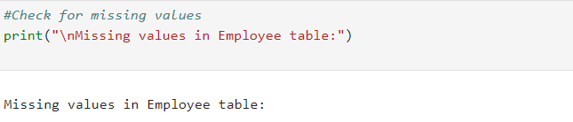

- Check for duplicates, and inconsistencies:

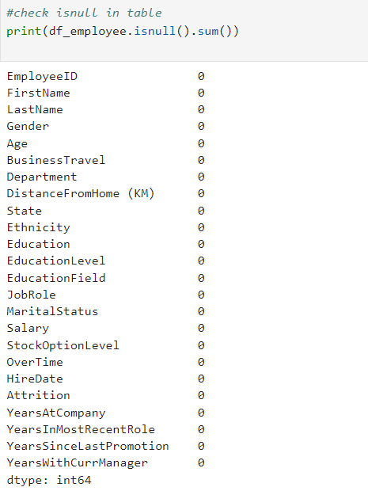

- Check The Shape:

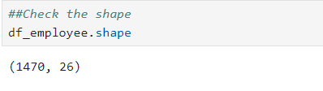

- show description:

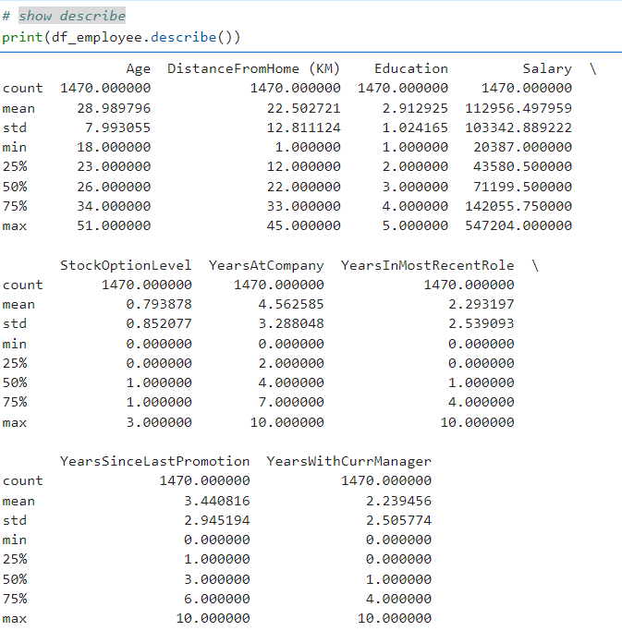

- Check the data types of each column:

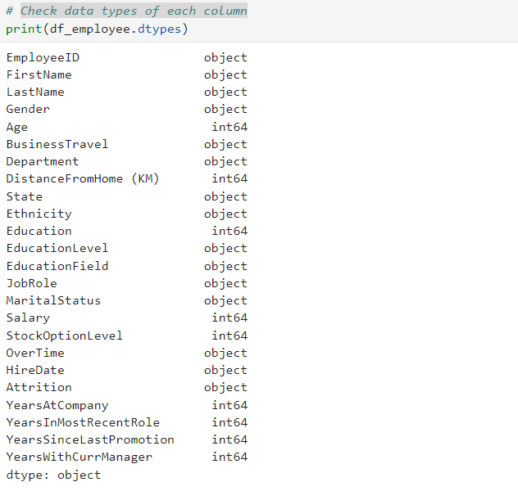
- Data Type Conversion:

Tools:
- Python (pandas): For data cleaning and preprocessing.
- SQL: For querying and transforming data if needed.

Performance Rating:

Step 1: Load the Dataset
- Use Python's pandas library to load the dataset:

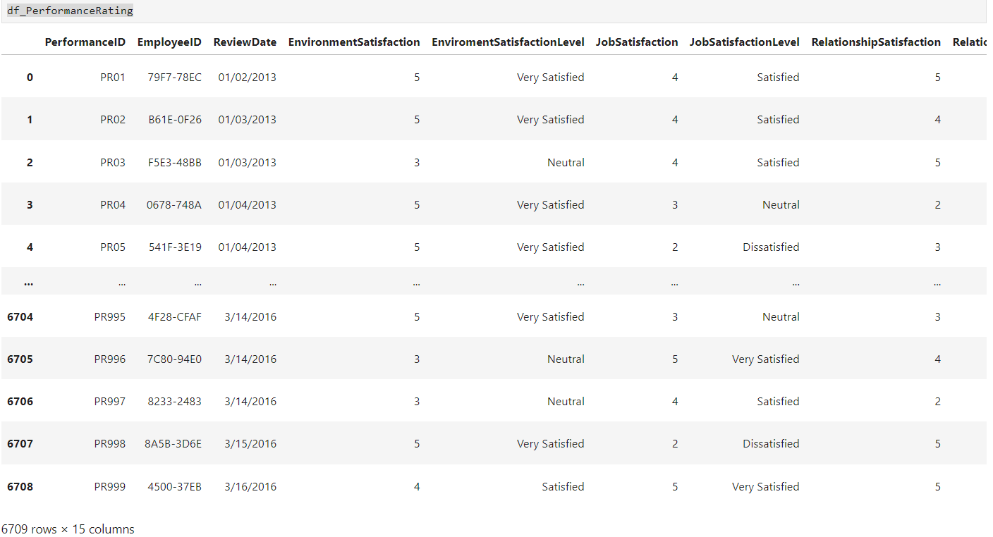

Step 2: Inspect the Dataset
- Check for missing values

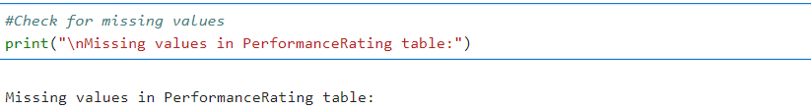

- Check for duplicates, and inconsistencies:

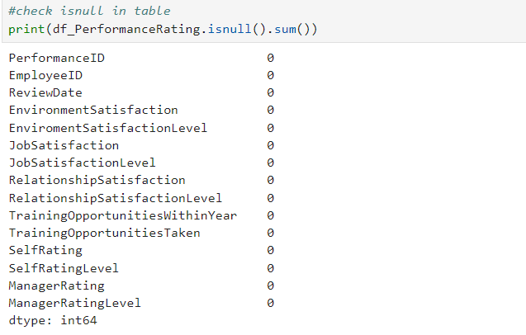
- Check The Shape:

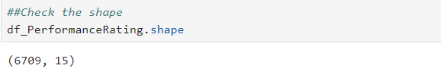

- show description:
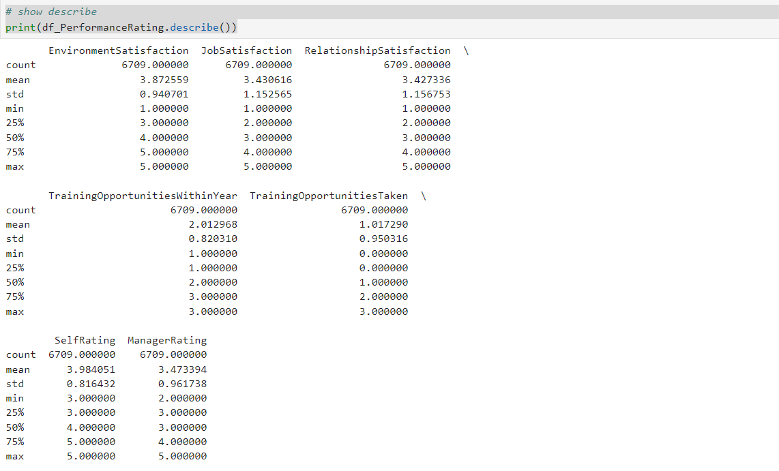
- Check the data types of each column:

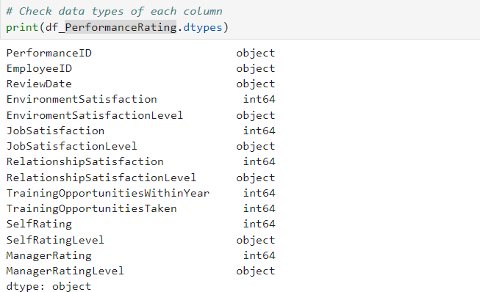

Tools:
- Python (pandas): For data cleaning and preprocessing.
- SQL: For querying and transforming data if needed.

Chapter 2: Analysis Questions Phase:

Tasks:
- Determine Data Analysis Questions: Identify key questions that can be answered using the dataset.
- Tools: SQL, Python (pandas, Matplotlib).
Step 1: Define Analysis Questions
As part of our analysis, the following key business questions were addressed through exploration of the employee and performance datasets:

🧩 Employee Distribution & Demographics

- What is the distribution of employees across departments and job roles?
- How is gender and age distribution across different departments?
- Which education levels and fields are most common?
🚪 Attrition & Retention Analysis

- What is the overall attrition rate?
- Which departments or job roles have the highest attrition?
- Does overtime, salary, or distance from home influence attrition?
💰 Salary Analysis

- What is the average salary across all employees?
- How does the average salary vary by department?
- Are there any salary differences between male and female employees?
- What are the highest and lowest paying job roles in the company?
- Does age have a correlation with salary levels?
- What is the salary distribution by education level?
- How does salary vary across different U.S. states?
- Is there a pattern in salary based on hire year (e.g., do more experienced employees earn more)?
- What percentage of employees fall under each salary level category (e.g., Low, Medium, High)?
- How does salary relate to attrition (e.g., do lower-paid employees leave more frequently)?

🌟 Performance & Evaluation Analysis

- Is there a link between salary level and performance ratings?
- What is the average manager rating per business travel?
- What is the average manager rating per overtime status?
- What is the average manager rating per training opportunities taken?
- How does average performance vary by department?
- What is the performance distribution across different age groups?
- Do employees with higher education levels tend to have better performance scores?
- Which job roles have the highest and lowest average performance ratings?
- Is there a relationship between performance level and attrition?

Step 2: Performce Analysis
Use SQL or Python to answer the questions
Employee Analysis
- How many employees are there in each department?

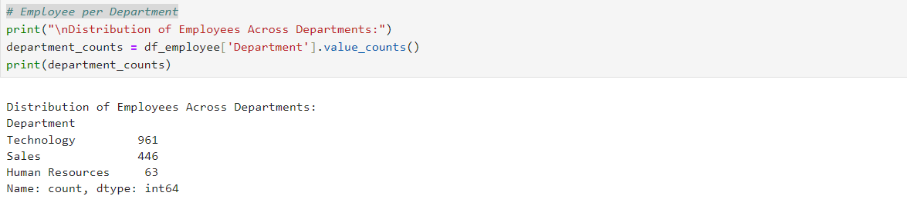
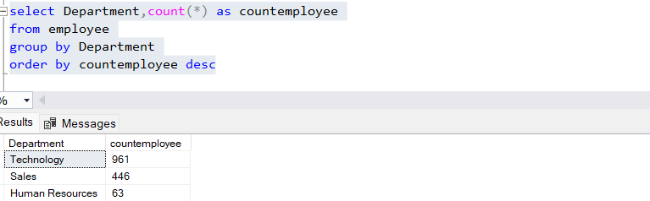

- What is the distribution of employees by gender?

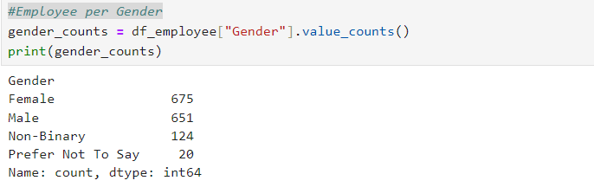

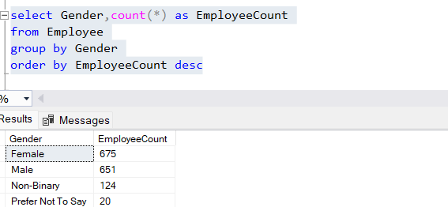

- What is the distribution of employees across different states?

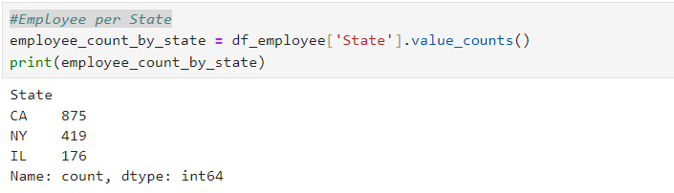
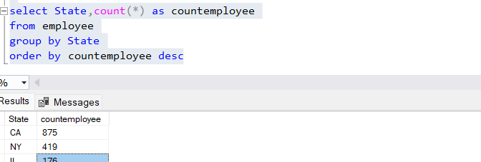
- What is the distribution of employees across different job roles?

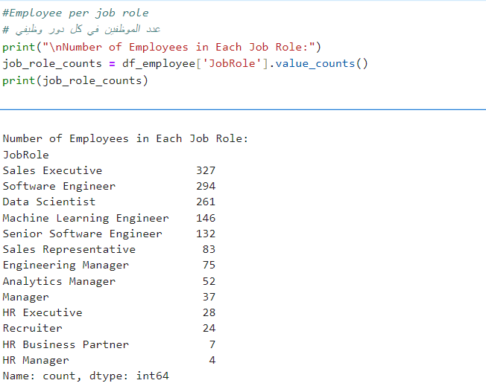
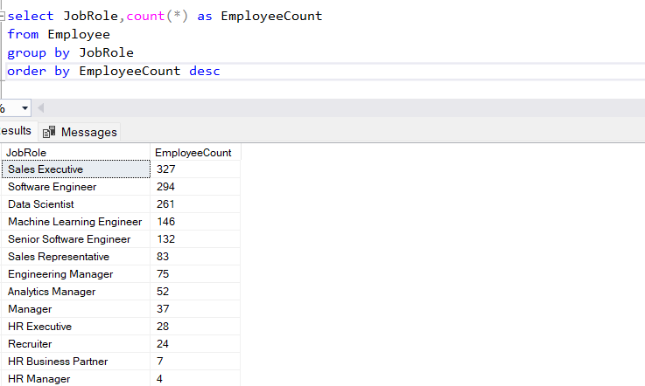
- What is the number of employees per hire year?
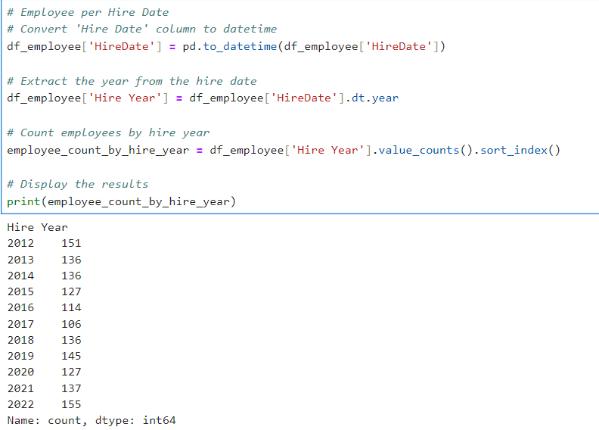
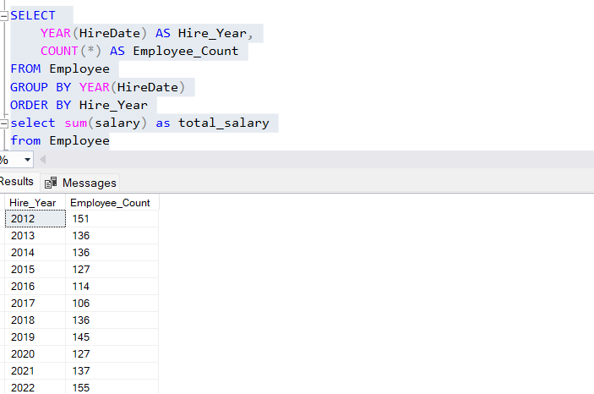

- What is the number of employees per business travel?
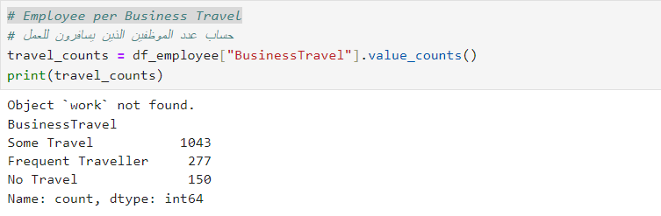
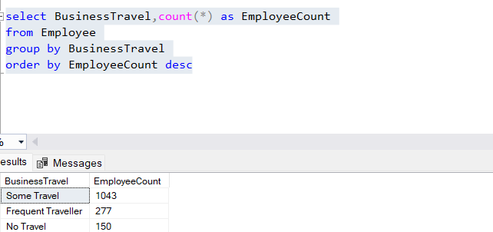
What is the number of employees per age group?
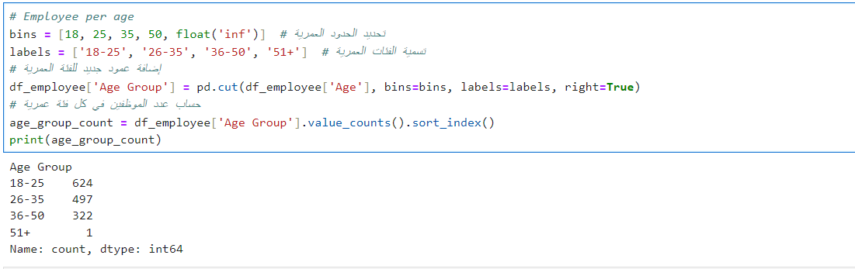
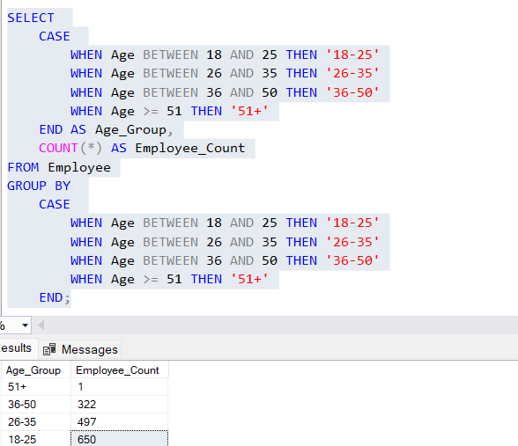
Salary Analysis
- What is the average salary per department?
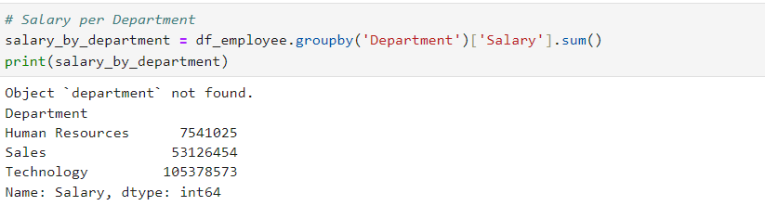
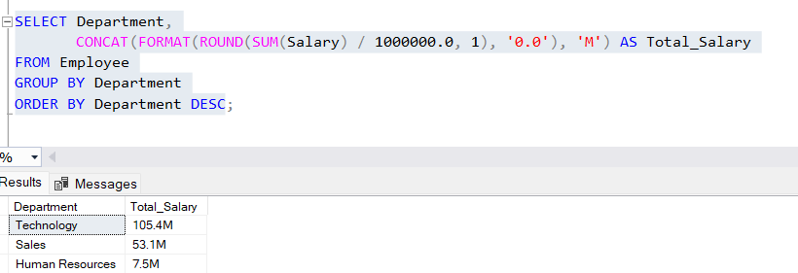

- What is the average salary per job role?
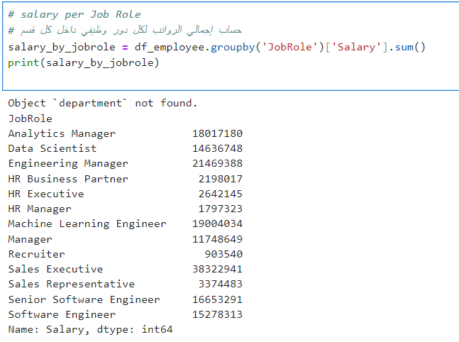
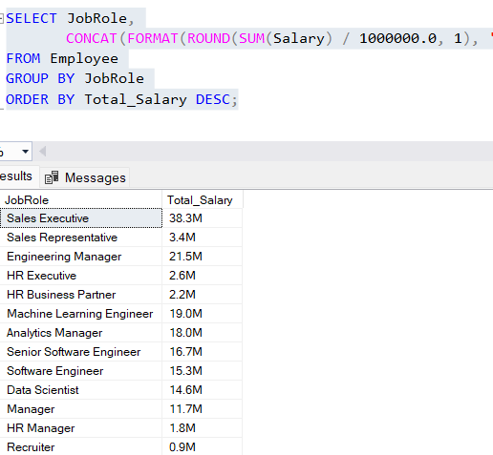

- What is the average salary per state?
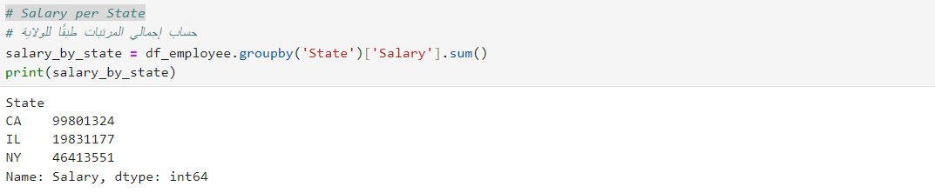
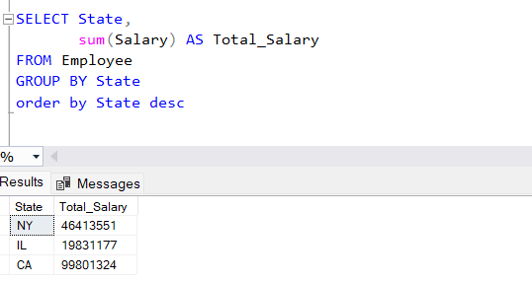
- What is the average salary per gender?
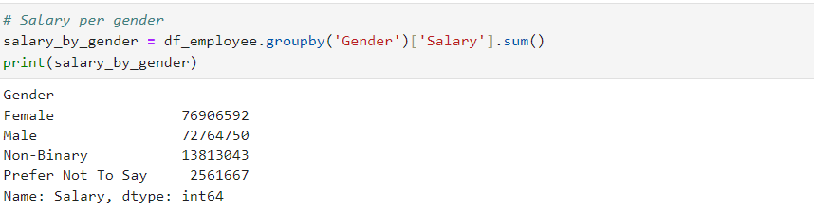
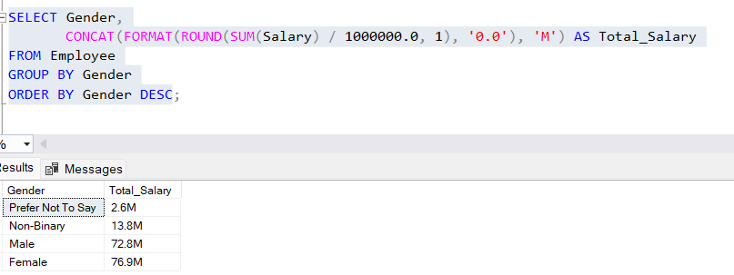
- What is the average salary per education level?
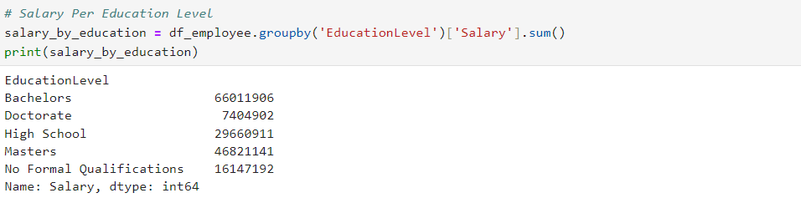
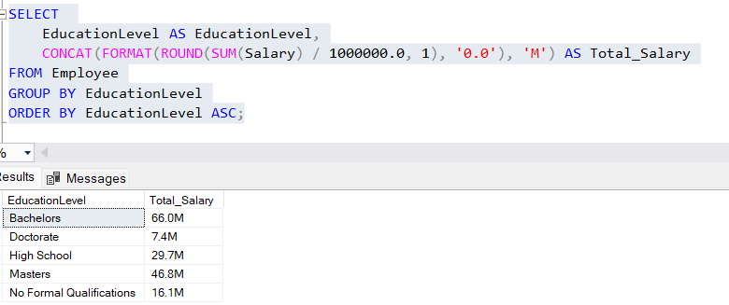What is the average salary per age group?
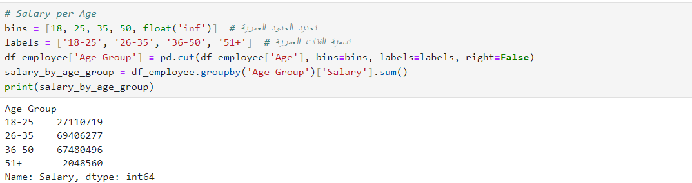

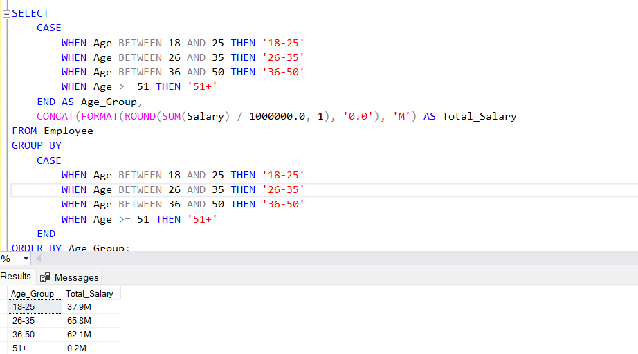What is the average salary per hire date?
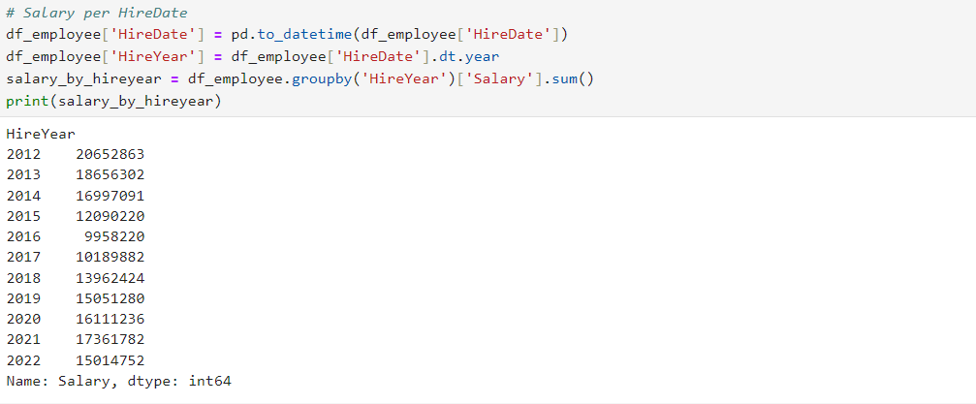
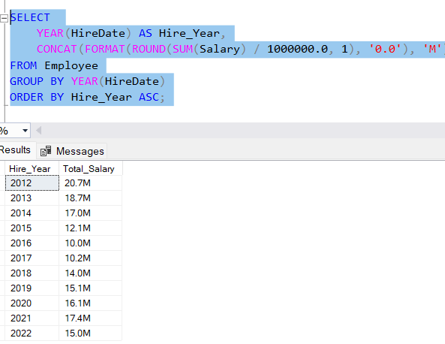
Attrition Analysis
- What is the attrition rate per department?
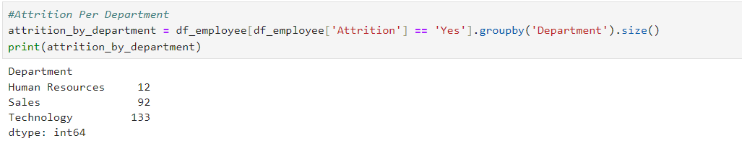
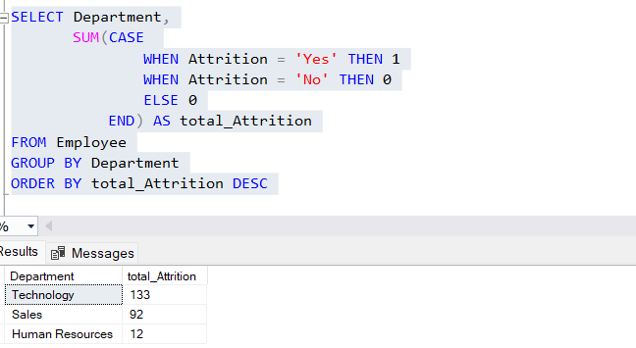

- What is the attrition rate per job role?
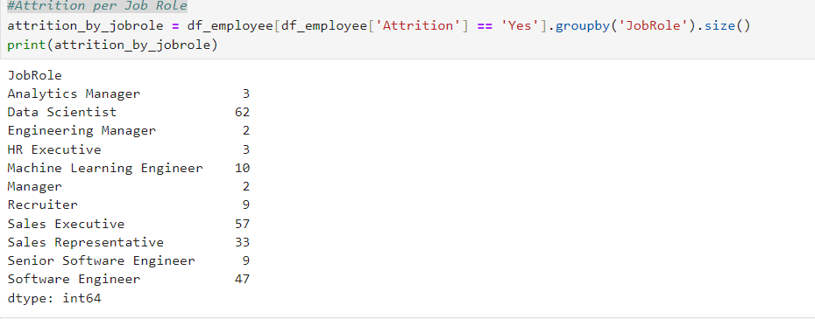
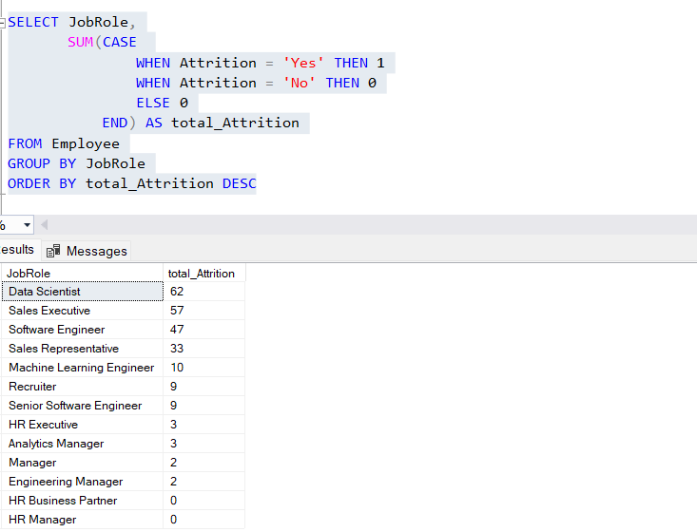

- What is the attrition rate per hire date?
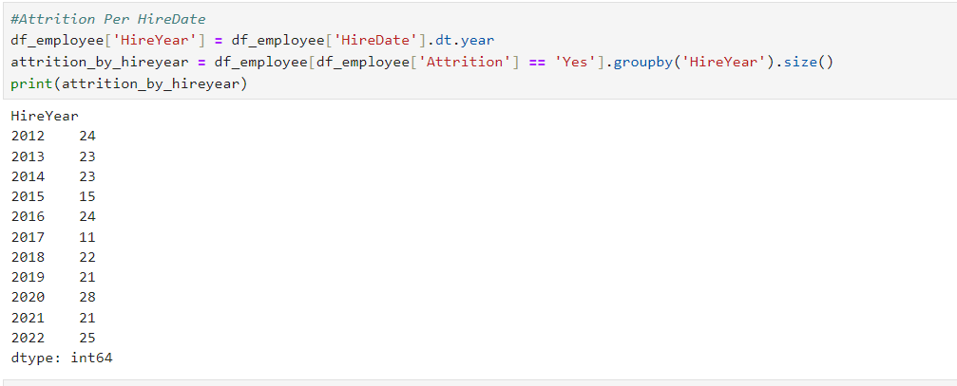
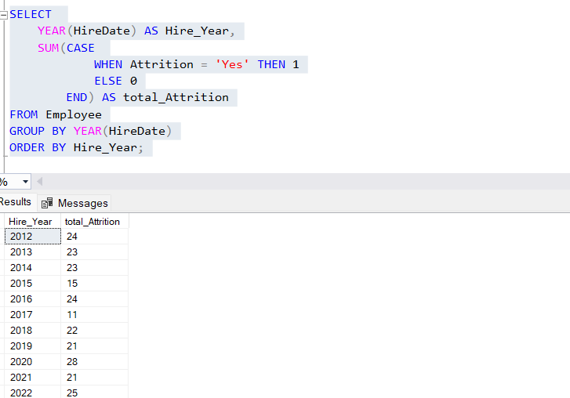

- What is the attrition rate per education level?
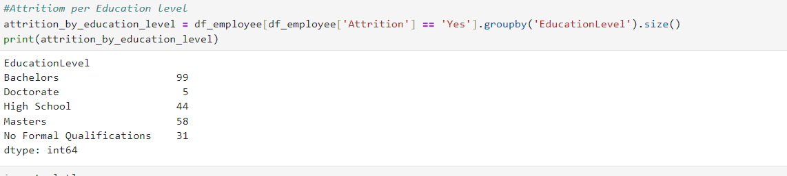
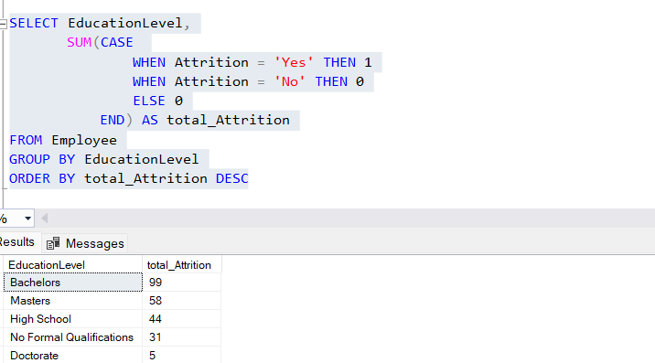
- What is the attrition rate per gender?
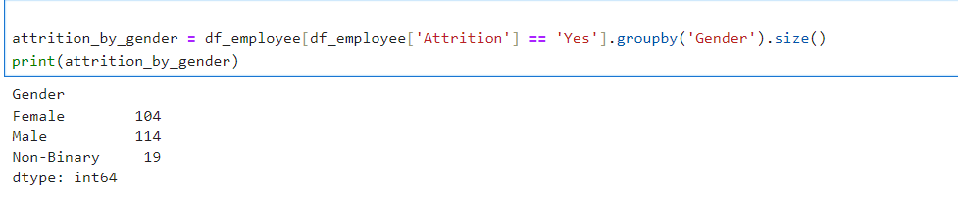
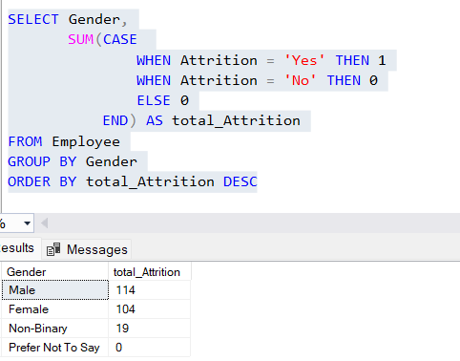

20.What is the attrition rate per state?
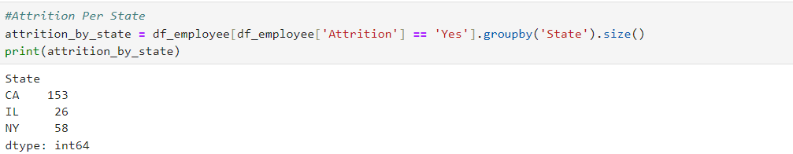

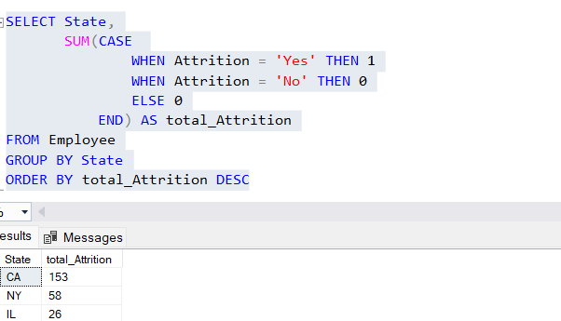

21.What is the attrition rate per business travel?
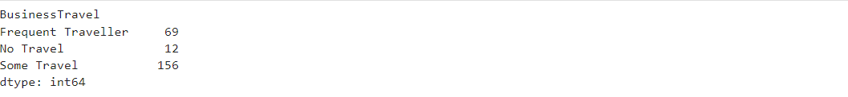
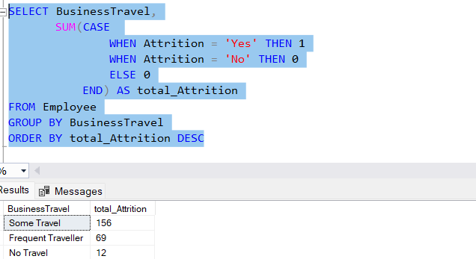

Performance Analysis
- What is the average manager rating per department?
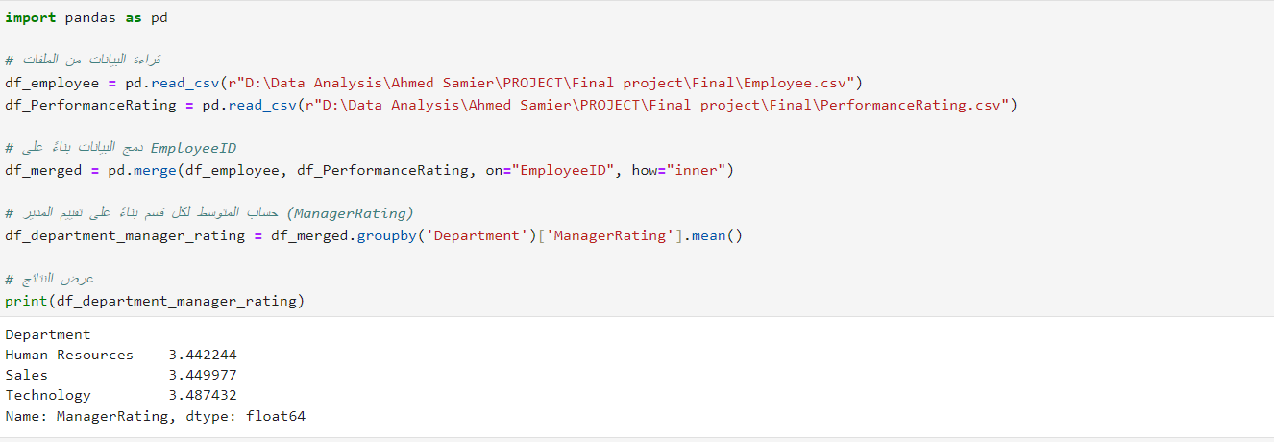

- What is the average manager rating per job role?
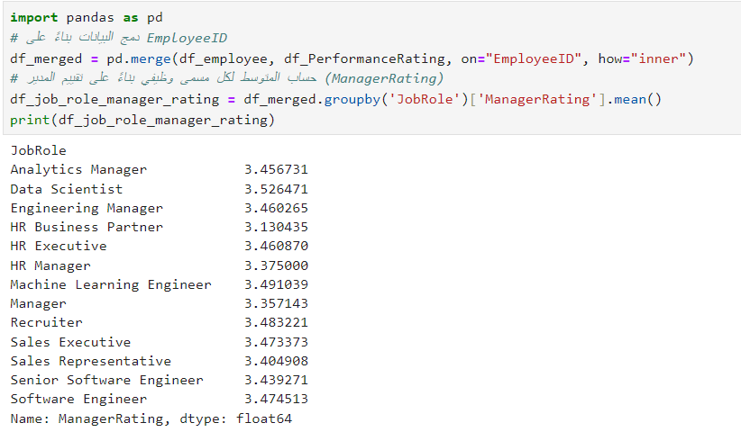

- What is the average manager rating per business travel?
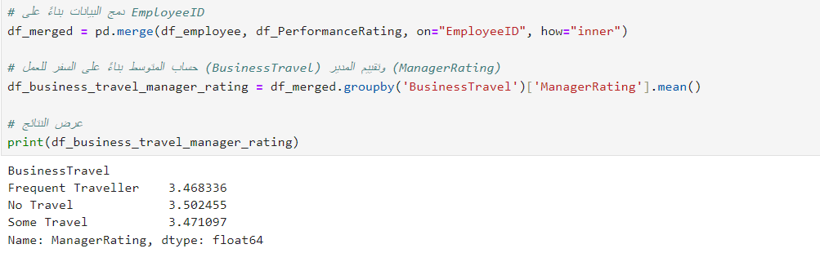
- What is the average manager rating per overtime status?
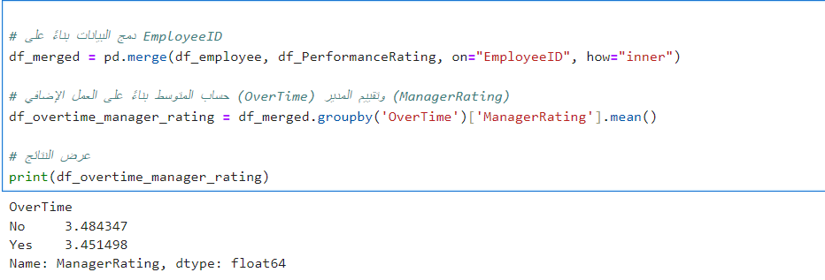
- What is the average manager rating per training opportunities taken?

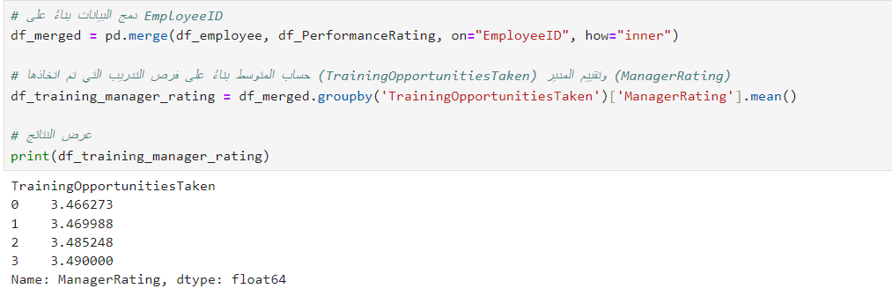

6. What is the average manager rating per salary level?
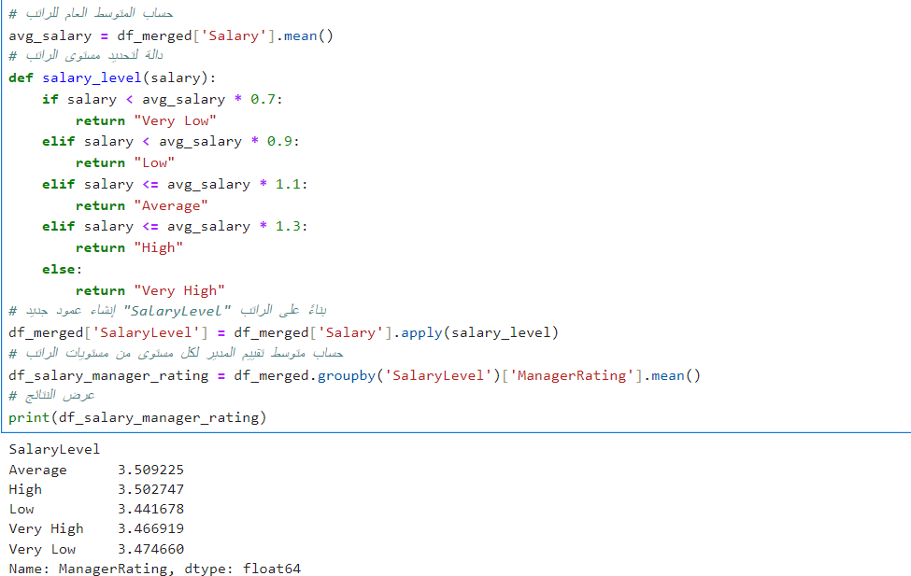
7. What is the average manager rating per age group?
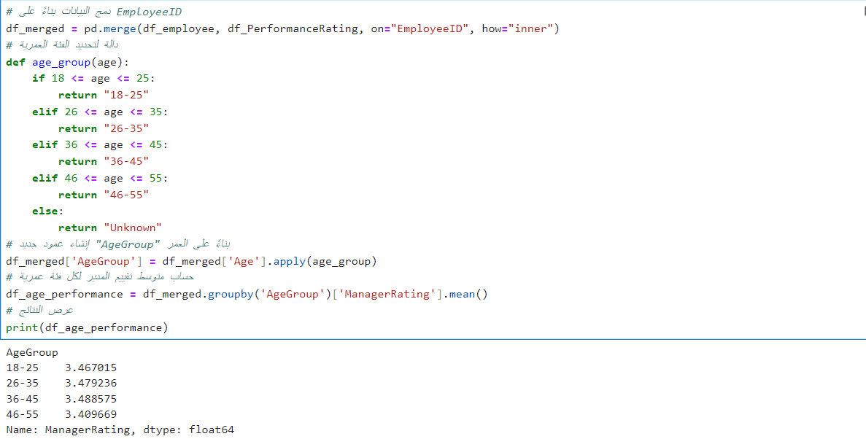

Deliverables:
- Set of Analysis Questions: A list of questions that can be answered using the dataset.
- SQL Queries/Python Code: Code to answer the analysis questions.

Chapter 3: Visualization Dashboard
Dashboard 1: Employee Analysis Dashboard

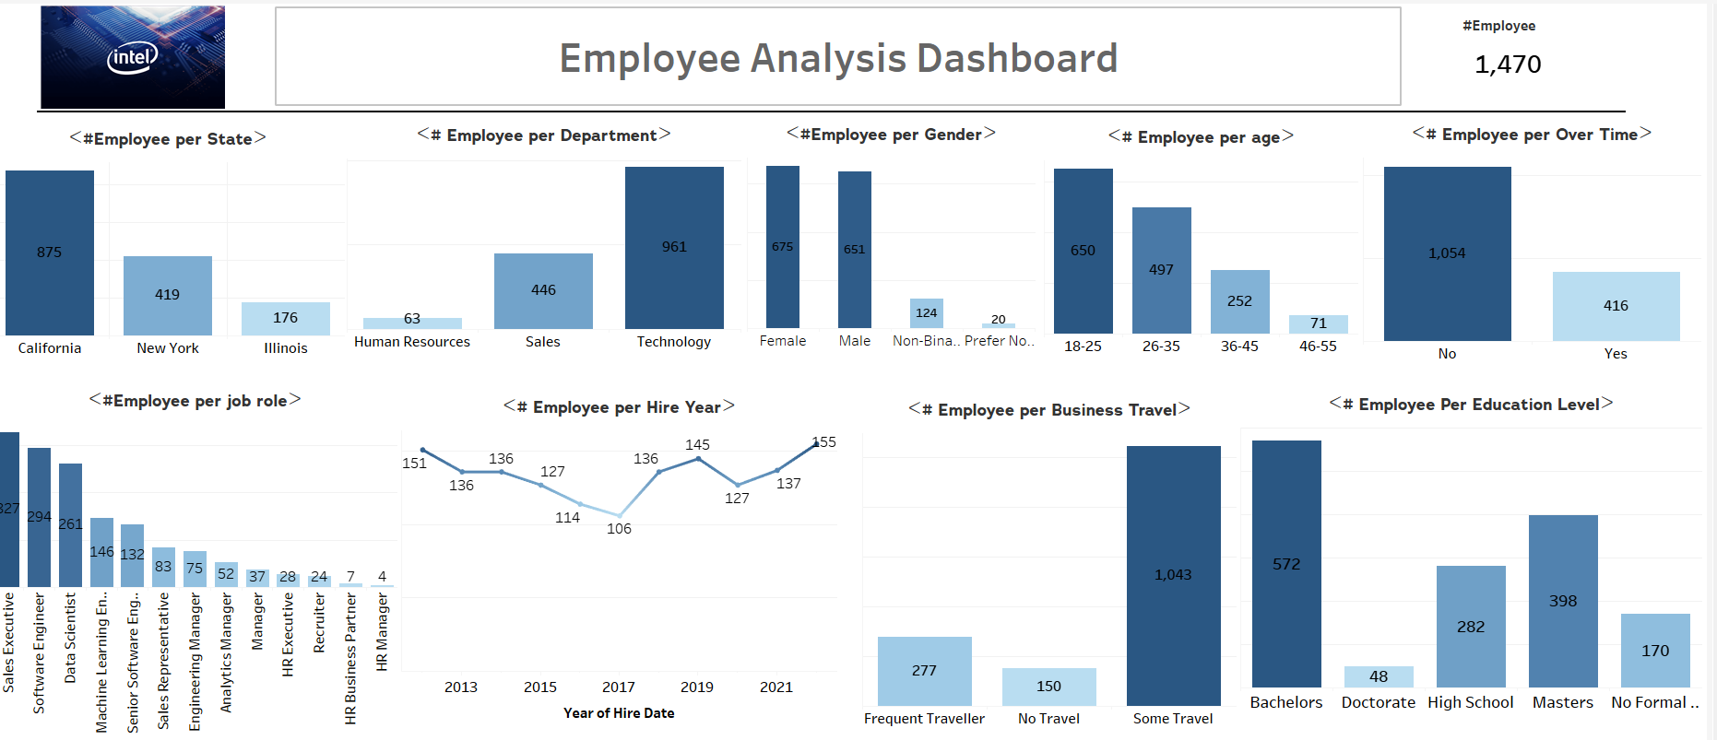

Employee Analysis Dashboard – Quick Summary
This dashboard provides a holistic view of the workforce, helping HR teams and decision-makers understand key patterns across:
- Employee Distribution
  - Breakdown by department, education, job roles, and marital status.
  - Helps identify which departments or groups are over- or under-staffed.
- Hiring Trends
  - Shows employees count by joining year and age group, indicating hiring growth and generational workforce shifts.
- Experience Levels
  - Highlights average and total years of experience, useful for assessing seniority and internal talent pipeline.
- Job Role Insights
  - Analyzes count and characteristics (e.g., experience, education) by job role.
  - Helps detect which roles are most common or critical to operations.
- Education & Career Stage
  - Tracks on how education levels relate to career progression and job types

Dashboard 2: Salary Analysis Dashboard

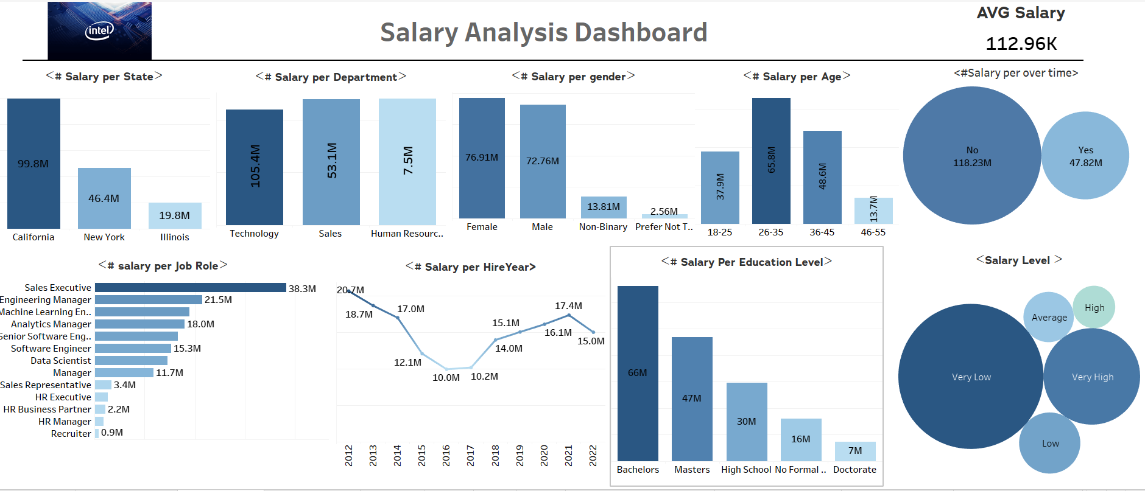

Salary Analysis Dashboard – Quick Summary
This dashboard provides insights into how salaries are distributed across the organization, helping identify pay trends, gaps, and optimization opportunities.
- Salary Distribution by Department
  - Visualizes total salary spend per department.
  - Helps identify cost-heavy functions and evaluate ROI per unit.
- Salary by State & Gender
  - Compares salaries across locations and gender, revealing regional differences and potential pay equity issues.
- Salary by Age Group & Education Level
  - Shows how salary changes with age and qualifications, useful for career planning and fair compensation strategy.
- Job Role Salary Insights
  - Highlights which roles receive the highest/lowest salaries, helping align pay with role value and market benchmarks.

Dashboard 3: Attrition Analysis Dashboard

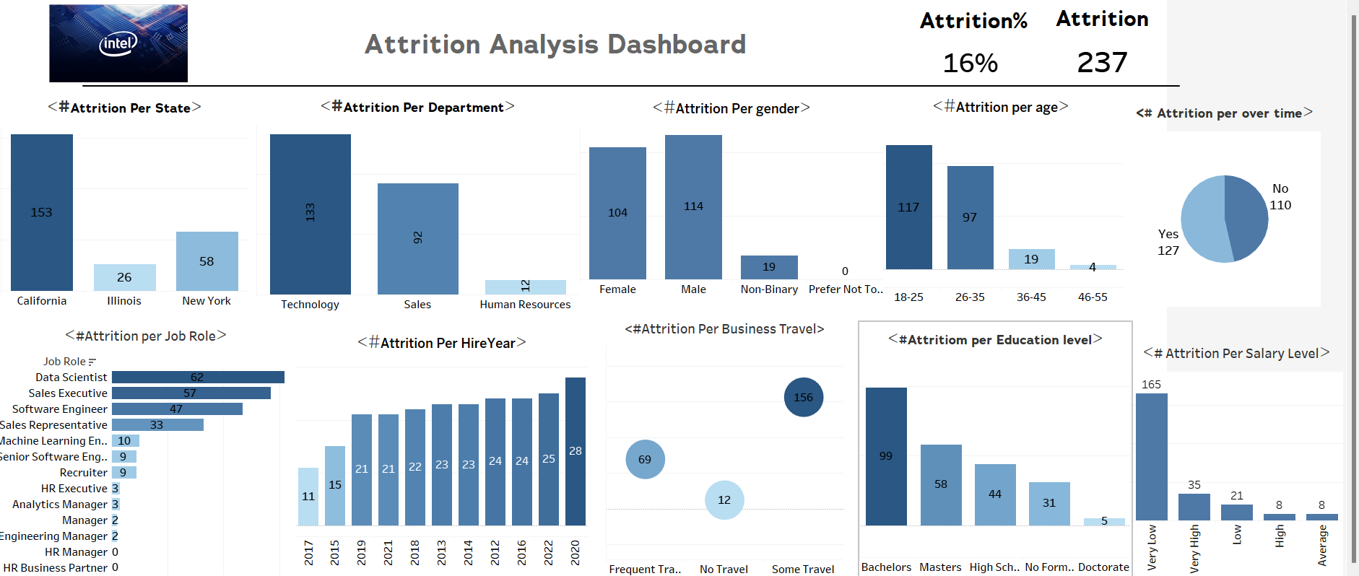

• Attrition by Department
- Visualizes the number of employees who left from each department.
- Helps identify high-turnover departments and potential organizational issues.
• Attrition by State & Gender
- Compares attrition rates across different locations and between genders.
- Reveals regional or demographic patterns that may require attention.
• Attrition by Age Group & Marital Status
- Shows how attrition varies across different age ranges and marital statuses.
- Useful for understanding which life stages or personal circumstances influence turnover.
• Attrition by Overtime & Experience
- Highlights the impact of overtime and years at the company on attrition.
- Helps identify burnout risks and opportunities for early employee engagement

Dashboard 4: Performance Analysis Dashboard
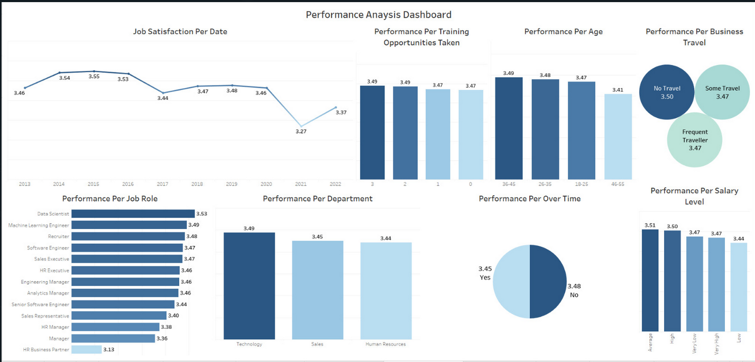
Performance Analysis Dashboard – Quick Summary

• Performance per Age
- Displays performance differences across various age groups.
- Useful for analyzing how age may influence job performance.
• Performance per Business Travel
- Compares performance among employees based on their frequency of business travel.
- Highlights whether travel commitments affect employee productivity.
• Performance per Job Role
- Shows the average performance score for each job title.
- Helps identify which roles have the highest and lowest performance levels.
• Performance per Department
- Displays average performance across different departments.
- Useful for evaluating departmental strengths and performance gaps.
• Performance per Over Time
- Compares performance between employees who work overtime and those who don't.
- Provides insights into whether overtime contributes to higher or lower performance.
• Performance per Salary Level
- Analyzes performance based on salary levels.
- Helps understand if compensation is linked to employee output

Chapter 5: Recommendations
Based on the findings of the HR data analysis, the following recommendations are proposed to reduce attrition, improve employee satisfaction, and enhance overall organizational performance:
1-Increase Salaries for Very Low Earners
The attrition rate is highest among employees in the 'Very Low' salary category. Prioritizing raises for this group can significantly curb early exits.

2-Review High Salary Attrition
The 'Very High' salary group also shows notable attrition (35 cases). This suggests exploring non-financial factors like job satisfaction.

3-Annual Salary Reviews
Implement structured salary revisions based on market benchmarks and inflation trends.

4-Update Static Salary Structure
The current salary structure hasn't changed since 2020 despite economic shifts.

5- Investigate Overtime Trends: Identify departments/roles with excessive overtime and understand the underlying causes.

6- Implement Workload Balancing: Redistribute tasks to prevent employee overload and set realistic deadlines.
7- Support Well-Being: Encourage regular breaks, promote a healthy work-life balance, and offer stress management resources

8- Hire Additional Support: Consider increasing team size if overtime is a recurring need.

9- Promote Efficiency Over Hours: Shift focus from long hours to smart, results-driven work culture

10- Review KPIs for Low-Performing Roles: Ensure fair, measurable performance criteria exist for HR and managerial roles.

11- Provide Role-Specific Development: Offer training and coaching tailored to HR and leadership positions.

12- Align Expectations and Resources: Check if underperforming roles are overburdened or lack necessary support.

13- Recognize Contextual Challenges: Factor in non-measurable contributions like employee well-being, culture-building, and conflict resolution.

14- onduct Employee Feedback Surveys regularly to understand pain points.

15-Reinforce Mental Health & Wellness Programs, especially post-2020.

16-Improve Work-Life Balance Policies: hybrid flexibility, workload adjustments, and PTO encouragement.

17-Enhance Internal Communication: transparent updates and recognition can help rebuild morale.

18-Monitor Satisfaction Quarterly to track improvements and adjust strategies dynamically.
19- Limit Non-Essential Travel: Use virtual meetings when possible to reduce unnecessary trips.
20-Enhance Remote Support: Ensure employees have full access to systems, data, and support while traveling.

21-Offer Flexible Recovery Time: Allow for downtime after travel to recharge and refocus.

22-Provide Comfort and Convenience: Support premium travel options, comfortable accommodation, and manageable schedules.

