**1. Introduction**

**Objective**

The objective of this analysis is to examine and gain insights from Amazon sales data. This includes understanding sales trends, distribution of quantities across categories, sales performance by country, and distribution of fulfillment methods and sales channels. The ultimate goal is to provide actionable recommendations to improve sales strategies and operational efficiency.

**Dataset Description**

* **Source**: Amazon sales data.
* **Number of Records**: 128,799
* **Columns**:
  + **index**: Unique identifier for each row.
  + **Order ID**: Unique identifier for each order.
  + **Date**: Date when the order was placed.
  + **Status**: Current status of the order (e.g., Shipped, Pending, Returned).
  + **Fulfilment**: Method of fulfillment (e.g., Amazon, Merchant).
  + **Sales Channel**: Channel through which the sale was made (e.g., Online, Offline).
  + **ship-service-level**: Level of shipping service (e.g., Standard, Expedited).
  + **Style**: Style of the product.
  + **SKU**: Stock Keeping Unit, a unique identifier for each product.
  + **Category**: Category of the product (e.g., Electronics, Clothing, Books).
  + **Size**: Size of the product.
  + **ASIN**: Amazon Standard Identification Number, a unique identifier for each product on Amazon.
  + **Courier Status**: Current status of the shipment (e.g., Delivered, In Transit, Out for Delivery).
  + **Qty**: Quantity of products ordered.
  + **currency**: Currency in which the transaction was made (e.g., USD, EUR).
  + **Amount**: Total amount of the transaction.
  + **ship-city**: City to which the order was shipped.
  + **ship-state**: State to which the order was shipped.
  + **ship-postal-code**: Postal code of the shipping address.
  + **ship-country**: Country to which the order was shipped.
  + **B2B**: Indicates if the transaction was Business to Business (B2B).
  + **Month**: Month in which the order was placed.

**2. Data Cleaning**

**Initial State of the Data**

The initial dataset consists of 128,977 records and 24 columns. Below is the initial state of the data, including data types and the number of missing values.

**Data Types and Missing Values**

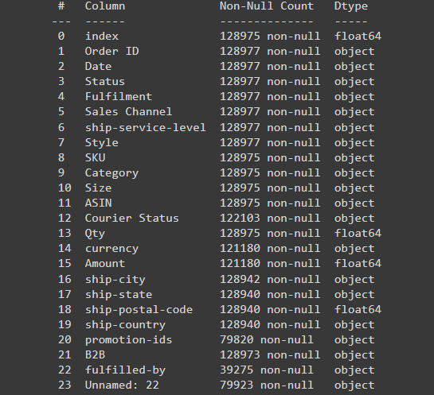

**Summary Statistics for Numerical Variables:**

**Summary Statistics for Categorical Variables:**

**Distribution of Numerical Columns**  
  
**Distribution of Categorical Columns**

**Missing Values in Columns as percentage:**

N**umber of Missing Values:**

Ater removing the 3 Columns that had a lot of missing values percentage and imputing the numerical and categorical columns.

1. **imputing in numerical using Median:**

1. **imputing Using Mode:**

1. **In Categorical Using Mode:**

1. **Result After Cleaning:**

1. **Data Type conversion:**

1. **Treatment of the Outliers:**

**3. Data Visualization:**

Creating insightful diagrams using Matplotlib and Seaborn:

* **Like Distribution of Qty and Distribution of Amount**

* **Count Plot of Status and Count Plot of Category**

* **Trend Chart of Amount Over Time**

* **Correlation Heatmap between Quantity and Amount**

* **Add Some Visual Analysis like:**
  + **Monthly Sales Trend:**

* + **Top 10 Selling Categories**

* + **Top Selling Products:**
  + **Sales Distribution by Country**

**4. Machine Learning Models:**

* **Drop unnecessary columns and encode the categorical columns**

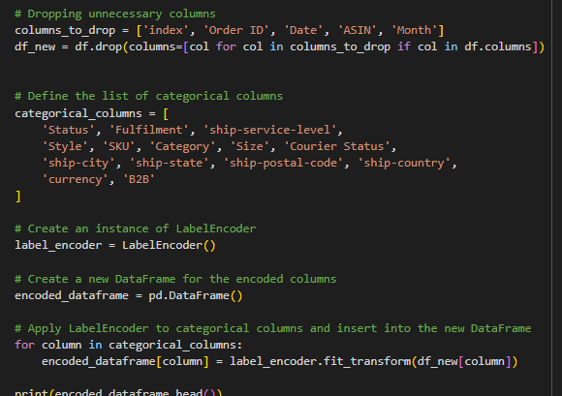

* **Create the machine learning models:**

* **Evaluate the Accuracy of each Model:**

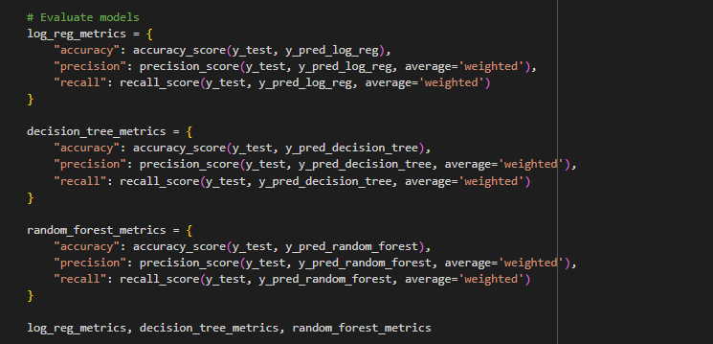

* **Cross-Validation for each Model:**

