

**كلية الهندسة بشبرا**

**جامعة بنها**

**بحث مرجعي**

مقدم لـ

|  |  |
| --- | --- |
| **الرياضيات والفيزياء الهندسية** | **القسم** |
| **---------** | **الشعبة** |
| **٢٠١٩ – ٢٠٢٠ الفرقة الإعدادية** | **السنة الدراسية** |
| **حاسب آلي** | **اسم المقرر** |
| **ECE001** | **كود المقرر** |

**العنوان:-**

**فروع الهندسة المدنية ومجالات كل فرع واهميته في خدمة المجتمع**

بواسطة:-

|  |  |  |  |
| --- | --- | --- | --- |
| رقم الجلوس | البريد الالكتروني الجامعي | الاسم |  |
| 52 | Ahmed195053@feng.bu.edu.eg | أحمد حمدي محمد فهمي عبدالحميد | 1 |

**Topic:** Artificial Intelligence

**Application Brief:**

Artificial intelligence is one of the best significant breakthroughs of the 21st century. Specialists from different industries study its capabilities and discover new ways of its application. We call artificial intelligence an emerging technology, however, scientists have been working in this direction since the 1950s.

Artificial Intelligence is the concept of what defines AI has changed over time, but at the core there has always been the idea of building machines which are capable of thinking like humans.

**Applications of AI:**

* **Expert systems:** An Expert System is a computer program designed to act as an expert in a particular domain.
* **Natural Language Processing (NLP):** The goal of NLP is to enable people and computers to LP communicate in a natural (humanly) language(such as, English) rather than in a computer language.
* **Speech recognition:** The primary interactive method of communication used by humans is not reading and writing, it is speech. The goal of speech recognition research is to allow computers to understand human speech.
* **Computer vision:** People generally use vision as their primary means of sensing their environment, we generally see more than we hear, feel or smell or taste. The goal of computer vision research is to give computers this same powerful facility for understanding their surrounding. Here A.I helps computer to understand what they see through attached cameras.
* **Robotics:** A Robot is a electro-mechanical device that can by programmed to perform manual tasks or a reprogrammable multi functional manipulator designed to move materials, parts, tools, or specialized devices through variable programmed motions for performance of variety of tasks.

**Screenshots**

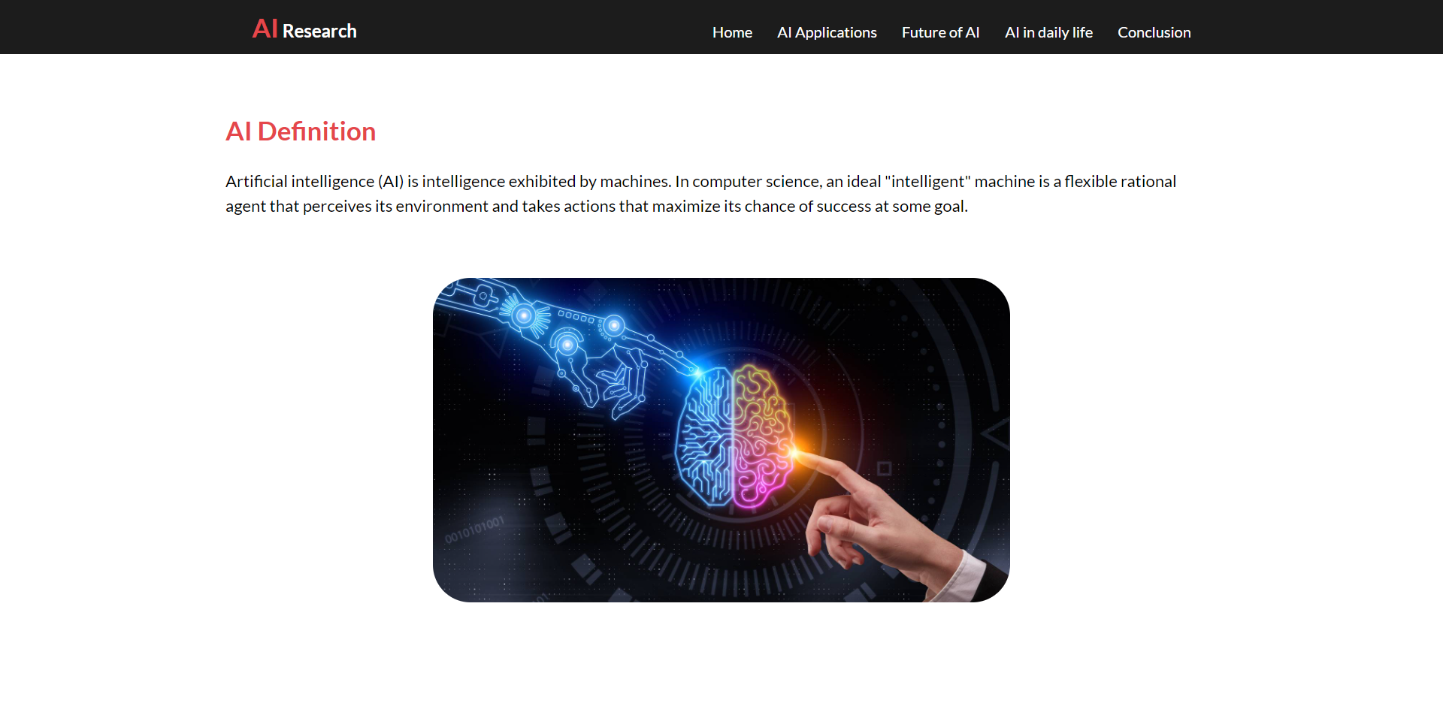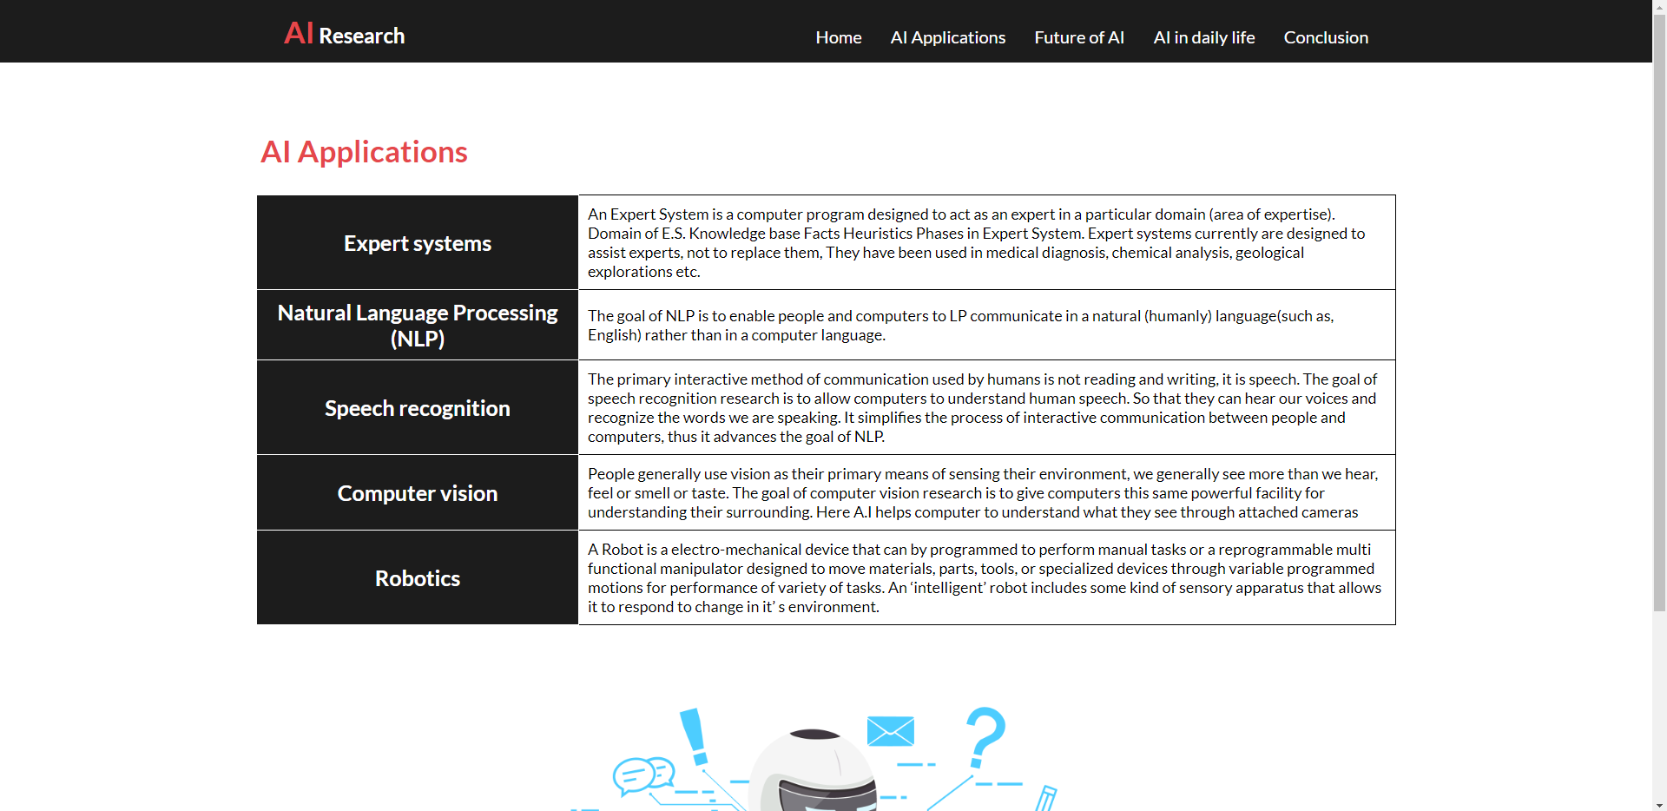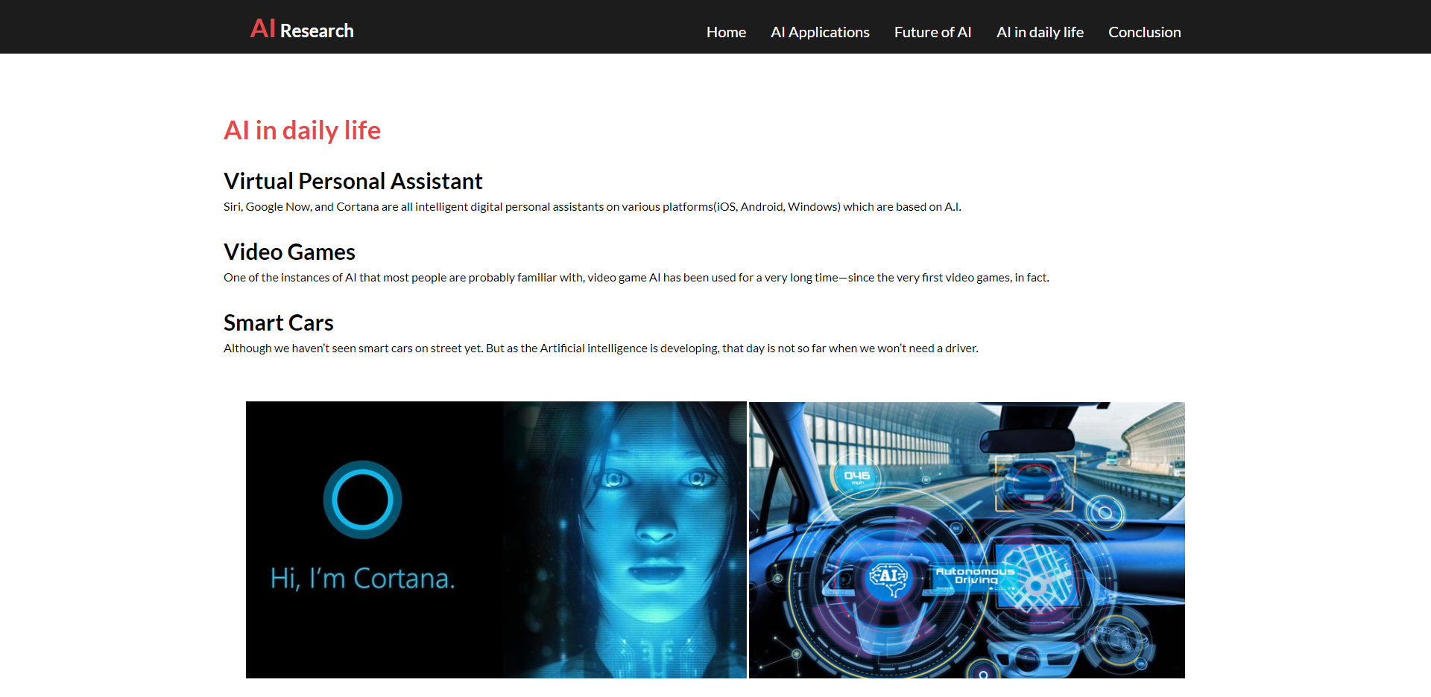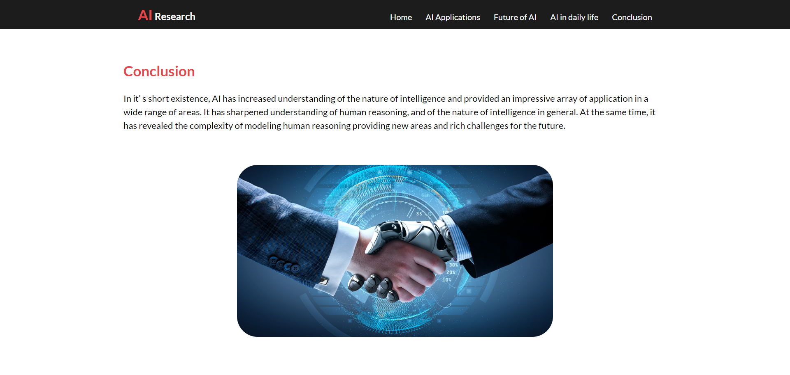

**Source Code**

