Assignment 1 Report
Quantization

Student Name | BN | Code
Ahmed Hamed | 3 | 9220027
Somia Saad El-shemey | 26 | 9202666

1. Uniform Scalar Quantizer
- First step was to shift the input signal by the offset using this equation:
shifted_val = in_val - (m * delta / 2)
- Then we rounded it to the nearest level and clip the signal from 0 to L-1

2. Uniform Scalar De-Quantizer
- We reconstructed the signal according to this formula:
deq_val = (q_ind - L / 2 + m / 2) * delta
Quantizer and De-Quantizer are made using scalar division and independent of the bitrate

3. Testing on Deterministic Input
- Tested Quantizer and De-Quantizer on a ramp signal and got the correct signals
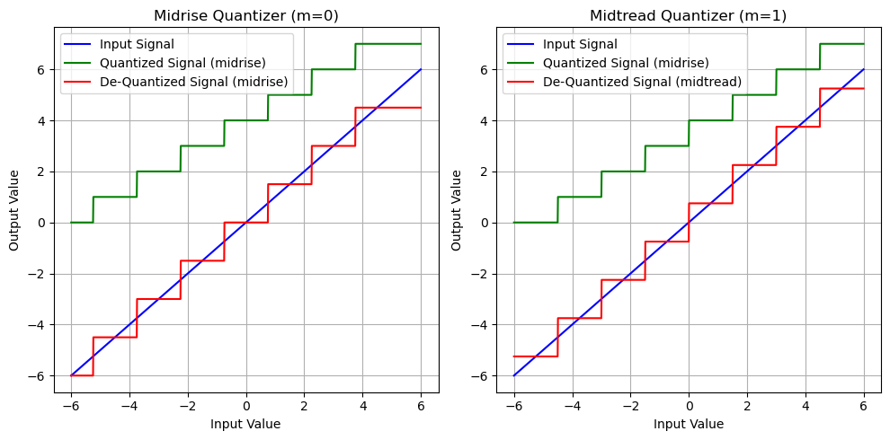

4. Testing on Uniform Random Input
- Tested SNR results on a uniform random input signal and compared it to the theoretical values

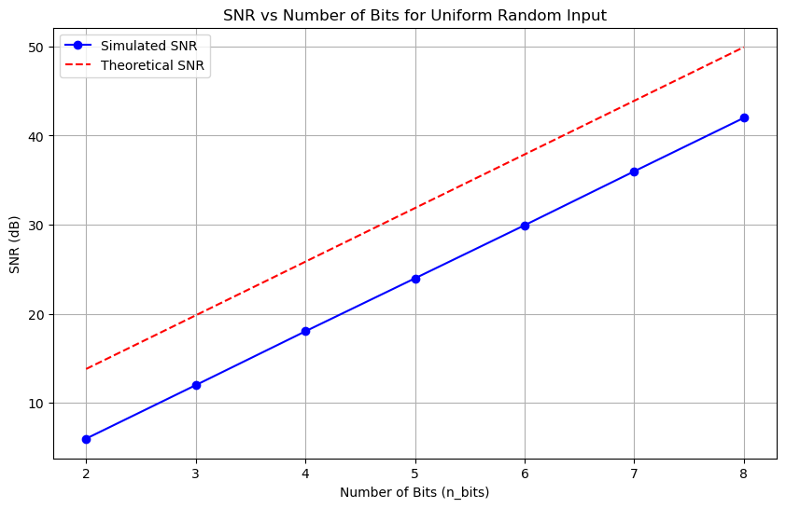
5. Testing on Non-Uniform Input
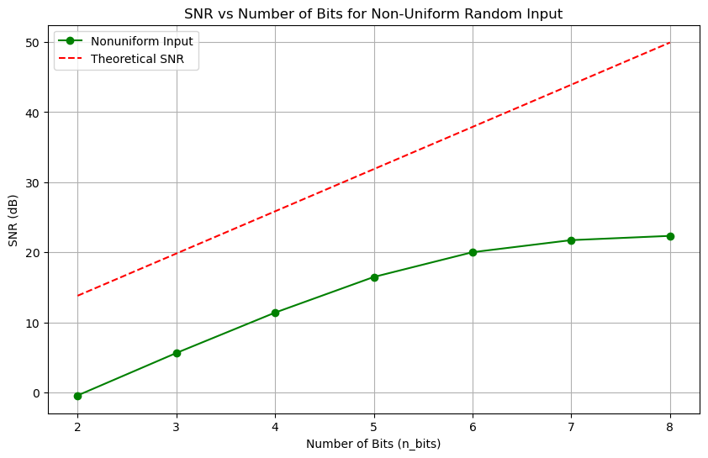
- Tested SNR results on an exponentially distributed random input signal and compared it to the theoretical values

6. μ\mu-Law Quantization
- Implemented a non-uniform quantizer using a uniform quantizer by using (μ Law) with compressing the signal before quantization and expanding it after de-quantization
