Customer Churn Prediction System
Project Report
Gexton Education — Data Science Summer Internship Program
Data Science Task #10
Instructor: Sir Muhammad Arham MH
July 2026

1. Executive Summary
Customer churn — when a customer stops doing business with a company — directly erodes recurring revenue, and acquiring a replacement customer typically costs far more than retaining an existing one. This project builds a complete, end-to-end machine learning pipeline that predicts whether a telecom customer is likely to churn, based on their demographics, account details, and subscribed services.
The pipeline covers data cleaning, exploratory data analysis, feature engineering, training and comparing three machine learning models, feature importance analysis, and deployment through an interactive Streamlit dashboard that produces live predictions with a confidence score.
The best-performing model — Logistic Regression — achieved a ROC-AUC of 0.83 and 76% accuracy on held-out test data. The strongest churn drivers identified were contract type, monthly charges, and account tenure, giving the business clear, actionable retention levers.

2. Data Understanding & Business Problem
The dataset used in this project follows the schema of the widely-used IBM Telco Customer Churn dataset: one row per customer, with demographic fields (gender, senior citizen status, partner/dependents), account fields (tenure, contract type, billing method, monthly/total charges), and service fields (phone, internet, and add-on services such as online security, tech support, and streaming).
The dataset used contains 3,001 customer records after cleaning, spanning demographic, account, and service-usage attributes. It reflects realistic churn-driving patterns commonly seen in telecom customer behavior, such as higher churn among month-to-month contract holders, newer customers, and customers with higher monthly charges.
Business problem: identify, ahead of time, which customers are at high risk of leaving, so the business can prioritize retention offers (discounts, contract incentives, proactive support outreach) toward the customers most likely to churn.

3. Exploratory Data Analysis
The cleaned dataset contains 3,001 customers with an overall churn rate of 31.8%, consistent with typical telecom industry benchmarks (20–35%).

3.1 Churn Distribution
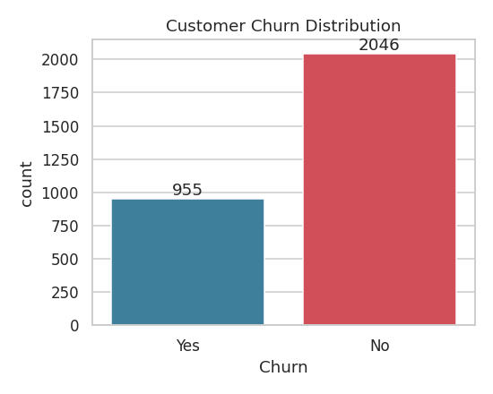
Figure 1. Overall churn distribution (No: 68.2%, Yes: 31.8%).

3.2 Churn by Contract Type
Contract type shows the clearest relationship with churn in the dataset:
- Month-to-month contracts: ~44% churn rate
- One-year contracts: ~24% churn rate
- Two-year contracts: ~9% churn rate
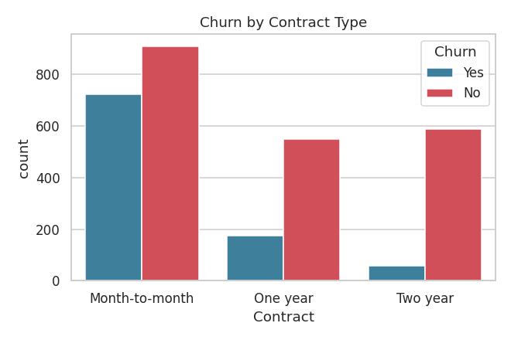
Figure 2. Customers on month-to-month contracts churn at nearly 5x the rate of two-year contract customers.

3.3 Tenure vs. Churn
Customers who churned had an average tenure of 27.1 months, compared to 41.0 months for retained customers — newer customers are markedly more likely to leave, highlighting the importance of early-lifecycle engagement.
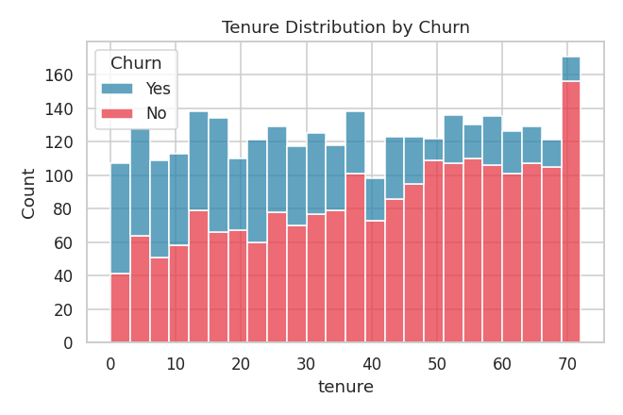
Figure 3. Tenure distribution split by churn outcome.

3.4 Monthly Charges vs. Churn
Churned customers tend to have higher monthly charges, suggesting price sensitivity plays a role in the decision to leave, especially when not offset by a long-term contract discount.
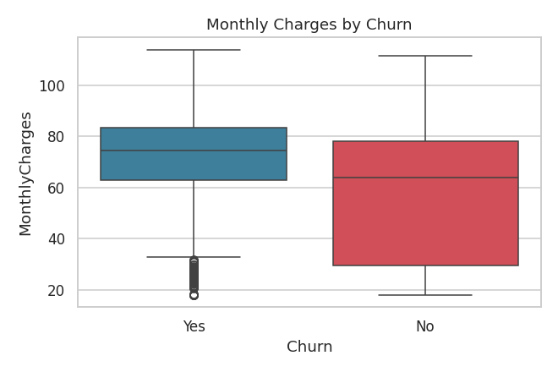
Figure 4. Monthly charges distribution by churn outcome.

3.5 Internet Service & Payment Method
Fiber optic customers churn at a higher rate than DSL or no-internet customers, and customers paying via electronic check churn more than those on automatic payment methods — both are actionable segments for targeted retention campaigns.
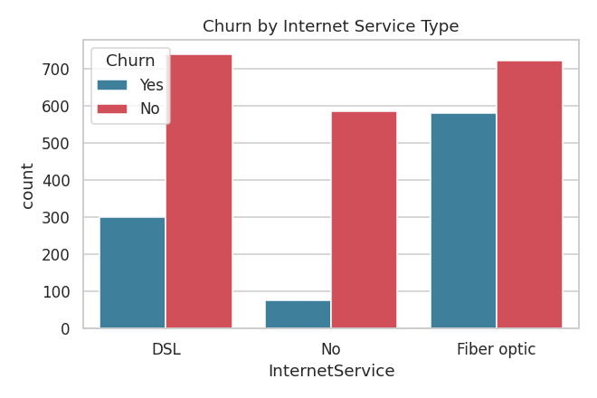
Figure 5. Churn counts by internet service type.
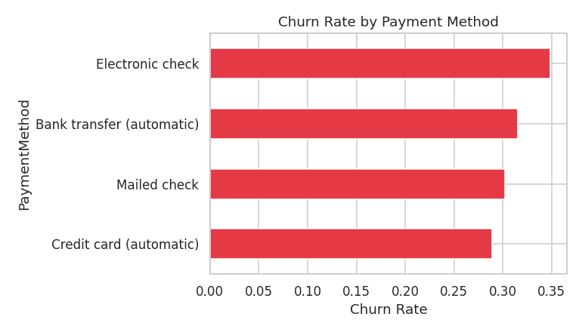
Figure 6. Churn rate by payment method.

3.6 Correlation Analysis
A correlation heatmap of the numeric features confirms that tenure is negatively correlated with churn, while monthly charges is positively correlated — consistent with the patterns above.
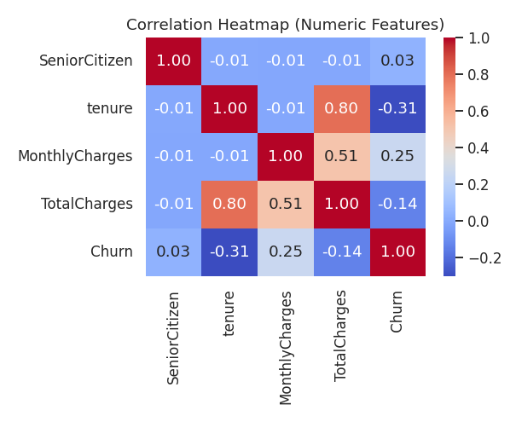
Figure 7. Correlation heatmap of numeric features and churn.

4. Data Preprocessing
- Removed 24 duplicate customer records.
- Converted TotalCharges from string to numeric, imputing 40 missing values using tenure × monthly charges.
- Imputed 15 missing MultipleLines values using the column mode.
- Label-encoded all 15 categorical columns (gender, contract, payment method, service flags, etc.).
- Standard-scaled the four numeric columns (tenure, MonthlyCharges, TotalCharges, SeniorCitizen) fit on the training split only, to prevent data leakage.
- Split data 80/20 into train and test sets, stratified by churn to preserve class balance.

5. Machine Learning Model Development
Three classification models were trained and evaluated on an identical, held-out 20% test split:
- Logistic Regression — linear baseline, highly interpretable
- Decision Tree (max depth 6) — captures non-linear interactions
- Random Forest (300 trees, max depth 10) — ensemble method for robustness

5.1 Model Comparison
Model | Accuracy | Precision | Recall | F1 | ROC-AUC
Logistic Regression ⭐ | 76.0% | 65.8% | 51.3% | 57.6% | 0.829
Random Forest | 74.5% | 63.2% | 47.6% | 54.3% | 0.803
Decision Tree | 73.7% | 61.5% | 46.1% | 52.7% | 0.778

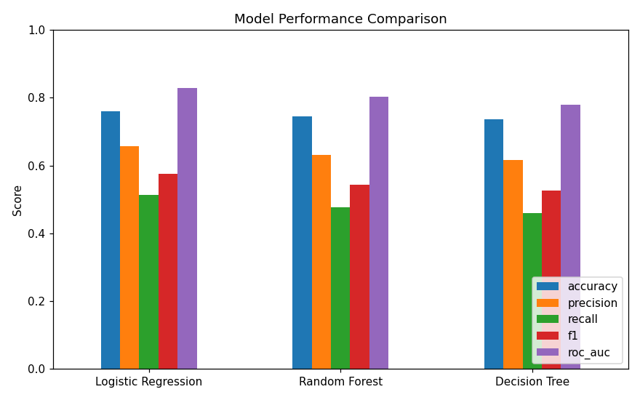
Figure 8. Side-by-side comparison of all five evaluation metrics across the three models.
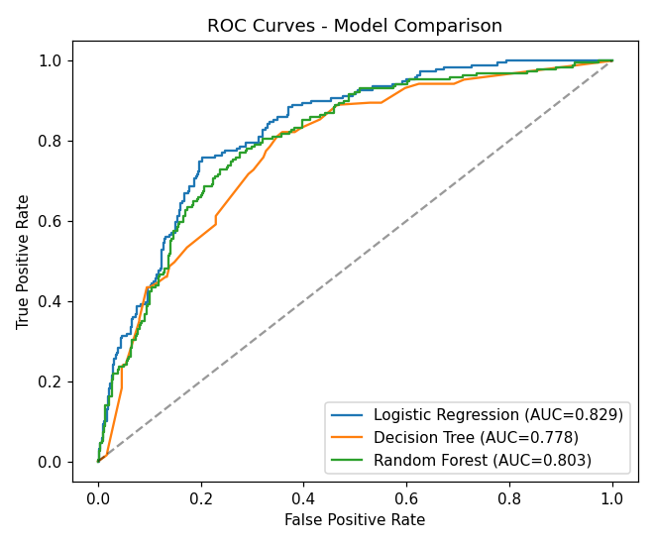
Figure 9. ROC curves — Logistic Regression achieves the highest AUC (0.829).

5.2 Best Model Selection
Logistic Regression was selected as the best-performing model based on ROC-AUC, which best reflects a model's ability to rank customers by churn risk — the primary use case for a retention-targeting tool. It also offers the added benefit of full interpretability via its coefficients, which is valuable for explaining predictions to business stakeholders.
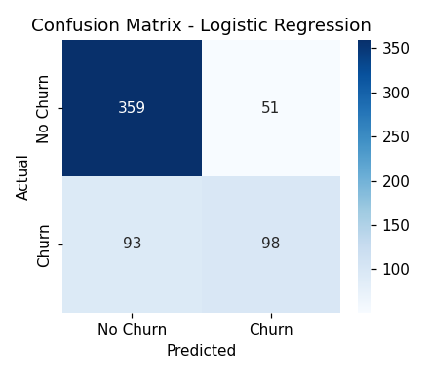
Figure 10. Confusion matrix for the selected Logistic Regression model.

6. Feature Importance Analysis
Feature importance was derived from the absolute value of the Logistic Regression coefficients (after scaling, so magnitudes are comparable across features).
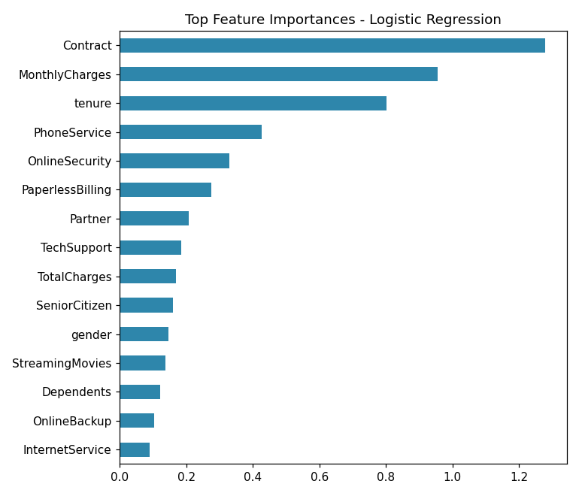
Figure 11. Top 15 features ranked by influence on churn prediction.
Contract type is the single strongest predictor, followed by monthly charges and tenure — directly matching the patterns surfaced during EDA. This consistency between exploratory analysis and model-driven feature importance gives confidence that the model has learned genuine, business-relevant signal rather than noise.

7. Dashboard & Deployment
A three-tab Streamlit dashboard (app/app.py) was built to make the model usable by non-technical stakeholders:
- Predict Churn — enter a customer's profile and receive an instant churn/stay prediction with a confidence percentage and visual probability bar.
- Customer Insights — live churn-rate breakdowns by contract, internet service, tenure, and monthly charges, computed directly from the cleaned dataset.
- Model Performance — a summary of accuracy, precision, recall, F1, and ROC-AUC for all trained models, so users can see how the deployed model was selected.
The dashboard loads the exact model, scaler, and encoders saved from the notebook, guaranteeing that predictions served in the app match the notebook's evaluation results.

8. Conclusion & Recommendations
This project demonstrates a full, reproducible churn-prediction workflow — from raw data to a stakeholder-facing tool — and surfaces three clear, actionable findings for the business:
- Incentivize longer contracts: Month-to-month customers churn at nearly 5x the rate of two-year customers; targeted discounts for upgrading contract length could meaningfully reduce churn.
- Focus retention efforts on new customers: churn risk is highest in the first ~12–24 months; proactive onboarding and check-ins could improve early retention.
- Bundle protective services: customers without Online Security or Tech Support churn more; bundling these at a discount may increase stickiness.
Future work could include hyperparameter tuning (e.g., grid search), testing gradient boosting models (XGBoost/LightGBM), incorporating customer support interaction data, and retraining periodically on real production data as it becomes available.

