Gexton Education
Summer Internship Program
Data Science Task # 09
Project: E-commerce Sales Analytics Dashboard
Prepared for: Sir Muhammad Arham MH
Project Report
July 2026
Dataset Source:
Global E-Commerce Sales & Customer Data (Kaggle)

1. Project Overview
This project analyzes an e-commerce sales dataset to uncover business insights, identify sales trends, understand customer purchasing behavior, and build a machine learning model to predict future sales. The findings are presented through an interactive Streamlit dashboard.
The dataset used for this analysis was sourced from Kaggle:
https://www.kaggle.com/datasets/muhammadaammartufail/global-e-commerce-sales-and-customer-data

Dataset Summary
Attribute | Detail
Total Records | 2,000 orders
Time Period | January 2023 – December 2025
Columns | 15 (Order, Customer, Product, Financial & Payment details)
Countries Covered | 20 countries across 5 regions
Product Categories | Technology, Office Supplies, Furniture, Clothing & Accessories
Missing Values Found | 0
Duplicate Rows Found | 0

2. Data Cleaning & Feature Engineering
The following steps were performed to prepare the dataset for analysis and modeling:
- Converted Order_Date to a proper datetime format.
- Checked for and removed duplicate records (none found).
- Checked for and handled missing values (none found — dataset was already clean).
- Extracted date-based features: Year, Month, Quarter, Day of Week, and Month-Year label.
- Derived Profit Margin (%) per order for profitability analysis.
- Verified that Total_Sales already reflects quantity, unit price, and discount applied.
The cleaned dataset, including all engineered features, was exported as global_ecommerce_sales_cleaned.csv for use in analysis and modeling.

3. Revenue & Profit Overview (KPIs)
$484,559  Total Revenue | 2,000  Total Orders | $158,872  Total Profit | 32.8%  Profit Margin

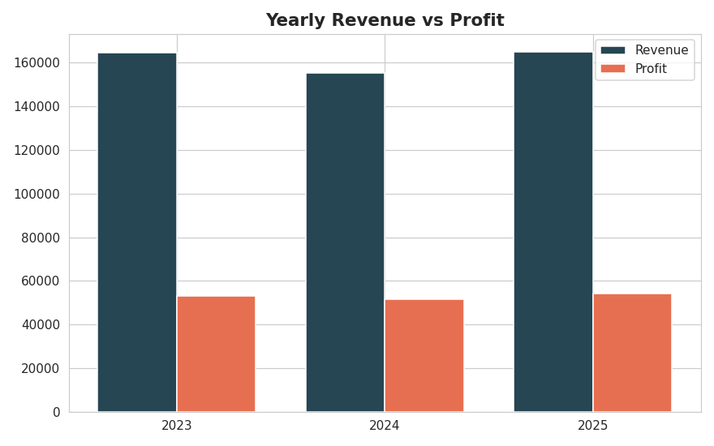
Figure 1: Yearly Revenue vs Profit

4. Exploratory Data Analysis

4.1 Monthly Sales Trend
Monthly revenue fluctuates across the three-year period without a single dominant seasonal spike, indicating fairly stable demand across the year with periodic month-to-month variation.
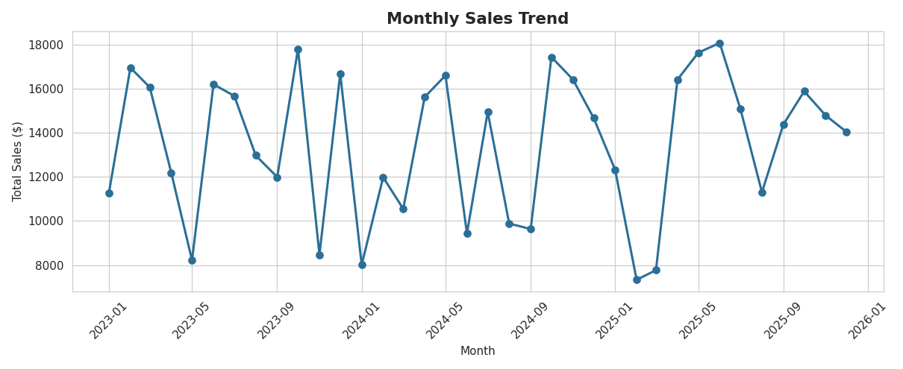
Figure 2: Monthly Sales Trend (2023–2025)

4.2 Top Selling Products
The Standing Desk Converter is the top revenue-generating product, reflecting strong demand for home/office furniture upgrades.
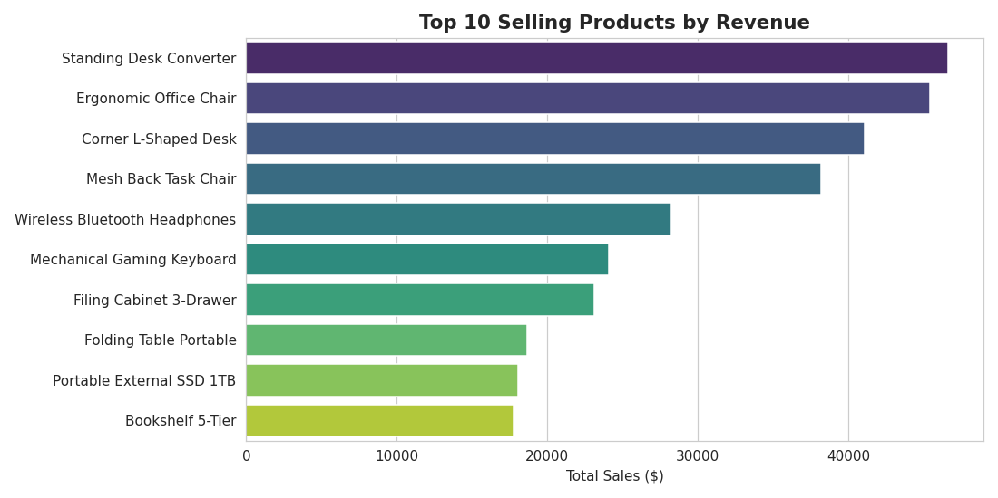
Figure 3: Top 10 Products by Revenue

4.3 Best Performing Categories
Furniture is the top-performing category by total revenue, followed by Technology. Both categories also contribute strongly to overall profit.
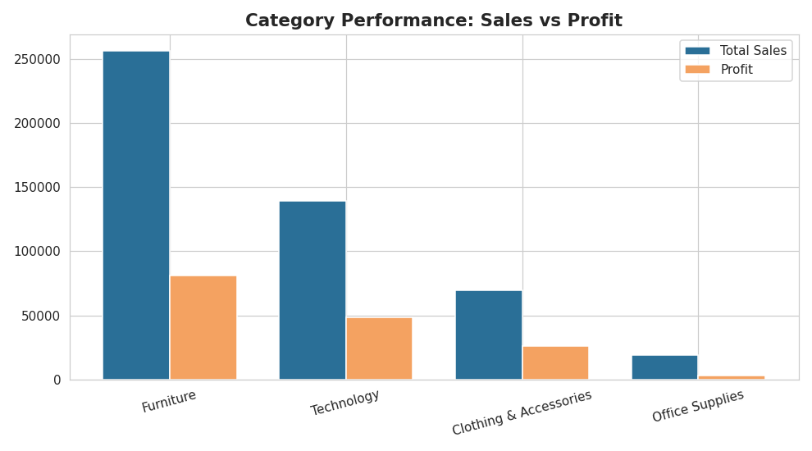
Figure 4: Category Performance — Sales vs Profit

4.4 Regional Sales Performance
Europe leads all regions in total sales, followed by North America, with the remaining regions contributing smaller but meaningful shares.
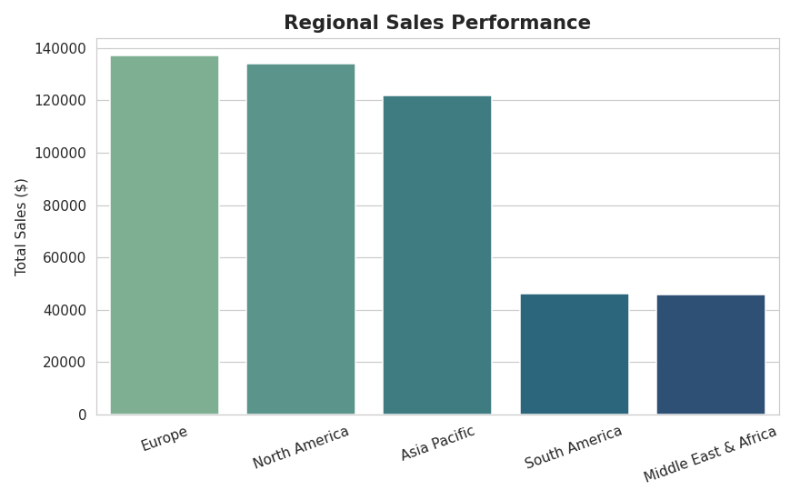
Figure 5: Regional Sales Performance

4.5 Customer Purchase Behavior
The Consumer segment generates the highest total revenue and order volume, while also maintaining the highest average order value among the three segments, ahead of Corporate and Home Office.
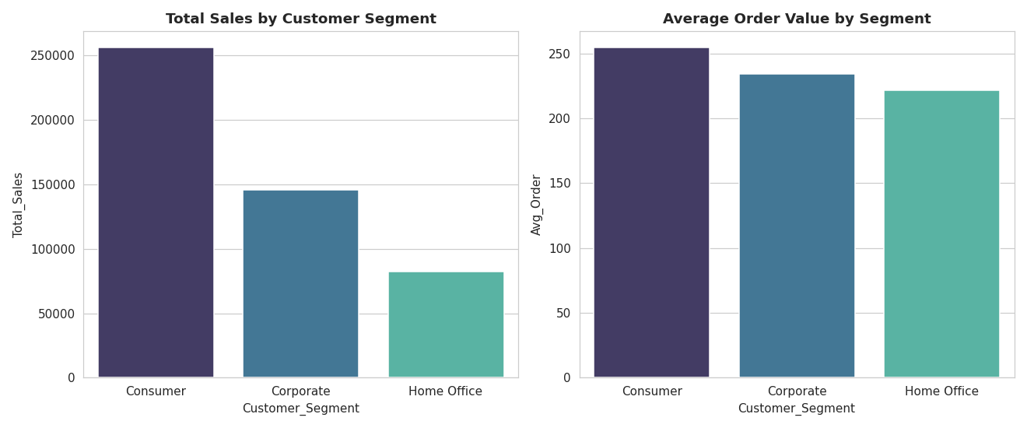
Figure 6: Sales and Average Order Value by Customer Segment

4.6 Payment Method Analysis
Credit Card is the most frequently used payment method, accounting for roughly 40% of all orders, followed by the other three methods in fairly even proportions.
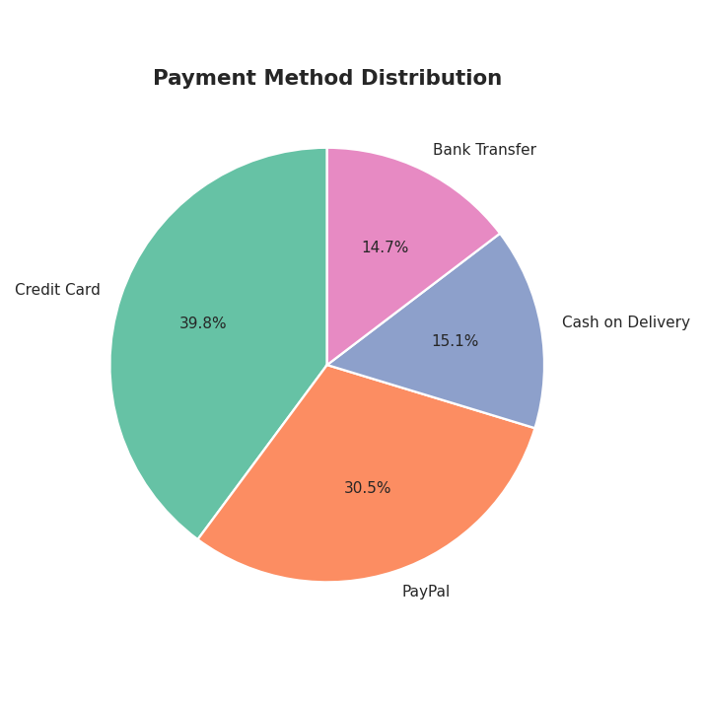
Figure 7: Payment Method Distribution

4.7 Correlation Analysis
As expected, Total_Sales is strongly correlated with Quantity and Unit_Price, while Discount_Percent shows a comparatively weaker relationship with final sales value.
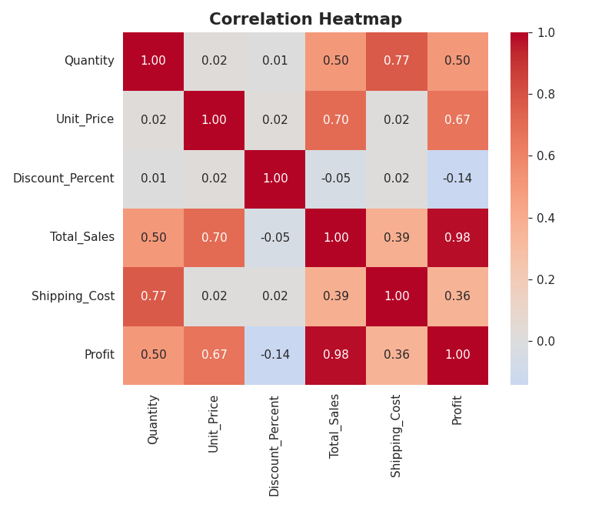
Figure 8: Correlation Heatmap of Numeric Features

5. Machine Learning — Sales Prediction
The goal of the modeling phase was to predict Total_Sales for an order based on customer, product, and order-level attributes. Categorical features (Customer Segment, Country, Region, Product Category, Day of Week) were one-hot encoded, and numeric features (Quantity, Unit Price, Discount %, Shipping Cost, Month, Quarter) were standardized. The data was split 80/20 into training and testing sets.

5.1 Models Trained
- Linear Regression — baseline linear model
- Decision Tree Regressor (max depth = 8)
- Random Forest Regressor (200 trees, max depth = 12)

5.2 Model Comparison
Model | MAE ($) | RMSE ($) | R² Score
Random Forest Regressor | 19.59 | 65.64 | 0.968
Decision Tree Regressor | 26.03 | 79.61 | 0.953
Linear Regression | 119.85 | 198.20 | 0.709

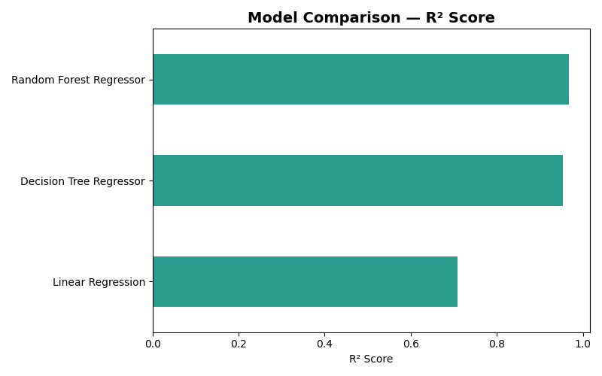
Figure 9: Model Comparison by R² Score

5.3 Best Model Selected
The Random Forest Regressor was selected as the final model, achieving the lowest error (MAE of $19.59, RMSE of $65.64) and the highest R² score of 0.968 — meaning it explains about 96.8% of the variance in order sales value. This model was saved as sales_prediction_model.pkl and integrated into the Streamlit dashboard's Sales Prediction tab.
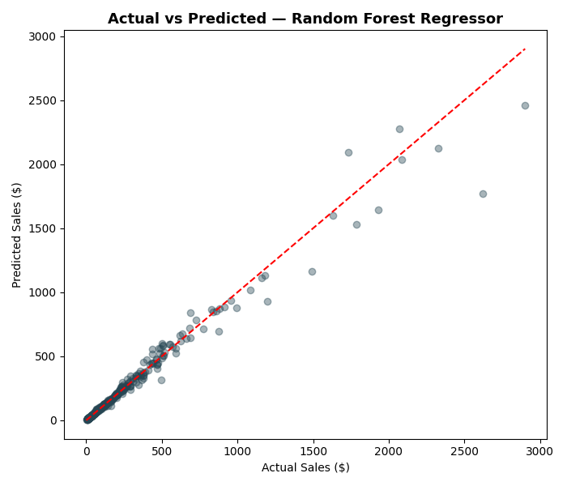
Figure 10: Actual vs Predicted Sales (Random Forest)

6. Interactive Dashboard
A Streamlit dashboard (app.py) was built with the following features:
- Sales Overview — KPI cards and monthly sales trend
- Top Products & Category-wise Sales
- Regional Performance — by region and country
- Customer Insights — segment-level analysis
- Sales Prediction — interactive form using the trained Random Forest model
- KPI Cards — Revenue, Orders, Profit, Profit Margin
- Sidebar filters for Region, Category, Customer Segment, and Date Range
Run locally with: pip install -r requirements.txt && streamlit run app.py

7. Key Business Insights
- Furniture and Technology are the two strongest revenue and profit-generating categories.
- Europe is the top-performing region, suggesting stronger market penetration there.
- The Consumer segment drives the most revenue and the highest average order values.
- Credit Card is the dominant payment method at ~40% of transactions.
- Sales are fairly stable year-over-year (2023–2025) with no major seasonal category shift.
- The Random Forest model provides highly reliable sales predictions (R² = 0.968), making it suitable for forecasting and planning.

8. Final Deliverables
Deliverable | File
Source Code | analysis.py, eda.py, ml_model.py, app.py
Jupyter Notebook | ecommerce_sales_analysis.ipynb
Cleaned Dataset | global_ecommerce_sales_cleaned.csv
Trained ML Model | sales_prediction_model.pkl
Streamlit Dashboard | app.py
Project Report | Project_Report.docx (this document)
Dataset Source | Kaggle — Global E-Commerce Sales & Customer Data

Dataset link: https://www.kaggle.com/datasets/muhammadaammartufail/global-e-commerce-sales-and-customer-data

