Assignment #1

Name: Ahmed Hani Ibrahim

Subject: CS624

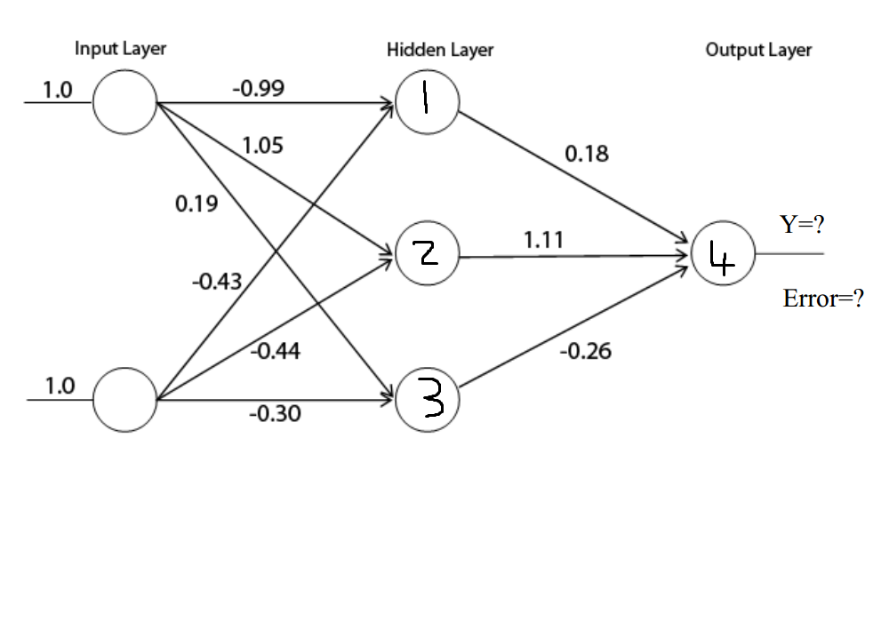



Step 1

* Calculating the values of each neuron in the hidden layer

Hidden Neuron #1 = (1.0 \* -0.99) + (1.0 \* -0.43) = -1.42

Activation of Hidden Neuron #1 = = 0.1946

Hidden Neuron #2 = (1.0 \* 1.05) + (1.0 \* -0.44) = 0.61

Activation of Hidden Neuron #2 = = 0.6479

Hidden Neuron #3 = (1.0 \* 0.19) + (1.0 \* -0.3) = -0.11

Activation of Hidden Neuron #3 = = 0.4725

Step 2

* Calculate the value of the neuron in the output layer

Output Neuron #4 = (0.1946 \* 0.18) + (0.6479 \* 1.11) + (0.4725 \* -0.26) = 0.6313

Activation of Output Neuron = = 0.3472

Step 3

* Calculate the error given the actual output

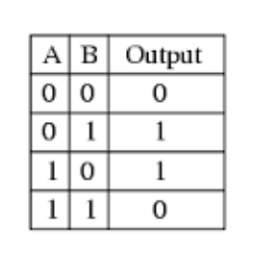

The actual output should be 0

So,

Output layer Neuron #4 error = The estimated – The actual = 0.3472 – 0 = 0.3472



Step 1

* Calculating the values of each neuron in the hidden layer

Hidden Neuron #1 = (1.0 \* -0.99) + (1.0 \* -0.43) = -1.42

Activation of Hidden Neuron #1 = = 0

Hidden Neuron #2 = (1.0 \* 1.05) + (1.0 \* -0.44) = 0.61

Activation of Hidden Neuron #2 = = 0.61

Hidden Neuron #3 = (1.0 \* 0.19) + (1.0 \* -0.3) = -0.11

Activation of Hidden Neuron #3 = = 0

Step 2

* Calculate the value of the neuron in the output layer

Output Neuron #4 = (0 \* 0.18) + (0.61 \* 1.11) + (0 \* -0.26) = 0.6771

Activation of Output Neuron = = 0.6771

The actual output should be 0

So,

Output layer Neuron #4 Error = The estimated – The actual = 0.6771 – 0 = 0.6771