TOASOL
Database Design

1. Database Design Overview
The database supports the TOASOL MVP: parent and center accounts, child profiles, center discovery, specialist and service management, availability, booking, online payment, center subscriptions, commission records and reviews. Future child-progress tracking and educational-content modules are excluded from the MVP schema.

2. Conceptual ERD
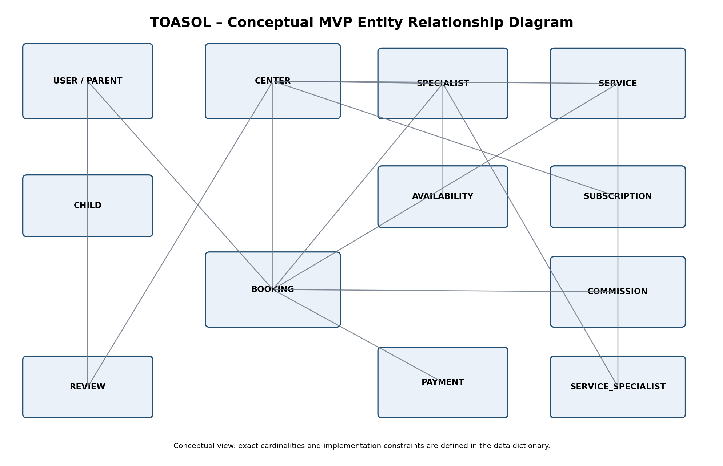
The diagram is a conceptual overview. The detailed tables below define the proposed implementation structure.

3. Proposed Relational Data Model
The supplied requirements define separate PARENT and CENTER account tables. The following design preserves that approach and adds CHILD, specialist availability, booking/payment, subscription and commission structures required by the stated workflows.

PARENT
ParentID (PK); FirstName; LastName; Gender; Email (Unique); PasswordHash; Phone; GovernorateID (FK); CityID (FK); Street; BuildingNumber; EmailVerified; ProfileCompleted; TermsAcceptedAt

CENTER
CenterID (PK); CenterName; Email (Unique); PasswordHash; Phone; GovernorateID (FK); CityID (FK); Street; BuildingNumber; CommercialRegisterNumber (Unique); ContactPersonName; SupportingDocumentPath; ApprovalStatus; RejectionReason; EmailVerified; Description; AccountStatus

CHILD
ChildID (PK); ParentID (FK); FirstName; LastName (optional if collected); DateOfBirth; Gender; CreatedAt; IsActive

SPECIALIST
SpecialistID (PK); CenterID (FK); FullName; Title; YearsOfExperience; Bio; PhotoPath (optional); IsActive

SERVICE
ServiceID (PK); CenterID (FK); ServiceName; Description; Price; DurationMinutes; MinAge; MaxAge; IsActive

SERVICE_SPECIALIST
ServiceID (PK, FK); SpecialistID (PK, FK)

SPECIALIST_AVAILABILITY
AvailabilityID (PK); SpecialistID (FK); DayOfWeek; StartTime; EndTime; IsActive

SPECIALIST_BLOCKED_DATE
BlockedDateID (PK); SpecialistID (FK); BlockedDate; StartTime (nullable); EndTime (nullable); Reason (optional)

BOOKING
BookingID (PK); ParentID (FK); ChildID (FK); CenterID (FK); ServiceID (FK); SpecialistID (FK); AppointmentDate; StartTime; EndTime; TotalPrice; Status; PaymentStatus; CreatedAt; CommissionRateSnapshot; CommissionAmount

PAYMENT
PaymentID (PK); PayerParentID (FK, nullable if shared payer model adopted); PaymentType (Booking/CenterSubscription); Amount; Status; GatewayName; GatewayReference; PaymentMethod; CreatedAt; PaidAt

PAYMENT_BOOKING
PaymentID (PK, FK); BookingID (PK, FK) – use if one payment may cover multiple bookings.

CENTER_SUBSCRIPTION
SubscriptionID (PK); CenterID (FK); SubscriptionPlanID (FK); PaymentID (FK); StartDate; EndDate; Status

SUBSCRIPTION_PLAN
SubscriptionPlanID (PK); PlanName; Price; BillingPeriod; ManagementFeatures; IsActive

COMMISSION
CommissionID (PK); CenterID (FK); BookingID (FK); PaymentID (FK); CommissionRate; GrossAmount; CommissionAmount; CenterNetAmount; Status; CreatedAt

REVIEW
ReviewID (PK); CenterID (FK); ParentID (FK); Rating (1–5); Comment; CreatedAt

4. Relationship and Cardinality Summary
Relationship | Cardinality | Description
PARENT – CHILD | 1 : Many | One parent can manage multiple child profiles; each child belongs to one parent.
PARENT – BOOKING | 1 : Many | A parent can create multiple bookings; each booking is created by one parent.
CHILD – BOOKING | 1 : Many | A child can have multiple bookings; each booking is for one child.
CENTER – SPECIALIST | 1 : Many | A center manages multiple specialists; each specialist belongs to one center.
CENTER – SERVICE | 1 : Many | A center offers multiple services; each service belongs to one center.
SERVICE – SPECIALIST | Many : Many | A service can be assigned to multiple specialists and a specialist can provide multiple services; resolved through SERVICE_SPECIALIST.
SPECIALIST – AVAILABILITY | 1 : Many | A specialist can have multiple recurring availability records and blocked-date records.
BOOKING – PAYMENT | Many : Many (via PAYMENT_BOOKING) | Supports one checkout payment covering multiple bookings; if checkout is restricted to one booking, simplify to 1:1.
CENTER – SUBSCRIPTION | 1 : Many | A center can have subscription history over time; each subscription belongs to one center.
BOOKING – COMMISSION | 1 : 0..1 (or 1:Many if per item) | Commission is generated after successful payment. Use one record per booking unless the commission is deliberately split by session.
CENTER – REVIEW | 1 : Many | A center can receive multiple reviews.
PARENT – REVIEW | 1 : Many | A parent can submit multiple reviews.

5. Booking and Commission Transaction Logic
- The parent selects a child, service, specialist and an available time.
- The system validates that the center is approved and active, the child meets the service age range, the specialist is assigned to the service, and the requested time is available.
- The system creates a pending checkout/payment transaction and temporarily reserves the selected slot according to the agreed hold policy.
- The payment gateway processes the payment. TOASOL verifies the server-side callback/webhook and confirms the amount and transaction reference.
- Only after successful verified payment does the system confirm the booking.
- At that same successful-payment point, the system calculates and records the commission. It does not wait for attendance or session completion.
- The commission rate used for the transaction should be stored as a snapshot so later rate changes do not rewrite historical transactions.

6. Important Integrity and Security Rules
- Store password hashes only; never store plaintext passwords.
- Use unique constraints for parent/center email and center commercial registration number.
- Only approved and active centers can be shown in public search or receive bookings.
- A specialist belongs to exactly one center; a service can only be assigned specialists belonging to its own center.
- Each service must have at least one active assigned specialist to be bookable.
- Prevent overlapping confirmed bookings for the same specialist and overlapping sessions for the same child.
- Recheck availability at payment confirmation to prevent race conditions.
- Use idempotent payment callback processing so repeated gateway notifications cannot create duplicate bookings or commission entries.
- Do not store card numbers, CVV, or other payment-card credentials.
- Keep private center verification documents inaccessible to public users.
- Record payment, refund, commission and payout events for auditability.

7. Differences and Gaps to Resolve in the Source Requirements
Gap / inconsistency | Design treatment / decision needed
Child profile table is not defined, although booking requires a child. | CHILD table is added as a necessary MVP entity. Confirm exact child fields collected during registration/profile completion.
Availability and blocked dates are referenced in booking rules but no tables are specified. | SPECIALIST_AVAILABILITY and SPECIALIST_BLOCKED_DATE are added to support schedule validation.
Existing document says commission only on completed sessions/bookings. | Superseded by the confirmed team decision: commission is calculated immediately after successful booking payment.
Existing document describes optional Free/Pro plans. | Updated commercial direction: centers subscribe to use TOASOL's management system. Plan structure, price and billing cycle remain TBD.
The source includes refunds, cancellations and payouts but does not fully define policy. | Retain transaction/refund/payout data structures where required; finalize policy and commission reversal behavior before implementation.
Existing requirements allow a cart with multiple centers and children. | If retained, use PAYMENT_BOOKING to connect one payment to multiple bookings; otherwise simplify checkout and relationships.

8. Data Model Exclusions for MVP
No child progress, specialist evaluation, educational video, home activity, educational game or progress-report tables are included. These belong to a later product phase and should be added only when those features are approved.

9. Open Technical Decisions
- Confirm whether a checkout can contain multiple bookings or only one appointment.
- Confirm whether booking is for one appointment or a package of multiple sessions.
- Confirm the exact child profile fields and whether date of birth is mandatory.
- Confirm the commission percentage, calculation base and refund reversal logic.
- Confirm center subscription plan(s), billing cycle and access behavior after expiry.
- Confirm whether reviews are allowed only after a paid booking and whether one review is allowed per booking.

