

**Control Engineering**

**Assignment #1**

**Submitted to**

Dr. Meena Elia Samouil Girgis

Eng. Youssef

**Submitted by**

| **Name** | **Sec** | **BN** |
| --- | --- | --- |
| **Ahmed Hosny Abdalrzaik** | **1** | **2** |
| **Mahmoud Reda Sayed** | **2** | **21** |
| **Ahmed Alaa El-Sayed Arabi Zidan** | **1** | **7** |

**Requirement 1:**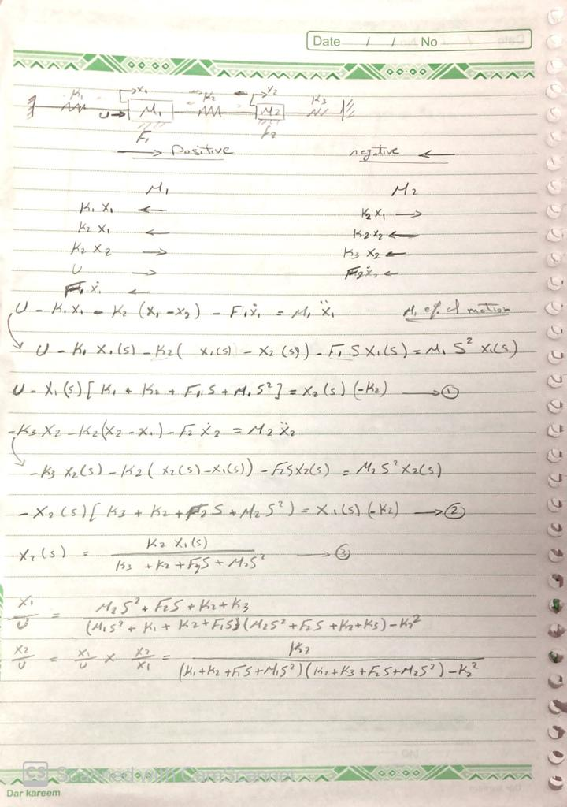

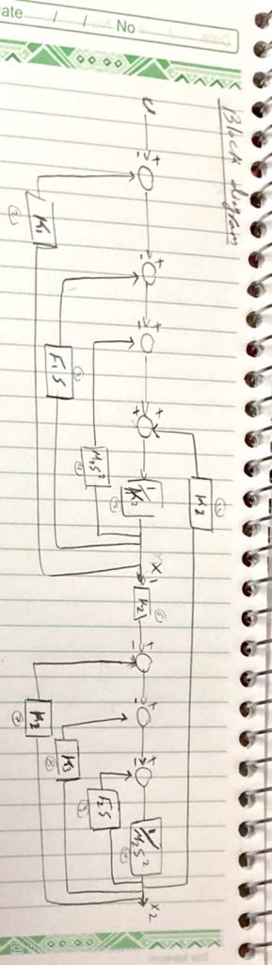

**Requirement 2:**

transfer functions

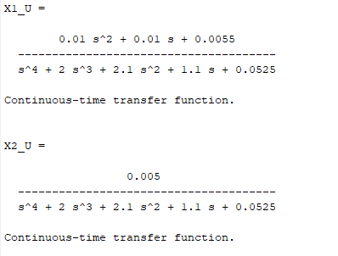

**Requirement 3:**

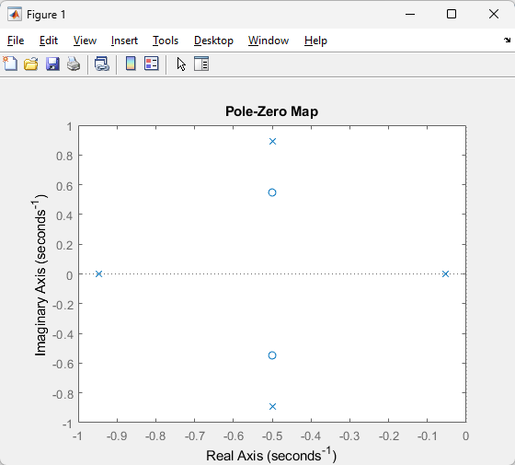

From the shown graph we can say the system is stable as

All the poles less than zero so the system is stable

If we have at least one pole greater than 0 the system will be unstable

If we have one pole equal to zero and all the others less than zero the system will be critical stable

**Requirement 4:**

Steady state value for X1 0.104222

Steady state value for X2 0.094698

**Requirement 5:**

We will use unity feedback system and use G as Ses 2

**Requirement 6:**

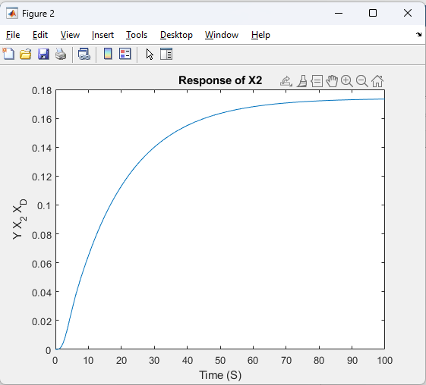

**Requirement 7:**

RiseTime: 37.4676

SettlingTime: 68.9668

SettlingMin: 0.0784

SettlingMax: 0.0869

Overshoot: 0

Undershoot: 0

Peak: 0.0869

PeakTime: 125.2935

**Requirement 8:**

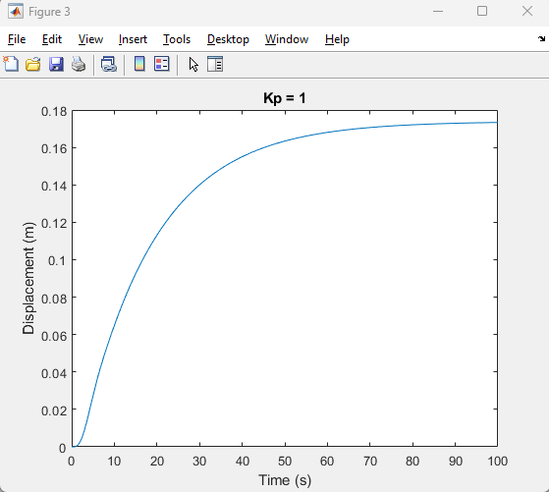

**For K = 1**

RiseTime: 37.4676

SettlingTime: 68.9668

SettlingMin: 0.0784

SettlingMax: 0.0869

Overshoot: 0

Undershoot: 0

Peak: 0.0869

PeakTime: 125.2935

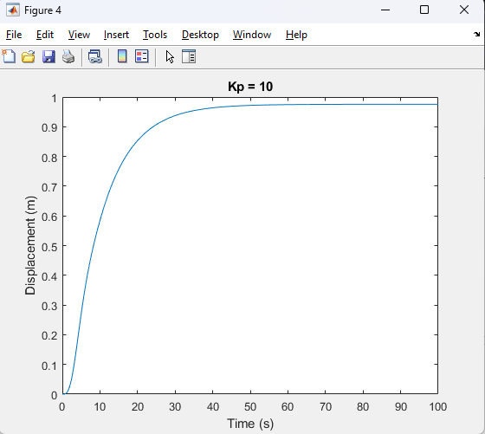

**For K = 10**

RiseTime: 18.8465

SettlingTime: 35.7815

SettlingMin: 0.4393

SettlingMax: 0.4873

Peak: 0.4873

PeakTime: 61.3895

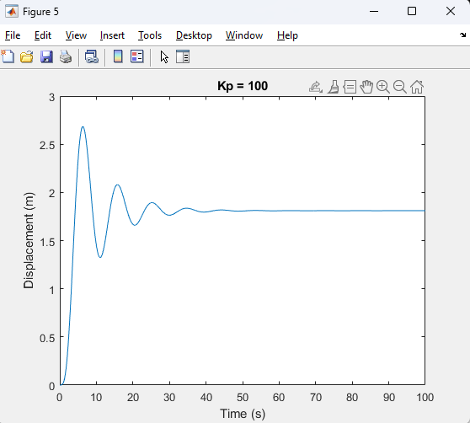

**For K = 100**

RiseTime: 2.2180

SettlingTime: 31.0141

SettlingMin: 0.6622

SettlingMax: 1.3416

Peak: 1.3416

PeakTime: 6.3068

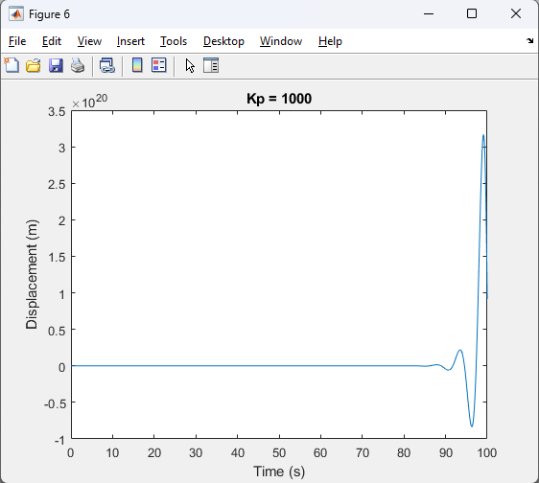

**For K = 1000**

Peak: Inf

PeakTime: Inf

**Requirement 9:**

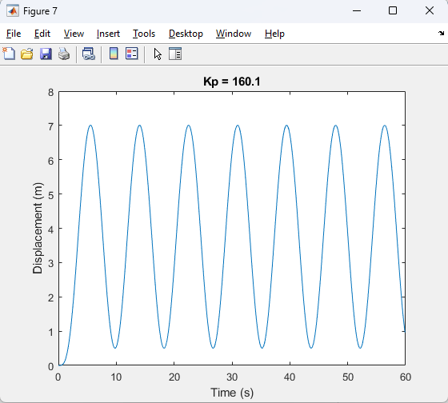

**Comment:** Instead of hand analysis i generalized it by looping over Kp by step 0.1 until satisfying ess <= 0.01 or the system going out the stability state [become critical stable or unstable] So once the [Kp = 160.1] the system becomes critical stable instead of stable so we can’t reach ess <= 0.01 and the system is stable in the same time.

**Requirement 10:**

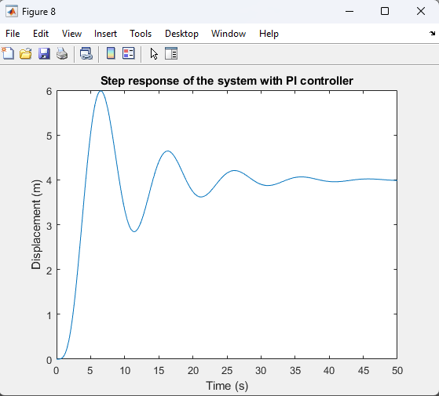

**Comment:** I choosed Kp = 100 and Ki = 5 so i get the following values which i be abled to eliminate ess:  
Ess = 0.000000

The system is stable

and the poles are

-0.8611 + 0.6671i

-0.8611 - 0.6671i

-0.1141 + 0.6409i

-0.1141 - 0.6409i

-0.0497 + 0.0000i