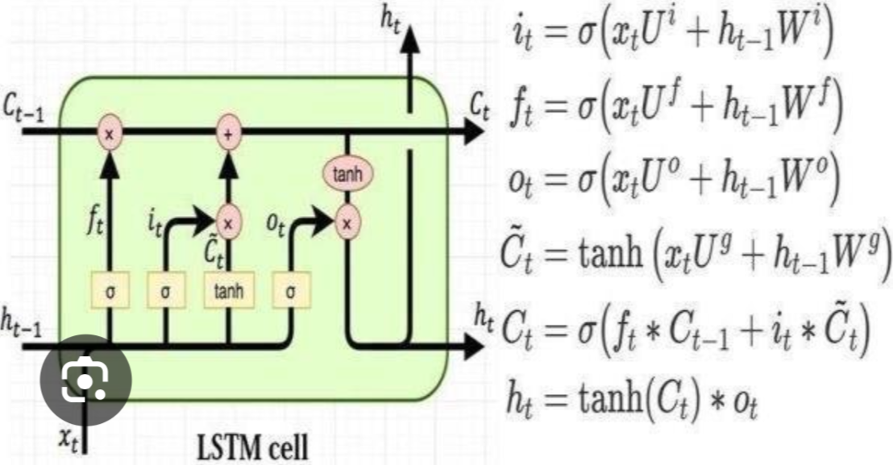

U and W are the weights for the input and the previous hidden state (short term memory)

O(t) is the potential short term memory % to remember

Tanh(Ct) is the potential short term memory

C_(t) or G(t) is the potential long term memory

I(t) is the potential long term memory % to remember

F(t) is the % of the previous long term memory to remember

C(t) is the new long term memory

H(t) is the new short term memory

