Alzheimer’s Disease Classification from Brain MRI using Convolutional Neural Networks

Ahmed Ibrahim Khalifa, Caren Hany Albert.

[Faculty of Engineering, Biomedical and Bioinformatics], [Egypt Japan Univeristy Of Science and Technology E-JUST], Egypt

# Abstract

Alzheimer's Disease (AD) is a progressive neurological disorder and a major contributor to global dementia cases. Accurate and early classification of Alzheimer's stages can significantly improve patient care and delay disease progression. In this work, we present a convolutional neural network (CNN)-based approach to classify brain MRI images into four AD stages: NonDemented, VeryMildDemented, MildDemented, and ModerateDemented. Our model achieved over 95% validation accuracy and showed high generalization on unseen test data. Confusion matrix analysis highlighted strong performance across most classes, with minor misclassifications in the ModerateDemented category. The results support the viability of CNNs as a decision-support tool in medical imaging diagnostics.

# Introduction

Alzheimer’s Disease (AD) is a degenerative brain disorder characterized by memory loss, cognitive decline, and behavioral disturbances. As the most common form of dementia, AD imposes a growing burden on healthcare systems worldwide, especially with an aging global population. MRI imaging provides detailed visualization of brain structures, making it a valuable tool in early detection and staging of AD. However, manual interpretation is often subjective and time-consuming.  
  
The application of artificial intelligence, particularly deep learning, has revolutionized the field of medical image analysis. Convolutional Neural Networks (CNNs) have demonstrated exceptional performance in pattern recognition tasks, including disease classification from imaging data. This study aims to leverage CNNs to automate and enhance the classification of Alzheimer’s stages from brain MRI images.

# Methods

We used a publicly available real images "not augmented to maintain reliability" of MRI dataset [1] consisting of grayscale brain scans labeled into four stages of Alzheimer’s Disease: NonDemented, VeryMildDemented, MildDemented, and ModerateDemented. Each image was resized to 128×128 pixels and normalized to a [0, 1] range to standardize inputs.   
  
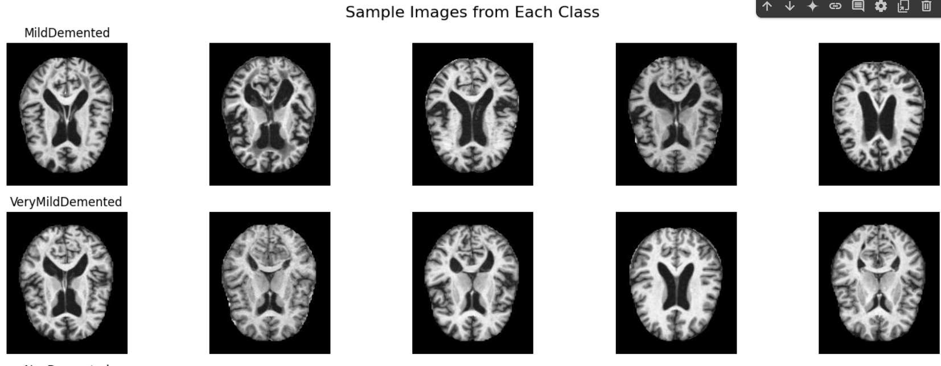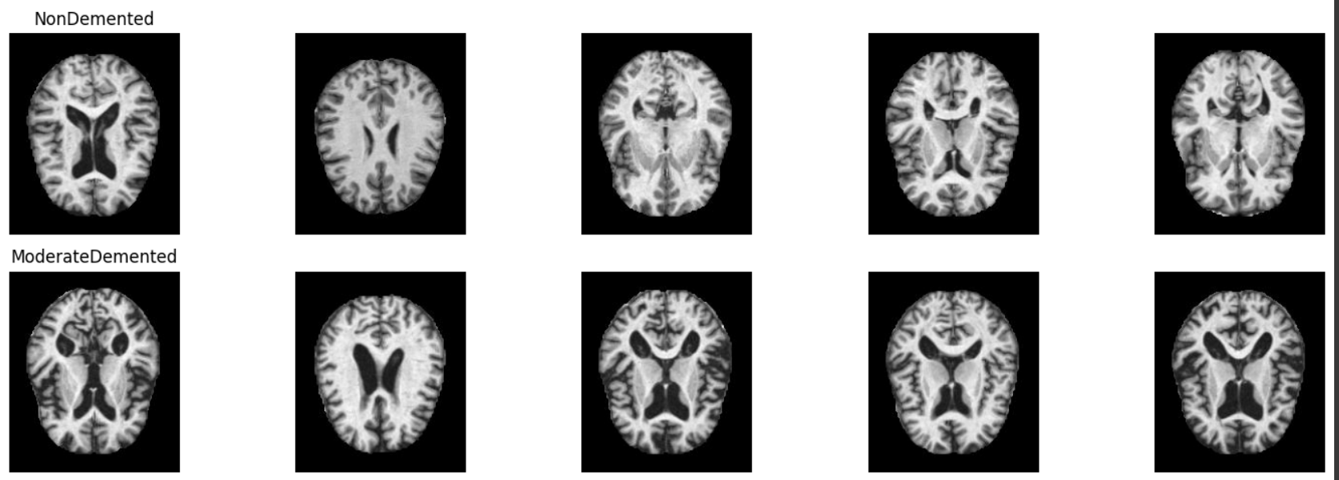

The dataset was split into training (70%), validation (15%), and test (15%) sets using stratified sampling. To address class imbalance—especially the underrepresentation of ModerateDemented cases—we applied class weighting during training.  
  
Our CNN model comprises two convolutional layers followed by max pooling, a flattening layer, and fully connected layers with dropout regularization. The architecture ends with a softmax layer for multi-class classification. The model was trained using the Adam optimizer, categorical cross-entropy loss, and evaluated using accuracy and confusion matrix metrics.

# Results

The model achieved a validation accuracy exceeding 97% after 10 epochs of training. On the test set, it maintained high generalization performance. Most NonDemented and VeryMildDemented samples were classified correctly, while some MildDemented samples were confused with ModerateDemented. The classification report showed high precision, recall, and F1-scores across most classes, with the lowest performance on the underrepresented ModerateDemented category.  
  
Confusion matrix visualization confirmed strong diagonal dominance, indicating reliable classification. However, misclassifications suggest overlap in visual patterns between adjacent disease stages.  
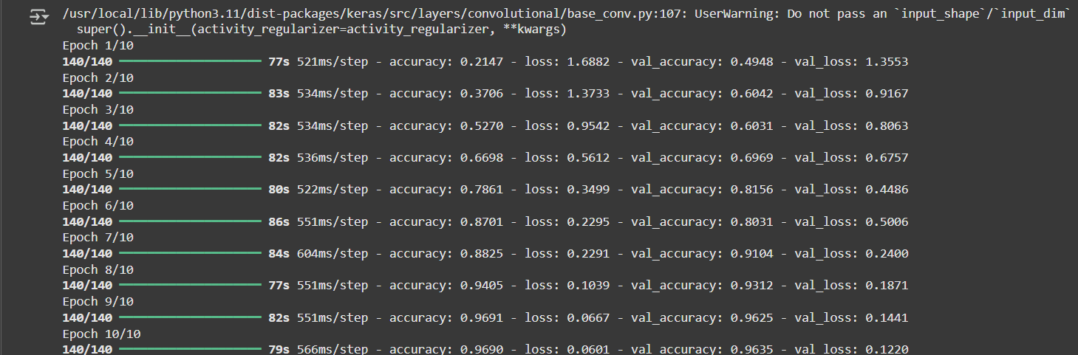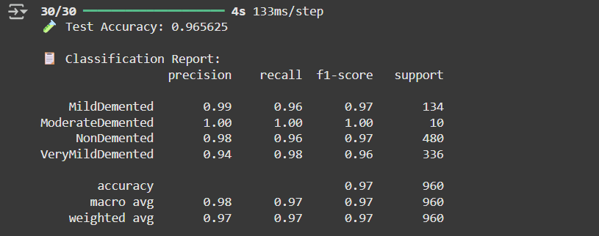

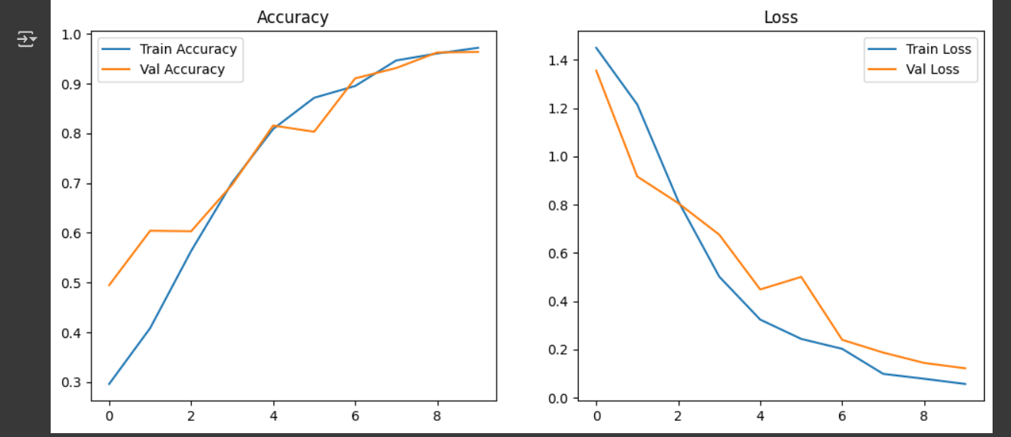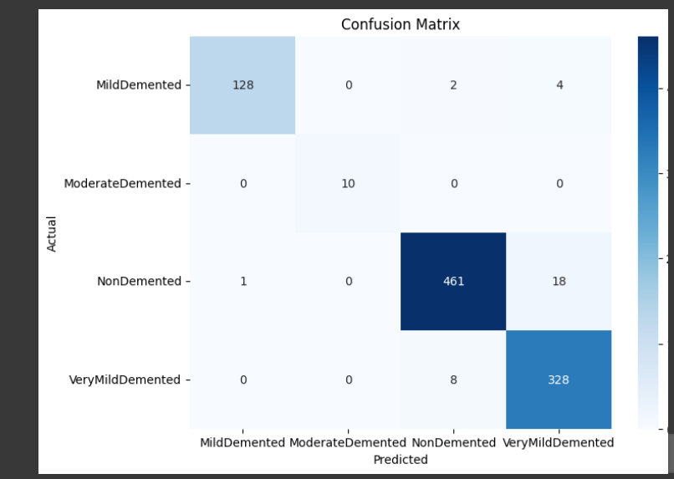

# After a new trial for running the code the accuracy increases. there is the githublink: <https://github.com/AhmedIbrahim068/Alzheimer-CNN-Classification> .

# Discussion

Although the CNN model demonstrated strong performance, several limitations remain. The dataset was imbalanced, particularly in the ModerateDemented class, which affected model sensitivity for that category. Future work should explore techniques such as advanced data augmentation, synthetic sample generation, or transfer learning with pretrained models to enhance feature extraction.  
  
Additionally, incorporating multimodal data—such as clinical reports or PET scans—could further improve classification robustness. Expanding the model to longitudinal studies could also enable progression prediction over time, enhancing clinical decision support.

# References

[1] https://www.kaggle.com/datasets?search=alzheimer+MRI

[2] Jack, C.R., et al. (2010). The Alzheimer's Disease Neuroimaging Initiative (ADNI): MRI methods. Journal of Magnetic Resonance Imaging, 27(4), 685-691.  
  
[3] Basaia, S., et al. (2019). Automated classification of Alzheimer’s disease and mild cognitive impairment using a single MRI and deep neural networks. NeuroImage: Clinical, 21, 101645.  
  
[4] Krizhevsky, A., Sutskever, I., & Hinton, G. (2012). ImageNet classification with deep convolutional neural networks. Advances in Neural Information Processing Systems, 25.  
  
[5] Alzheimer MRI Dataset. Available on: https://www.kaggle.com/datasets/jerinjerin/alzheimer-mri-dataset  
  
[6] Litjens, G., et al. (2017). A survey on deep learning in medical image analysis. Medical Image Analysis, 42, 60–88.