Cairo University  
Faculty of Computers and Information



**CS251**

**Software Engineering I**

**Social Network API Requirement Analysis Document (RAD)**

2019/2020

Contents

Team 3

Document Purpose and Audience 3

System Models 3

I. System Decomposition 3

II. Class diagrams 4

Important Algorithm 4

III. Sequence diagrams 5

Class - Sequence Usage Table 5

# Team

|  |  |  |
| --- | --- | --- |
| **ID** | **Name** | **Group** |
| 20160302 | Ahmed Ismail Ahmed | IS_5 |

Note: I am in total for one alone as instructed by Doctor

# Document Purpose and Audience

System design is documented in the System Design Document (SDD). It describes design goals set by the project, subsystem decomposition (with UML class diagrams), hardware/software mapping (with UML deployment diagrams), data management, access control, control flow mechanisms, and boundary conditions. The SDD is used to define interfaces between teams of developers and serve as a reference when architecture-level decisions need to be revisited.

The audience for the SDD includes the project management, the system architects (i.e., the developers who participate in the system design), and the developers who design and implement each subsystem.

# System Models

## System Decomposition

## 

## 

## II. Class diagrams

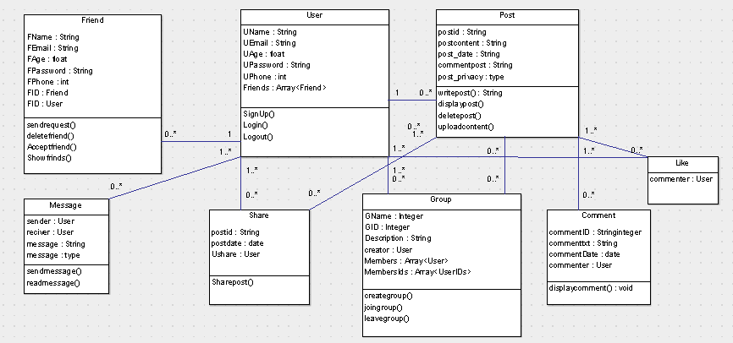

| **Class ID** | **Class Name** | **Subsystem ID** | **Description & Responsibility** |
| --- | --- | --- | --- |
| 1 | user | 1 | User has one Account ,zero or many friends, username, userpassword and userEmail, and do login() and logout() and so on. |
| 3 | post | 2 | Post class has post_title, post_content, post_date and do displypost() and newcommend() and has tow type, zero or many group and zero or many comment |
| 4 | comment | 3 | Comment class has comment_creater ,comment_content and createcomment() and  One post. |

## III. Sequence diagrams

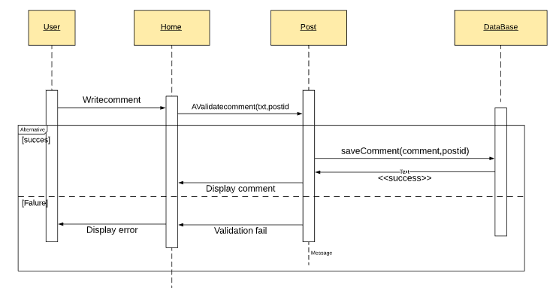

| **Class Name** | **Sequence Diagrams** | **Overall used methods** |
| --- | --- | --- |
| User | 2,4,17 | Login(),logout() |
| Friends | 6,7,8 | Addfriend(),deletefriend(),editefriend() ,savefriend() |
| post | 10,11,12 | Displaypost(),addpost,savepost() |
| share | 14,15,16 |  |

