Faculty of Computer Science

Fall Semester 2021

CS486

Image Processing Project

**Done by:**

|  |  |
| --- | --- |
| **Name** | **ID** |
| Ahmed Mohamed Abdelfattah Issa | 191947 |
| Ahmed Tarek Mohammed | 150717 |

**Submitted to:**

Dr. Ehab Emam

colab live demo: https://colab.research.google.com/drive/1LW2aCbeGpDT-aE356pkl4BURJbC16WUl?usp=sharing

**Smoothing Spatial Filters:**

The technique is applied directly to image pixels. A mask is typically thought to be added in size so that it has a specific center pixel. This mask is moved across the image so that its center traverses all image pixels.

* **Median Filter**

The median filter is commonly used to reduce noise in images. It is used to eliminate the salt and pepper. The pixel value is replaced by the median value of the neighboring pixel in this case. The Median Filter method accepts two arguments: an image array and a filter size. Assume you have an Image array in the variable img_arr and want to remove noise from it using a 3x3 median filter. That's how it's done.

You see a noisy image corrupted by salt and pepper noise below. After running our code this is the result we got.

* **Averaging Filter**

In the preceding example, the filtered image is slightly blurred. More blurring can be obtained by increasing the size of the averaging mask.

**Sharpening Spatial Filters:**

* **Laplacian Operator**

The Laplacian operator is a second-order differential operator that is commonly used in image enhancement and edge extraction. It uses grey difference to calculate the pixels in the neighborhood. The basic procedure is to determine the grey value of the image's center pixel and the grey value of the pixels surrounding it. If the grey value of the center pixel is greater, the grey value of the center pixel is greater; Reduce the grey level of the center pixel to achieve image sharpening operation.

* **Roberts Operator**

The cross-differential algorithm, Roberts operator, detects edge lines through local differential calculation. It is frequently used to process images with a lot of noise. When the image's edge is close to positive or negative 45 degrees, the processing effect of this algorithm is more optimal.

* **Sobel Operators**

The Sobel operator is a discrete differential operator that combines Gaussian smoothing and differential derivation and is used for edge detection. This operator is used to calculate the approximate value of the image's brightness. Specific points in the area exceeding a certain number are recorded as edges based on the brightness of the image's edge.

After running our code this is the result we got.

**Noise Filters:**

We will try few noise distributions in this picture

* **Impulse noise**

The function returns image with impulsive noise (0 and/or 255) to replace pixels in the image with some probability

* image: input image
* prob: probability for the impulsive noise generation
* mode: type of noise, 'salt', 'pepper' or 'salt_and_pepper'
* Text

  Description automatically generatedreturn: noisy image with impulsive noise

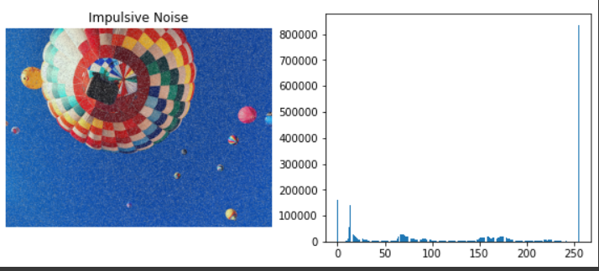

* **Gaussian noise**

This function generates a matrix with Gaussian noise in the range [0-255] to be added to an image

* size: tuple defining the size of the noise matrix
* mean: mean of the Gaussian distribution
* std: standard deviation of the Gaussian distribution, default 0.01
* return: matrix with Gaussian noise to be added to image

The values are more likely around the intensity values, which are the mean of the distribution

* **Uniform noise**

Generates a matrix with uniform noise in the range [0-255] to be added to an image

* size: tuple defining the size of the noise matrix
* prob: probability for the uniform noise generation
* Text

  Description automatically generatedreturn: matrix with uniform noise to be added to image

we add uniform noise, values are added (or subtracted) from those intensities, producing a wider range of intensities around the original values

**The Transform / Frequency Domain Filters:**

* **Histogram Equalization**

calculates normalized histogram of an image. finds cumulative sum of the array. Find the cumulative distribution function. find transfer function values. Then applying transferred values for each pixels.

