

**Software Design Document for project School Management System**

|  |  |
| --- | --- |
| Ali Mohamed Hobeldin | 192231 |
| Soliman Salama Harby | 191523 |
| Ahmed Mohamed Issa | 191947 |
| Mohamed Ibrahim Abodia | 191333 |
| Marwan Mahmoud Meligy | 195997 |

Supervised by: Dr. Ayman Ezzat

December 31, 2020

# 1 Introduction

## 1.1 Purpose

This document intended to automate the learning process through our system starting from attendance of staff till to the learning material of students but all of users must have the basic knowledge of dealing with computers to deal with our system easily.

## 1.2 Scope

The scope of this document will be on Students, Teachers,Supervisors and Admins. This system is responsible for operating a school management system, providing books library, taking assignments, helping with the educational process and enrolling students.

**1.3 Overview**

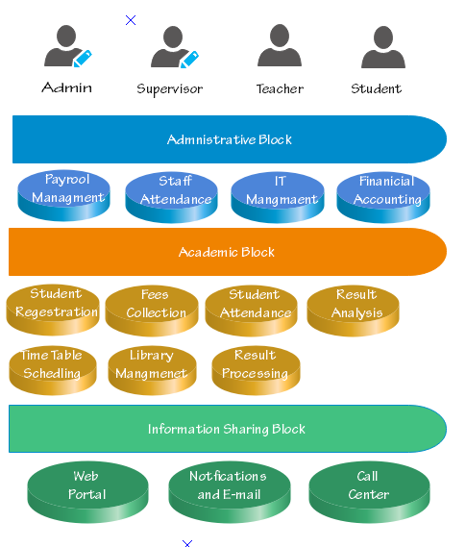

## 1.4 Reference Material

Attendance Sheet :

This sheet consist of a table that contains a rows for name and 7 days each day is a row and which time and some notes this sheet aims to monitor all the staff and evaluate their attendance to see that they deserves the salary they have this sheet will be converted to an excel sheet in our system for more see appendices: No. 1

## 1.5 Definitions and Acronyms

This section is optional. Provide definitions of all terms, acronyms, and abbreviations that might exist to properly interpret the SDD. These definitions should be items used in the SDD that are most likely not known to the audience.

|  |  |
| --- | --- |
| **Term** | **Definition** |
| Software Design Document (SDD) | Used as the primary medium for communicating software design information. |
| Design Entity | An element of a design that is structurally and functionally distinct from other elements. |

# 2 System Overview

Our project is tending to solve two main problems, it will solve the data redundancy and save time. it will also replace the usual paper-based system for school operations, supervisors will be able to enroll students and manage them and students will be able to download course materials and upload assignments.

# 3 System Architecture

## 3.1 Architectural Design

**Sequence Diagram:**

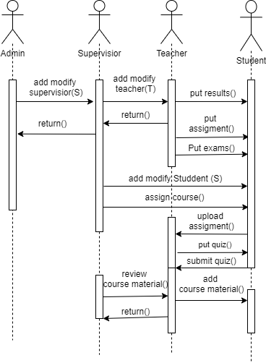

**Process Diagram:**

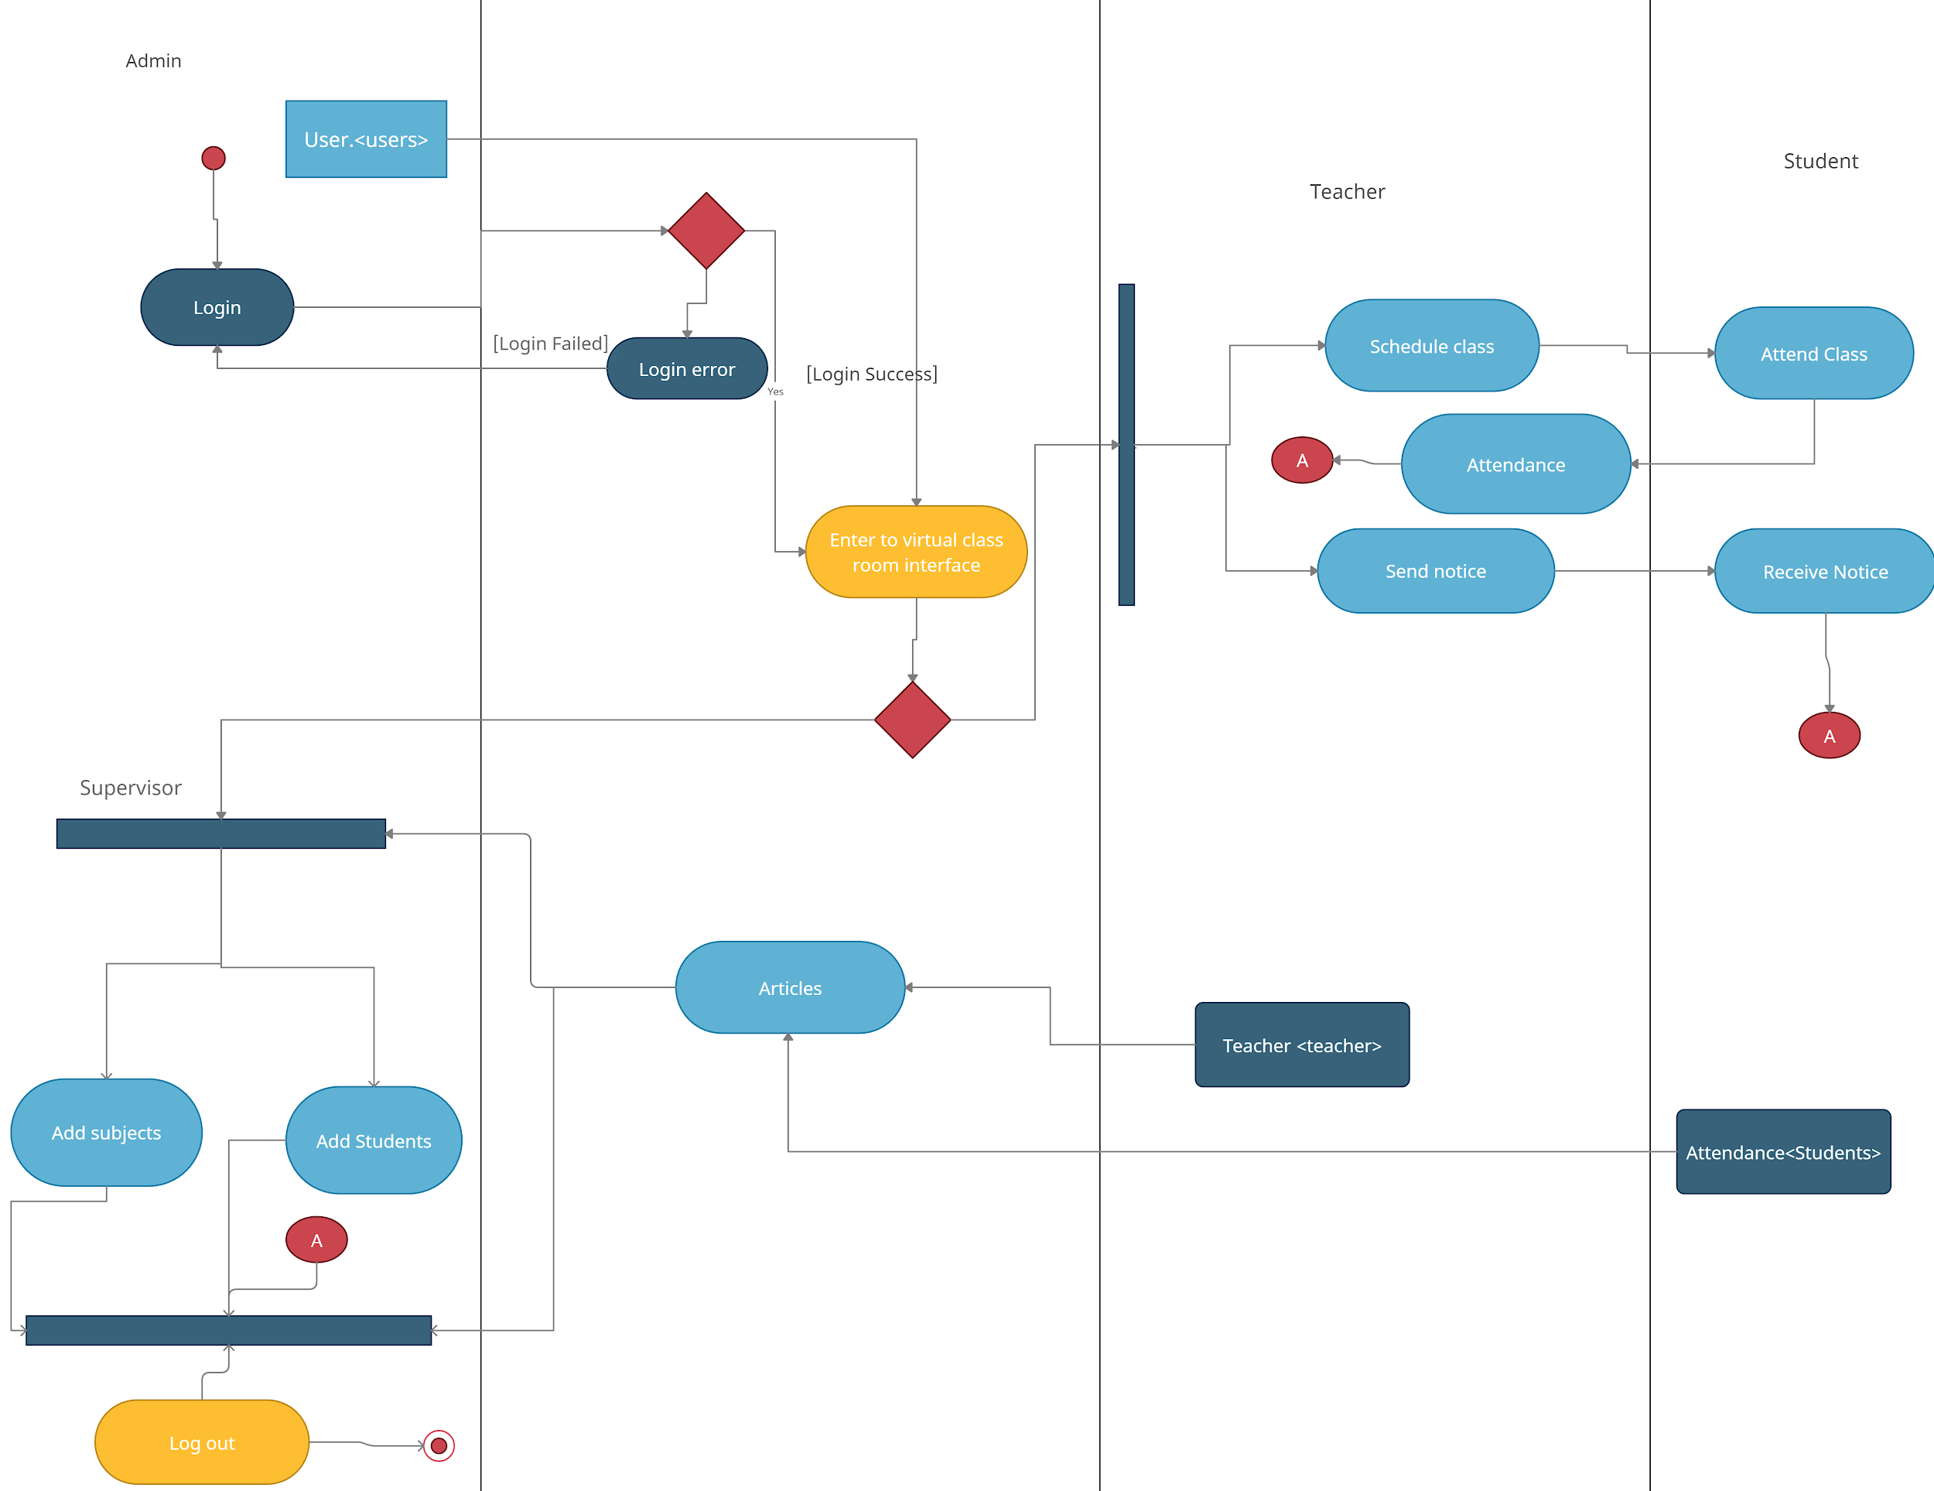

**Hardware diagram:**

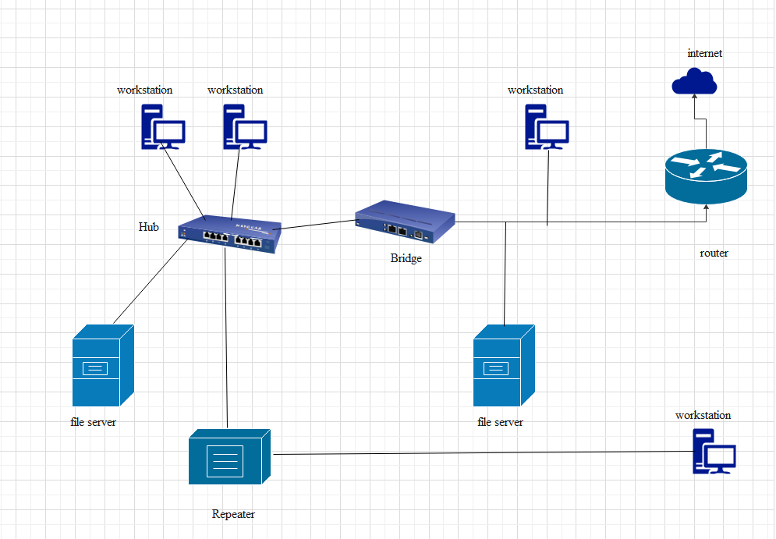

## 3.2 Decomposition Description

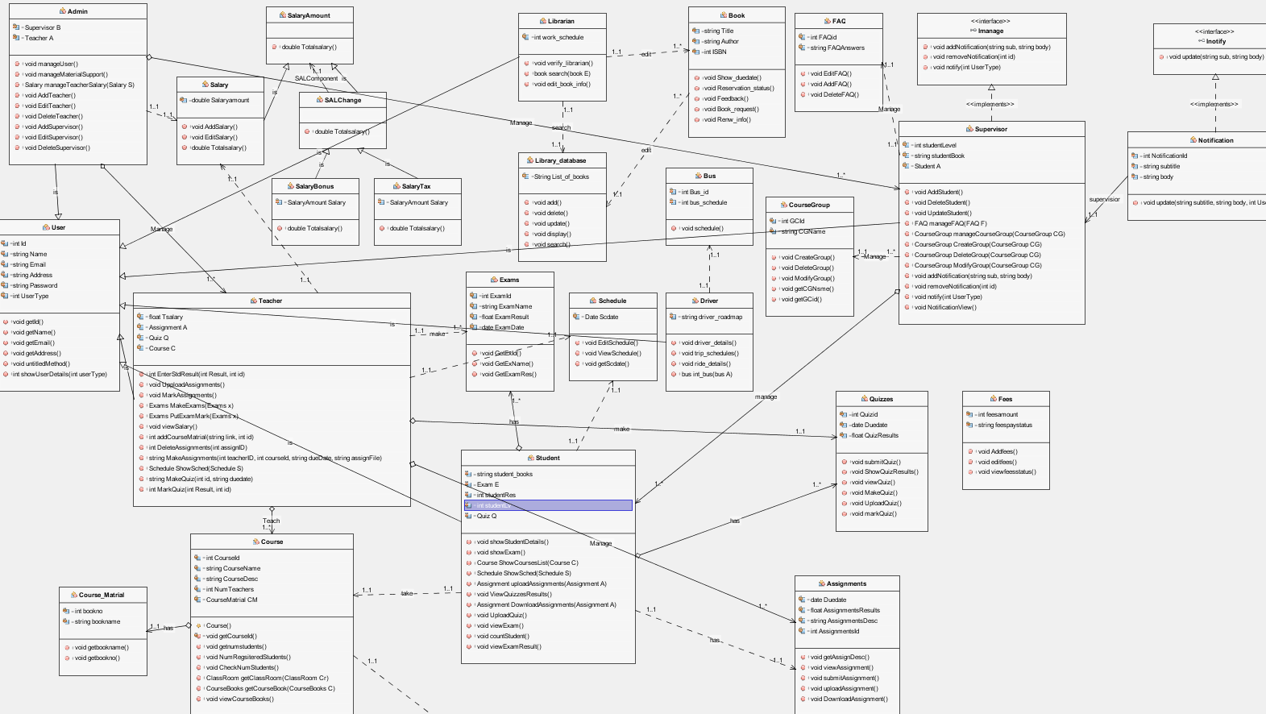

Each of Admin, Teacher, Student and Supervisor class was made by using the mvc design pattern.

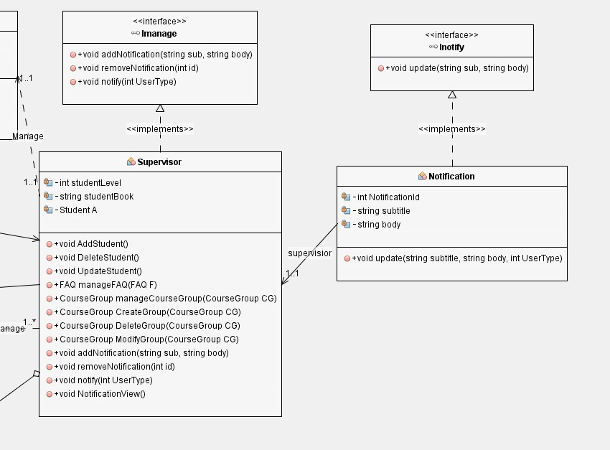

in iManage and Inotify we used the observer design pattern

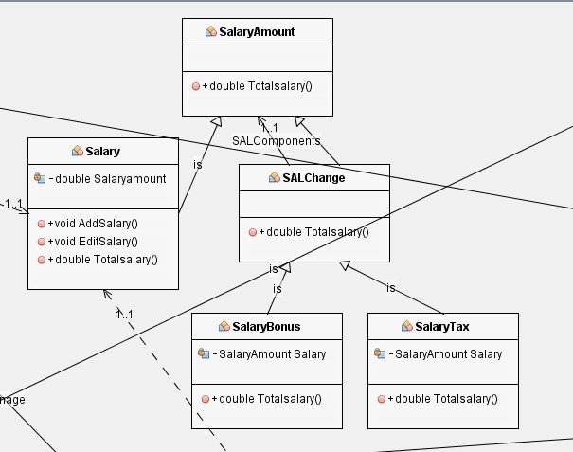

in Salary amount we used Decorative design pattern.

# 4 Data Design

## 4.1 Data Description

we used MVC since MVC supports rapid and parallel development also because the modification does not affect the entire model and it has the ability to provide multiple views.

we also used the observer since it is mainly for the power loose coupling

we also use decorative design pattern since it allows a user to add new functionality to an existing object without altering its structure

## 4.2 Data Dictionary

Alphabetically list the system entities or major data along with their types and descriptions. If you provided a functional description in Section 3.2, list all the functions and function parameters. If you provided an OO description, list the objects and its attributes, methods and method parameters.

# 6 Human Interface Design

## 6.1 Overview of User Interface

Describe the functionality of the system from the user's perspective. Explain how the user will be able to use your system to complete all the expected features and the feedback information that will be displayed for the user.

## 6.2 Screen Images

Display screenshots showing the interface from the users perspective. These can be hand drawn or you can use an automated drawing tool. Just make them as accurate as possible.

**6.3 Screen Objects and Actions**

A discussion of screen objects and actions associated with those objects.

# 7 Requirements Matrix

Provide a cross reference that traces components and data structures to the requirements in your SRS document. Use a tabular format to show which system components satisfy each of the functional requirements from the SRS. Refer to the functional requirements by the numbers/codes that you gave them in the SRS.

# 8 APPENDICES

Appendix (1) :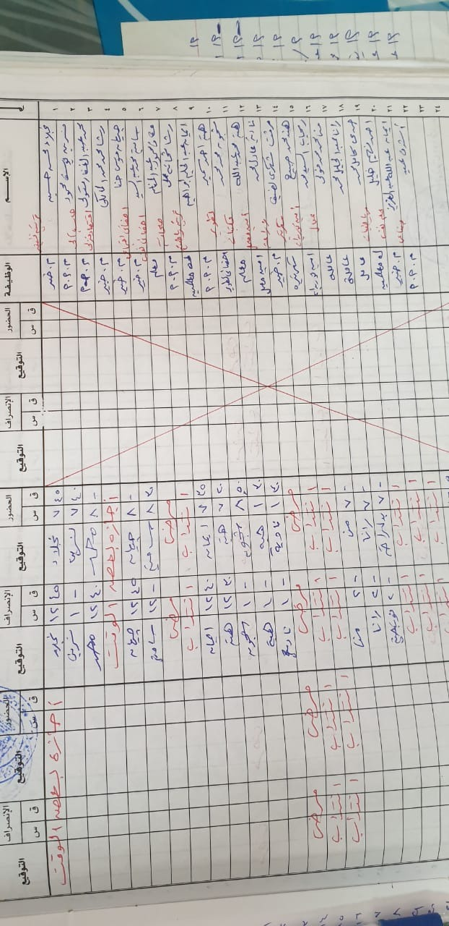

**9 References**

# References