ANALYSIS AT THE END Practical 2: Complexity Analysis
Background
When we study algorithms, we are interested in characterizing them according to their efficiency. We are interested in the order of growth of the running time of an algorithm, not in the exact running time. We call this the asymptotic running time. We need to develop a way to talk about the rate of growth of functions so that we can compare different algorithms. Asymptotic notation gives us such a method.

So if someone tells you that their algorithm runs in O(n³), then that means their code has n³ operations or less. For this very reason Big O notation is said to give you upper bounds on an algorithm’s performance. Big O tells you that your algorithm is at least this fast or faster - it won’t run slower.

In general, you would not say a function runs in Big O of n² if you can prove that it runs in Big O of n. If someone showed you the print Hello() function above, in an interview and asked you to find the complexity of it, if you answer O(n²), more than likely they would disqualify you. Even though it is technically correct, the answer they would expect is O(n).

What am I doing today?
Today’s practical focuses on 3 things:
- Understanding the basic order of growth functions
- Classifying several algorithms and code snippets in Big-O
- Run two different Big-O algorithms that solve the same problem and compare performance

Instructions
Try all the questions. Ask for help from the demonstrators if you get stuck.
Solutions will be posted afterward.

Grading: Remember if you complete the practical, add the code to your github repo which needs to be submitted at the end of the course for an extra 5%
**Github classroom will be setup from Week3

>>Copy this doc into your own folder

Order of growth classifications
The following are some of the common complexity functions you will encounter:
- Constant: O(k), for example O(1): independent of the size of the input n
- Logarithmic: O(log n): Always increases, but at a slower rate as n increases. Typically found where the algorithm can systematically ignore fractions of the input.
- Linear: O(n): as n increases, run time increases in proportion
- Linearithmic (n log n): Combination of O(n) and O(log n)
- Quadratic: Θ(n² ): As n doubles, run-time quadruples. • However, it is still polynomial, which we consider to be good.
- Polynomial: Θ(n^{k} )
- Exponential: Θ(k^{n}); This class is pretty much as bad as it gets. Can be used only for small values of n in practice.

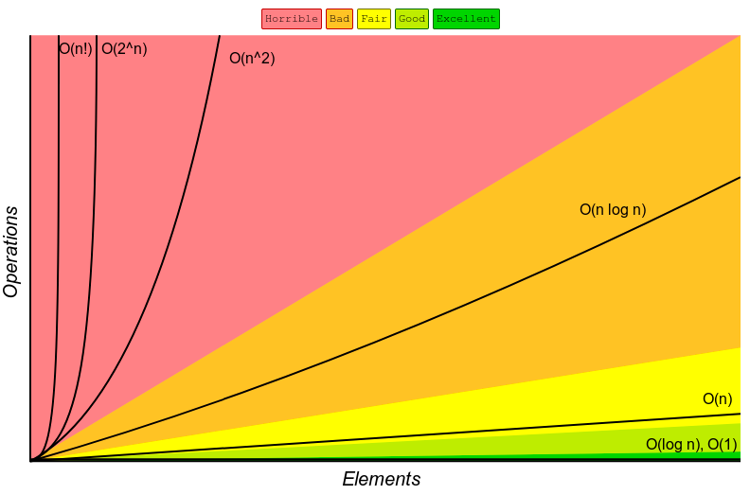

Exercise 1: Complete these sentences..
- Algorithms with time complexities such as n and 100n are called Linear algorithms.
- Algorithms with time complexities such as n² are called quadratic-time algorithms (True or False).
- Any quadratic-time algorithm is eventually more efficient than any linear-time algorithm (True or False).
- Functions such as 5n² and 5n² +100 are called Quadratic functions.

Exercise 2: Order of Growth Classifications
Rank the functions below according to their growth - marking 1 for the slowest growing functions (or fastest algorithm) to 7 for the fastest growing function (or slowest algorithm).
T(N) | Growth function
n² | 6
480 | 1
2^{n} | 7
logN | 3
2⁴ | 1
380N | 3
1/2N | 3

Same thing:
T(N) | Growth function
N logN | 4
N⁴ | 8
2^{n} | 9
log₈N | 2
nlog₄N | 4
log₂N | 2
nlog₆N | 4
300 | 1
6N³ | 7
*note: when speaking asymptotically, the base of logarithms is irrelevant. This is because of the identity loga b logb n = logan

Which kind of growth best characterizes each of the functions below?
T(n) | Constant | Linear | Polynomial | Exponential
1 | ✔
2n³ |  |  | ✔
(4/3)n |  | ✔
2^{n} |  |  |  | ✔
4n² |  |  | ✔
5600 | ✔
2493n |  | ✔
3/2^{n} |  |  |  | ✔

Simplify the following functions into their closest Big O growth factors
Remember the rules to find the asymptotic behavior of the following functions:
- Drop lower-order terms
- Drop constant factors
- Keep the terms that grow the fastest.
- Use the smallest possible class of functions
Examples:
Say “2n is O(n)” instead of “2n is O(n2)”
Say “3n + 5 is O(n)” instead of “3n + 5 is O(3n)
f( n ) = 5n + 12 => O(n)

Try these ones yourself:
- f( n ) = 5n + 12
- f( n ) = 109
- f( n ) = n²+ 3n + 112
- f( n ) = n³ + 1999n + 1337

Answers:
- It becomes O(n) as we drop the multiplier 5 and the constant 12 as they are negligible as seen in the example above. F(n) = n.
- It becomes O(1) as we drop the multiplier 109 and leave 1 there to show that its not a zero function. F(n) = 1.
- It becomes O(n^2) as we drop the 3n and 112 constant as n^2 grows larger than both of them for sufficiently large n. F(n) = n^2.
- It becomes O(n^3) as we drop 1999n and 1337 as n^3 grows larger than both for sufficiently large n. F(n) = n^3.

Rules for classifying functions
For Loop: The running time of a for loop is at most the running time of the statements inside the loop times the number of loops
for (int I = 0; I < n; i++){  doSomething();  } | O(n)

Nested loops: Do the analysis inside out. The total running time of a statement inside a group of nested loops is the running time of the statement times the product of the sizes of all the loops
for (int i = 0; i < n; i++){  For (int j = 0; j <n; j++){  doSomething();  }  } | O(n²)

Consecutive Statements / Functions
These simply add - the maximum is the one that counts.
for (int I = 0; I < n; i++){  doSomething();}  for (int i = 0; i < n; i++){  For (int j = 0; j <n; j++){  doSomething();  } } | O(n)  O(n²)  T(N) = Total = O(n) + O(n²) = O(n²)

What is the complexity of the functions below?
int sum = 0;
for (int i = 1; i < N; i *= 2)
for (int j = 0; j < N; j++)
sum++;
Quadratic O(n^2)
2 nested loops each looping N times

function isEven(value){
if (value % 2 == 0){
return true;
}
else
return false;
}
Constant Time O(1)
Only takes 1 value and does the comparison once and returns once, no repetition

arrayMax(A, n) {
currentMax = A[0]
For (i=1; i< A.length; i++){
If (A[i] > currentMax) then
currentMax = A[i]
}
Linear O(n)
1 loop, looping N times performing constant time operations

function areYouHere(arr1, arr2) {
for (let i=0; i<arr1.length; i++) {
const el1 = arr1[i];
for (let j=0; j<arr2.length; j++) {
const el2 = arr2[j];
if (el1 === el2) return true;
}
}
return false;
}
Quadratic O(n^2)
2 loops each looping N times, each run of the 1st loop you run the 2nd loop N times

function isPrime(n) {
if (n < 2 || n % 1 != 0) {
return false;
}
for (let i = 2; i < n; ++i) {
if (n % i == 0) return false;
}
return true;
}
Linear O(n)
1 loop, looping N times as u disregard the if statement as it runs in constant time

function findRandomElement(arr) {
return arr[Math.floor(Math.random() * arr.length)];
}
Constant Time O(1)
No looping/repetition, selects a random array and return it, both constant time operations

function createPairs(arr) {
for (let i = 0; i < arr.length; i++) {
for(let j = i+1; j < arr.length; j++) {
console.log(arr[i] + ", " + arr[j] );
}
}
}
Quadratic O(n^2)
2 nested loops each looping N times, each iteration of the outer loop runs the inner loop n times

public static int binarySearch(int[] a, int key)
{
int lo = 0, hi = a.length-1;
while (lo <= hi)
{
int mid = lo + (hi - lo) / 2;
if (key < a[mid]) hi = mid - 1;
else if (key > a[mid]) lo = mid + 1;
else return mid;
}
return -1;
}
Logarithmic O(log N)
Binary search halves the size of the array each iteration and therefore is much more effecient

sum = 0;
for(inti=0;i<n;++i){
for(int j = 0; j < n*n; ++j) {
sum++;
}
}
Quadratic O(n^2)
2 nested loops each looping N times

Big O Notation
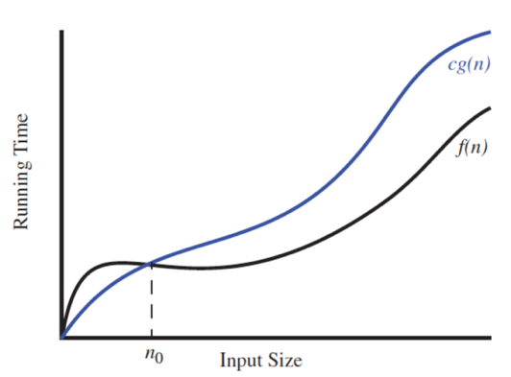

Formal proof
Given two functions f(n) and g(n), we say that f (n) is O(g(n)) if and only if there are positive constants c and n0 such that f(n)≤cg(n) ∀ n≥n0
**Note Constants C and n0 need to be independent (i.e. not dependent on N)

Example
f(n) = 11n + 5 <= c*g(n)
Let’s try C = 12
11n + 5 <= 12n
f(n) = 11n + 5 <= c*g(n)
11n + 5 <= 12n
5 <= 12n - 11n
5<= n
f(n) = 11n + 5 <= c*g(n)
11n + 5 <= 12n
5 <= 12n - 11n
5<= n
f(n)≤12g(n) ∀ n≥5
We chose C = 12 but we could choose any real number >= 12 and any integer greater than or equal to 5 works for N
Try this one yourself
Show that 8n + 5 is O(n)
f(n) = 8n + 5
f(n)≤cg(n) ∀ n≥n0
Solution:
Let’s take c = 9,
8n + 5 <= 9n
5 <= 9n-8n
5 <= n
Therefore f(n) <= 9g(n) for all n >= 5

Comparing two algorithms from different growth classes
We have two algorithms (ThreeSumA and ThreeSumB) that count the number of triples in a file of N integers that sums to 0 (ignoring integer overflow).

- Estimate the Big O for each of these algorithms by looking at their code
- Add simple java code to time the running time of both algorithms
- Use the input files provided to run timing tests on both algorithms for each file, noting the results
- Graph the results

*Note to run each file you need to first compile the java files to class files (use javac from the command line or your IDE) and then run each class with the different input files to time their performance. For example:
java ThreeSumA 1Kints.txt
java ThreeSumB 1Kints.txt
...and so on...and on.

Practical 2 ThreeSumFile

Files supplied:
- ThreeSumA.java
- ThreeSumB.java
- Input files of integers: 8ints, 1Kints, 4Kints, 8Kints, 16Kints, 32Kints

- Use same code as last week for this:
import java.lang.*
This method returns the difference, measured in milliseconds, between the current time and midnight, January 1, 1970 UTC(coordinated universal time)
Final long elapsedTime = System.currentTimeMillis()

Sample code you can use to time how your algorithm performs with different size input:
public static void main(String[] args)
{
final long startTime = System.currentTimeMillis();
myFunction(N):
final long elapsedTime = System.currentTimeMillis() - startTime;
System.out.println(“the time taken ” + elapsedTime);
}

Converting to more readable time using something like below:
// long minutes = (milliseconds / 1000) / 60;
- long minutes = TimeUnit.MILLISECONDS.toMinutes(milliseconds);

- // long seconds = (milliseconds / 1000);
- long seconds = TimeUnit.MILLISECONDS.toSeconds(milliseconds);

- We expect to see something like the outputs below for both programs
threeSumA | threeSumB
* java ThreeSumA 1Kints.txt  * 70  *  * java ThreeSumA 2Kints.txt  * 528  *  * java ThreeSumA 4Kints.txt  * 4039  *  * java ThreeSumA 8Kints.txt  * 127867  *  *  *  *  *  * | * java ThreeSumB 1Kints.txt  * 70  *  * java ThreeSumB 2Kints.txt  * 528  *  * java ThreeSumB 4Kints.txt  * 4039  *  * java ThreeSumB 8Kints.txt  * 32074  *  * java ThreeSumB 16Kints.txt  * 255181  *  * java ThreeSumB 32Kints.txt  * 2052358

Analysis of Results
ThreeSumA |  | ThreeSumB
File | Time | File | Time
1Kints | 70 ms | 1Kints | 70 ms
2Kints | 528 ms | 2Kints | 528 ms
4Kints | 4 secs | 4Kints | 4 secs
8Kints | 2.1 mins | 8Kints | 32 secs
16Kints | Too Long | 16Kints | 4.2 mins
32Kints | Too Long | 32Kints | 30 mins

These results are expected because ThreeSumA uses 3 nested for loops giving a time complexity of O(n^3), while ThreeSumB has only two nested for loops which normally gives quadratic time, however binary search is performed in the nested loops which has a time complexity of log n, therefore the overall time complexity is O(n^2 log n).

