SOLVED: Practical 8: Run Length Compression
Ahmed Jouda
18329393

Data compression reduces the size of a file to save space when storing it and to save time when transmitting it. While Moore's law guides that the number of transistors on a chip doubles every 18-24 months, Parkinson's law tells us that data expands to fill available space. The text, images, sound, video, and so on that we create every day is growing at a far greater rate than storage technology.
As an aside and illustration: Wikipedia provides public dumps of all its content for academic research and republishing. To compress these large files it uses bzip and SevenZip's LZMA (more on this later) and can take a week to compress of 300GB of data.

Today’s practical focuses on:
- Build a run length encoded function that takes any string inputs and outputs the compressed output
- Make use of the helper files and the provided RunLength java file to compress the files provided

DONE Step 1 Implement Run Length Encoding
Write your own Java function that takes in a string as a command line argument and returns a compressed string that uses Run Length Encoding (RLE).
So for example if the input (argument) into your program is:
“aaaabbbbb”
Then your program should return
“a4b5”
Pseudocode
To implement RLE you need to first loop through the characters in the input string. You use an int counter that counts the number of times you have seen the same character in a row. Once you encounter a different character, you then output the value of the counter you’ve just seen and the number (your count variable) that you have been counting. Then repeat until you get to end of the input string. If you want to optimize your compression, you could choose not to output a count if there is only one instance of the character (i.e., “a” instead of “a1”).
Steps
- Read in your input string
- Start at the first character in the input string
- Create a counter
- Keep incrementing as long as you keep seeing the same character in a row
- Once you encounter a new character, output the previous character and its count
- Repeat the same steps with the next character until you reach the end of the string
- Output the compressed string
Results Analysis
Run Length encoding is great compression algorithm sometimes but not so great at others as proven by my three examples:
Original String | Compressed String | Compression Percentage
wwwwaaadexxxxxxywww  = 19 chars = 38 bytes | w4a3d1e1x6y1w3  = 14 chars = 28 bytes | 28/38 = 73.68%
mmmmmmmmmmmmjjjjjjoooooodddduuuuuuuuqqqq = 40 chars = 80 bytes | m12j6o6d4u8q4  = 13 chars = 26 bytes | 26/80 = 32.5%
ahmedjouda  = 10 chars = 20 bytes | a1h1m1e1d1j1o1u1d1a1  = 20 chars = 40 bytes | 40/20 = 200% [EXPANSION]

As we can see above, for the first and second examples we achieved compression however in the third one we ended up with expansion!
This is the risk with RLE, in the 2nd examples it worked great, the compressed string is a third of the original, however in the 3rd example it was terrible, the “compressed” string ended up being twice as large as the original. This is because it works based on consequential stream of the same char, if the string doesn’t have that it ends up expanding it!

DONE Step 2 Use the RunLength.java implementation that works with the binary input and output libraries provided
In the next step we are going to work at the bit level to measure the amount of compression we can attain by applying Run Length Encoding on a series of files (text, binary and bitmaps). To refresh your memory, the BIN files included contain binary code (i.e. 0s and 1s). You’ll need to work in the Terminal (Mac), CommandPrompt (Windows), Shell etc., or use the input options in Eclipse for a lot of this exercise.

Included for your use in the repo are the following java files:
- BinaryStdIn - to work at the fundamental level of compression, we want to work at the bit level. BinaryStdIn is included to read in 1 bit at a time.
- BinaryStdOut - a corollary of BinaryStdIn but for write bits out 1 at a time
- BinaryDump - how can we examine the contents of the bits or bitstreams that we are working with (particularly while you are working on a program)? BinaryDump outputs the input in binary.
- HexDump - this is the same as BinaryDump but in hex code which is more compact if you can read it using the table below
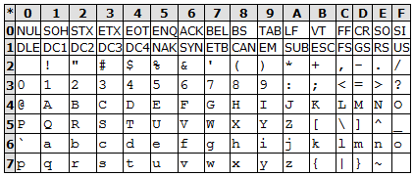
- RunLength (see below) - implements Run Length Encoding (as you did in Strings) but in binary and builds on the previous libraries provided above

static void | compress()  Reads a sequence of bits from standard input; compresses them using run-length coding with 8-bit run lengths; and writes the results to standard output.
static void | expand()  Reads a sequence of bits from standard input (that are encoded using run-length encoding with 8-bit run lengths); decodes them; and writes the results to standard output.
static void | main(String[] args)  Sample client that calls compress() if the command-line argument is "-" an expand() if it is "+"
Input files included in the repo include:
- 4runs.bin
- abra.text
- q32x48.bin
- q64x96.bin

Binary Compression
- Begin by first outputting the number of bits in the binary file ‘4runs.bin’

Use the command: java BinaryDump 40 < 4runs.bin
Note down the bits.
Original: 40 bits

- Now let’s try to compress this file with Run Length Encoding and see what we get (we’ll combine RunLength with BinaryDump to see how much compression we achieve)

Use the command: java RunLength - < 4runs.bin | java BinaryDump
Note down the bits.
Compressed: 32 bits
Calculate the compression ratio: compressed bits / original bits
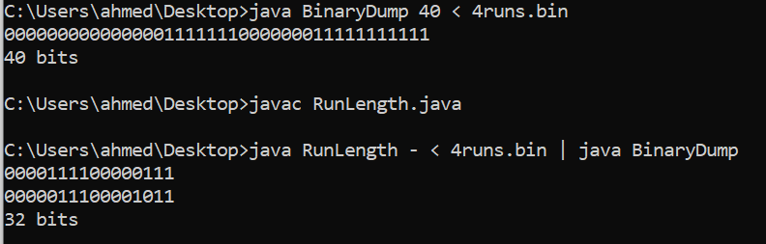
32/40 = 0.8

- Next we’ll output this compressed file to a new binary file and check we have the same compression ratio.
Use the command: java RunLength - < 4runs.bin > 4runsrle.bin
Use Binary Dump to check the bits: you can create this command yourself now
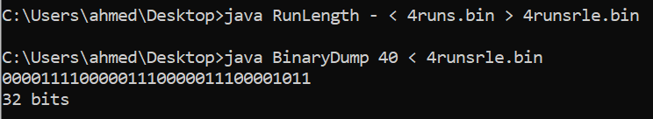
32/40 = 0.8, hence same compression ratio

ASCII Compression
- Let’s run through some of the same steps but with a text file
Use the command: java BinaryDump 8 < abra.txt
How many bits do you get?
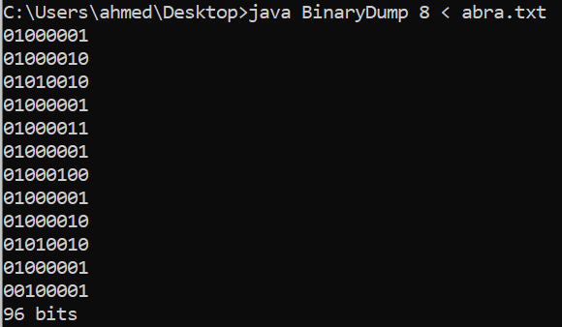
Original: 96 bits
- Let’s see what we can get to with compression
java RunLength - < abra.txt | java BinaryDump 8
How many bits did you get?
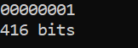
Compressed: 416 bits
What is the compression ratio?
416/96 = 4.3

Why do you think you got this? What is happening?
The RLE is multiplying the text in size instead of compressing it because it is adding an encoding to it when there are no consecutive repetition of letters. The RLE method must somehow analyze the uncompressed data stream to determine whether to use a literal pixel run.

- Create your own text file that does lend itself to RunLength Encoding and perform the same steps as above, reporting your compression ratio.
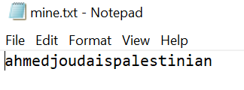
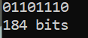
Original: 184 bits
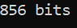
Compressed: 856 bits
Ratio: 856/184 = 4.65

Bitmap Compression
Run Length encoding is widely used for bitmaps because this input data is more likely to have long runs of repeated data (i.e. pixels).

Step 1: Use BinaryDump to find out how many bits the bitmap file q32x48.bin has
Note down your answer
1536 bits

Step 2: Use Run Length function to compress the bitmap file q32x48.bin
Use the command to compress and output the compressed file to a new file:
Java RunLength - < q32x48.bin > q32x48rle.bin

Now use the BinaryDump function to count the bits in the compress file (‘q32x48rle.bin’).
1144 bits

Step 3: Calculate the compression ratio
1144/1536 = 0.74

Step 4: Perform the Steps 1 and 2 on the higher resolution bitmap file q64x96.bin
Note down the original bits and compressed bits.
Original: 6144 bits
Compressed: 2296 bits
Calculate the compression ratio?
2296/6144 = 0.37

Step 4: Compare the compression ratio of the first bitmap image to this second compressed bitmap image. What do you think is the reason for this difference?
The second image was compressed way more (the ration of the second image is way less). This is because it is bigger and therefore has more white space that is compressed. (Because the large image in mostly white).

Files created & used:
