

**Faculty of engineering - Shoubra**

**Benha University**

**Research Project**

**in fulfillment of the requirements of**

|  |  |
| --- | --- |
| **Department** | **Engineering Mathematics and Physics** |
| **Division** | **----------------------** |
| **Academic Year** | **2019-2020 Preparatory** |
| **Course name** | **Computer** |
| **Course code** | **ECE001** |

**Title: -**

**Build a website on Operating Systems**

**By:**

|  |  |  |  |
| --- | --- | --- | --- |
|  | **Name** | **Edu mail** | **B.N** |
| **1** | **أحمد كمال محمد إبراهيم** | **Ahmed195110@feng.bu.edu.eg** | **106** |

**Approved by:**

|  |  |
| --- | --- |
| **Examiners committee** | **Signature** |
| **Dr. Ahmed Bayoumi** |  |
| **Dr. Shady Elmashad** |  |
| **Dr. Abdelhamid Attaby** |  |

***The operating system is the brain and soul of any hardware material, so if I told you that i will take out your soul and brain, you'll be just a useless body. That's any hardware without it's operating system as we defined in the website the operating system is is the program which is responsible for the execution of application programs and act as an interface between user of the computer and the computer hardware.***

***The Global market share of operating systems either for desktops or mobiles isn't considered to be competitive, as we also mentioned actually 6 systems for either mobiles or desktops are competing each other's and android for mobiles or windows for desktops are controlling the market share.***

***We have traced the journey of the most influencing operating systems and how they evolved and become in the situation or position we see now, most of us know about IOS or android for the mobile users who are actually more than the desktop users but how they started, how they gained their experience? A little knows.***

***We also tried to show the pros and cons of each of the mentioned operating systems and who always has the lead, and who learns from the mistakes. We tried to grab the information using more than a resource for each.***

***Through this report we'll try to show the website, the codes used for it's building process and the main points that we focused on for the topic.***

***Technology development is great and fast, we can't expect what's going to happen next through our look for the operating systems and how they developed we can expect that there's more to come in the next years so we have to keep pace!***

***Through this website we tried to apply all of what was required as using tables or adding images to the website or making lists…etc.***

1. **The Main Page**

***We have designed the main page in order to give such an introduction to the topic by mentioning what's the operating system and what's it's function and mentioning the two types of operating systems for mobile phones and desktops.***

1. ***Main page screenshots***

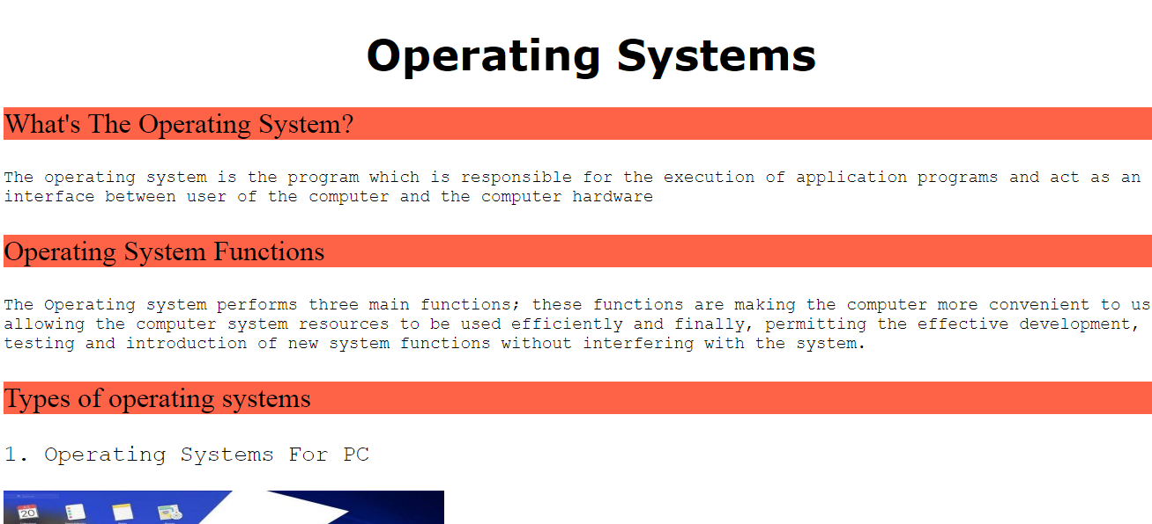

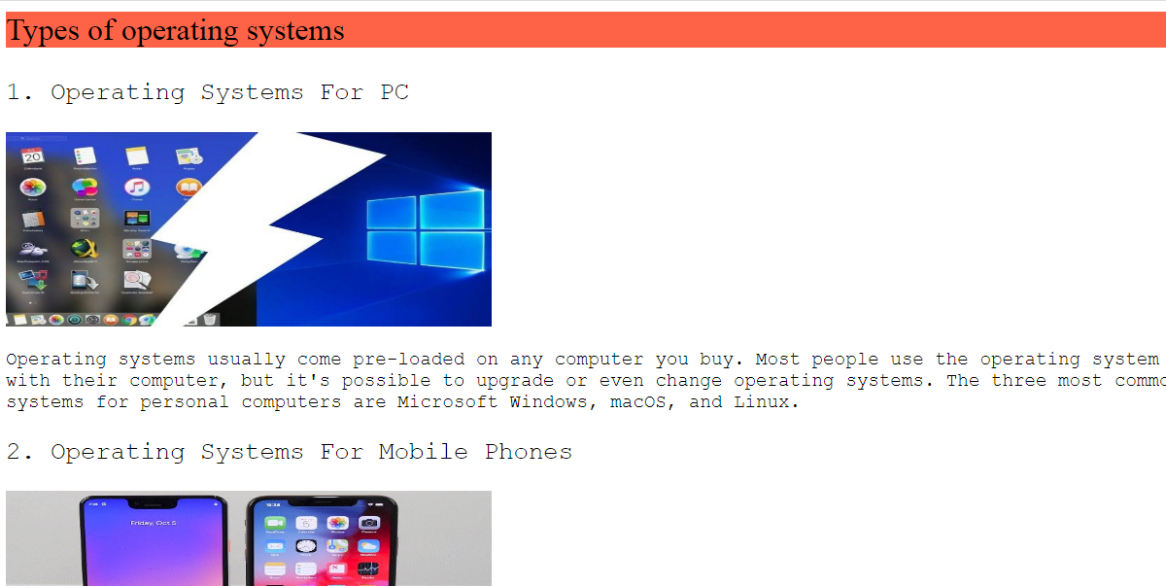

1. **Source code of main page**

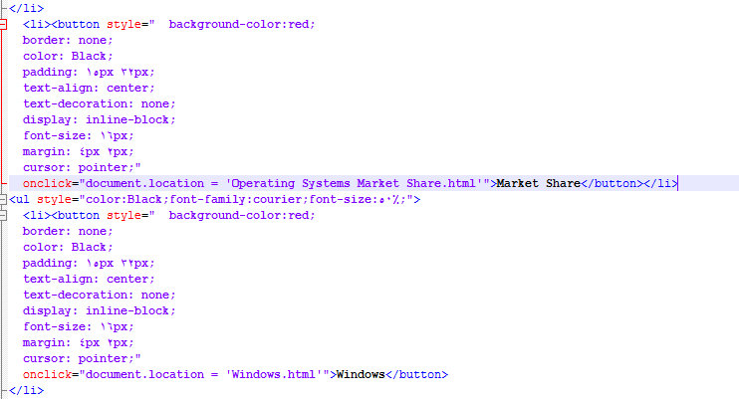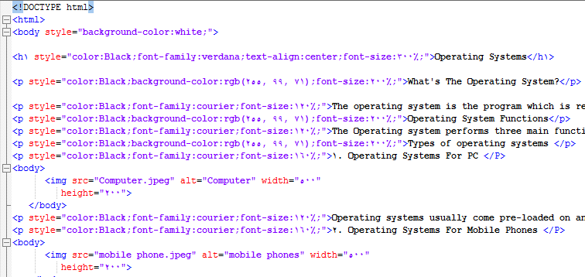

1. **Linking the main page with other pages**

***We have made a list of buttons, each button is linked to another page, we have 8 pages each of them is linked by the others so at any page you can use the button to go to wherever you want .***

1. ***Buttons Screenshots***

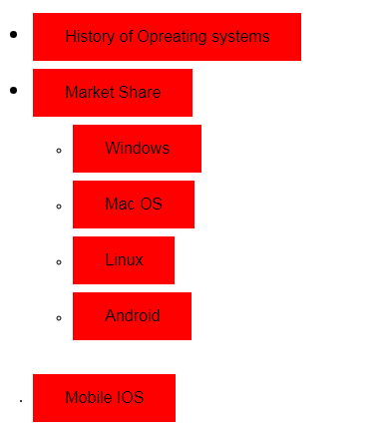

1. ***Buttons Source Code***

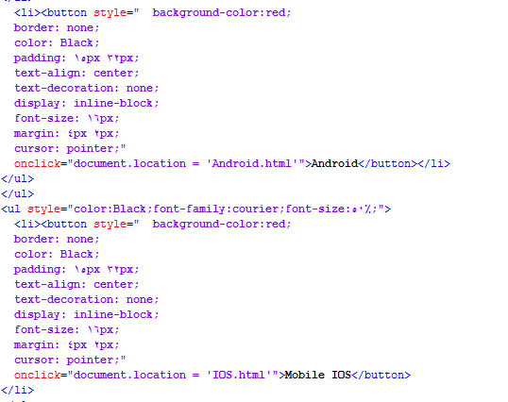

1. **Using Images**

***We used images in each page of the 8 pages of the website in order to illustrate the discussed topic and try to make the reader more attracted to the article.***

1. ***Screenshots for used images***

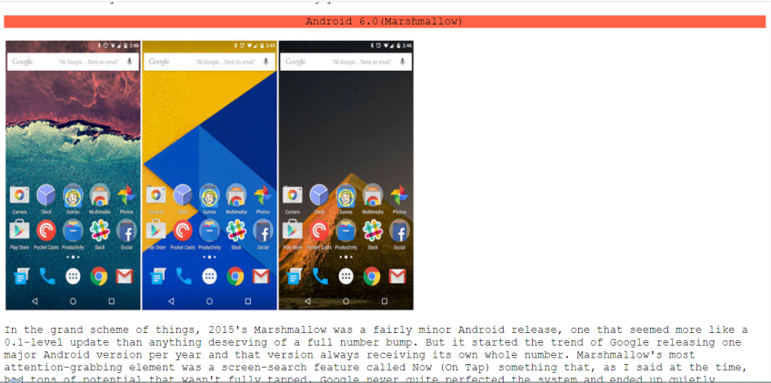

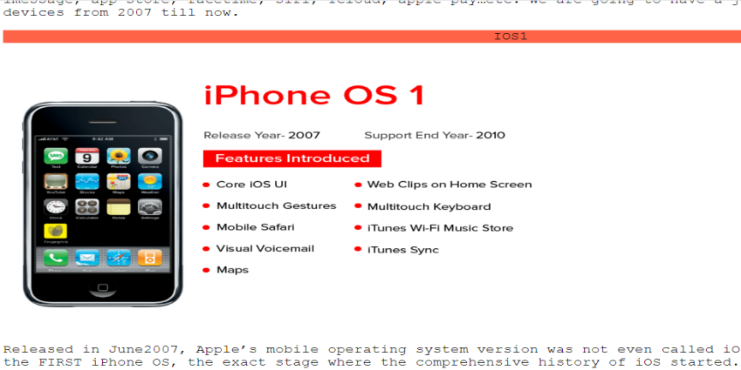

1. ***Images Source Code***

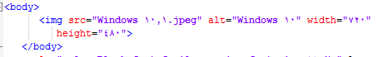

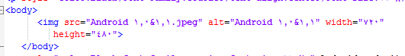

1. **Using Tables**

***In the website we used two tables in order to express the percentage of each of the Operating Systems market share, we used one of the tables to express the desktop operating systems market share and the other one to express the mobile phones operating systems market share.***

1. 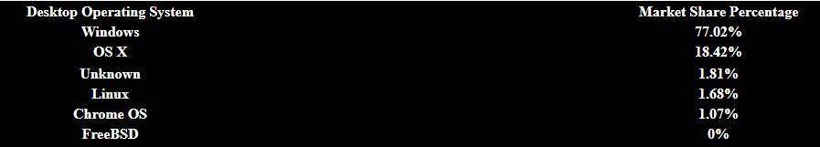***Tables Screenshots***

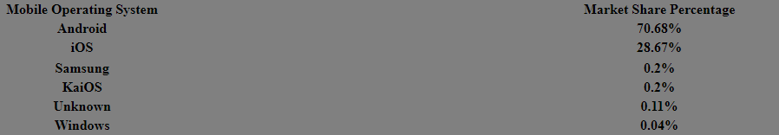

1. 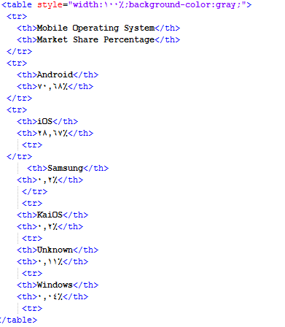***Tables Source Code***

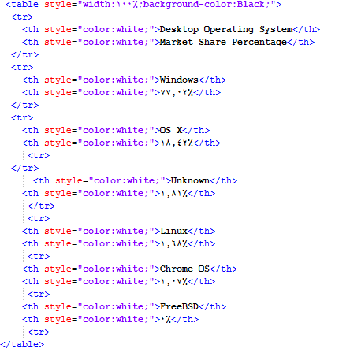

1. **Using Lists**

***We used lists in the website for two reasons, the first one to list the buttons linking the web pages together and the second one to illustrate some pros of a kind of the mentioned operating systems.***

1. ***Lists Screenshots***

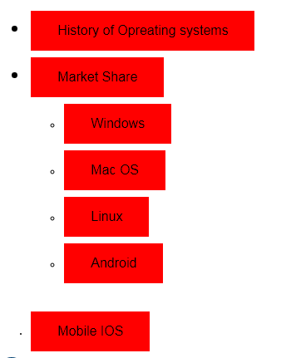

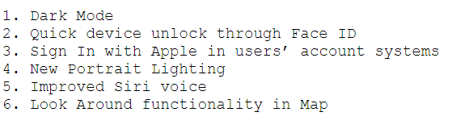

1. ***Lists Source Code***

