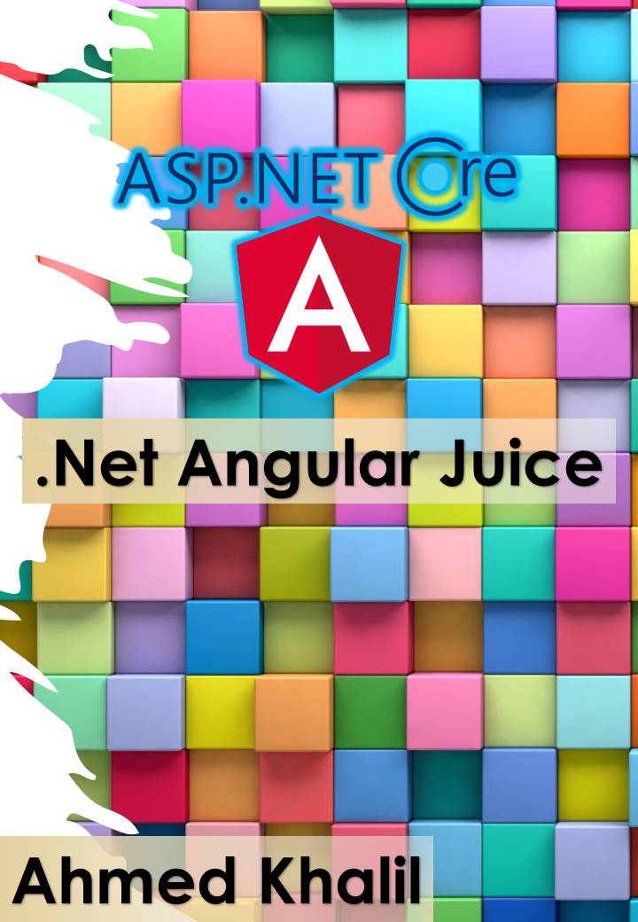Edition V1.0

Published By: Ahmed Khalil {Student of Computer and Information Systems Department Mansoura University Egypt}

Using Technologies of Microsoft, Our beloved organization (.Net Core and Visual Studio and other tools}

Using Trading Mark of Microsoft and .Net Organization

Using Angular Trading Mark

Copyright © 2020 Ahmed Khalil

Acknowledgement

Table of Contents

About this guide 1

Introduction to .Net Core 1

Asp.Net Core 2

Technologies and Tools 2

Angular 9 2

Single Page Application Paradigm 2

Bibliography 6

Abstract

Introduction

The technologies of development are daily in changes, for many reasons the technologies are provided to improve quality and decrease the time of works and projects, as the guide talk about tow technologies are in trends today but not for all the future, so these guides make just a realtime guides, but developers spend much time for recognition and learning.

.Net Core Rest APIs become much usable as a backend tool to satisfy more productivity, as it is a way to resolve and module the system into many parts like Microservices Architecture and other Architecture, but the jobs really need someone who can do specialized thing like Backend developer or Frontend developer, because the fall of the Fullstack development.

Someone specialized in .Net Core APIs and another one specialized in Angular is best than MVC developer as a performance of coding because of modular systems.

Angular is most popular frontend framework the can module the architecture of web Pages into components and load each component when request by rewriting the content not to reload a new page so the performance is after loading SPA (Initial loading).

# About this guide

This guide for every backend and frontend developer who need to merge the concepts and integrate the backend with frontend in best practices of Microsoft standards and Heuristics of clean code principles, the guide separate the two concepts so the reader can be only an Angular developer or a .Net Backend developer, so the most required concern here is separation of these concepts, and making Not a juice type, but like the water and oil to make sense.

This guide is working in a good example of application Market.IO is available on GitHub repos.

Focusing in tow technologies or frameworks that achieve backend and frontend concepts is the good way to start a good career based on the experience of work.

# Versions

This guide has been revised to cover the .Net Core 3.x and Angular 9 plus many additional update related to tow “Waves” of technologies like .Net Core Packages provided by Nuget package manager and Angular 9 provided by NPM, and because of the existence of tow frameworks as cores so the versions begin with version 1.

# Introduction to .Net Core

.Net is a platform that provide the developer with tools, like its built-in tools, programming languages and libraries, that can build many types of Applications.

* Programming Languages C#, F#, Visual Basic
* Tools supported for Linux, Mac, Windows, and Docker
* Libraries working with Files, Strings, Databases, Cloud, Realtime and more

.Net Core is a cross platform and the successor of .Net framework, it is lightweight to run on many operating systems Mac, Windows, Linux, for many processor types X64, X86, ARM 32, ARM 64.

The Most important tool for web development is Asp.net that extends the functionalities of the .Net Platform to serve the developers in web development, and othe tools for managing the services in Web Background.

# Asp.Net Core

ASP.Net Core provide the good tools to build Backend-Applications like Rest APIs, GraphQL, gRPC, the provide the services over many protocols and this is the core study of book, this book will show different tools and libraries that developers can use to build good applications.

Tools that developer can use to process web requests in C# or F# and using such web-page templating syntax like razor but this is not our study, libraries for common web patterns MVC using adaptable technologies to register as a service like SPA, GraphQL etc.

This technology and Libraries are used by this book as a core technology to support the application as Backend Services.

## Technologies and Tools

* .Net Core 3.1 Runtime
* .Net Core 3.1 SDK
* Visual Studio Code: For simple backend development
* Visual Studio: For Heavy Backend development
* Packages
  + Aspnetcore.MVC
  + Signalr
  + EfCore
  + Swagger
  + Health Checks

# Angular 9

Angular is a platform for building mobile and desktop web applications this is the book frontend application technology, serve as SPA, this paradigm of technology use one page to control all other functionalities of system by calling something called components, these components shown by programming functionalities that provided by initial loading files and some requests to backend.

## Single Page Application Paradigm

A single-page application (SPA) is a web application or website that interacts with the web browser by dynamically rewriting the current web page with new data from the web server, instead of the default method of the browser loading entire new pages. The goal is faster transitions that make the website feel more like a native app. (WikiPedia, 2019)

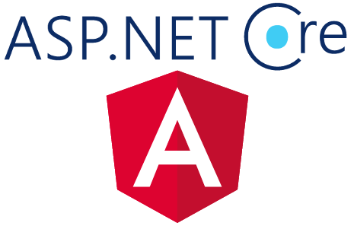

# Bibliography

Flanagan, D. (2006). *JavaScript - The Definitive Guide.*