

**Faculty of Informatics and Computer Science.**

**Piano Touch.**

By: Ahmed khawaga.

Supervised By

Ann Nosseir.

**June 2020.**

**Abstract.**

Nowadays a huge number of people like to play music especially piano because it has some health benefits like relaxing, releasing stress, and reduce heart and respiratory rates. Music is one of the important hobbies in our life as too many people dream to become musicians, but the main obstacle is that learning music is taking too much time. So we come up with an idea to manufacture a product consist of gloves called Mobile Music Touch (MMT) that help the learner to learn playing piano in a short period of time. This research uses the Convolutional Neural Network (CNN) to promote a algorithm that can help the new learner musicians to learn playing piano and develop their skills in a short time.

Attestation &Turnitin Report

**Signature** Ahmed khawaga. **Date:** 15-8-2020

**Acknowledgements.**

I want to thank all my doctors and express my appreciation and respect towards them for helping me from the first beginning till the end of my graduation project. I want to thank them for supporting me all the time and replying as fast as they can on any question I asked. Special thank to Dr.Ann for her time and attention

Contents

Attestation &Turnitin Report 2

- List of figures 3

1. Introduction. 4

1.1 overview. 4

1.2 problem statement. 8

1.3 Scope and objectives. 8

1.4 Report organization. 8

1.5 work methodology. 9

1.6 Work plan (Gantt chart). 10

2 Related work. 10

2.1 Background. 10

2.2 Literature Survey. 11

3 proposed solution. 13

3.1 solution methodology. 13

3.2 Functional/ Non-functional requirements. 13

3.2.1 Functional Requirements 13

3.2.2 Non-Functional Requirements. 14

3.3 Design/ simulation set up. 14

3.3.1 Components Used. 14

3.3.2Procedures: 16

4. Implementation. 21

5. Testing and Evaluation. 25

5.1 Testing. 25

5.2 Evaluation. 25

6. Results and Discussions. 26

7. Conclusion and Future Work. 26

7.1 Conclusion. 26

7.2 Future work. 27

References 27

1, Appendix 1 28

# List of figures

Figure 1 Displays used vibration motor, and it can generate strong tactile sensations while it is small. 7

Figure 2 controller 7

Figure 3 Gloves 8

Figure 4 Work methodology 11

Figure 5 Gantt chart 11

Figure 6 Imports 16

Figure 7 coding 17

Figure 8Sample from run 18

Figure 9 Music scale 18

Figure 10 Algorithm 19

Figure 11Algorithm while working 20

# Introduction.

# 1.1 overview.

Imagine that you learn playing the piano within 30 minutes instead of days. Yes, it becomes a fact. Now you can learn to play piano as fast as possible by using Mobile Music Touch. A huge number of people dream to become professional in playing the piano but they need too much time to become professionals. From 1655 to 1731 in Italy, Bartolomeo Cristofori was the first person who manufactures the piano but he found that the instrument is harpsichord which means that its voice was soft and loud noise. He decided to invent the first modern piano in 1700. There are some health benefits from playing the piano which is releasing stress, stimulate the brain, and strengthen muscles and improving the language skills by understanding the sound patterns and foreign languages. Secondly, moving to the product, which is Piano Touch, Time usage is often not limited to the initial learning of songs alone, but is compounded by the challenge of preserving the content. Once a new song is learnt, it soon starts to forget. Therefore, the new skills required time-consuming and repeated practice to maintain. Nevertheless, learning isn't always an active process. A lot of work had been conducted on the Haptic Passive Learning phenomenon. Passive learning is described as learning that is "caught rather than taught" and it is usually effortless, sensitive to animated sensations, susceptible to artificial stimulation aid and lacking learning resistance. Studies have shown that passive learning can occur when subjects are exposed to environmentally rich media. In a study conducted by Zukin and Snyder, it was found that subjects living in a media-rich atmosphere and actively exposed to political knowledge were 40 percent more likely than subjects living in a low media setting to receive the information. The specifics were not of political concern to all the target parties. In this paper we explore the ability of physical abilities to be acquired passively. If a person can be passively exposed to the practice and repetition when participating in their everyday activities (e.g. working at a desk, traveling by subway, etc.), then they will be able to naturally learn and improve the skills. To this end, we created and implemented a program to allow the learner to practice piano at any time , location, and while performing other tasks. The key feature of the device is a haptic glove, equipped with small vibration engines. To boost physical dexterity, fingertips were cut on the glove. This glove helps users not only to hear the sound, but also to feel the notes on their fingers. Research has also shown that a multimodal combination of audio and haptic signals gives the user a better understanding of musical structure and improves musical piece performance. A tiny Bluetooth device for wireless communication is integrated into the

glove. If the music played from a different electronic device (in this case, a laptop electronic),

The glove sends vibrations to all fingers to show which fingers the notes perform. Although a laptop or any smart device used in this setup, it is easy to integrate the Piano Touch device with other mobile devices such as cell phones or MP3 players. Moving on to the Piano Touch system component. the Piano Touch system consists of three distinct components: Figure 1 tiny vibration motors, one for each finger,

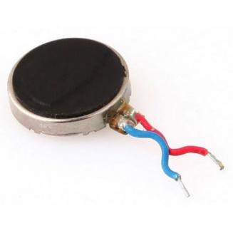

Figure 1 Displays used vibration motor, and it can generate strong tactile sensations while it is small.

Figure 2 controller

Figure 2 shows the component is consisting of 10 diodes which is responsible for preventing the current to return to the motors, while Arduino is the main controller. In addition, Rosetta is responsible for receiving the signals from the controller and give it to the motors. In the board, there are 6 Rosetta, 5 for the motors and 1 for the battery. Finally, the battery is responsible for

supplying power.

Figure 3 Gloves

Figure 3 represents that gloves used to hold the motors and the Arduino controller. It represents also the battery, wires and motors are on the front side of the hand and fingers, so it does not impact the user’s grip. A laptop computer with music output and glove control via Bluetooth to transmit synced vibrations. By using two objects detectives which are YOLO and HOUGH, as YOLO is the ARCHTER for CNN gloves which is responsible for detecting the circles in the note when entering a picture. Piano Touch code is divided into two sections which are audio processing and image processing. So YOLO is responsible for detecting the circles or multiple objects like note that found in the Piano Touch code in the image processing section. While HOUGH is responsible for line detecting which means that it is responsible for determining the location of the circles or the codes in the image.

## 1.2 problem statement.

Moving to the problem statement, there was a problem to inform the gloves to the all piano keyboards because the gloves have 10 fingers so each glove has 5 fingers only so it was difficult to let the gloves have the ability to determine the whole piano keyboards. While the solution is to condone this problem and focusing on the 10 fingers only.

## 1.3 Scope and objectives.

**Scope.**

This gloves is targeting people who wants to learn piano and they want to avoid consuming too much time. It is also targeting people who sells music instruments or people who have places to learn others playing instruments.

**Objectives.**

The main objectives of this project are to help piano’s learner to learn and become professionals as fast as possible and avoid consuming too much time. It won’t cost too much as the price will be average and anyone can buy it.

## 1.4 Report organization.

Section 1.5 Work Methodology.

Section 1.6 Work Plan (Gantt Chart).

Section 2 Related Work (State-of-The-Art).

Section 2.1 Background.

Section 2.2 Literature Survey.

Section 2.3 Analysis of The Related Work Section 3 Proposed Solution.

Section 3.1 Solution Methodology.

Section 3.2 Functional and Non-Functional Requirements.

Section 3.3 Design and Simulation Set Up.

Section 4 Implementation.

Section 5 Testing and Evaluation.

Section 5.1 Testing.

Section 5.2 Evaluation.

Section 6 Results and Discussion.

Section 7 Conclusion and Future Work.

Section 7.1 Summary Section.

7.2 Future Work.

## 1.5 work methodology.



Figure 4 methodology

## 1.6 Work plan (Gantt chart).

Figure 5 Gantt chart

# 2 Related work.

## 2.1 Background.

In Georgia 2010, a study mentioned some features of Mobile Music Touch (MMT) as the product is very lite, wireless haptic including fingerless gloves with vibration motors and a Bluetooth to permit the computing devices like mobile phones When the passages are loaded into the phone and played regularly when the user has various tasks to perform. MMT is organized to send vibrations to each finger when implementing the notes of the music. So MMT signalize which finger is used to play the note depending on the coming signal. The study mentioned also that “Participants with no piano experience could repeat the passages after passive training while subjects with piano experience often could not”. The study mentioned that learning not always useful and by mentioning some researches described that passive learning is “caught, rather than taught” as haptic passive learning doesn’t need much effort.

## 2.2 Literature Survey.

Moving to the Literature survey, this study made two experiments the first experiment is “*Audio & Tactile Stimulation Versus Audio Stimulation Alone”* while the second experiment is *“Comparing Time for Active Training Versus Passive Training”.* Firstly, the main target First experiment to assess the ability of passive haptic learning to do. The experiment was performed on 16 individuals (12 males and 4 females) between the ages of 18 and 36 as the subjects were identified. They have improved their design of the pilot study to be more accurate and to eliminate any obstacles or issues they had before. Secondly, the procedures of the experiment are That the design of the study is in-subject, and each subject contained a session with each sentence. The Audio replay takes place in both sentences, while each sentence consisted of tactile stimulation. The participants were then told to place their fingers on the 5 keyboards and listen to the first sentence. During listening to the phrase, the gloves sent vibration to the finger which is responsible to use. In the first trial, they asked the participants to play the first phrase and they captured the performance by MIDI keyboard. The result of the first trial was that subjects made many errors in their performance. So they were asked to read some comprehensive tasks of SAT-Level questions for half an hour and at the same time, they were wearing the gloves and listened to the same phrase. They divided the participants into group A and group B and For each party the expression "Expression A and Phrase B" provided tactile stimulation. Then they were asked to play the note again without any help and they also used MIDI keyboard to capture their performance. For the remaining music the participants repeated the cycle. On the other hand for compare active and passive preparation, the second experiment. The participants are 10 users who were divided into passive and active training sessions under controlled laboratory conditions. The learners created random 10 note sequence "(composed of the same 5 tones as the previous study)". So the experiment in the active trial is that the MIDI piano keyboard Carried out the sequence and set the keys under each key to light them with hidden LEDs. The participants will gradually repeat this cycle until the subject repeated it in the correct way. While in the passive trial, they used the same 10 note sequence and they made the piano perform the sequence while the subject tried to repeat it. They want to figure how much time the passive learner or the active learner will take to repeat it correctly.

**2.3 Analysis of the Related Work.**

The results of the first experiments show that participants learned the required sequence during half an hour of reading comprehension as when audio and tactile stimulation were displayed while it became fruitless when using audio-only. On the other hand, in the second experiment, the results show that those passive participants had some obstacles in learning the required note sequence so they need more sessions to repeat it correctly. While the active participants succeeded to repeat the sequence in a short time. The study mentioned that “This result may be due to a natural tendency for slowing performance to concentrate on performing the note sequence correctly”.

# 3 proposed solution.

## 3.1 solution methodology.

Mobile Music Touch (MMT) helps teach users play melodies from the piano when performing other activities. MMT is a lightweight, portable haptic music guidance system consisting of fingerless gloves and a computing device powered by Bluetooth, such as a cell phone. Passages to know are loaded into the cell phone and played over and over again as the user performs other tasks. When each note of the music plays, vibrators are triggered on each finger of the gloves, signaling which finger is used to play each note

## 3.2 Functional/ Non-functional requirements.

## 3.2.1 Functional Requirements

**The Gloves must do the following:**

1.Run the note on the gloves motor through vibration.

2. Active the cross-ponding motor to the finger depending on the coming signal.

3.The motors on the gloves should only run when It have the signal.

4.The gloves should not miss any coming signal and detect all moldy on the note.

5. The gloves should stop vibrating after sequence of time.

**The user should be able to do the following attributes in the code**:

1. Modify/Input note to be played.

2. Modify/Input length how many to repeat the note.

## 3.2.2 Non-Functional Requirements.

* **Performance Efficiency:** The Gloves/algorithm Capacity to perform its required tasks, while consuming minimal resources.
* **Portability**: The easiness of transferring the gloves.
* **Reliability:** The gloves/algorithm Capability to perform its functional requirements, for a specific time interval, under pre-specified conditions.

## 3.3 Design/ simulation set up.

## 3.3.1 Components Used.

1-Vibrating DC-motors

2-Printed circuit board

3-Diodes

4-Arduino Nano

5-Gloves

**1-Vibrating DC-motors**

A motor with direct current (DC) is a type of electrical machine which converts electrical energy into mechanical power. DC motors use direct current to take electrical power and convert this energy into mechanical rotation.

The term 'DC motor' is used to refer to any rotary electrical machine which converts electrical direct current into mechanical energy. The size and power of DC motors can vary from small motors in toys and appliances to large mechanisms that power vehicles, lifts, and drive steel rolling mills.

DC motors are consisted of two key components: a stator and an armature. The stator is the motor's stationary part, while armature rotates. The stator provides a rotating magnetic field in a DC motor that propels the armature to rotate.

**How does it vibrate:**

There are two basic types of motor vibrations.

1.An eccentric rotating mass vibration motor (ERM) uses a small unbalanced mass on a DC motor when it rotates, creating a force that translates to vibration.

2.A linear resonant actuator (LRA) has a small internal mass that is attached to a spring, creating a force when driven.

I used mini ERM vibrating motors as it is suitable for my application and more available.

With an input voltage that varies between 3-5V as the manufacturer mentioned.

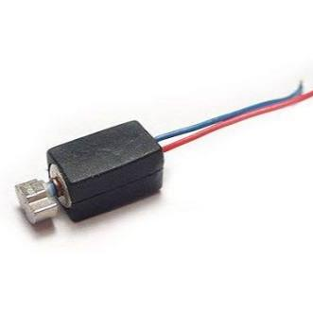

**2-Printed circuit board**

Printed circuit boards are used to support the electronic components mechanically and connect them electrically. PCBs use conductive pathways, tracks, or signal traces etched from laminated copper sheets onto a non-conductive substrate not conducting electricity. Electronic components are then added to the board, and etchings are made on its surface, allowing the current to flow from component to component through the copper.

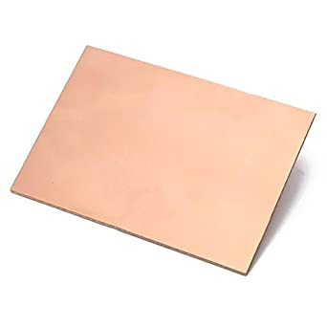

**3-Diodes**

A diode is a two-terminal electronic component that mainly conducts current in one direction (asymmetric conductance); it has low resistance (ideally zero) in one direction, and high resistance (ideally infinite) in the other.

Diode of code 1N4007 is used as it is suitable for my low power application

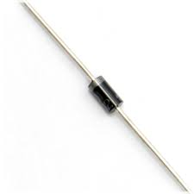

**4-Arduino Nano:**

Arduino is an open source platform used to build projects in the field of electronics. Arduino consists of both a physically programmable circuit board (often called a microcontroller) and a piece of software, or IDE (Integrated Development Environment) running on computer, used to write and upload computer code to the physical board.

Arduino nano is used as its specifications and size is suitable for the application

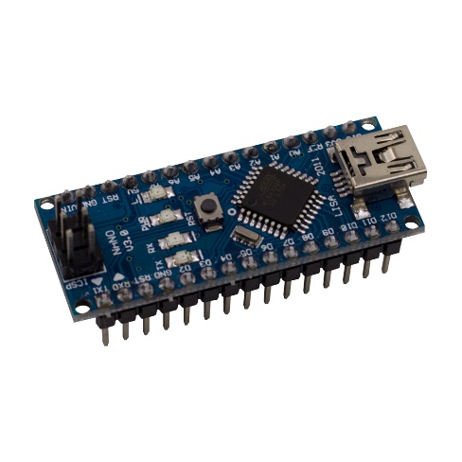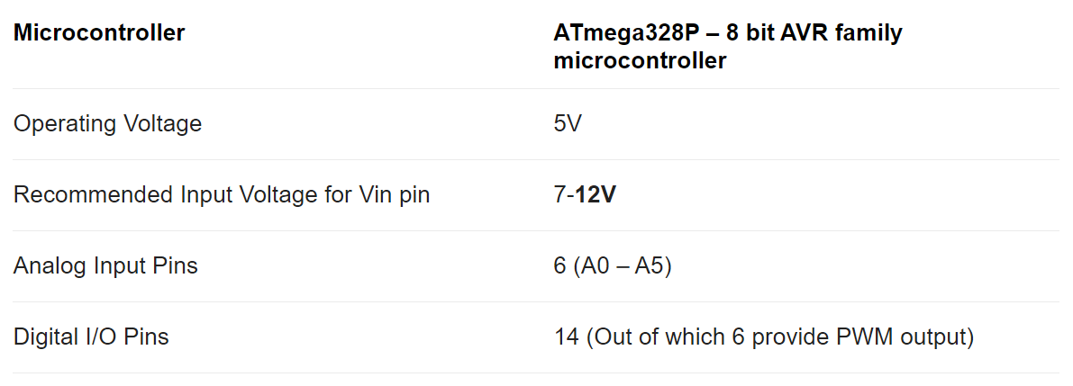

**5-Gloves**

Normal wool leather hybrid gloves.

## 3.3.2Procedures:

1-Circuit design

2-Inking the circuit on PCB

3-Processing the board

4-Connectoins

**1-Circuit design**

It is required to enable 5-Motors using Arduino nano, as the operating current of the motors is too low(4uA/empirical data)(suitable for Arduino nano),I decided to take the signal out from the Arduino to directly enable the motors.

**Schematic:**

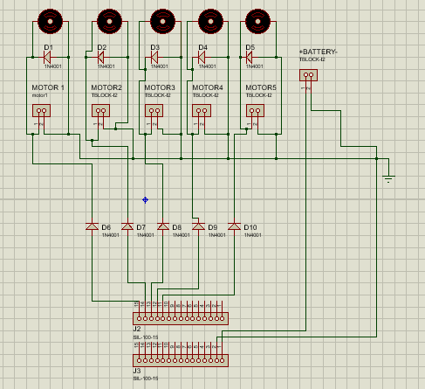

I used proteus to design my schematic because it is simple and offer a good PCB layout feature.

The diodes (D1, D2, D3, D4, D5) is to provide a secure path for the motor's inductive kickback (back emf). If you suddenly try to switch off the current in an inductor, it will produce whatever voltage is needed to keep the current flowing in the short time.

The diodes(D6,D7,D8,D9,D10) is to provide extra security for Arduino from back ,and also as the motors operation voltage varies from 3V to 5V and I don’t prefer to work on a max voltage these diodes will make a voltage drop on each branch by approximately 0.7V that leaves for the motor 4.3V to operate safely.

**PCB layout:**

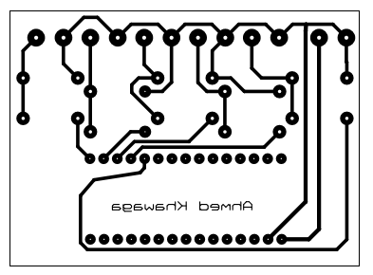

The trace style T25 is used as a factor of safety.

**Top silk:**

Top silk is used to ease the process of attaching the components in the right hole.

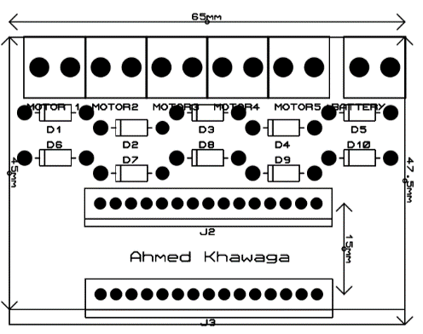

**3d Visualizer:**

Expected final shape of the board.

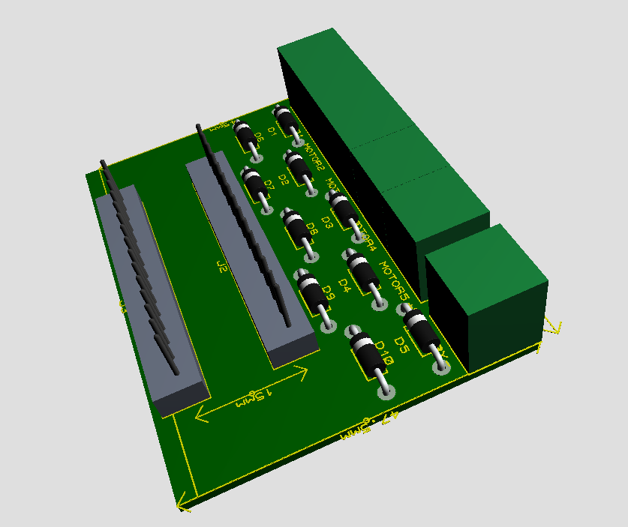

2**-Inking the circuit on PCB**

In order to print the PCB layout on the PCB I used a CNC ink-plotter.

CNC Machines are Computerized Numerical Control Machines used for drawing anything or designing any mechanical part according to the design program fed into their controller. Controller unit can be either microcontroller or computer, depending on what the machine wants to do, programmers use G and M code. While G code is the most common programming language used by the CNC software, M code has specific applications as well.

**Results from inking:**

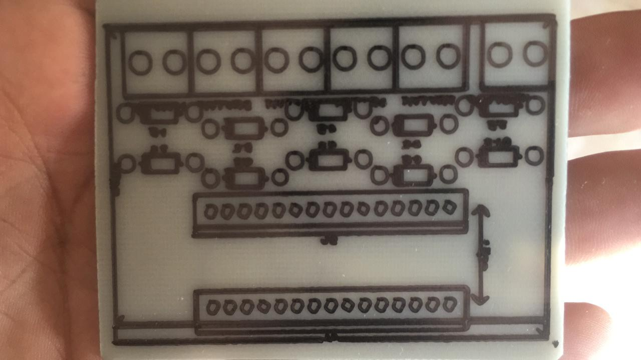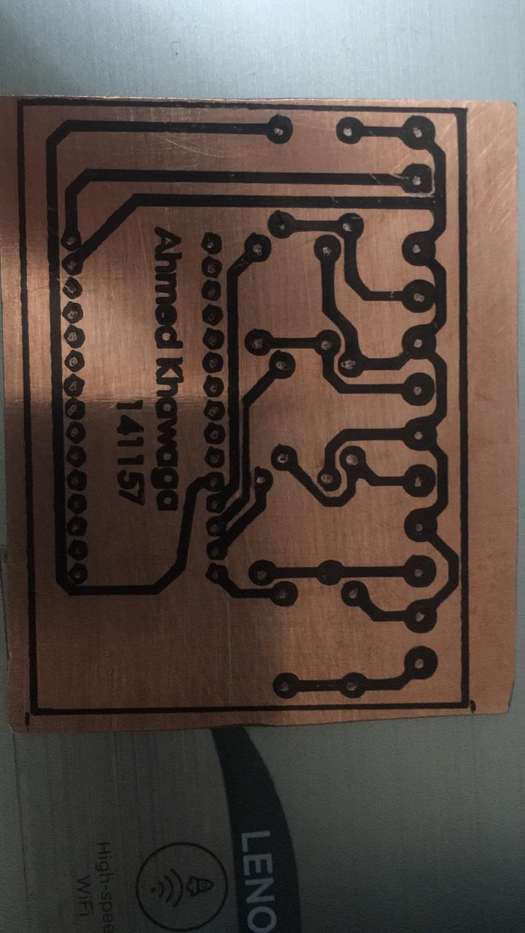

**3-Processing the board:**

In order to etch the PCB, I used HCL and O2 and water to etch all copper except for the traces that inked before.

According to my solutions concentration the ratio for the solution HCL:O2:Water 1:1:2,after mixing the solution I have to put the board in it for 5sec .

**Result from the solution process:**

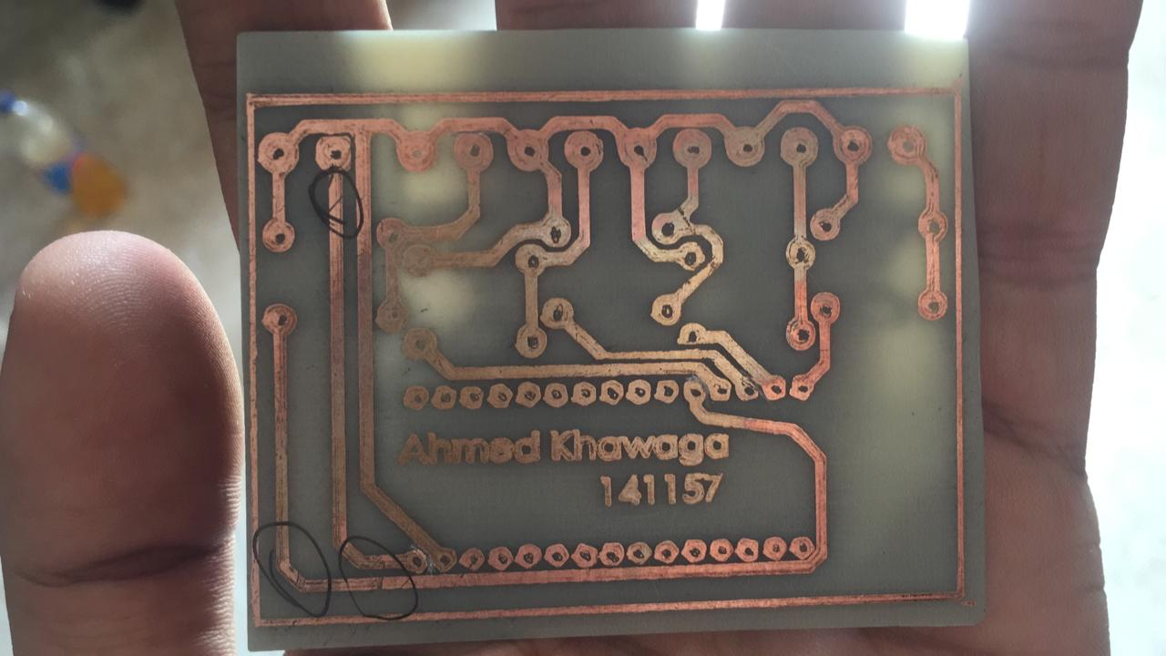

After testing all traces by buzzing comes the drilling the holes for the components and soldering them.

**Result from the whole process:**

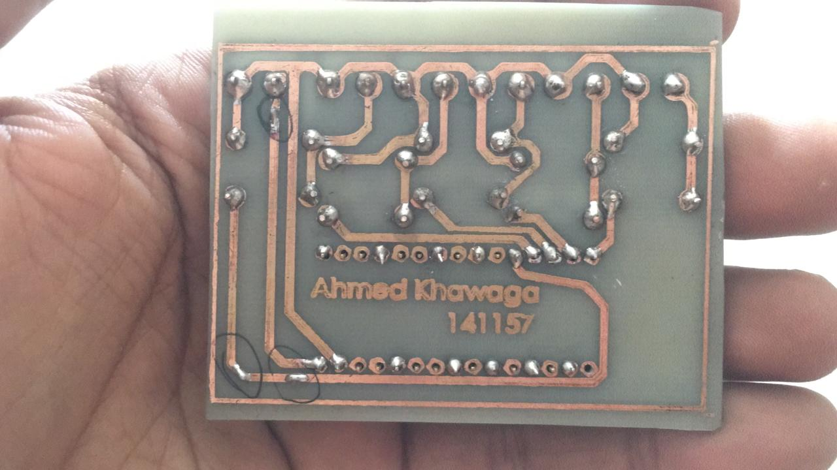

**4-Connectoins**

The last process is to attach the board and the 5-Motors on the gloves, since the connecting material must be flexible due to the continuous motion on the gloves that leads to WAX.

**Testing connection by simple Arduino code:**

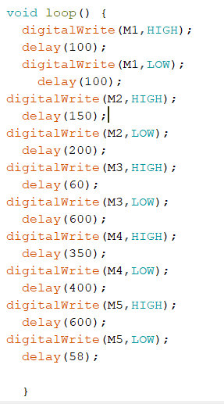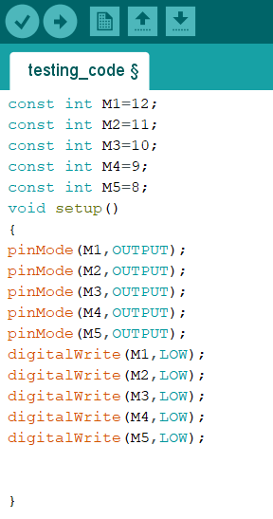

# 4. Implementation.

The implementation is done by importing an image firstly for the desired note then applying the HOUGH line detection algorithm to find the location of all the horizontal lines. Then the same image is fed into the YOLO network that is trained to find melody. The network outputs all the available melodies and their locations. According to the relative location of the melodies for each other and their location relative to the horizontal lines, it decided which detected melody represents which note and what is their sequence.

Imports.

**OpenCV-Python:** It is a library linking Python designed to solve computer vision issues.

**NumPy:** NumPy is an array-processing program widely used. It offers a high-performance multidimensional array object and software to work with these arrays. NumPy can also be used as an effective multidimensional generic data container in addition to its obvious computational uses.

**Math:** The math module in Python is a standard module and is always available. Under this module, using mathematical functions.

**The Glob:** The glob module finds all the pathnames that match a specified pattern according to the Unix shell rules, although results are returned in arbitrary order.

**Line Detector:** Is the code responsible to detect the horizontal lines using HOUGH algorithm.

**PyFirmata** **:** It's basically a prebuilt python software library package that can be installed in Arduino to allow serial communication between a python script on any device and an Arduino. This python package can render any pin read and write on the Arduino.

**The gloves work depending on 2 Equations**

1-line detector to detect the horizontal line in the given image

2-To detect object in the image.

Sample From run.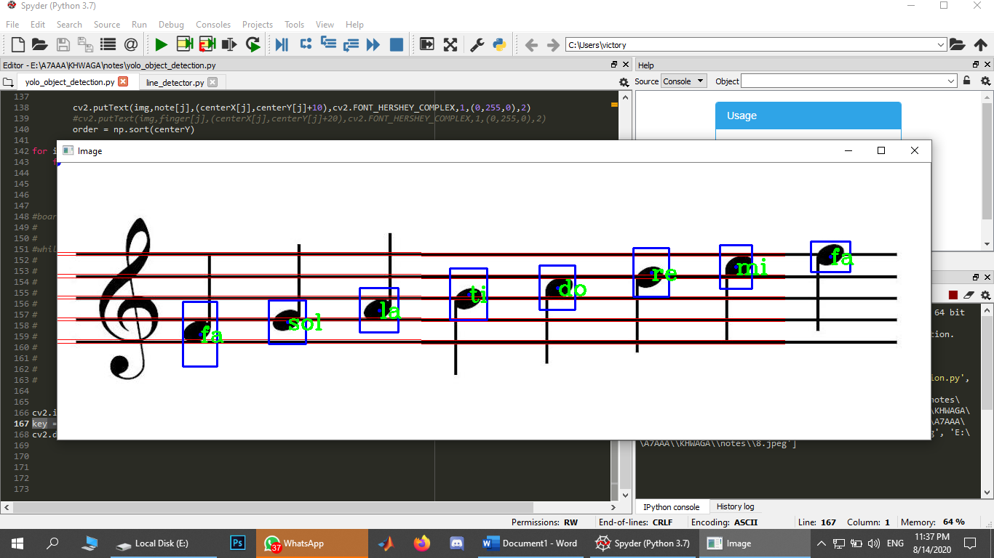

After getting the sequence the second step is the hardware implementation which is done on an Arduino uno board and the code is automatically generated using the python pyfirmata library which generates C codes for the board.

For the audio path first, the record is sectioned into subsections with length of half a second or a whole each. Then each subsection is fed into a Fourier series analysis algorithm which is responsible for detecting the dominant frequency in each subsection. According to the output, it decided which melody it belongs to and then the auto code generation step proceeds

# 5. Testing and Evaluation.

## 5.1 Testing.

For the testing step it is done by using multiple images with different sizes and sequences to determine the efficiency of the algorithm and then comparing the results

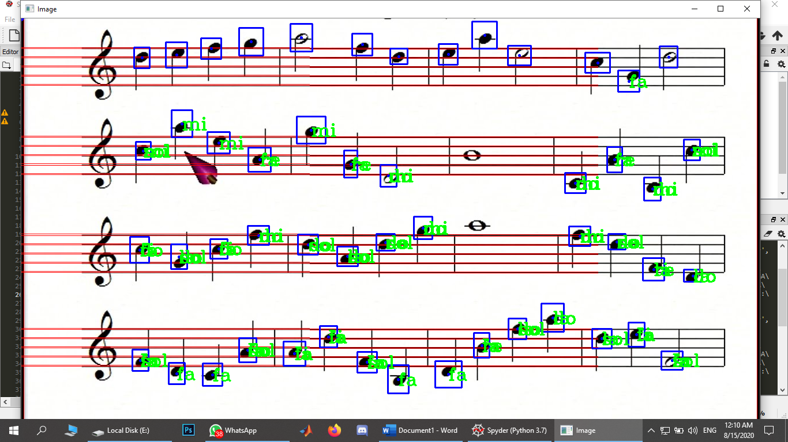

## 5.2 Evaluation.

It has been noticed that the smaller the note the better the classification and the better the results. As notes become complicated and increase the accuracy and the overall performance decreases. It also could be better for YOLO model to fully classify the detected melodies instead of only outputting its location and this could increase the accuracy, the performance and overcome the dimensionality and complexity problems of the note itself.

# 6. Results and Discussions.

After testing the automated system, the code and functions necessary for optimization, efficiency displays, epochs, training accuracy and test accuracy are added. We dived the data set into two main point for testing and training. The data set divided into 80% training and 20 % for the testing. And for the accuracy it is 75% A help function is added which plots the test images and a help function which shows the results is added.

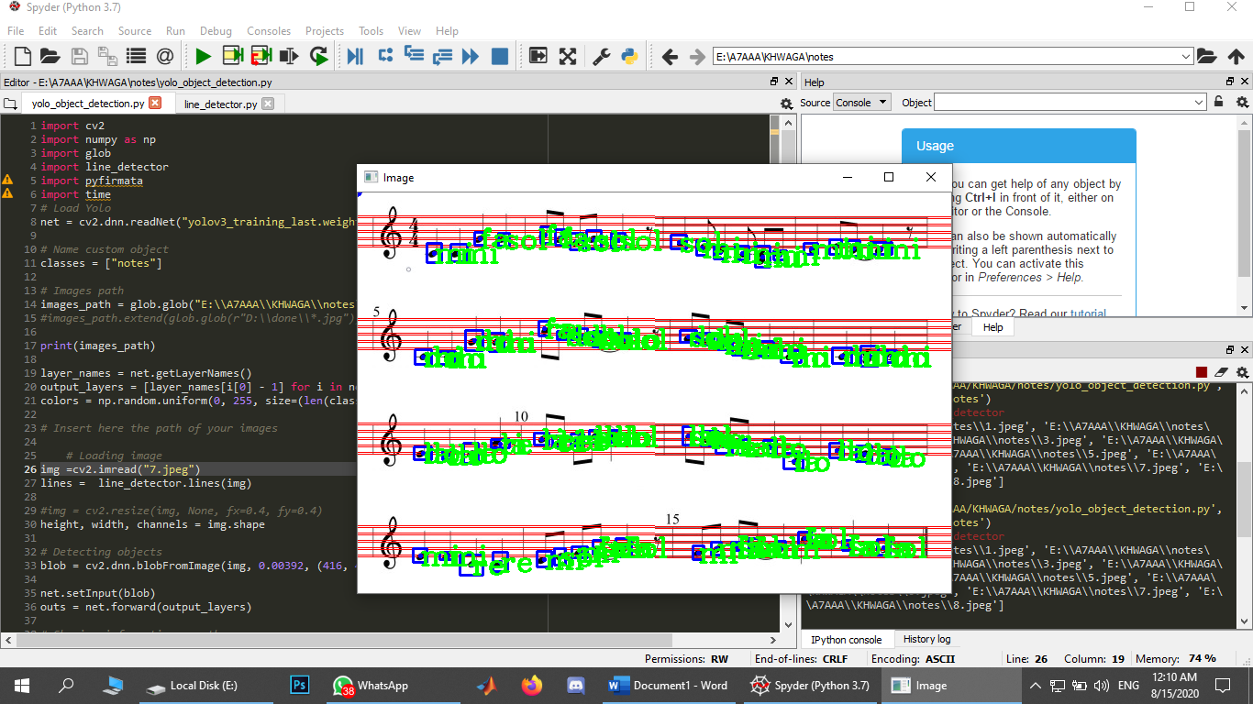

# 7. Conclusion and Future Work.

## 7.1 Conclusion.

Finally, this paper mentioned all the procedures for manufacturing the MMT product and its system components. As well as there were some problems and it was easy to find solutions and there were some problems and I had to ignore it because it doesn’t have any solution, for example, the gloves only have 10 fingers and the piano keyboards have more than 10 keys. Besides, this paper mentioned the steps of the implementation, the results of testing and evaluating the product then analyzing and discussing these results. Finally, MMT worked successfully and perform his responsibilities accurately.

## 7.2 Future work.

In the future, we will create a mobile application that will be responsible to upload an audio or image note on the gloves and control the number of repeating notes. In addition, the gloves will be manufacture with high-quality and will be over-qualified. We will reduce its size and makes its special design.

# References

Caitlyn Seim, Thad Eugene Starner. *Patent Application Publication*. 29 October 2015. 13 August 2020. <https://patentimages.storage.googleapis.com/b3/82/dc/113fab605a9bba/US20150310762A1.pdf>.

Hamed Ketabdar, Amirhossein Jahanbekam et al. *MagiMusic: using embedded compass (magnetic) sensor for touch-less gesture based interaction with digital music instruments in mobile devices*. January 2010. 13 August 2020. <https://dl.acm.org/doi/abs/10.1145/1935701.1935749>.

Kevin Huang, Thad Starner et al. *Mobile music touch: mobile tactile stimulation for passive learning*. April 2010. 12 August 2020. <https://dl.acm.org/doi/10.1145/1753326.1753443>.

M, Neeraj. *Mobile Music Touch Gloves: Wear And Play Like Beethoven* . 2014 July 2016. 13 August 2020. <https://dazeinfo.com/2014/07/01/mobile-music-touch-gloves-wear-play-like-beethoven/>.

*Mobile Music Touch*. 5 September 2013. 13 August 2020. <https://www.studymode.com/essays/Mobile-Music-Touch-1920146.html>.

Mosler W. 7 Deadly Innocent Frauds of Economic Policy. St. Croix, USVI: Valance Company; 2013.

Palley TI. The Critics of Modern Money Theory (MMT) are Right. Review of Political Economy. 2014;27(1):45-61. doi:10.1080/09538259.2014.957473

Krugman P. MMT, Again. The New York Times. https://krugman.blogs.nytimes.com/2011/08/15/mmt-again/. Published August 15, 2011.

Strain MR. ‘Modern Monetary Theory’ Is a Joke That’s Not Funny. Bloomberg. https://www.bloomberg.com/opinion/articles/2019-01-17/modern-monetary-theory-would-sink-u-s-in-debt. Published January 17, 2019.

# 1, Appendix 1



Figure 1 Displays used vibration motor, and it can generate strong tactile sensations while it is small.

Figure 2 controller

Figure 3 Gloves



Figure 4 Work methodology

Figure 5 Gantt chart

Figure 6 Imports

Figure 7 Line detector Equation.

Figure 8 Sample from run



Figure 9 Music scale



Figure 10 Algorithm



Figure 11Algorithm while working