**android E-PROJECT**



**Leave Management System**

**GROUP MEMBERS: SUBMITTED TO:**

* **HAFIZ MUHAMMAD WAQAS aatikaliaquat@aptechnn.com**
* **MUHAMMAD HUZAIFA PROJECT INSTRUCTOR:**
* **SOHAIB HUSSAIN SIDDIQUI AATIKA LIAQUAT**
* **SYED MUHAMMAD AHMED KHURSHID CURRICULUM CODE:**

APTECH NN

**6740**



APTECH NN

**SPLASH SCREEN**

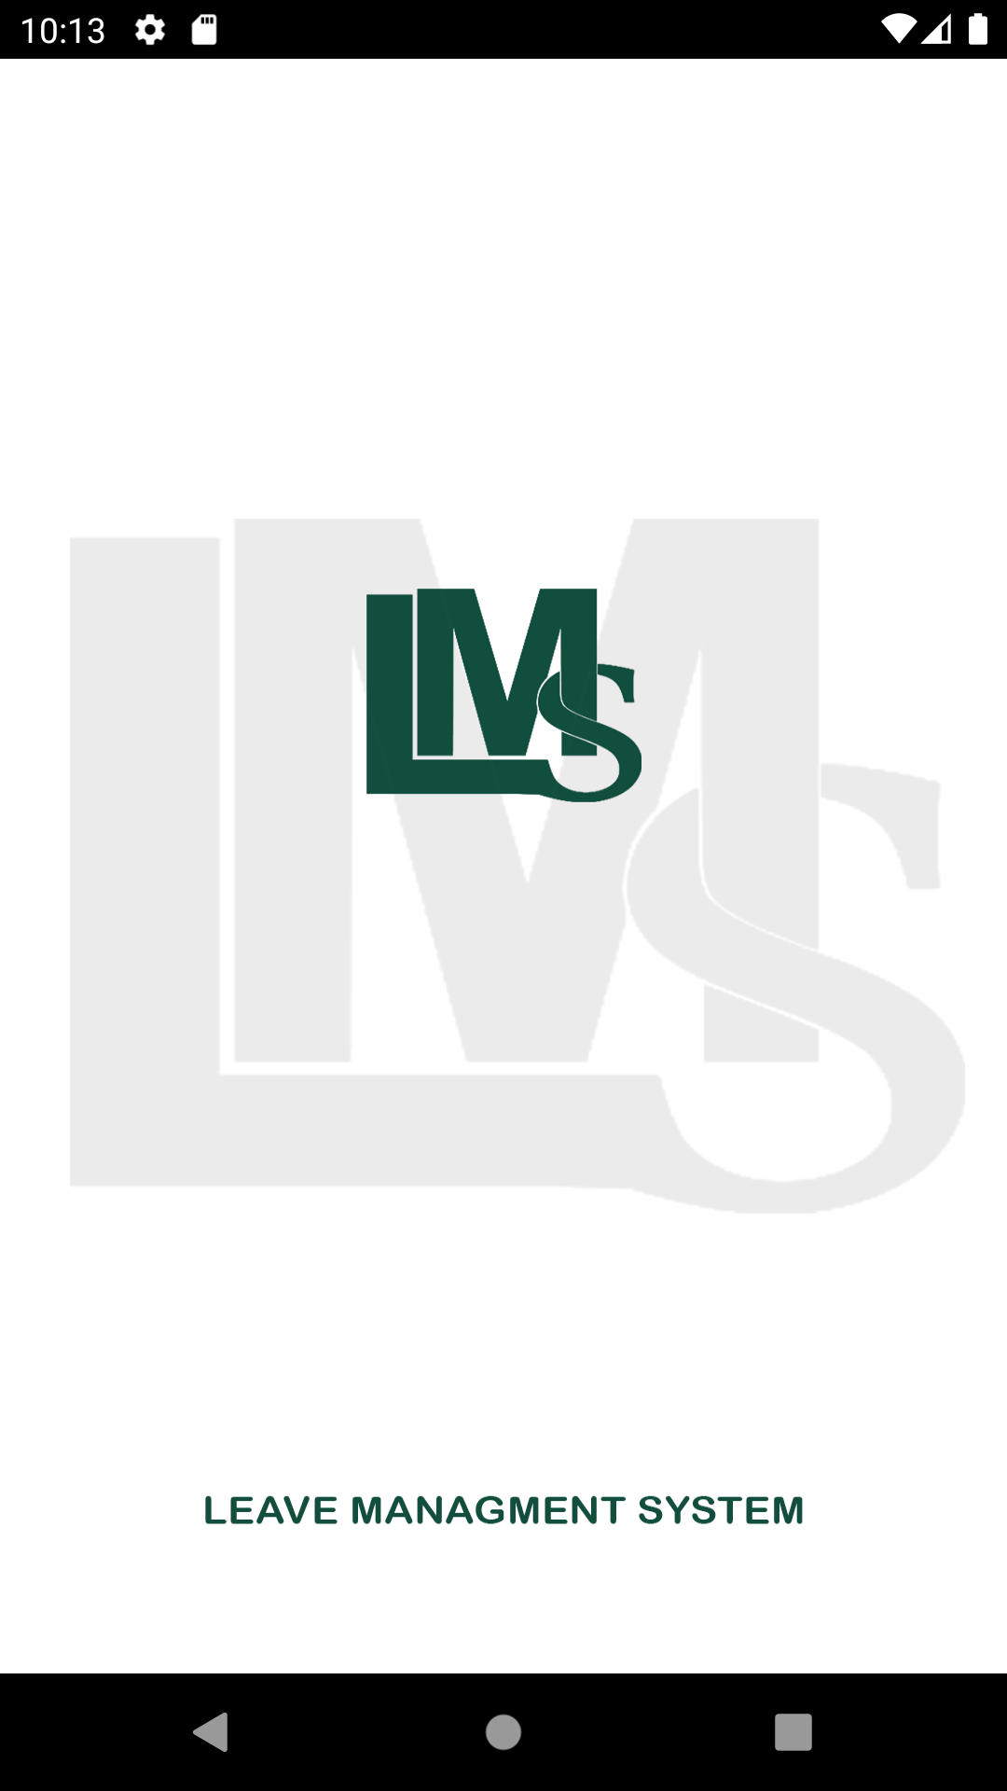

**LOGIN PAGE:**

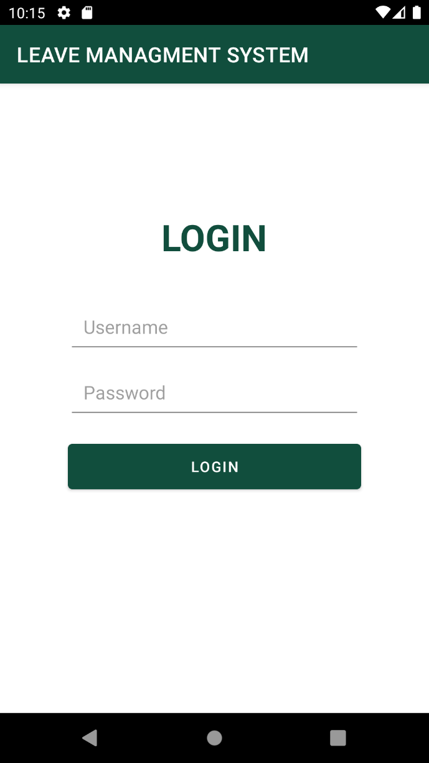

**welcome page:**



**APPLY LEAVE ACITIVITY:**

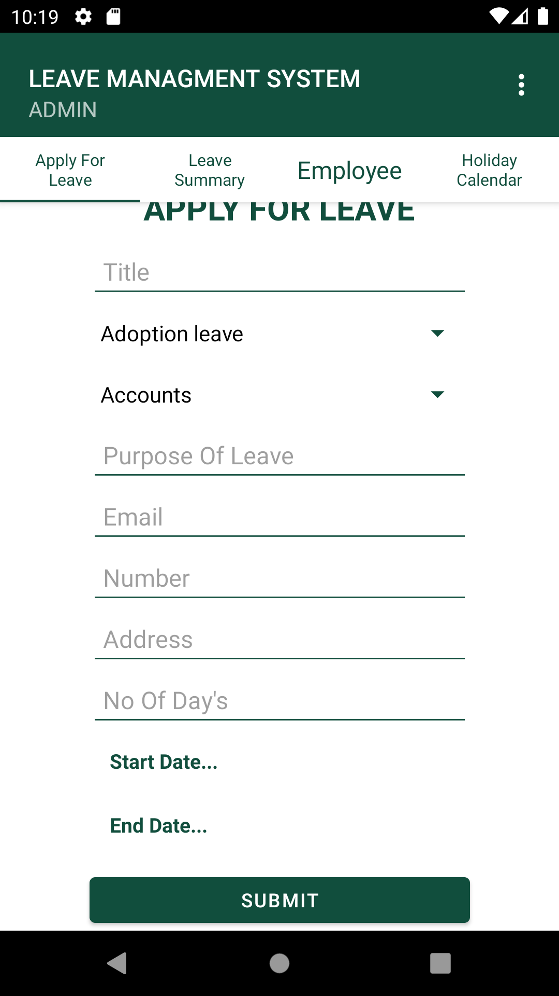

**ADMIN PANEL:**

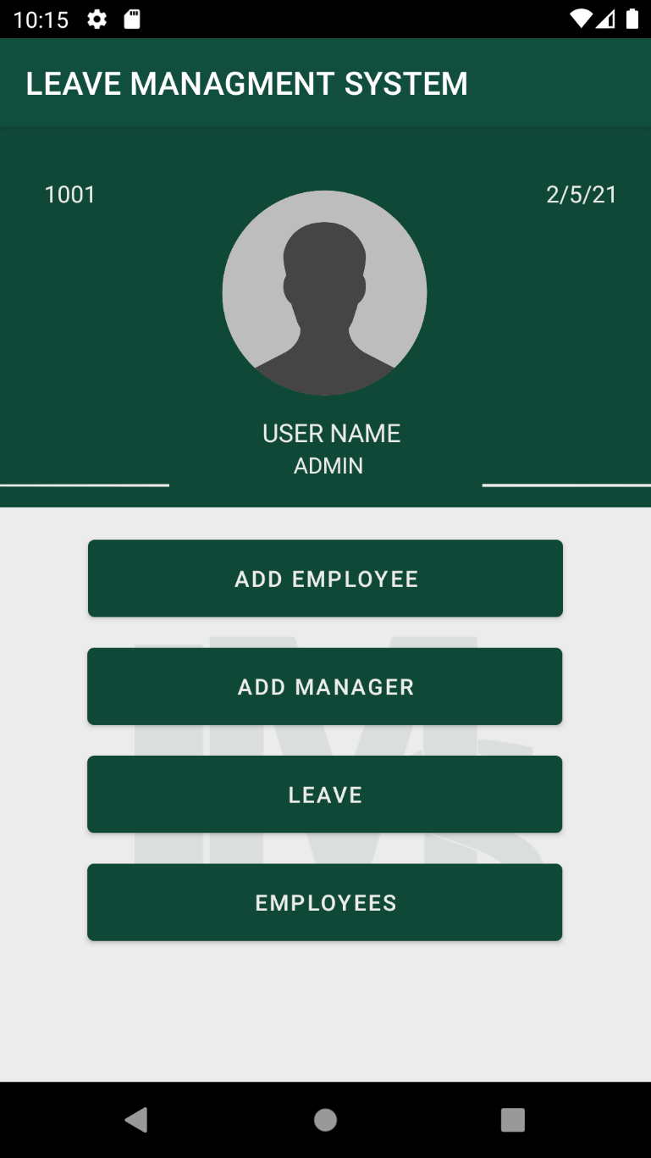

THANK YOU…