**The goal :**

**cluster the colors of the image to a smaller number of clusters (input) .**

## Some Usages :

1. ***Target different devices:*** color quantization is critical for displaying images with many colors on devices that can only display a limited number of colors, usually due to memory limitations.
2. ***Image compression:*** by reducing number of bits per pixels without affecting the image view. It’s used as a step in the compression pipeline of most common formats like JPEG and MPEG.
3. ***Image segmentation:*** is the process extracting useful objects from an image.

**The main idea :**

**find the distinct colors and construct a graph where the euclidean distance between 2 colors is the cost of the edge between them , after constructing the graph find the minimum spanning tree between all colors .**

**the total time needed to cluster an image of resolution 8K is only ~ 70 seconds .**

**Graph construction: using a Boolean array to find the distinct colors in the image .**

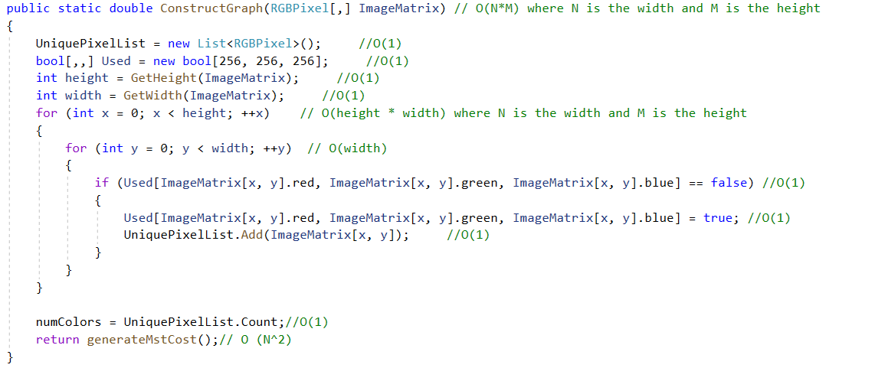

**Using Disjoint union find data structure to find the minimum spanning tree .**

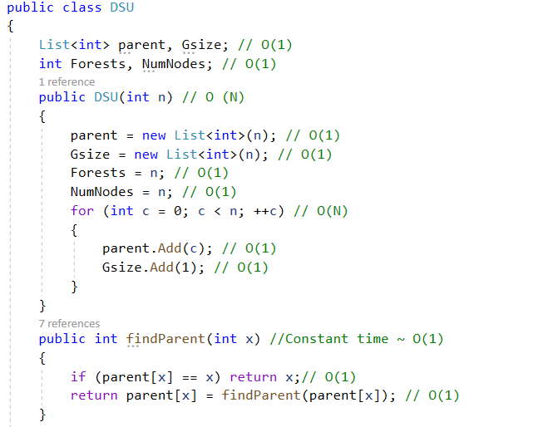

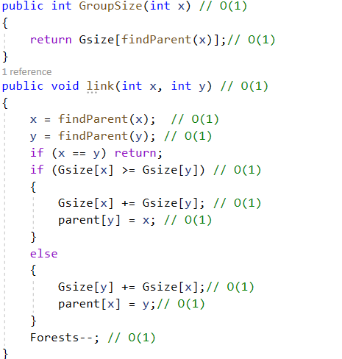

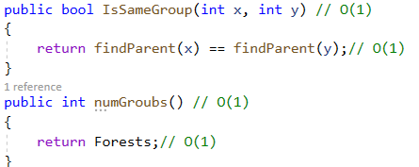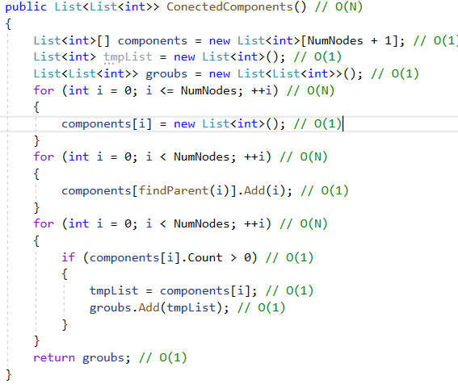

**Calculating Minimum Spanning Tree Cost :**

**Using prim algorithm to find the minimum spanning tree , but instead of using priority queue , use a single variable to find the next working node , and use array to obtain the cost of the unvisited nodes .**

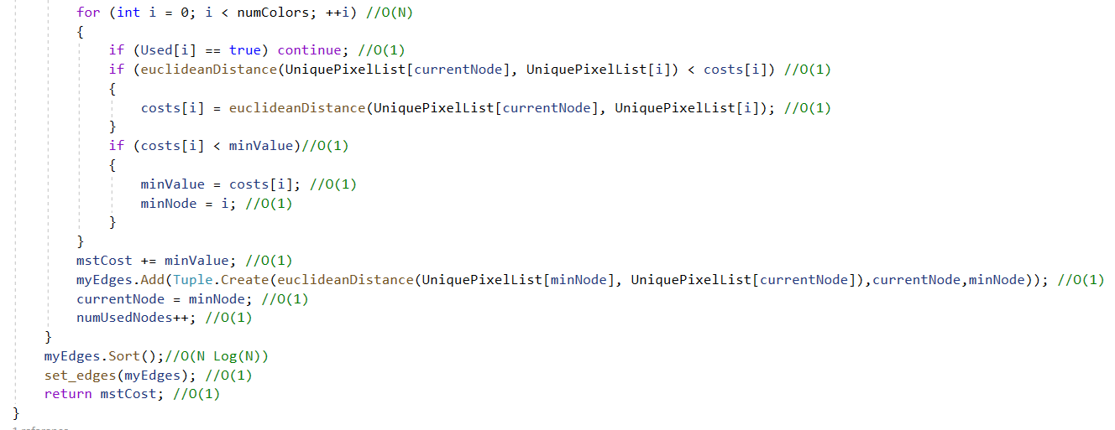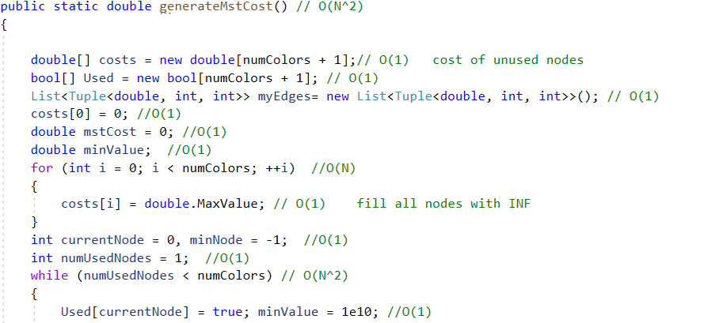

**Euclidean Distance between two colors:**

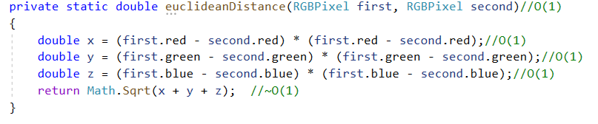

**Finding The Clusters :**

**Merging the colors with the minimum edge cost and not in the same group . until the current number of clusters equals the required number .**

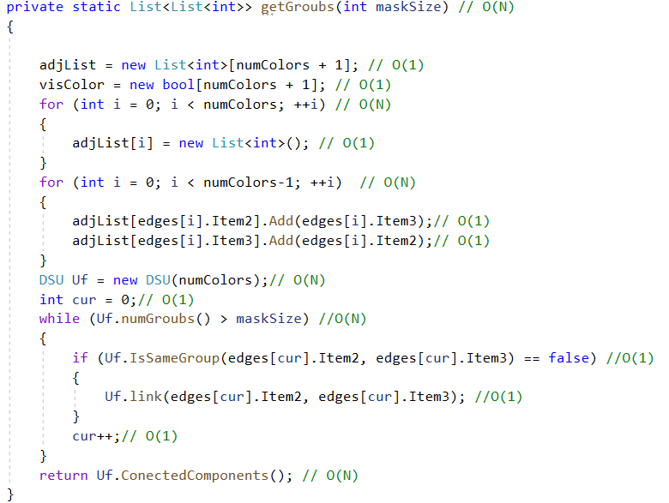

**Calculating the centroid of each cluster :**

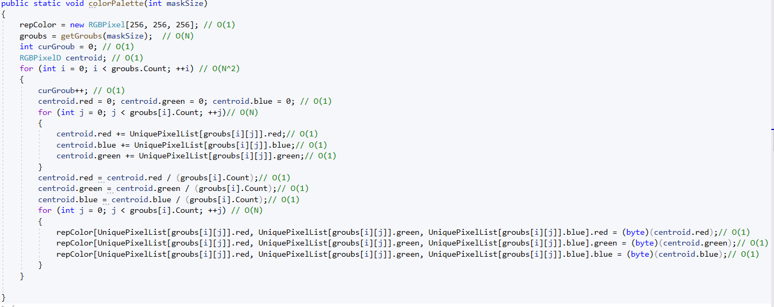

**recoloring the image with the new number of clusters**

