Pneumonia
Disease Overview, Symptoms, Types & Historical Research
March 2026

1. Introduction
Pneumonia is one of the oldest known diseases in human history, yet it remains one of the leading causes of death worldwide. According to the World Health Organization (WHO), pneumonia kills more children under the age of five than any other infectious disease, accounting for approximately 14% of all deaths in that age group annually. The disease affects people of all ages, but is particularly dangerous for the very young, the elderly, and those with weakened immune systems.

Pneumonia is characterized by inflammation of the lung tissue, most commonly caused by infection with bacteria, viruses, or fungi. Despite advances in medicine and the development of antibiotics and vaccines, pneumonia continues to pose a major global health burden, especially in low- and middle-income countries where access to healthcare is limited.

2. What is Pneumonia?
Pneumonia is an acute respiratory infection that affects the lungs. It occurs when the alveoli — the tiny air sacs that make up the bulk of the lungs — become inflamed and fill with fluid or pus. This makes breathing painful and limits the amount of oxygen that can enter the bloodstream, potentially depriving vital organs of the oxygen they need to function.

The lungs are a pair of spongy, air-filled organs located on either side of the chest. When healthy, the alveoli fill with air during each breath. In pneumonia, these sacs fill with fluid and pus, causing symptoms such as cough, fever, chills, and difficulty breathing. In severe cases, pneumonia can lead to respiratory failure and death.

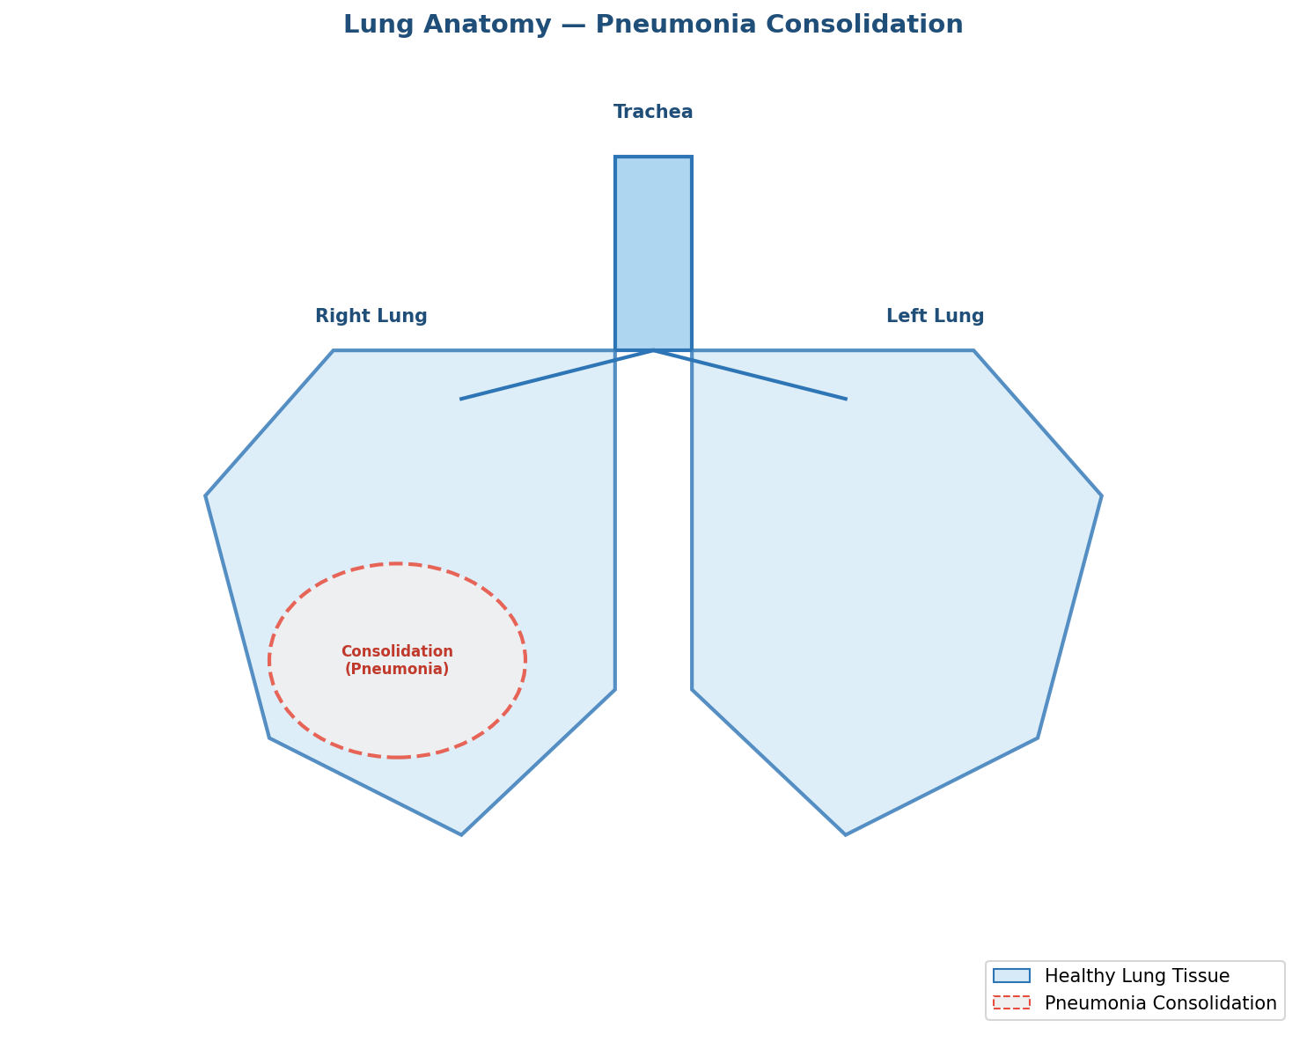
Figure 1: Diagram showing the lung anatomy and the area of consolidation caused by pneumonia

3. Types of Pneumonia
Pneumonia is classified in several different ways — by the causative agent, by the location in the lung where it occurs, or by where and how it was acquired. Understanding the type of pneumonia is important because it determines the appropriate treatment.

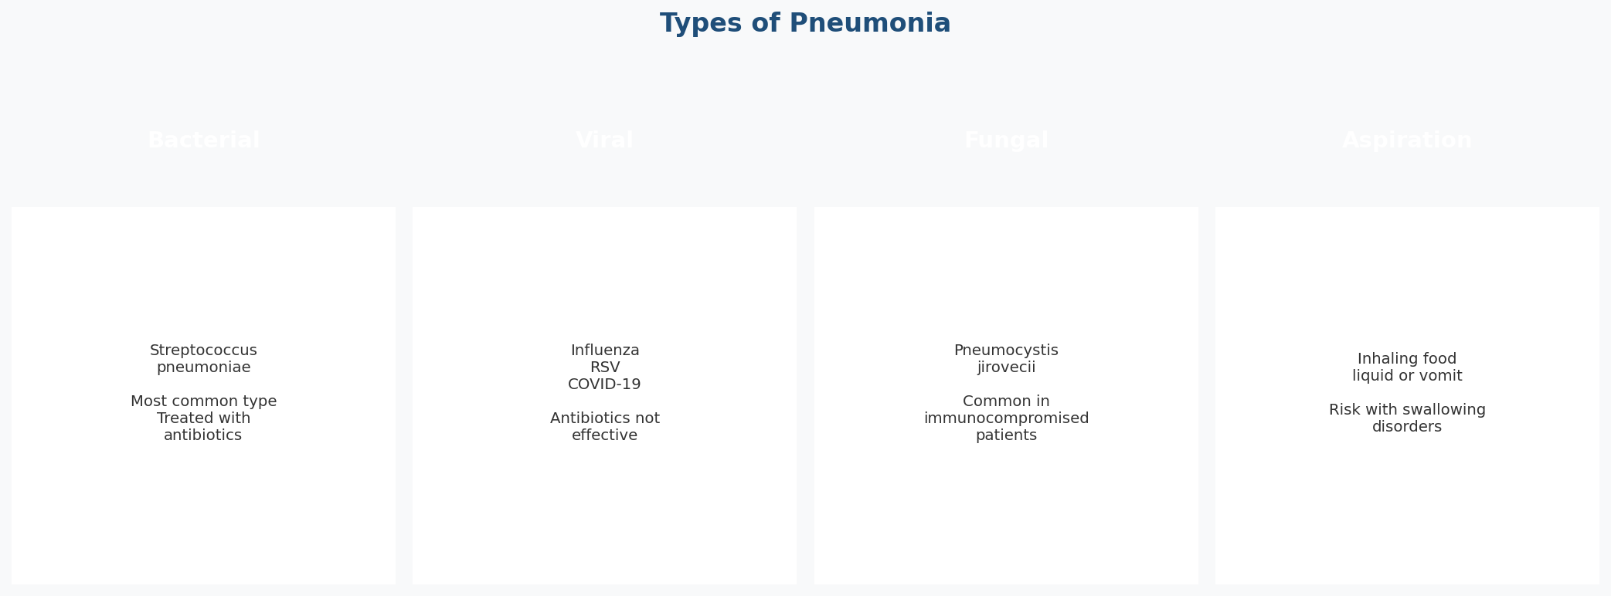
Figure 2: The four main types of pneumonia classified by causative agent

3.1 Bacterial Pneumonia
Bacterial pneumonia is the most common form of the disease in adults. The most frequent causative organism is Streptococcus pneumoniae (also called pneumococcus), though many other bacteria can also cause pneumonia, including Haemophilus influenzae, Staphylococcus aureus, and Klebsiella pneumoniae. Bacterial pneumonia is typically treated with antibiotics and, if caught early, responds well to treatment.

3.2 Viral Pneumonia
Viral pneumonia is more common in children than in adults. It can be caused by a wide range of viruses, including influenza A and B, respiratory syncytial virus (RSV), adenovirus, and — more recently — SARS-CoV-2 (the virus that causes COVID-19). Viral pneumonia does not respond to antibiotics; treatment focuses on supportive care and, in some cases, antiviral medications.

3.3 Fungal Pneumonia
Fungal pneumonia is less common but can be very serious. It is most frequently seen in people with weakened immune systems, such as those with HIV/AIDS, cancer patients undergoing chemotherapy, or organ transplant recipients taking immunosuppressive drugs. The most common causative organism is Pneumocystis jirovecii, formerly known as Pneumocystis carinii (PCP).

3.4 Aspiration Pneumonia
Aspiration pneumonia occurs when food, liquid, vomit, or other foreign material is inhaled into the lungs. This disrupts the normal lung defenses and allows bacteria from the mouth and throat to cause infection. It is more common in people with swallowing disorders, neurological conditions, or altered consciousness.

4. Signs and Symptoms
The symptoms of pneumonia can range from mild to severe, depending on the type of pneumonia, the causative organism, the patient's age, and their overall health status. In some cases — particularly in older adults, infants, and immunocompromised individuals — symptoms may be atypical or may develop gradually.

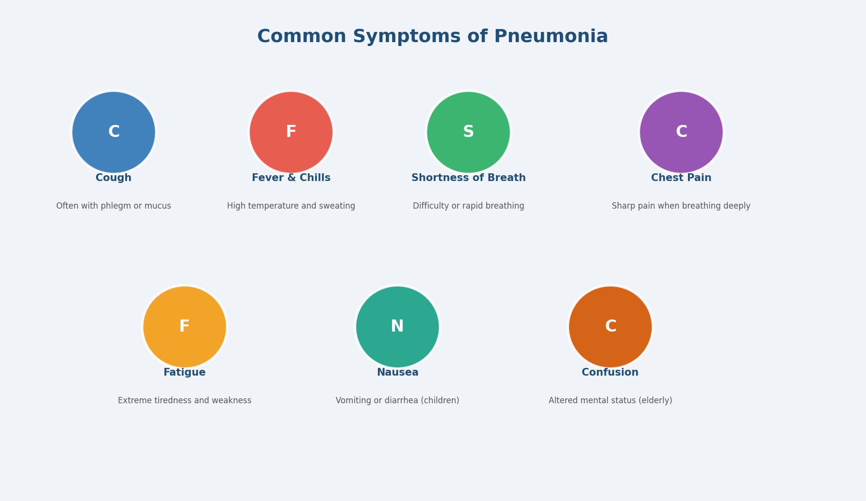
Figure 3: Common symptoms of pneumonia across all patient groups

4.1 Common Symptoms
- Cough — often productive, bringing up green, yellow, or blood-streaked mucus
- Fever — typically high (38.5°C / 101.3°F or above), accompanied by sweating and chills
- Shortness of breath — even when resting in severe cases
- Chest pain — sharp or stabbing, typically worsening with deep breathing or coughing (pleuritic pain)
- Fatigue and general weakness — often severe and prolonged
- Loss of appetite and dehydration
- Rapid breathing (tachypnea) and rapid heart rate (tachycardia)
- Bluish discoloration of lips or fingertips (cyanosis) — in severe cases indicating low oxygen

4.2 Symptoms in Specific Groups
Pneumonia can present differently depending on the patient's age and health status. In newborns and infants, symptoms may include difficulty feeding, grunting sounds during breathing, or the chest sinking inward with each breath. In elderly patients, the classic fever and cough may be absent; instead, confusion, sudden deterioration, or a fall may be the first sign. In immunocompromised individuals, symptoms may be less pronounced but the disease can progress much more rapidly.

5. Diagnosis
Accurate diagnosis of pneumonia requires a combination of clinical assessment, laboratory investigations, and medical imaging. No single test is sufficient on its own.

5.1 Clinical Examination
A physician will listen to the lungs with a stethoscope for abnormal breath sounds such as crackling (rales), reduced or absent breath sounds over consolidated areas, or dullness on percussion. These findings, combined with the patient's symptoms and history, provide the initial basis for suspecting pneumonia.

5.2 Chest X-Ray
Chest radiography is the gold standard imaging modality for diagnosing pneumonia. On a chest X-ray, pneumonia typically appears as an area of increased opacity (white or grey coloring) in one or both lungs, representing the consolidation of fluid, pus, and inflammatory cells in the alveoli. Lobar pneumonia affects an entire lobe and appears as a well-defined area of opacity. Bronchopneumonia, by contrast, shows patchy infiltrates distributed throughout the lung.

5.3 Laboratory Tests
- Complete blood count (CBC) — elevated white blood cell count suggests bacterial infection
- Blood cultures — to identify the causative organism and guide antibiotic selection
- Sputum culture and sensitivity — to identify the bacteria and test antibiotic susceptibility
- C-reactive protein (CRP) and procalcitonin — inflammatory markers that help assess severity
- Arterial blood gas (ABG) — to assess oxygen levels and respiratory function in severe cases

6. Complications
While many cases of pneumonia resolve fully with appropriate treatment, serious complications can develop — particularly in vulnerable populations or when diagnosis and treatment are delayed.

- Bacteremia — bacteria entering the bloodstream can spread to other organs, causing sepsis, a life-threatening condition
- Pleural effusion — fluid accumulation in the space between the lungs and chest wall, which may require drainage
- Empyema — pus in the pleural space, requiring chest tube drainage and prolonged antibiotics
- Lung abscess — a pocket of pus that forms in the lung tissue, sometimes requiring surgical intervention
- Respiratory failure — severe pneumonia can lead to acute respiratory distress syndrome (ARDS), requiring mechanical ventilation
- Multi-organ failure — in the most severe cases, particularly in elderly or immunocompromised patients

7. Key Scientists in the History of Pneumonia Research
Our current understanding of pneumonia has been built upon centuries of scientific inquiry. The following scientists made particularly significant contributions to the identification, understanding, and management of the disease.

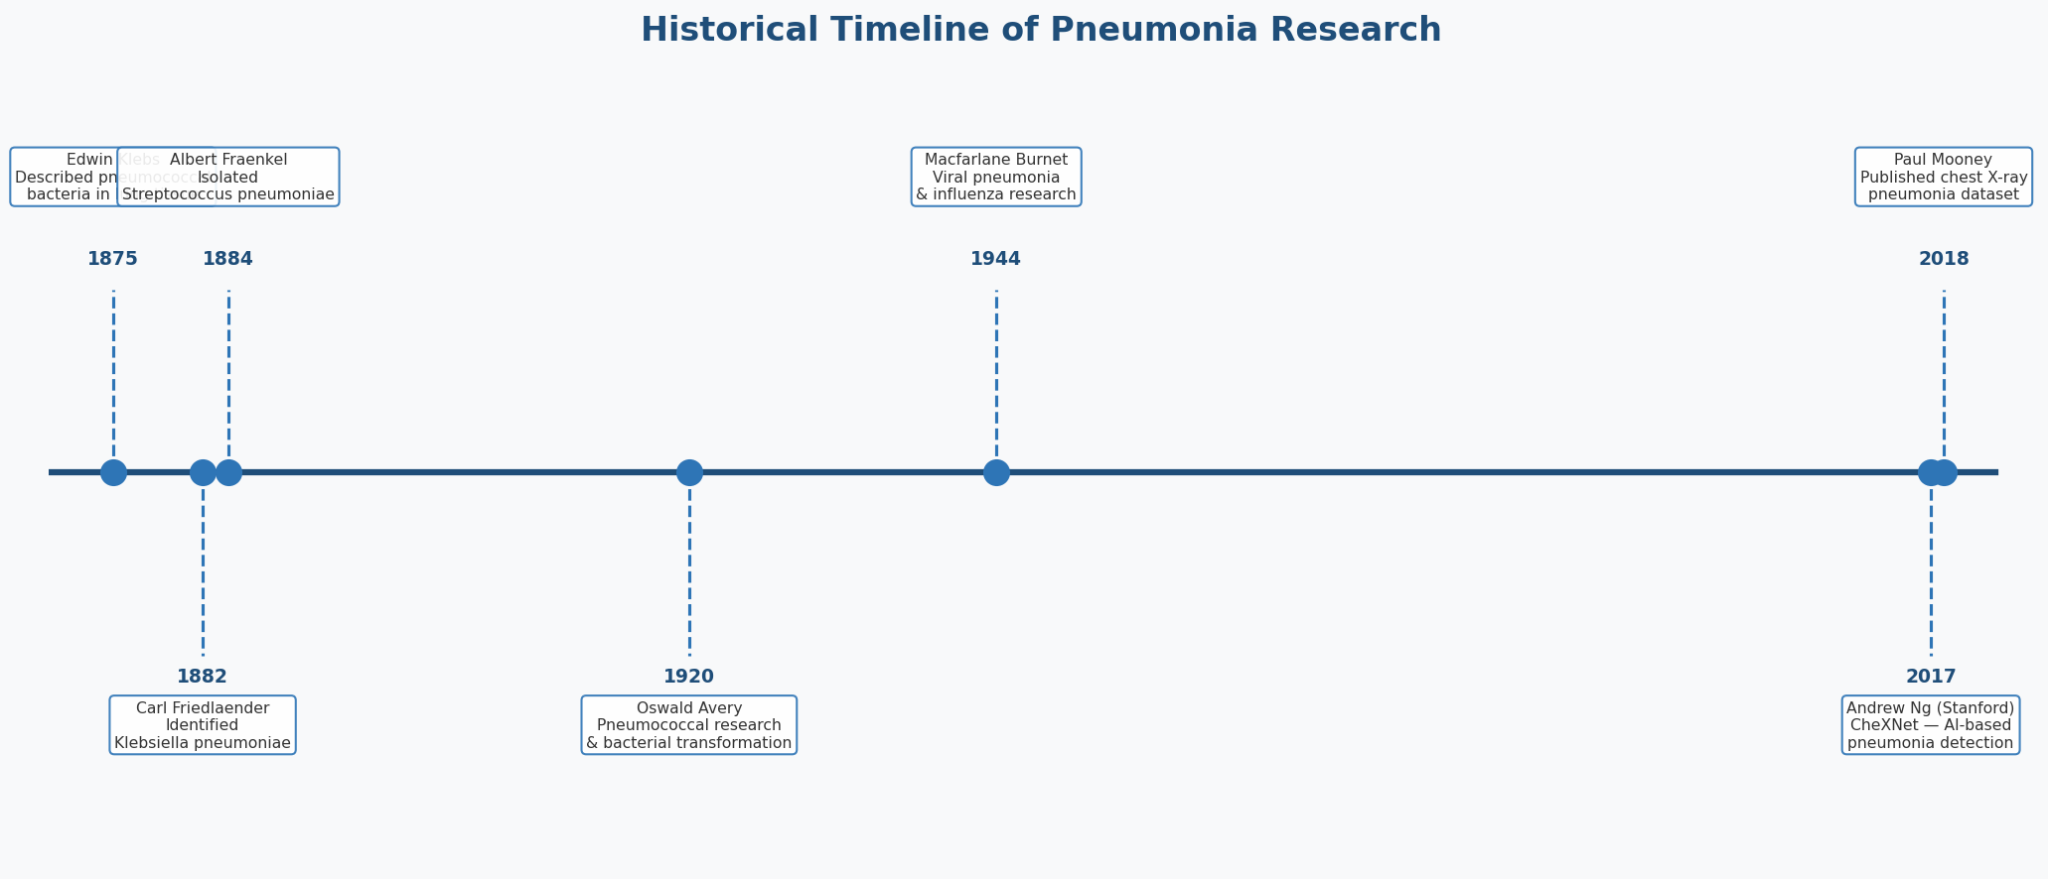
Figure 4: Historical timeline of major milestones in pneumonia research

Scientist / Team | Country | Contribution | Year
Edwin Klebs | Germany | First to describe pneumococcal bacteria in pulmonary tissue | 1875
Carl Friedlaender | Germany | Identified Klebsiella pneumoniae as a distinct cause of pneumonia | 1882
Albert Fraenkel | Germany | Isolated Streptococcus pneumoniae, establishing it as the primary cause of bacterial pneumonia | 1884
Oswald Avery | USA | Pioneered pneumococcal research and demonstrated that DNA carries genetic information (using pneumococci) | 1920s-1944
Macfarlane Burnet | Australia | Advanced the understanding of viral pneumonia, influenza, and host immune responses | 1940s-1960s
Maurice Hilleman | USA | Developed vaccines against pneumococcal pneumonia and influenza, saving millions of lives | 1950s-1980s
Robert Austrian | USA | Led clinical trials proving the effectiveness of pneumococcal vaccines in adults | 1970s
Andrew Ng & team | USA (Stanford) | Developed CheXNet — a deep learning system that detects pneumonia on chest X-rays at radiologist level | 2017
Paul Mooney | USA (Kaggle) | Published the chest X-ray pneumonia dataset used by researchers worldwide for AI-based detection | 2018

7.1 Edwin Klebs (1834–1913)
Carl Friedrich Wilhelm Klebs was a German-Swiss pathologist who made the first histological observation of bacteria in the lungs of patients who had died of pneumonia in 1875. Although he did not successfully isolate the organism, his work laid the foundation for the bacteriological discoveries that followed. Klebs is also remembered for his discovery of the diphtheria bacillus, named Klebs-Loeffler bacillus in his honor.

7.2 Carl Friedlaender (1847–1887)
Carl Friedlaender was a German pathologist and bacteriologist who, in 1882, isolated and described the bacterium now known as Klebsiella pneumoniae (originally called Friedlaender's bacillus). This Gram-negative bacterium is responsible for a less common but particularly severe form of pneumonia, especially in hospitalized and immunocompromised patients. Friedlaender's meticulous laboratory work helped establish the bacterial etiology of pneumonia.

7.3 Albert Fraenkel (1848–1916)
Albert Fraenkel was a German physician who, in 1884, successfully isolated Streptococcus pneumoniae (the pneumococcus) from the lungs of patients who had died of lobar pneumonia. This landmark discovery established pneumococcus as the primary causative agent of bacterial pneumonia and provided the scientific foundation for subsequent development of antibiotics and vaccines targeting this organism.

7.4 Oswald Avery (1877–1955)
Oswald Theodore Avery was a Canadian-American physician and medical researcher who spent most of his career at the Rockefeller Institute in New York. His decades of work on Streptococcus pneumoniae led to the landmark 1944 discovery — together with Colin MacLeod and Maclyn McCarty — that DNA is the material responsible for carrying genetic information. This discovery, made using pneumococcal bacteria, is considered one of the most important in the history of molecular biology.

7.5 Andrew Ng & Stanford ML Group (2017)
In 2017, Andrew Ng and his team at Stanford University published CheXNet, a deep learning algorithm trained on over 100,000 chest X-ray images from the NIH Clinical Center. CheXNet uses a 121-layer Dense Convolutional Network (DenseNet) and was demonstrated to detect pneumonia on chest X-rays at a level exceeding that of practicing radiologists. This groundbreaking work opened a new era of AI-assisted medical imaging diagnosis and inspired countless subsequent research projects, including the work presented in this report.

8. Treatment and Prevention

8.1 Treatment
Treatment depends on the causative agent and severity of the disease. Bacterial pneumonia is treated with antibiotics. Viral pneumonia is managed with supportive care and, in some cases, antiviral medications such as oseltamivir for influenza. Fungal pneumonia requires antifungal agents. In severe cases, hospitalization with oxygen therapy or mechanical ventilation may be necessary.

8.2 Prevention
- Vaccination — pneumococcal vaccines (PCV13, PPSV23) and influenza vaccines are highly effective preventive measures
- Good hygiene — handwashing and respiratory etiquette reduce the spread of infectious agents
- Smoking cessation — smoking damages the lungs' natural defense mechanisms
- Adequate nutrition — malnutrition weakens the immune system, increasing susceptibility
- Breastfeeding — protects infants through maternal antibodies and immune factors

9. References
[1] World Health Organization. (2022). Pneumonia Fact Sheet. Available at: https://www.who.int/news-room/fact-sheets/detail/pneumonia

[2] Fraenkel, A. (1884). Ueber die genuine Pneumonie. Berliner klinische Wochenschrift, 21, 673–681.

[3] Avery, O. T., MacLeod, C. M., & McCarty, M. (1944). Studies on the Chemical Nature of the Substance Inducing Transformation of Pneumococcal Types. Journal of Experimental Medicine, 79(2), 137–158.

[4] Rajpurkar, P., Irvin, J., Ball, R. L., et al. (2017). CheXNet: Radiologist-Level Pneumonia Detection on Chest X-Rays with Deep Learning. Stanford ML Group. arXiv:1711.05225.

[5] Niederman, M. S., et al. (2001). Guidelines for the Management of Adults with Community-acquired Pneumonia. American Journal of Respiratory and Critical Care Medicine, 163(7), 1730–1754.

[6] Mandell, L. A., et al. (2007). Infectious Diseases Society of America / American Thoracic Society Consensus Guidelines on the Management of Community-Acquired Pneumonia in Adults. Clinical Infectious Diseases, 44(S2), S27–S72.

[7] Mooney, P. (2018). Chest X-Ray Images (Pneumonia). Kaggle Dataset. Available at: https://www.kaggle.com/paultimothymooney/chest-xray-pneumonia

[8] Burnet, F. M. (1945). Virus as Organism. Harvard University Press, Cambridge, MA.

[9] Austrian, R. (1981). Some Observations on the Pneumococcus and on the Current Status of Pneumococcal Disease and Its Prevention. Reviews of Infectious Diseases, 3(Supplement), S1–S17.

[10] Torres, A., et al. (2021). Pneumonia. Nature Reviews Disease Primers, 7(1), 1–28.

