Fundamentals of Data Science
Final Project Report
Student Performance Analysis
Using Machine Learning Techniques

Table of Contents

1. Introduction 3
2. Dataset Description 4
3. Data Preprocessing 6
4. Exploratory Data Analysis (EDA) 7
5. Handling Missing Data 8
6. Machine Learning 9
7. Conclusion 12
8. Appendix: Python Code 13

1. Introduction

This project applies data science techniques to a synthetic student performance dataset. The goal is to predict exam scores using regression models (Linear, Ridge, Lasso) and to group students using K-Means Clustering. A second dataset with missing values is used to evaluate the effect of data quality on model results.

- Data loading and inspection
- Data cleaning and preprocessing
- Exploratory Data Analysis (EDA)
- Missing data handling
- Regression modeling
- K-Means Clustering

2. Dataset Description

2.1 Primary Dataset — student_performance_dirty.csv
202 rows × 6 columns. Used for regression and clustering tasks.

Column | Type | Category | Description
Study_Hours | Float | Quantitative | Hours studied per week
Attendance | Float | Quantitative | Attendance score
Assignments_Score | Float | Quantitative | Assignment score
Exam_Score | Float | Quantitative — Target | Final exam score (prediction target)
Projects_Score | Float | Quantitative | Project score
Major | String | Qualitative (Nominal) | CS / Engineering / Medicine / Business

Missing values before cleaning:

Column | Missing Values
Study_Hours | 7
Attendance | 3
Assignments_Score | 5
Exam_Score | 5
Projects_Score | 2
Major | 0

2.2 Hidden Dataset — synthetic_student_performance_hidden.csv
200 rows × 10 columns. Contains substantial missing values. Used for the Missing Data section.

Column | Type | Category | Description
StudentID | String | ID | Unique student identifier
Age | Float | Quantitative | 14 – 18 years
Gender | String | Qualitative (Nominal) | Male / Female
Subject | String | Qualitative (Nominal) | Math / Science / English / History / Art
HoursStudied | Float | Quantitative | Hours studied per session (1 – 19.7)
StudyMethod | String | Qualitative (Nominal) | Solo / Group / Tutoring / Online
AttendanceRate | Float | Quantitative | 60% – 99.6%
PreviousGrade | Float | Quantitative | Prior grade (50 – 100)
FinalExamScore | Float | Quantitative — Target | Final exam score (39 – 100)
Passed | String | Qualitative (Binary) | Yes / No

3. Data Preprocessing

3.1 Removing Missing Target Rows
Rows where Exam_Score was missing were dropped. Dataset reduced from 202 to 197 samples.

3.2 Imputation
- Numerical columns: filled with column mean.
- Major (categorical): filled with the mode. No missing values found.

3.3 Encoding
Major was encoded with One-Hot Encoding (drop_first=True) producing 3 binary columns.

3.4 Train / Test Split
- Training set: 157 samples (80%)
- Test set: 40 samples (20%) — random_state = 42

3.5 Feature Scaling
All features standardized using StandardScaler before K-Means.

4. Exploratory Data Analysis (EDA)

4.1 Descriptive Statistics
Column | Mean | Std | Min | Max | Median
Study_Hours | 1.15 | 6.22 | -13.66 | 14.05 | 2.21
Attendance | 2.75 | 6.63 | -14.23 | 16.82 | 3.55
Assignments_Score | -3.76 | 4.04 | -13.78 | 4.49 | -2.90
Exam_Score (Target) | 0.10 | 7.21 | -15.72 | 13.59 | 0.00
Projects_Score | 0.55 | 7.73 | -15.30 | 16.50 | -0.03

4.2 Key Observations
- Exam_Score is approximately normally distributed (mean ≈ 0, range -15.7 to +13.6).
- Study_Hours shows a mild positive trend with Exam_Score.

4.3 Students by Major
Major | Students
Medicine | 63 (32.0%)
Engineering | 49 (24.9%)
Computer Science | 49 (24.9%)
Business | 41 (20.8%)

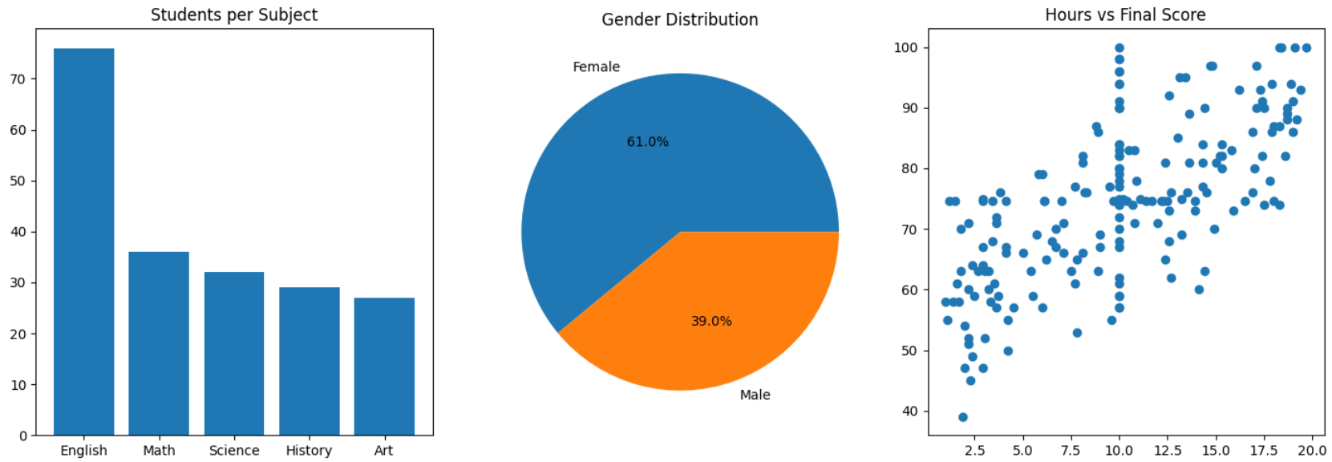

5. Handling Missing Data

5.1 Missing Values — Hidden Dataset
Column | Missing | % Missing
Passed | 54 | 27.0%
HoursStudied | 39 | 19.5%
Subject | 38 | 19.0%
Gender | 37 | 18.5%
PreviousGrade | 36 | 18.0%
Age | 34 | 17.0%
AttendanceRate | 34 | 17.0%
StudyMethod | 33 | 16.5%
FinalExamScore | 25 | 12.5%
StudentID | 0 | 0.0%

5.2 Imputation Methods
- Numerical columns (Age, HoursStudied, AttendanceRate, PreviousGrade, FinalExamScore): filled with the column mean.
- Categorical columns (Gender, Subject, StudyMethod, Passed): filled with the column mode.

5.3 Impact on Models
- Untreated missing data causes model failure or biased coefficients.
- Mean/mode imputation preserves sample size but may underestimate variance and weaken feature correlations.

6. Machine Learning

6.1 Regression Models
Three models were trained on 80% of the data and evaluated on 20% using MSE and RMSE:

Model | MSE | RMSE | Rank
Linear Regression | 42.2374 | 6.4990 | 3rd
Ridge Regression (alpha = 1.0) | 42.2360 | 6.4989 | 2nd
Lasso Regression (alpha = 0.1) | 42.0795 | 6.4869 | 1st ✓

- Linear Regression: baseline — fits a linear equation by minimizing squared residuals.
- Ridge (L2 regularization): penalizes large coefficients, reduces overfitting.
- Lasso (L1 regularization): can shrink coefficients to zero (feature selection) — best RMSE.

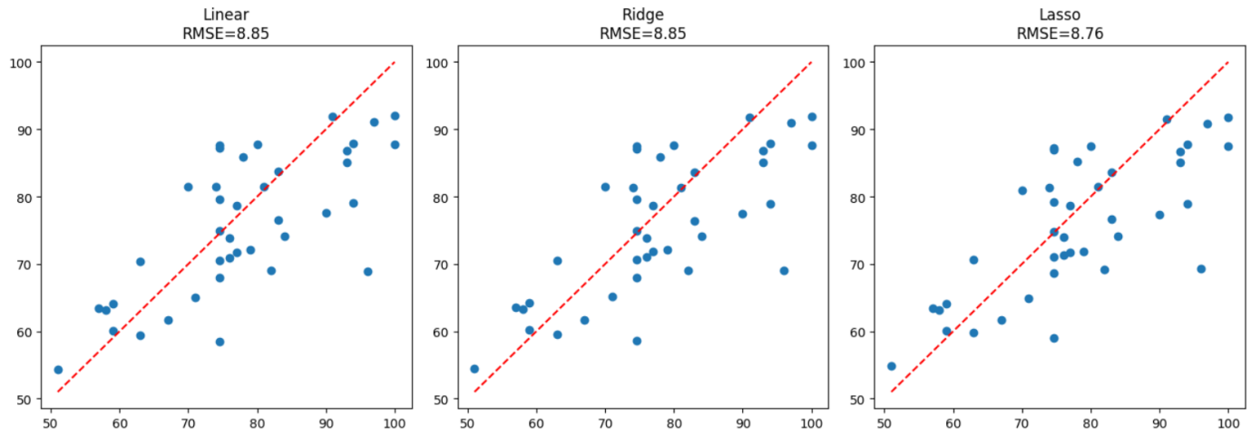

6.2 K-Means Clustering
The Elbow Method (K = 1 to 10) confirmed K = 4 as the optimal number of clusters.
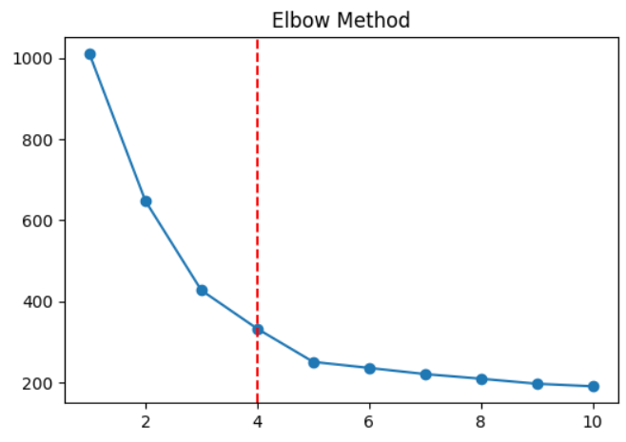

6.3 Cluster Profiles
Cluster | Size | Study Hours | Attendance | Exam Score | Projects Score
0 | 45 | 0.98 | 4.41 | -1.69 | 2.07
1 | 43 | 7.45 | -4.93 | 6.54 | -9.84
2 | 109 | -1.14 | 5.23 | -1.70 | 3.93

- Cluster 0 (45): Moderate study, good attendance, below-average exam scores.
- Cluster 1 (43): High study hours, low attendance — highest exam scores. Self-directed learners.
- Cluster 2 (109): Low study hours, good attendance — below-average scores. Largest group.

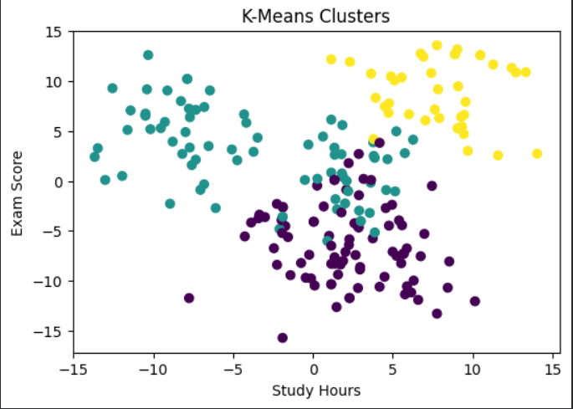

7. Conclusion

- Data Preprocessing: Dropping missing target rows and imputing feature values was essential before any modeling could take place.
- Regression: All three models produced similar results (RMSE ≈ 6.49). Lasso achieved the best score by eliminating less informative features.
- Clustering: K-Means (K = 3) identified three distinct student profiles — self-directed learners, attendance-dependent learners, and passive learners.
- Missing Data: Untreated missing values compromise model quality. Simple imputation improves trainability but may introduce bias.

8. Appendix: Python Code

import pandas as pd
import numpy as np
import matplotlib.pyplot as plt

from sklearn.linear_model import LinearRegression, Ridge, Lasso
from sklearn.model_selection import train_test_split
from sklearn.preprocessing import LabelEncoder, StandardScaler
from sklearn.metrics import mean_squared_error, r2_score
from sklearn.cluster import KMeans
from sklearn.impute import SimpleImputer df1 = pd.read_csv('synthetic_student_performance_hidden.csv')
df2 = pd.read_csv('student_performance_dirty.csv')

df1_dropped = df1.dropna().copy()

print(df1.shape)
print(df2.shape)
num1 = ['Age', 'HoursStudied', 'AttendanceRate', 'PreviousGrade', 'FinalExamScore']
cat1 = ['Gender', 'Subject', 'StudyMethod', 'Passed']

num2 = ['Study_Hours', 'Attendance',
'Assignments_Score', 'Exam_Score',
'Projects_Score']

df1[num1] = SimpleImputer(strategy='mean').fit_transform(df1[num1])
df1[cat1] = SimpleImputer(strategy='most_frequent').fit_transform(df1[cat1])

df2[num2] = SimpleImputer(strategy='mean').fit_transform(df2[num2])

print(df1.isnull().sum())
print(df2.isnull().sum())
fig, axes = plt.subplots(1, 3, figsize=(14,5))

s = df1['Subject'].value_counts()

axes[0].bar(s.index, s.values)
axes[0].set_title('Students per Subject')

g = df1['Gender'].value_counts()

axes[1].pie(g, labels=g.index, autopct='%1.1f%%')
axes[1].set_title('Gender Distribution')

axes[2].scatter(df1['HoursStudied'], df1['FinalExamScore'])
axes[2].set_title('Hours vs Final Score')

plt.tight_layout()
plt.show()
le = LabelEncoder()

for col in cat1:
df1[col + '_enc'] = le.fit_transform(df1[col])

features = [
'Age',
'HoursStudied',
'AttendanceRate',
'PreviousGrade',
'Gender_enc',
'Subject_enc',
'StudyMethod_enc'
]

print(df1.head())
X = df1[features]
y = df1['FinalExamScore']

X_train, X_test, y_train, y_test = train_test_split(
X, y, test_size=0.2, random_state=42
)

scaler = StandardScaler()

X_train = scaler.fit_transform(X_train)
X_test = scaler.transform(X_test)

models = {
'Linear': LinearRegression(),
'Ridge': Ridge(alpha=1.0),
'Lasso': Lasso(alpha=0.1)
}

results = {}

for name, model in models.items():

model.fit(X_train, y_train)

preds = model.predict(X_test)

results[name] = {
'preds': preds,
'RMSE': round(np.sqrt(mean_squared_error(y_test, preds)), 2),
'R2': round(r2_score(y_test, preds), 3)
}
fig, axes = plt.subplots(1, 3, figsize=(14,5))

for ax, (name, res) in zip(axes, results.items()):

ax.scatter(y_test, res['preds'])

mn = y_test.min()
mx = y_test.max()

ax.plot([mn, mx], [mn, mx], 'r--')

ax.set_title(f'{name}\nRMSE={res["RMSE"]}')

plt.tight_layout()
plt.show()
X_clust = StandardScaler().fit_transform(df2[num2])

inertias = []

for k in range(1, 11):

km = KMeans(n_clusters=k, random_state=42, n_init=10)

km.fit(X_clust)

inertias.append(km.inertia_)

optimal_k = 4

df2['Cluster'] = KMeans(
n_clusters=optimal_k,
random_state=42,
n_init=10
).fit_predict(X_clust)
plt.figure(figsize=(6,4))

plt.plot(range(1,11), inertias, marker='o')

plt.axvline(x=optimal_k, color='red', linestyle='--')

plt.title('Elbow Method')

plt.show()
plt.figure(figsize=(6,4))

plt.scatter(
df2['Study_Hours'],
df2['Exam_Score'],
c=df2['Cluster']
)

plt.title('K-Means Clusters')

plt.xlabel('Study Hours')
plt.ylabel('Exam Score')

plt.show()

