

Cairo University

Faculty of Computers and Information

Department of Computer Science

Care Point

Supervised by

*Dr. Emad Nabil*

*TA. Heba Tallah Youssef Mahgoub*

Implemented by

|  |  |
| --- | --- |
| *20140015* | *Ahmed Hussein Karam* |
| 20140035 | Ahmed Mohamed Ahmed |
| 20140081 | Andrew Emad Nassif |
| 20140263 | Mariam Ashraf Fekry |

Academic Year 2017-2018

Midyear Documentation of Graduation Project

Table of contents goes here…

List of illustrations (tables/figures) goes here…

List of appreciations/abbreviations? goes here…

**Chapter 1: Introduction**

**1.1 Main area of the project**

“Care Point” is a website that provides a set of medical services. The idea is to keep a way of communication between the three main parties of the medical system: patients, doctors and pharmacists. Also, it aims to add more flexibility to the medical service in Egypt by connecting individual services through one integrated system. The project focuses mainly on care-related services.

**1.2 Motivation**

In the recent few years, many reports and articles have been published to draw attention to significant problems in the medical service, either in Egypt or generally in the world.

In 2006, Washington Institute of Medicine (IOM) published a report saying that wrongly read prescriptions cause around 7000 ***yearly*** deaths all over the world. The reason, according to the report, is the sloppy doctor’s handwriting.

In 2011, an Egyptian Medical Board Officer said that about 30% of diagnosis in the Private Sector, and about 70% of them in the Public Sector were wrong, with total of 114 complaints from citizens in one year.

In 2017, Hossam Abdel Ghaffar, the spokesman of the Egyptian Ministry of Health, said that there is around 50% of shortage in ICUs in Egypt. This definitely makes it harder for a patient to quickly find a care room.

Those examples and many others are motivating us to do our project, hoping it will be a new contribution to the medical system in Egypt.

**1.3 Problem definition**

One of the main problems in the medical system in Egypt is the lack of coordination among medical organizations, like hospitals, clinics, pharmacies, … etc. That is, the patient looks for some place to get one medical service and that’s it. This problem has led to a shortage in the medical system ***as a whole***.

**1.4 Project objective**

“Care Point” aims to enable every citizen to easily search for a medical service, such as ICUs, incubators, dialysis rooms, … etc. The search can be based on different criteria such as distance, cost, popularity, rate ***or any combination of them***. By this, it eliminates the traditional way of single-criteria search. This is also powered by the ability to search for a medicine in the surrounding pharmacies.

“Care Point” also aims to provide the doctor with the whole medical history of his patients, along with all medical examinations they made such as radiology, analysis, … etc. By this, it breaks the boundary between medical organizations and gives the doctor all information he needs to correctly diagnose a patient.

Another important service is attempting to create a channel between doctors and pharmacists. For example, doctors can send prescriptions to pharmacies, and while writing a prescription, the system suggests alternative medicines to the doctor, so that ***accepted alternatives*** are shown to the pharmacist.

All of these services are integrated with other supplementary features. For example, when a doctor adds a ***genetic*** disease to the medical history of a patient, the system sends a warning to his family as they have the same disease. Finally, in an emergency situation a citizen can send an SOS to his friends, his family and the nearest hospitals.

**1.5 Project time plan**

Gantt Chart goes here…

|  |  |  |  |
| --- | --- | --- | --- |
| **Task** | **Task Title** | **Description** | **Task Status** |
| 1 | Idea selection | Prioritize candidate ideas and meet our supervisor to discuss them and choose one | Completed |
| 2 | Scope specification | Determine project scope and prioritize features | Completed |
| 3 | Learning plan | Determine which technologies can help us, decide which technologies we will use and put a plan to learn them | Completed |
| 4 | Similar work analysis | Discover previous projects with similar work, determine the pros and cons for each one and how we can avoid those cons in our project, then document the results | Completed |
| 5 | SWOT & PEST analysis | * Determine project strengths, weaknesses, opportunities and threats through SWOT analysis * Determine political, economic, social and technological factors that can affect the project through PEST analysis | Completed |
| **First milestone** | | | |
| 6 | Requirement elicitation | * Determine needed information and prepare questions we need to ask * Schedule meetings with our stakeholders (mainly doctors and pharmacists) * Put simple and opinion-based questions in a survey and publish it in online communities for doctors and pharmacists | Completed |
| 7 | FURPS+ documentation | Formally document the functional and non-functional requirements | Completed |
| **Second milestone** | | | |
| 8 | System diagrams design | Divide system features into groups and ***incrementally*** design the use-case, class, and sequence diagrams | Completed |
| 9 | DB design | Design an ERD diagram and prepare the DB schema | Completed |
| 10 | UI design | - Design a blue print for the solution  - Design a logo | Completed |
| **Third milestone** | | | |
| 11 | Implementation plan | - Divide system into four releases, and put a deadline for each release  - Assign roles to team members (e.g. front end, backend, testing, …etc.) | Completed |
| 12 | Midyear documentation | Prepare the midyear GP document | Completed |
| 13 | Design enhancements | Resolve design problems that are discovered later during implementation | In progress |
| 14 | Complete and test release 1 | Release 1 is concerned with:   * Registration and login * Medical history * Patient attachments (e.g. radiology, analysis, … etc.) * Patient prescriptions | In progress |
| **Fourth milestone** | | | |
| 15 | Complete and test release 2 | Release 2 is concerned with:   * Adding medical organizations * Enabling medical organizations to edit available services, care units and service work slots * Searching for medical services * Searching for user accounts * Suggesting medicine alternatives to the doctor while writing a prescription | Expected |
| **Fifth milestone** | | | |
| 16 | Complete and test release 3 | Release 3 is concerned with:   * Ability to add friend, parent or sibling * Prognosis and warning from probable genetic diseases * Sending SOS signals to the nearest hospitals, relatives and friends | Expected |
| **Sixth milestone** | | | |
| 17 | Compete and test Release 4 | Release 4 is concerned with:   * Adding pharmacy services (Selling medicines, extracting a receipt, managing inventory) * Searching for medicines * Rating a medical service * Publishing advertisements for top rated services | Expected |
| 18 | Deployment | Deploy the project on MS Azure | Expected |
| 19 | Documentation | Prepare final GP document | Expected |
| **Seventh milestone** | | | |

**Table**

**1.6 Development methodology**

Because the project includes various services and involves different parties (e.g. clinic, radiation center, pharmacy… etc.), it is very hard to reach a well-defined or constant set of requirements. In other words, the functional and non-functional requirements are expected to change regularly during the implementation. So, the scrum methodology is chosen for this project, and it is divided into four releases (see tasks 14-17 in Table 1).

**1.7 Tools used in the project**

To be able to accomplish the project, we are using the following tools and technologies:

* **ASP.Net:** the technology we use to develop the website.
* **Microsoft Azure:** we use it to host the database, and we will use it to deploy the website.
* **Gitlab:** we use it to collaborate and share project files.
* **Moqups:** used to make UI blueprints.
* **Microsoft Project:** usedto help us do project management tasks.
* **Barcode reader:** used to read barcodes on medicines to enable pharmacy transactions.

**1.8 Document organization**

In Chapter 2, we give examples of other related projects, their advantages and disadvantages and how our project is different. In Chapter 3, we discuss the formal project requirements, system design and sample testcases. Finally, in Chapter 4 we give an overview of DB and UI designs.

**Chapter 2: Related work**

**2.1 Human Dx**

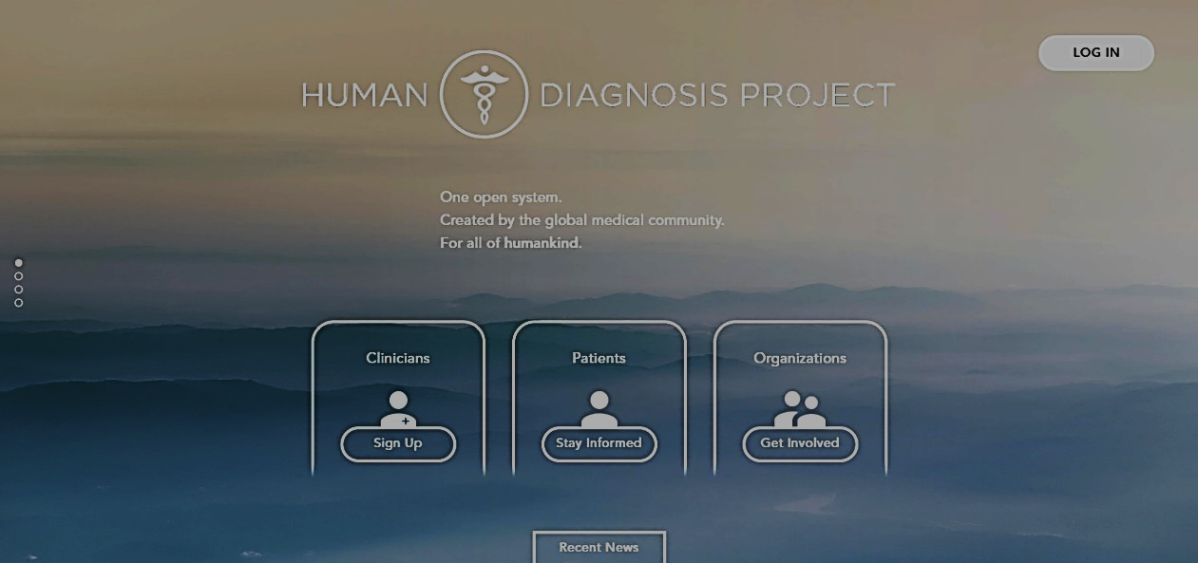

**Figure**

**Country:** USA (created in 2017, not fully developed yet)

**Technologies:** web

**Main features:**

1. Doctors can write case studies and others solve them. After a doctor solves a case study, he can see solutions of other doctors, and the system measures his accuracy according to what it learnt from previous experience.
2. System uses its experience to diagnose patients.

**Advantages:**

1. The system improves itself with the help of machine learning.
2. Useful for both humans and the machines.

**Disadvantages:**

1. Depends totally on the volunteer of doctors to create or solve case studies.
2. The data used to learn is not much trusted, because the system allows ***anyone*** to solve case studies.

**Our improvement:**

We encourage specialists to join the system by freely advertising for the top-rated services. Also, instead of learning machines how to diagnose, we focus on providing doctors with all information they need to diagnose correctly.

**2.2 Vezeeta**

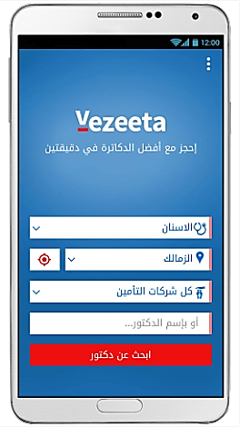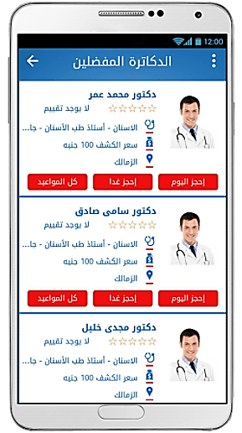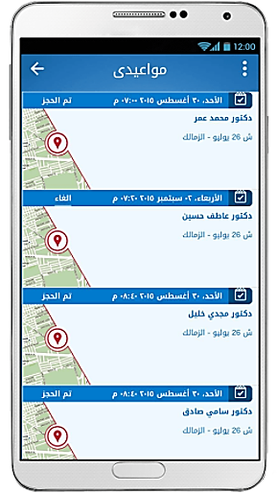

**Figure**

**Country:** Egypt

**Technologies:** Android - Web

**Main features:**

1. Patients can search doctors by name, region, specialty or examination cost.
2. Patients can reserve appointments with doctors.
3. Patients can save favorite lists of doctors.
4. People can give ratings to doctors.

**Pros:**

1. Provides different ways to search for a doctor
2. Provides a website, an application for android phones and an application for iphones and ipads.

**Cons:**

1. Covers only regions in Cairo and few other regions around it.
2. Some ***related functions are separated*** in different vezeeta apps. For example, a doctor needs to install “Vezeeta Profile” to publish his profile to patients, while he needs to install “Vezeeta Care” to see analysis or radiology results of his patients.

**Our improvement:**

“Care Point” services are available for all Egyptians on one system.

**Chapter 3: System analysis**

**3.1 Project specification**

**3.1.1 Functional requirements**

* A user can register as a regular citizen, a doctor or a pharmacist.
* Every citizen has a medical history on the system. Each entry in the history should contain patient symptoms, diseases, medicines, doctor remarks, doctor name, the name of the medical organization and the date.
* Every citizen is provided with an IQR code, and the IQR code can be used by specialists to access his medical history.
* While adding a disease to the medical history of a patient, the doctor can mark it as a genetic disease.
* While prescribing some medicine, the system suggests alternative medicines to the doctor. After that, ***only accepted alternatives*** are shown to the pharmacist.
* A doctor can export his prescription to a printable file.
* A doctor can upload an attachment for his patient. For example, he can attach an X-ray image, medical analysis results, … etc.
* Doctors are able to create a profile for a hospital, clinic, radiation center, pharmacy or medical analysis laboratory. Also, pharmacists can create a pharmacy profile.
* Medical organization profile contains its name, description, photo, contacts, location and services it provides.
* Every medical organization can edit services (e.g. X-ray, eye clinic) or care units (e.g. incubators, ICUs) it provides. They can update the number of available rooms in any care unit.
* The system asks the user to give a feedback to the medical service in the following cases:
  + A new entry or attachment is added to his medical history.
  + The user makes a transaction in a pharmacy.

According to user feedback, the system updates the rate for the service.

* Every user can search for other user accounts. Also, a user can mark another user as friend, parent or sibling.
* Every user can search for medical organizations and sort the results by distance, cost, popularity, rating or any combination of these criteria.
* A citizen can send an SOS signal to the *nearest* hospitals, his family or his friends. The citizen can optionally add a description of the emergency situation.
* The system warns the citizen from diseases that he might catch depending on the medical history of him and his family, and considering his demographic location.
* Medical organizations are able to publish advertisements on the system. The higher the rating of the medical organization, the greater the priority given for its advertisements to appear to users.
* A citizen can search for a medicine in surrounding pharmacies.
* The system should send notification in the following cases:

|  |  |
| --- | --- |
| **Notification trigger** | **Receivers** |
| A new attachment is added to a medical history | The medical history owner (citizen) |
| Citizen A marks citizen B as friend, parent or sibling | Citizen B |
| A ***genetic*** disease is added in the medical history of some citizen | Citizen’s family |
| A specialist requests membership in a medical service, care unit or pharmacy | Medical organization administrators |
| A membership request is ***confirmed or denied*** | The specialist who made the request |
| A specialist requests a care unit for his patient | The staff working in the care unit |
| A care unit request is ***confirmed or denied*** | The specialist who requested the care unit |
| Some citizen sends an SOS | Friends, family and the nearest hospitals |
| Some hospital responds to an SOS | The SOS sender, his family and his friends |
| A citizen creates an account | System admin |
| A specialist adds a medical organization to the system | System admin |
| System admin ***approves or denies*** a medical organization | The specialist who added the organization |

**Table**

**3.1.2 Non-functional requirements**

**Usability:**

* The number of clicks doesn’t exceed 6 clicks to do any task on the website.
* ***When possible***, users do not type anything but they just click buttons or choose from checkboxes and radio-buttons.

**Reliability:**

* The system validates the family tree and prevents illogical relationships between users. For example, a user cannotmark the parent of his sibling as a sibling!
* The system reminds care unit owners of updating the number of available rooms to keep track of it with minimum possible error. The reminder rate is controllable.
* ***When possible***, the system provides auto-complete feature to the user while entering a textual input. This minimizes problems that can be caused by typo-errors.

**Performance:**

The website takes no more than 5 seconds to load any page.

**Supportability:**

When an error occurs within the system, the user can contact the support, and the support responds within 24 hours.

**Scalability:**

Up to 10,000 users can interact with website simultaneously without affecting its stability.

**Security:**

* No one can access the system without providing his username and password. However, guest users can only contact support.
* A Specialist cannot see the medical history of a patient ***for the first time*** without using the patient’s IQR code.
* A user can only recover his account with his phone number.
* A specialist cannot join a medical organization on the system without a confirmation from one of its administrators.
* Only the administrators of a medical organization can add specialists, add services, stop services or edit schedules for that organization.
* Only the owner of a medical organization can remove administrators from it.

**Cost:**

“Care Point” is available for free, but the only feature that can chargeable is adding advertisements for medical services.

**3.2 Sample use cases**

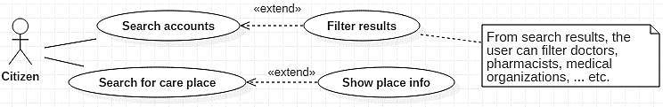

**Figure**

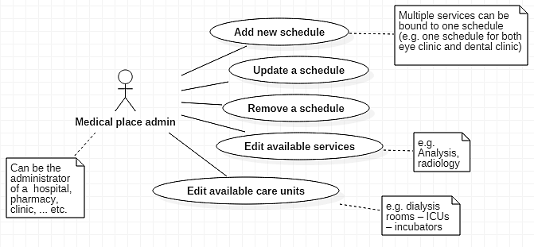

**Figure**

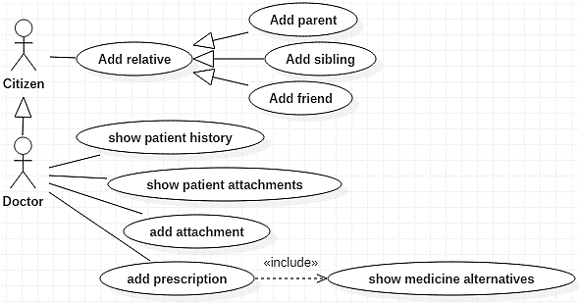

**Figure**

**3.3 Sample sequence diagrams**

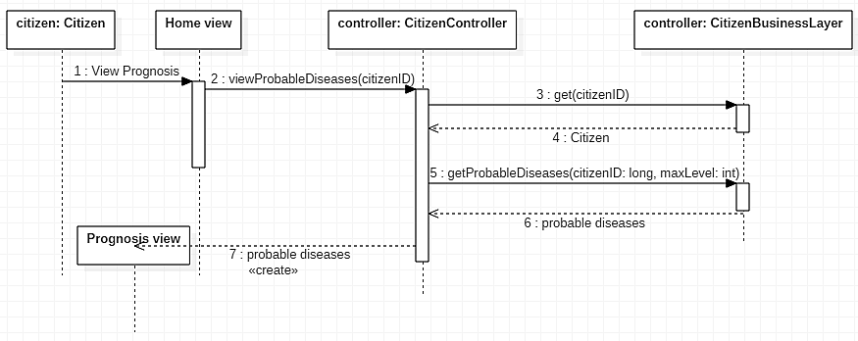

**Figure**

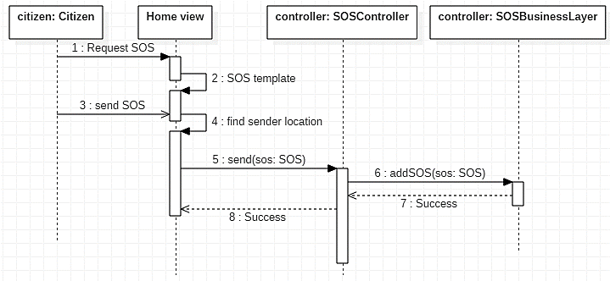

**Figure**

**3.4 Sample system test cases**

|  |  |
| --- | --- |
| testcase ID | 1 |
| Test case description | Test sign up to Care Point |
| Test scenario | Verify on entering an invalid user data, the user citizen account isn’t created |
| Step details | 1. Go to http://localhost:51902/Account/Register 2. Enter valid first name 3. Enter valid middle name 4. Enter valid last name 5. Enter valid national ID 6. Enter valid email 7. Enter valid phone 8. Upload national photo 9. Enter valid password 10. Enter valid confirmation password 11. Enter birthdate 12. Enter blood type 13. Enter valid birthdate 14. Enter specialty 15. Enter profession license 16. Click sign up |
| Test data | First Name: John  Middle Name: Jony  Last Name: Jack  national ID: 12345678912345  email: [user1@y.c](mailto:user1@y.c)  phone: 01200000001  gender: male  national Photo: upload image  password: Abc@123  confirmation Password: Abc@123  blood Type: A+  birthdate: 11-11-1999  specialty: none  profession license: upload image |
| Expected result | User account isn’t created |
| Actual result | As expected |
| Pass/fail | pass |

**Table**

|  |  |
| --- | --- |
| testcase ID | **2** |
| Test case description | Test login to Care Point |
| Test scenario | Verify on entering a valid mail and password, user can sign in |
| Step details | 1. Go to (http://localhost:51902/Account/Login) 2. Enter valid mail 3. Enter valid password 4. Click login |
| Test data | E-mail: user@y.c  Password: Abc@123 |
| Expected result | User is logged in |
| Actual result | As expected |
| Pass/fail | pass |

**Table**

**Chapter 4: System design**

**4.1 Project ERD design**

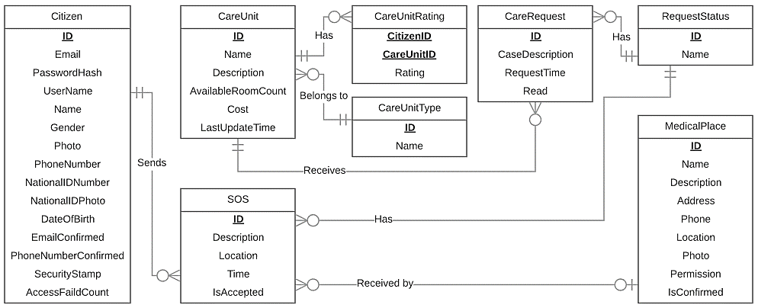

**Figure:** Conceptual design of emergency domain

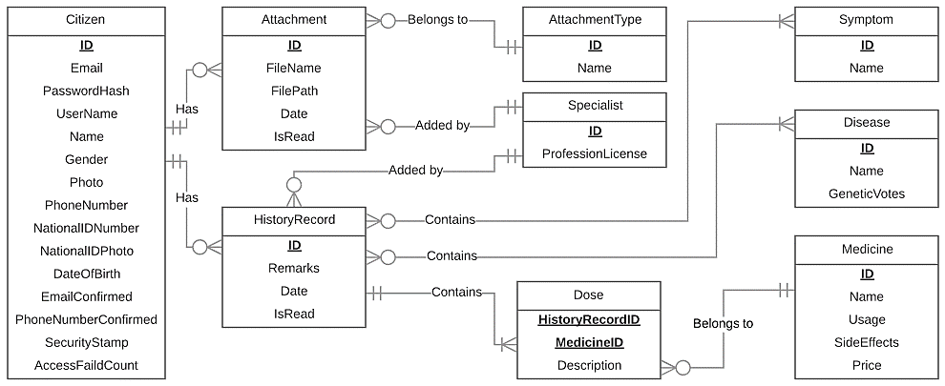

**Figure:** Conceptual design of medical history domain

**4.2 Project UI design**

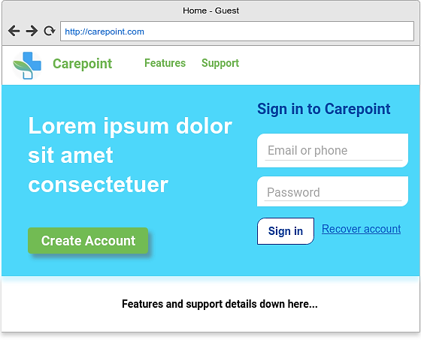

**Figure**

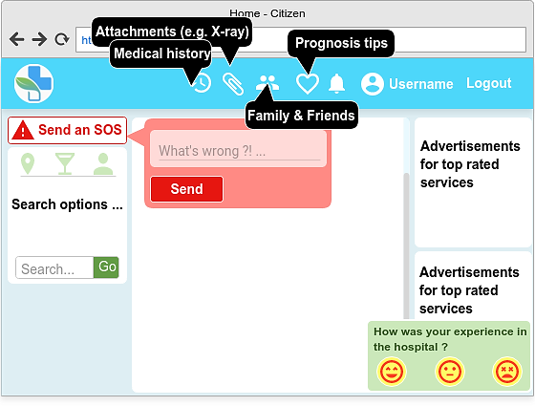

**Figure**

References:

* Washington Institute of Medicine (IOM) report, 2006 [Internet] [Uploaded in January 2017], available from <http://content.time.com/time/health/article/0,8599,1578074,00.html>
* Article by Entisar El-Samany, [Internet] [Uploaded in December 2011], available from <https://www.sudaress.com/alintibaha/6247>
* El-Bawaba News report, [Internet] [Uploaded in September 2017], available from <http://www.albawabhnews.com/1504049>