GHCN Data Analysis using Spark
DATA420-26S2 (C) — Assignment 1
Contents
Background 2
Processing 2
Q1 — Structure, compression and size of the data 2
Q2 — Loading the data and defining schemas 4
Q3 — Building the enriched stations table 5
Q4 — Checking for missing stations in daily 7
Analysis 7
Q1 — How many stations, and where are they? 7
Q2 — Geographical distance between stations 8
Q3 — The daily climate summaries in more detail 10
Visualizations 12
Q1 — TMIN and TMAX for New Zealand stations 12
Q2 — Global rainfall 15
Conclusions 19
References 19

Background
This assignment uses the Global Historical Climatology Network – Daily (GHCN-Daily) dataset to build a distributed data pipeline in Spark. GHCN-Daily is a collection of daily land-surface climate summaries maintained by NOAA, assembled from more than twenty independent sources that have each passed quality-assurance review. It reaches back over 250 years and covers more than 100,000 stations across roughly 200 countries and territories.
The data comes in two parts. The daily climate summaries are comma-separated files, one per year, where each row records one observation for one station on one day for one element, maximum and minimum temperature, precipitation, snowfall, snow depth and many others. So, a single station-day usually spans several rows. Supporting these are four fixed-width metadata tables: stations (coordinates, elevation, country and state codes, network flags), countries and states (codes and names), and inventory (which elements each station recorded, and the first and last year for each).
The objective was to understand how the data is structured, join the metadata into a single enriched station table, answer specific questions about the stations and their observations, and produce time-series and geospatial visualisations. Spark is the right tool because daily is roughly 13 GB compressed and 3.19 billion rows, far beyond what one machine can hold. Spark expresses the work as lazy transformations executed in parallel across partitions, so only small, aggregated results return to the driver.
Across the three sections I built a reusable enriched station table saved as partitioned Parquet, established that only 63 of 132,501 stations never appear in daily, computed pairwise distances between all New Zealand stations, counted observations for the five core elements across the whole dataset, and produced three visualisations. The most useful thing I took away was a habit, not a number: reduce the data before joining it, and check whether an extreme value is real or just an outlier. All work ran against Azure Blob Storage over wasbs://, reading from campus-data and writing outputs to my own campus-user/ama778 container.

Processing

Q1: Structure, compression and size of the data
I explored the directory using hdfs commands only, without loading anything into Spark. The structure is shallow: a single daily/ sub-directory holding one gzip-compressed CSV per year, alongside four uncompressed fixed-width text files.
ghcnd/
├── daily/ 265 files, 13.1 G
│ ├── 1750.csv.gz
│ ├── 1763.csv.gz ... (gzip-compressed, one file per year)
│ └── 2026.csv.gz
├── ghcnd-stations.txt 11,395,086 B (fixed-width, uncompressed)
├── ghcnd-inventory.txt 35,991,182 B (fixed-width, uncompressed)
├── ghcnd-countries.txt 3,659 B (fixed-width, uncompressed)
└── ghcnd-states.txt 1,086 B (fixed-width, uncompressed)

Figure 1. Directory tree of the ghcnd dataset in cloud storage, from hdfs dfs -ls and -count.
(a) How is the data structured, and is any of it compressed?
The daily summaries are gzip-compressed CSV (.csv.gz), one file per year; the four metadata tables are uncompressed fixed-width text. This matters twice over: gzip is not splittable, so Spark reads each yearly file with a single task and parallelism is bounded by the 265 files rather than by block count; and because the metadata is fixed-width rather than delimited, it cannot be read with spark.read.csv and must be parsed by character position.
(b) How many years are contained in daily, and how does the size of the data change?
daily contains 265 distinct years spanning 1750 to 2026, with a twelve-year gap: 1751–1762 are missing entirely. Compressed size per year grows dramatically. The eighteenth-century files are a few kilobytes, the data reaches megabytes by the 1890s, tens of megabytes by the 1910s, and roughly 150–175 MB per year through the 2010s and 2020s. The 2026 file is smaller (≈ 82 MB) because it is a partial year.
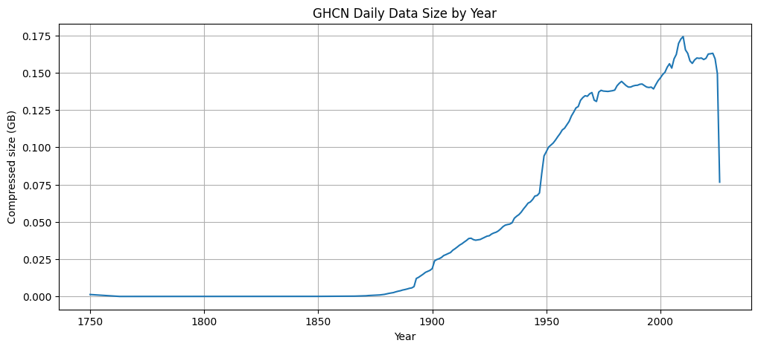
Figure 2. Compressed size of each year of daily data. Negligible before about 1870, climbing steeply from 1890, with a sharp jump around 1948, then a plateau near 0.16 GB per year after 2000. The final drop is the partial 2026 file.

The curve reflects growth of the observing network, not any change in climate: more stations, over more days, recording more elements. The step around 1948 marks a large expansion in contributing station.

(c) What is the total size of all of the data, and how much of that is daily?
The ghcnd directory size is 13.19 GB, of which daily is 14,116,195,511 bytes which translates to 13.15 GiB) approximately 99.67% of ghcnd directory size. The four metadata tables together make under 0.35%.
Estimating the uncompressed size:
To calculate the uncompressed size of “daily”, I first decompressed a recent year (2025) by streaming it through gzip -dc | wc -c rather than materialising it. That file expands from 160,283,428 to 1,261,472,066 bytes, a compression ratio of 7.87×, giving an estimated uncompressed daily of ≈ 111.1 GB (103.5 GiB). Using a recent year is an intentional decision because the last few decades dominate the total volume of daily. Older files are sparser and may compress differently, so this is an estimate. It still makes the key point: the working dataset is roughly eight times larger than its footprint on disk, and that is what must move through memory and across the network during a scan.
Table 1. Dataset sizes and row counts.
Dataset | Format | Size on disk | Rows | Share of total
daily (compressed) | .gzip CSV - 265 files | 14,116,195,511 B ≈ 13.15 GiB | 3,190,506,382 | 99.67 %
daily (uncompressed, estimated) | CSV | ≈ 111.1 GB (103.5 GiB), 7.87× ratio | 3,190,506,382 | —
inventory | fixed-width text | 35,991,182 B ≈ 34.3 MB | 782,417 | 0.254 %
stations | fixed-width text | 11,395,086 B ≈ 10.9 MB | 132,501 | 0.080 %
countries | fixed-width text | 3,659 B | 219 | 0.00003 %
states | fixed-width text | 1,086 B | 74 | 0.00001 %
Total |  | 13.19 GB |  | 100 %

Table 1 drives every later design decision: stations is about 1,240 times smaller than daily, so broadcast joining metadata tables with daily should be preferred every time.

Q2: Loading the data and defining schemas
(a)–(b) Loading the metadata.
Since all of the metadata tables are fixed width, I loaded each file with spark.read.text function and extracted fields using substring Spark method as per the documented character ranges in the assignment brief and then cast numeric columns and trimmed the text ones. When dealing with strings, Whitespace matters i.e., null fields in fixed-width files are blank, not empty strings, so trim is needed before any comparison or a JOIN. Otherwise, for instance, "NZ " will not match with "NZ".
Rows in each metadata table:
- Stations: 132,501,
- countries: 219,
- states: 74,
- inventory: 782,417

(c) Defining a schema for `daily`:
I defined a StructType with
- ID as StringType(),
- DATE as DateType,
- ELEMENT as StringType(), VALUE as DoubleType(),
- The three flags (MEASUREMENT, QUALITY, and SOURCE) as StringType()
- OBSERVATION_TIME as StringType().

(d) What went wrong, and what types I ended up using:
Declaring DATE as DateType initially and subsequently reading the year 2026 daily file produced every `DATE` value as NULL. Spark accepted the schema without giving any error, but its CSV reader couldn’t not parse the compact YYYYMMDD form.
The lesson I learned was that an accepted schema is not the same as parsed data. Had I not inspected the output, I would have silently lost the entire date column.
The direct fix for this problem was to load DATE as StringType initially and later convert it date format using to_date(col("DATE"), "yyyyMMdd"), stating the source format explicitly.
The final schema looked as follows:
- ID, ELEMENT and the three flags as StringType();
- VALUE as DoubleType();
- DATE as DateType;
- OBSERVATION_TIME kept as StringType(), because HHMM clock reading has no arithmetic meaning and an integer would remove the leading zero from times like 0630.
(e) Rows in all of `daily`, and does memory matter?
daily has 3,190,506,382 rows (~3.19 billion), and the most 2026 which is the most recent year in ghcnd daily, contains 17,988,944 rows.
Counting 3.19 billion rows with 2 executors and 1 core each can be really slow, but it doesn’t require the data to fit in memory. Spark reads the data partition by partition and each Executor computes a partial count. Only one integer returns to the driver. Having said that, Executor memory still has an importance because each Executor must hold the partitions and intermediate result it is working on, and operations which are shuffle-heavy like joins, distinct, groupBy) are where insufficient memory causes spilling. Due to this, collect() or cache() on daily would be inappropriate as both materialise the whole dataset rather than stream it.

Q3: Building the enriched stations table
(a). I extracted the two character country code from the first two characters of each station ID from stations by the help of Spark method: withColumn("COUNTRY_CODE", substring(col("ID"), 1, 2)),
(b). Afterwards, I performed a LEFT JOIN between countries and states on the state field. Since both were LEFT joins so that no station was dropped even when metadata was missing. The row count stayed at 132,501 throughout which I validated after each join.
(c) Which countries have stations with state codes?
16 countries. I filtered the enriched table to a non-null STATE and took the distinct country names which gave me the following stations with state codes:
- United States
- Canada
- American Samoa
- Guam
- Northern Mariana Islands
- Johnston Atoll
- Palmyra Atoll
- Puerto Rico
- Virgin Islands
- Wake Island
- Midway Islands
- Marshall Islands
- Palau
- Federated States of Micronesia
- Bahamas
- Russia
Russia and the Bahamas were a genuine surprise to me because the GHCN state field is documented for US/Canada, so these are cases where it has been populated with state codes outside its intended scope. This serves as a good reminder that a column's documented meaning and its actual contents do not always agree. Another lesson worth remembering.
(d) Inventory summary. I aggregated inventory with groupBy("ID") with the help of collect_set("ELEMENT") for the element set per station and further used min(FIRSTYEAR) and max(LASTYEAR) to find out the active span. I later created “ACTIVE_2026” BooleanType flag for each distinct station ID and counted the active stations in 2026 with the help of that flag using binary logic.
Answers:
- Active in 2026 based on `inventory` alone (LAST_YEAR ≥ 2026): 37,422 stations.
- Stations collecting all five core elements: 20,505.
- Stations collecting only precipitation and nothing else: 16,189.
The precipitation-only contributes about 12% of all stations. In the brief it is noted that around half of the stations, only precipitation is reported; It is worth noting that "only PRCP and nothing else" is a far stricter test than "reports precipitation". There are many stations which record precipitation plus other elements like snowfall and snow depth without temperature. A quick data quality check is worth recording here. Since the total stations are 132591, the inventory covers 132,437 stations, so 64 have no inventory record, whereas 0 inventory records refer to an unknown station. I kept those 64 because a station present in the metadata but not in the inventory is a finding, not noise.
(e) The enriched table and how it was stored:
As per assignment instructions, I performed a LEFT JOIN of the station/country/state table onto the inventory summary which produced 132,501 rows and 18 columns as expected from a left join.
Table 2. Structure of the final enriched `stations` table (`stations_final`).
Column | Type | Description
ID | string | 11 character GHCN station identifier
LATITUDE | double | Latitude in decimal degrees (negative = Southern Hemisphere)
LONGITUDE | double | Longitude in decimal degrees (negative = west of Greenwich)
ELEVATION | double | Station elevation in metres
STATE | string | Two-character state/territory code, blank for most countries
NAME | string | Human-readable station name
GSN_FLAG | string | GSN if the station is in the GCOS Surface Network
HCN_CRN_FLAG | string | HCN or CRN for the US Historical Climatology / Climate Reference Networks
WMO_ID | string | Five-digit WMO identifier where one exists
COUNTRY_CODE | string | Two-character country code taken from characters 1–2 of ID
COUNTRY_NAME | string | Country name joined from countries
STATE_NAME | string | State name joined from states, null where no state code
ELEMENTS | array <string> | Set of every element the station has recorded
FIRST_YEAR | int | Earliest year any element was recorded
LAST_YEAR | int | Latest year any element was recorded
ACTIVE_2026 | boolean | True when LAST_YEAR >= 2026
CORE_ELEMENT_COUNT | int | How many of the five core elements the station recorded (0–5)
OTHER_ELEMENT_COUNT | int | Count of non-core elements recorded

Storage format and partitioning. I saved the enriched stations table as Parquet, and I partitioned it by COUNTRY_CODE, after repartitioning to 3 Spark partitions. Parquet has advantages over in this case. CSV or CSV.gz Firstly, it is columnar, so queries needing only ID and COUNTRY_NAME, for instance, read just those columns only; Secondly, it is schema-aware, so the types and the ELEMENTS array survive a write/read cycle, which CSV cannot do without serialising the array to text, and last but not the least, it is compressed and splittable, unlike in case of gzip CSV.
I deliberately did patitioning by COUNTRY_CODE because it matches how the table is filtered downstream (Pushdown Filter) and lets Spark skip irrelevant files through partition pruning. I used 3 partitions instead of one per country intentionally because with almost 219 codes and only 132,501 rows, large partitions will have produced many tiny files and introduced overheads which would be more costly as compared to the parallelism gained. I read the Parquet back to confirm 132,501 rows loaded with the schema preserved.

Q4: Checking for missing stations in daily
(a) How expensive would a full join be, and is there a better way?
Joining all of daily to stations directly means scanning and parsing 3.19 billion rows and shuffling them by station ID so matching keys meet on the same executor. This would have produced enormous network I/O that would very likely spilled onto the disk. The physical plan for the naive approach confirmed this, showing a SortMergeJoin with a full hash-partitioning exchange on both sides.
The insight is that the question, which stations never appear in `daily`? needs no column from daily except ID. So, project daily to ID, broadcast the small 132,501-row station set and use a LEFT SEMI JOIN to keep only daily IDs belonging to a known station, de-duplicate that much smaller result, then LEFT ANTI JOIN stations against it. The plan confirmed a BroadcastHashJoin … LeftSemi, BuildRight: the small table is broadcast and the 3.19-billion-row side streams past it with no shuffle. When one side of a join is small, broadcasting converts an expensive shuffle join into a local hash lookup. Projecting to one column first matters independently. Carrying eight columns through a shuffle costs several times more.
(b) How many stations in `stations` are not in `daily`?
63 stations appear in the metadata but never occur anywhere in daily. In the other direction the semi-join matched all 3,190,506,382 daily rows, so 0 station IDs in `daily` are missing from `stations` i.e., referential integrity from daily to metadata is perfect.
Three counts are easy to confuse: 64 stations lack an inventory record (Q3), 63 never appear in daily (Q4), and 93,823 are absent from the 2026 file alone. The last meaning only that most stations were not reporting that year.

Analysis

Q1: How many stations are there, and where are they?
All of the below counts are read from the enriched stations table stored in the HDFS in parquet format and reloaded successfully. .

Table 3. Station counts.
Count | Value | What it represents
Total stations | 132,501 | Distinct station IDs in the metadata
GSN | 991 | GCOS Surface Network (GSN_FLAG = 'GSN')
HCN | 1,218 | US Historical Climatology Network
CRN | 234 | US Climate Reference Network
In more than one network | 15 | GSN and (HCN or CRN)
Southern Hemisphere | 25,357 | LATITUDE < 0
US territories, excluding the USA | 442 | Country name marked [United States]
New Zealand | 15 | Country code NZ

(a) Networks:
GSN has its own column. On the other hand, HCN and CRN share HCN_CRN_FLAG cloumn, so a station can be in GSN and in one of the US networks. Taking the overlap in consideration explicitly instead of assuming the groups are disjointed gives 15 stations in more than one network, so summing 991 + 1,218 + 234 would count them twice.
(b) Southern Hemisphere and US territories:
I defined the Southern Hemisphere as LATITUDE < 0. 25,357 stations qualify which is roughly 19% of the total, showing how heavily the stations network is concentrated in North America and Europe.
For US territories, I filtered on country names containing [United States]. An interesting observation that I noted was that one entry in ghcnd-countries.txt was malformed i.e., `Midway Islands [United States} ` closes with a curly brace. So, matching only the correct pattern silently dropped Midway's 3 stations and gave 439 station count. By matching both bracket I got the correct 442 stations across 9 territories:
Territory | Stations
Puerto Rico | 285
Virgin Islands | 79
Guam | 34
American Samoa | 21
Northern Mariana Islands | 12
Johnston Atoll | 4
Palmyra Atoll | 3
Midway Islands | 3
Wake Island | 1
Total | 442

Puerto Rico alone accounted for almost 67% of the territorial stations, and this was a useful reminder that string matching against a hand-maintained metadata file must be checked against the actual values. Out of curiosity, I explored as to why Puerto Rico had substantially more weather stations as compared to other US territories. Puerto Rico requires a dense network of weather stations because its rugged topography creates extreme microclimates and sharp precipitation gradients over very short distances (Daly et al., 2003).
(c) Stations per country:
I aggregated station counts by COUNTRY_NAME and performed a LEFT JOIN onto the countries table for later use. The join kept all of the 219 countries, including those with no stations Those came through as null rather than zero, a very important distinction that matters in the rainfall map.
Answer: New Zealand has 15 stations.

Q2: Geographical distance between stations
Why is spherical calculation required:
Latitude and longitude are angular coordinates on a curved surface, not Cartesian coordinates on a plane. Treating them as a flat grid ignores the Earth's curvature. It assumes a degree of longitude covers a constant distance when in reality that distance shrinks with the cosine of latitude. At New Zealand's ~41°S, a degree of longitude spans only about 75% of a degree of latitude, so a planar calculation systematically overstates east–west separation.
I used the Haversine formula, which returns the great-circle distance between two points on a sphere. It converted the coordinates to radians, computed a = sin²(Δφ/2) + cos φ₁ · cos φ₂ · sin²(Δλ/2), took the central angle c = 2 · asin(√a), and multiplied that by the Earth's mean radius R = 6,371 km. The cos φ₁ · cos φ₂ term accounts for meridian convergence and the central angle accounts for curvature. Haversine assumes a perfect sphere and ignores the Earth's ~0.3% equatorial bulge. An ellipsoidal method such as Vincenty is more accurate but iterative and much slower computationally. At this scale (tens to a couple of thousand kilometres), the spherical approximation is well within acceptable accuracy and is the right trade-off inside a UDF. I wrapped the function with udf(..., DoubleType()) and tested it on a small CROSS JOIN subset first.
(b) Pairwise distances for New Zealand:
225 ordered pairs were produced by a cross join of the 15 stations, including self-pairs and each real pair twice. I applied a filter with logic ID_1 < ID_2 to keep each unordered pair once which gave 105 pairs (15 × 14 / 2). Applying that filter before computing distances more than half the UDF calls. The result was saved to HDFS in Parquet format and read back to validate 105 recorded rows.
Answer: the two closest stations in New Zealand are `NZ000093417` (Paraparaumu AWS) and `NZM00093439` (Wellington Aero AWS), approximately 50.53 km apart (red circled in Figure 3.)
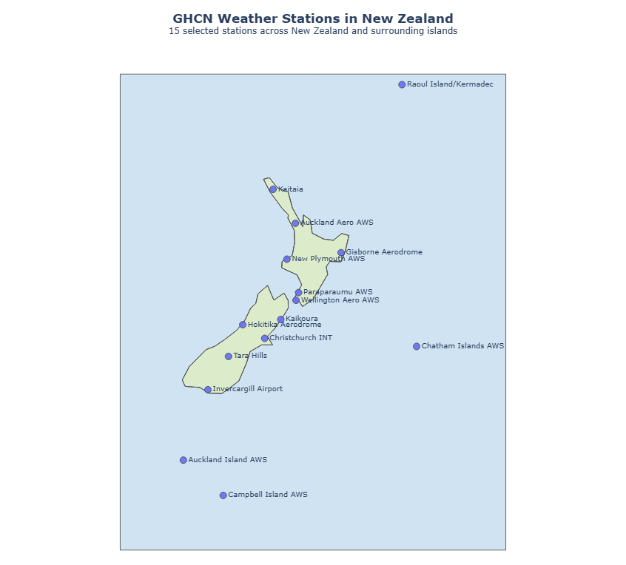
Figure 3. The 15 GHCN stations in New Zealand and its outlying islands, plotted with Plotly on a natural earth projection.
The map clearly shows the network's structure in a way the coordinate table cannot. Stations are located at both main islands at roughly one per region, but four sit on remote islands of Raoul Island/Kermadec at 29.3°S, the Chatham Islands to the east, and Auckland and Campbell Islands deep in the subantarctic at 50.5°S and 52.6°S. There was one problem: Raoul and the Chathams lie east of the 180° meridian with negative longitudes, so if I plotted them raw they would appear on the far side of the world. So, I added 360° to negative longitudes for plotting only leaving stored coordinates unchanged.

Q3: The daily climate summaries in more detail
(a) Stations active in 2026 according to `daily`:
38,678 stations in daily recorded at least one observation in the 2026 file.
As compared to the inventory-based figure from Processing Q3 (37,422), there is a difference of 1,256 stations between the two with daily showing more active stations than inventory. inventory's LASTYEAR is derived when the inventory is compiled, so it can lag the raw observations which are in daily i.e., a station that resumed reporting recently may appear in the 2026 daily file while its inventory record still shows an earlier final year. The two sources answer different questions, and where they conflict daily is the primary source of evidence.
(b) Observations for the five core elements:
I filtered daily with where(col("ELEMENT").isin("PRCP", "SNOW", "SNWD", "TMAX", "TMIN")) and grouped by element across the whole dataset to get the observations recorded by each core element.
Table 4. Observation counts for the five core elements (all years of `daily`).
Element | Description | Observations | Share of the five
PRCP | Precipitation | 1,095,438,345 | 39.9 %
TMAX | Maximum temperature | 466,229,927 | 17.0 %
TMIN | Minimum temperature | 465,041,338 | 16.9 %
SNOW | Snowfall | 367,671,806 | 13.4 %
SNWD | Snow depth | 306,402,150 | 11.2 %
Total |  | 2,700,783,566 | 100 %

PRCP has the highest observations count at 1,095,438,345 (than twice as many as any other element).
This confirms the network structure described in the brief that about almost half of all stations records precipitation only, so PRCP is measured at site far more than temperature. There are two more points worth considering: First, the five core elements make up about 85% of all 3.19 billion daily rows, leaving the other 139 element types just 15% between them. Second, the TMAX and TMIN are nearly same in count, (only a difference of 1,188,589 observations, 0.25%) This is expected, since a station recording one almost always records the other the same day, and it is that near equality that makes the next question more meaningful.
(c) TMAX observations with no corresponding TMIN:
The efficient approach is a LEFT ANTI JOIN keyed on [ID, DATE]. Take the TMAX rows, anti-join against the TMIN rows on both station and date and count what survives. An anti-join returns exactly the left rows with no match in a single shuffle. A full outer join would materialise both sides and then need filtering and grouping or pivoting per station-day shuffles far more data. Projecting each side to just ID and DATE before joining keeps the shuffle small, since VALUE and the flags are irrelevant here. Using both keys is essential i.e, joining on ID alone would only find stations that never record TMIN at all, not individual unpaired observations.
There are 10,727,375 TMAX observations that do not have a corresponding TMIN observation, contributed by 28,762 unique stations.
That roughly translates to 2.3% of all 466 million TMAX observations which confirms that the two elements are usually reported together. But 28,762 contributing stations is worth noting here. Unpaired observations are distributed thinly across a big share of the network instead of being confined to a few broken sites which points to possible routine intermittent collection gaps.

Visualizations

Q1: TMIN and TMAX for New Zealand stations
(a) Filtering and describing the data:
I parsed ID, DATE, ELEMENT and VALUE from the daily files and reduced to New Zealand TMIN/TMAX with a LEFT SEMI JOIN against the 15 NZ station IDs. The left semi-join is right tool because it filters daily without adding columns, so nothing from the station table travels through the shuffle.
Table 5. New Zealand TMIN/TMAX coverage.
Measure | Value
Total TMIN/TMAX observations | 500,840
Years covered | 87
First observation | 8 March 1940
Last observation | 1 August 2026
Expected calendar days in that span | 31,558
Distinct dates with at least one observation | 31,514
Dates with no observations at all | 44

Answer: there are 500,840 TMIN and TMAX observations for New Zealand, covering 87 years from 1940 to 2026. There are gaps: on 44 individual dates no New Zealand station reported either element.
To find the gaps I generated the complete calendar sequence between the first and last observation with sequence/explode, then anti-joined the observed dates against it as it is more reliable than differencing counts because it returns the actual missing dates. The 44 missing days are not spread evenly. Every one falls between 2006 and 2026, clustered into short runs, including eight consecutive days in May 2015 and five in March to April 2026. This suggests short data-feed interruptions affecting all stations at once rather than historical sparseness. A notworth point is that it measures dates when the entire country reported nothing. Individual stations have far more as shown in the subplots.
(b) Per-station time series:
Since raw daily values cannot be compared across 15 stations in one figure, I aggregated to monthly means per station and converted raw tenths of a degree to °C. That gave 9,062 station-months across 15 stations. I further pivoted TMIN and TMAX into separate columns and collected the result to the driver. That approach is safe because 9,062 rows is a quite small aggregate.
Another thing worth mentioning is that monthly averaging removes day to day noise but leaves a strong annual cycle dominating the plot. That’s is where a 12 month rolling average with min_periods=12 cancels that cycle almost exactly, leaving the long-term level, and trend remains visible. A shorter window retains seasonal oscillation, and a much longer one flattens real variation.
Gaps - min_periods = 12 produces the rolling average only where a full year of data exists, so gaps stay empty. I did not interpolate it intentionally since filling gaps would imply observations that were never made.
Alignment - To make the panels comparable I built a complete monthly timeline of 1,038 months (March 1940 to August 2026) and reindexed every station onto it, giving a 15 × 1,038 = 15,570-row frame with NaN where data is absent. With sharex=True, sharey=True every panel spans identical axes, so any station's level and record length reads directly against another's.
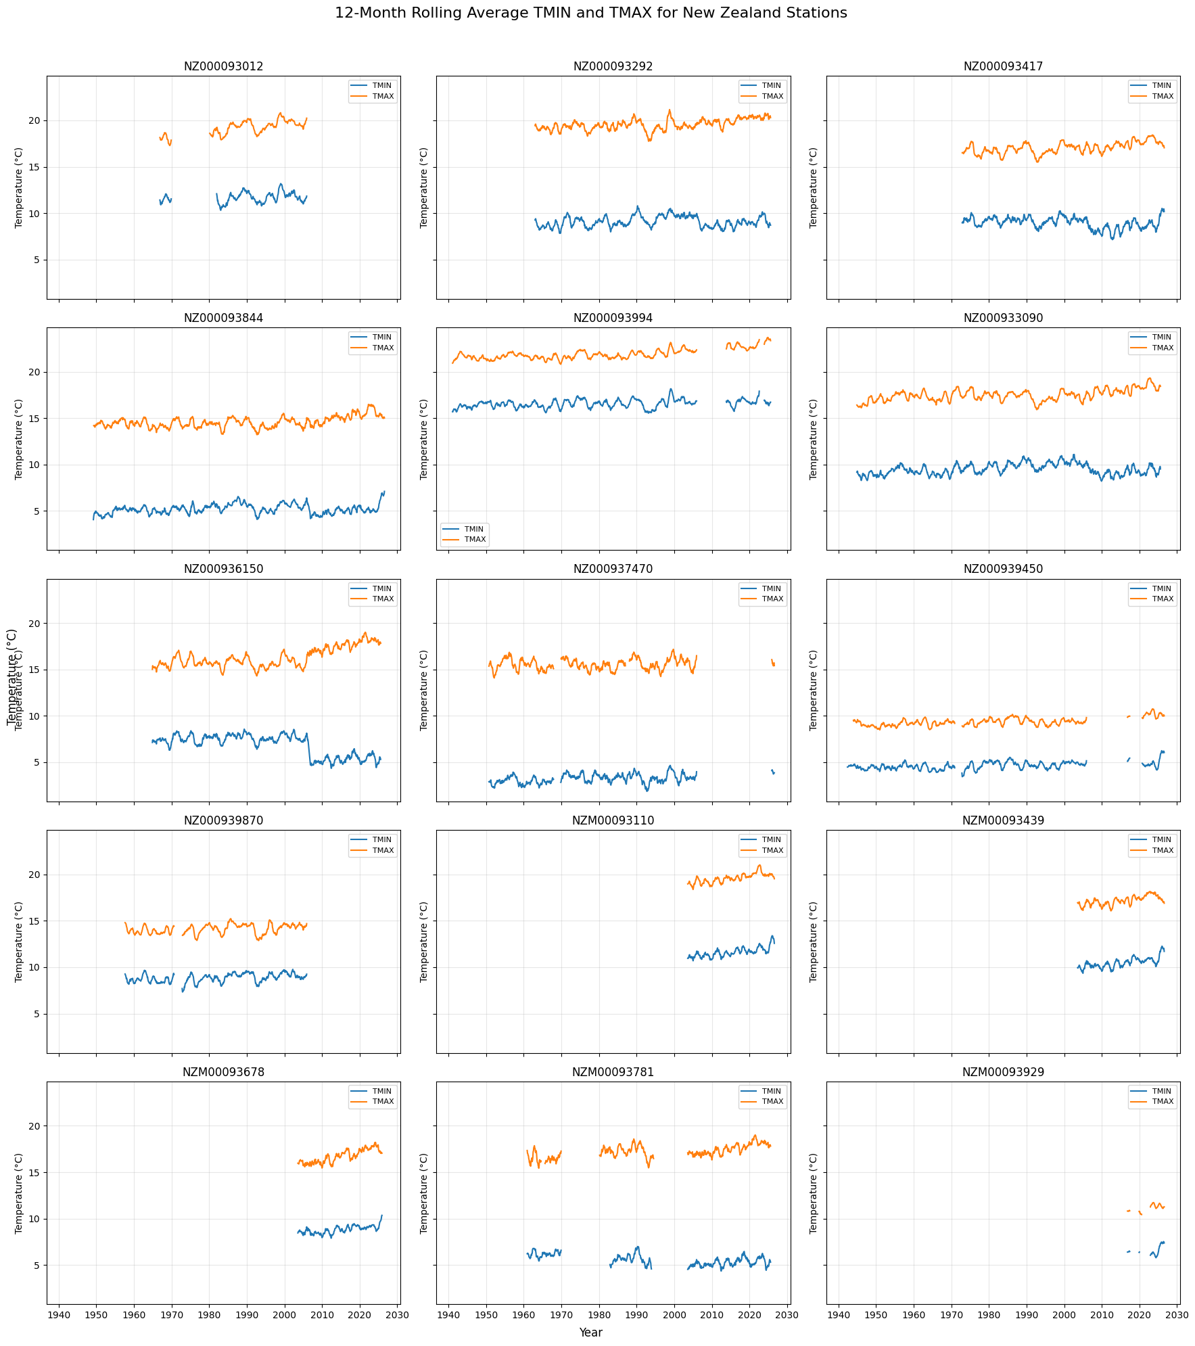
Figure 4. Twelve-month rolling average TMIN and TMAX for each of the 15 New Zealand stations, on shared axes.
Record lengths have a huge variations. Gisborne and Invercargill run for almost full 87 years, whereas Auckland, Wellington and Kaikoura begin only in the 2000s. Auckland Island is little more than a fragment. Temperature level are separated cleanly by latitude. Subantarctic and southern stations are around 5 °C TMIN, northern and Kermadec stations around 15–16 °C, and several show a mild upward drift over recent decades. Two features are artefacts rather than climate. First, the abrupt step in NZ000936150 (Hokitika) around 2005 where TMIN drops roughly 2 °C and remains there which is the signature of a station relocation or instrument change, Second, the broken segments in NZM00093781 (Christchurch) where gaps seem to be preserved rather than filled.
(c) Country-wide series. To calculate the national figure, I changed approach. I averaged across all stations each month and applied the same 12-month rolling mean which gave 1,038 monthly values on a single large axis. Fifteen overlaid series would have been unreadable at that size, so one national series makes the long-term signal much more readable.
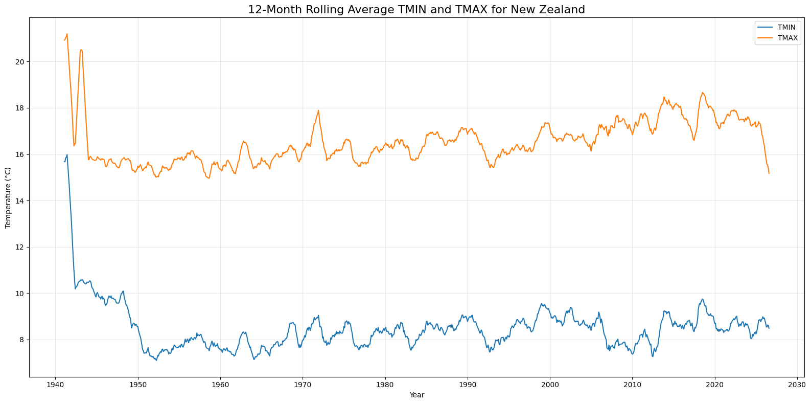
Figure 5. Twelve-month rolling average TMIN and TMAX averaged across all New Zealand stations.
From about 1950 onward the national series remains stable and shows mild warming in both TMIN and TMAX with TMAX rising from roughly 15.5 °C to around 17.5 °C. The 1940–1950 portion should not be read as climate because only one or two stations were reporting then, so the "national average" is really one station's record, and it swings wildly. TMAX shoots above 21 °C and TMIN falls by 8 °C within a couple of years, stabilising only as more stations join. This is a real limitation of averaging over a changing set of stations. The mean reflects which stations reported as much as the weather.

Q2 — Global rainfall
(a) Average daily rainfall by country and year:
Starting from the full daily dataset of 3,190,161,793 rows across the 264 files from 1763 to 2026, I filtered to ELEMENT = 'PRCP', retaining 1,095,197,420 observations, joined each station to its country through a small lookup, extracted the year, and grouped by year and country taking the mean of VALUE. This produced 17,789 country-year records, saved to Parquet. I excluded the 1750 file here for its known data-quality problems, which is why this count sits just below the 3,190,506,382 in Processing Q2.
What this average means matters for everything that follows: it is the average of reported PRCP observations for a country-year, not the average of one national value per calendar day. A country with 40 stations reporting daily contributes tens of thousands of observations; one with a single station reporting once contributes one. The measure is weighted by reporting effort, which causes the outliers below.
Table 6. Descriptive statistics for average daily rainfall by country-year (all years).
Statistic | Value (mm/day)
Count (country-years) | 17,789
Mean | 4.20
Standard deviation | 8.42
Minimum | 0.00
Maximum | 436.10

Raw GHCN precipitation values are in tenths of a millimetre, so all figures here are divided by 10. A mean of 4.2 mm/day is plausible for a global average of reported rainfall, while a standard deviation twice the mean and a maximum roughly 100 times signal a severely right-skewed distribution.
Which country has the highest average rainfall in a single year, and is it sensible?
Equatorial Guinea in 2000, at 436.1 mm/day. This result is not sensible.
I investigated rather than simply reporting it. Equatorial Guinea has two stations, and in 2000 the country's entire precipitation record was a single observation: station EKM00064810 (Malabo) on 22 June 2000, recording 4,361 tenths of a mm. One exceptionally wet day treated as a whole-year average produces a meaningless figure of 436 mm in a day. It is is extreme but possible in the tropics, but as an annual average it is absurd. The other top country-years follow the same pattern. Dominican Republic 1975, Laos 1974, Belize 1978, all small 1970s samples. The general lesson is that these extremes are not bad measurements but statistically unstable estimates from tiny samples, so the number of contributing observations must be checked before any country-year value is trusted.
(b) The 2025 choropleth:
For 2025 there are 172 country-year records, with mean 5.28 mm/day, median 3.83 and maximum 54.0 mm/day.
The 2025 maximum is Azerbaijan at 54.0 mm/day, again a sparse-sample artefact: the country reported only three precipitation observations all year, one of them 122 mm. Counting observations per country shows how uneven coverage is. 5 countries have 3 or fewer, 9 have 10 or fewer, and 17 have 30 or fewer:
Country | 2025 PRCP observations
Liberia | 1
Gambia, The | 2
Lebanon | 2
Angola | 3
Azerbaijan | 3
Zambia | 4
Kazakhstan | 4
Cape Verde | 9
Korea, South | 10

The distribution is heavily skewed: 25th percentile 1.89, median 3.83, 75th 6.78, 90th 10.04, 95th 11.25, and 99th 54.00 mm/day. Moving from the 95th to the 99th percentile is entirely because of Azerbaijan.
How I handled outliers: Instead of deleting the outliers, I capped the colour scale at the 95th percentile (11.25 mm/day) which kept the true values in the data and the hover text. If I deleted a country for having an extreme value, that would discard real information and hide a coverage problem the reader should be able to see. Had I left the scale uncapped, that would have compressed 169 countries into the bottom fifth of the colour range just to accommodate one. Capping is a visualization decision, and it is reversible.
Country matching: The choropleth keys of Plotly on ISO-3 codes and GHCN names did not match ISO names directly. So, I built an explicit name to ISO-3 mapping and verified it. The result showed all 172 records matched and 0 unmatched. One genuine ambiguity emerged though: Svalbard and Jan Mayen are separate GHCN entries sharing the single code `SJM` which collapsed 172 records to 171 unique codes. A choropleth on country-level cannot show two values for one shape and choosing one arbitrarily would be misleading. So, I excluded both from the map, after which only 170 countries were left and plotted. This decision only affected the visualisation.
Countries matched but with no observations: 47 countries and territories had stations but did not report any precipitation at all in 2025. Amongst them were Afghanistan, Belgium, Croatia, Cuba, Guatemala, Kuwait, Mali, Panama, Sudan, Syria and Uganda. These render as missing (uncoloured), not zero. The distinction has an importance because colouring them zero would show Belgium and Sudan as the driest places on Earth when nothing was reported. Genuinely low values like Liberia and Lebanon at 0.0 and the Gulf states at a fraction of a mm/day, appear at the pale end because they were observed.
Projection and colour scale: I used the natural earth projection for the choropleth. As choropleth compares areas, so a conformal projection like Mercator is a poor choice for visualization, inflating high latitudes until Greenland and Russia dominate. Natural earth helps with keeping area distortion modest and shapes recognisable. For colour I used `YlGnBu`, a sequential scale from pale yellow to dark blue. Rainfall is a single ended ordered quantity with no meaningful midpoint, so a sequential scale is correct. A diverging scale would imply a centre that does not exist in this case. A categorical palette would destroy the ordering. Plus, Yellow-to-blue also reads intuitively as dry-to-wet.
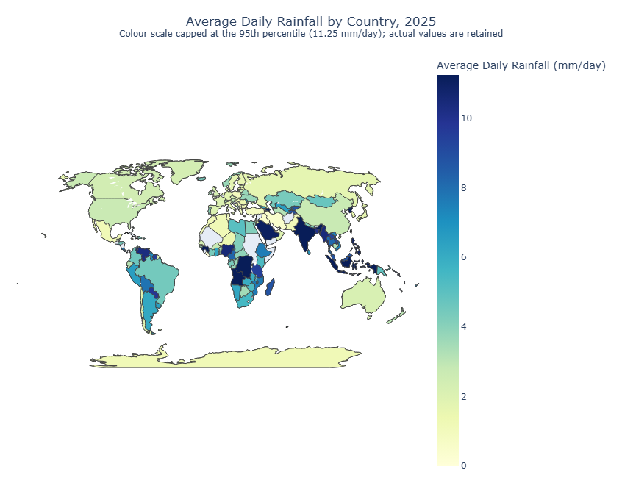
Figure 6. Average daily rainfall by country for 2025, natural earth projection, sequential YlGnBu scale capped at the 95th percentile.
How rainfall is distributed and what stands out: The broad pattern makes sense climatologically. The wettest areas run through the equatorial tropics i.e., Central Africa (Congo, Guinea, Cameroon), South and Southeast Asia (India, Bangladesh, Burma, Indonesia, Malaysia, the Philippines) and northern South America which matches with the Intertropical Convergence Zone. On the other hand, the driest areas are the arid subtropics, including the Sahara, the Arabian Peninsula, Iran and central Asia, plus inland Australia and much of western North America. Mid-latitude Europe, Canada and Russia sit in the low-to-middle range.
Three anomalies in the data are worth mentioning here: Azerbaijan and Angola appear as dark as the wettest tropical countries purely because they had only three-observation samples. Antarctica is coloured, which looks odd on a rainfall map, but GHCN does have Antarctic stations, and its value is genuinely reported precipitation. And the 47 blank countries (a conspicuous gap across parts of Africa, Central America and the Middle East) reflect missing 2025 reporting, not aridity. The map shows a fair picture of where rainfall was reported and how much, but due to uneven coverage, it is not to be considered a precise climate comparison.

Conclusions
Working through GHCN-Daily in whole gave me a solid sense of what changes when a dataset stops fitting on one machine. The data is now well characterised: daily is 13.15 GiB compressed across 265 yearly files, expanding roughly 7.9× to an estimated 111 GB and 3.19 billion rows, and accounting for 99.67% of the total; there are 132,501 stations, of which 20,505 record all five core elements and 16,189 record precipitation only; 63 never appear in daily; the two closest New Zealand stations are 50.5 km apart; precipitation dominates with 1.095 billion observations; and 2.3% of TMAX observations have no matching TMIN.
Three techniques did most of the work. Reducing before joining i.e., projecting daily to one column and deduplicating, turned an expensive join into a cheap one. Broadcasting the small side replaced a shuffle of 3.19 billion rows with a local hash lookup, as the physical plans confirmed. And aggregating before collecting meant every visualisation was driven by a few thousand rows on the driver rather than the raw data.
In this scenario, the judgement calls also mattered as much as technical Spark code proficiency. Declaring DATE as a date type silently produced nulls which taught me to always verify parsed output rather than trust an accepted schema. A malformed closing brace in the countries file also cost three stations until I checked the raw values and corrected the code logic. And the rainfall work could have been easily misrepresented. The headline of "wettest country-year on Earth" rested on a single observation, and the right approach was to explain why the number was meaningless rather than report it. Distinguishing no observation from zero on the choropleth is the same instinct applied to a map. If I continued, I would control for station composition in the national temperature series using anomalies relative to each station's own baseline, and attach an observation count to every country-year so sparse estimates can be filtered rather than caveated in prose.

References
- NOAA National Centers for Environmental Information. Global Historical Climatology Network – Daily (GHCN-Daily). https://www.ncei.noaa.gov/products/land-based-station/global-historical-climatology-network-daily
- Menne, M. J., Durre, I., Vose, R. S., Gleason, B. E., & Houston, T. G. (2012). An overview of the Global Historical Climatology Network-Daily database. Journal of Atmospheric and Oceanic Technology, 29(7), 897–910.
- NOAA NCEI. GHCN-Daily README — Section III element codes, units, and measurement/quality/source flags.
- Sinnott, R. W. (1984). Virtues of the Haversine. Sky and Telescope, 68(2), 159. — great-circle distance formula used in Analysis Q2.
- Apache Software Foundation. Spark SQL, DataFrames and Datasets Guide, Spark 3.3.5. https://spark.apache.org/docs/latest/sql-programming-guide.html
- Apache Software Foundation. Apache Parquet documentation. https://parquet.apache.org/docs/
- Plotly Technologies Inc. Plotly Express: Choropleth maps and Scatter plots on maps. https://plotly.com/python/choropleth-maps/ · https://plotly.com/python/scatter-plots-on-maps/
- Brewer, C. A., & Harrower, M. ColorBrewer 2.0: Colour advice for cartography. https://colorbrewer2.org — basis for the sequential YlGnBu scale.
- The Matplotlib Development Team. Matplotlib documentation. https://matplotlib.org/stable/index.html
- Daly, C., Helmer, E.H. and Quiñones, M., 2003. Mapping the climate of Puerto Rico, Vieques, and Culebra. International Journal of Climatology, [online] 23(11), pp.1359–1381

Use of generative AI is acknowledged separately in accordance with the assignment instructions, describing the tools used and how they were used.

