Ahmed Mazloum

2/23/2020

CIS 200 Project# 1

# Problem Statement

A program that plays reversi othello

# 2.0 ReadMe

The program is a two player game of reversi Othello using a 2-D array. The program will allow you to place a disk, the rules of the game, display possible moves, and the best move for the current player.

# 3.0 UML Class Diagram



# 4.0 Test Plan

|  |  |  |  |  |  |  |
| --- | --- | --- | --- | --- | --- | --- |
| Test # | Valid / Invalid Data | Description of test | Input Value | Expected Output | Actual Output | Test Pass / Fail |
| 1 | Invalid | Tests if a character works in the menu | Am | Invalid option, Please enter one of the menu options: | Invalid option, Please enter one of the menu options: | Pass |
| 2 | Valid | Tests the first option in the menu | 1  5 4 | b at the in the 5 4 spot | b at the in the 5 4 spot | Pass |
| 3 | Valid | Tests the second option in the menu for the directions | 2 | Movement Rules for the Reversi Othello  1)it creates a straight line(Horizontally, Vertically, or diagonally) between the newly placed disk and another of the player’s disk.  2)There must be one or more of the opponent’s disks between the current player’s disks.[A disk must get ‘flipped’.] | Movement Rules for the Reversi Othello  1)it creates a straight line(Horizontally, Vertically, or diagonally) between the newly placed disk and another of the player’s disk.  2)There must be one or more of the opponent’s disks between the current player’s disks.[A disk must get ‘flipped’.] | Pass |
| 4 | Valid | Test if an x is placed for the valid moves when 3 is entered | 3 | X’s should be placed for white player available moves | X’s should be placed for white player available moves | Pass |
| 5 | Valid | Test the best move when 4 is entered | 4 | Your best move is:3, 5 and will in a 0 score differential | Your best move is: 3, 5 and will in a 0 score differential | Pass |
| 6 | Valid | Test is the winner is displayed | none | Congrats! Player 2: White has won the game (45 -19)  Play again? (y/n): | Congrats! Player 2: White has won the game (45 -19)  Play again? (y/n): | Pass |
| 7 | Vaild | Test play again | y | Play again? (y/n): y | Play again? (y/n): y | Pass |

# 5.0 Screenshots

**Test#1**

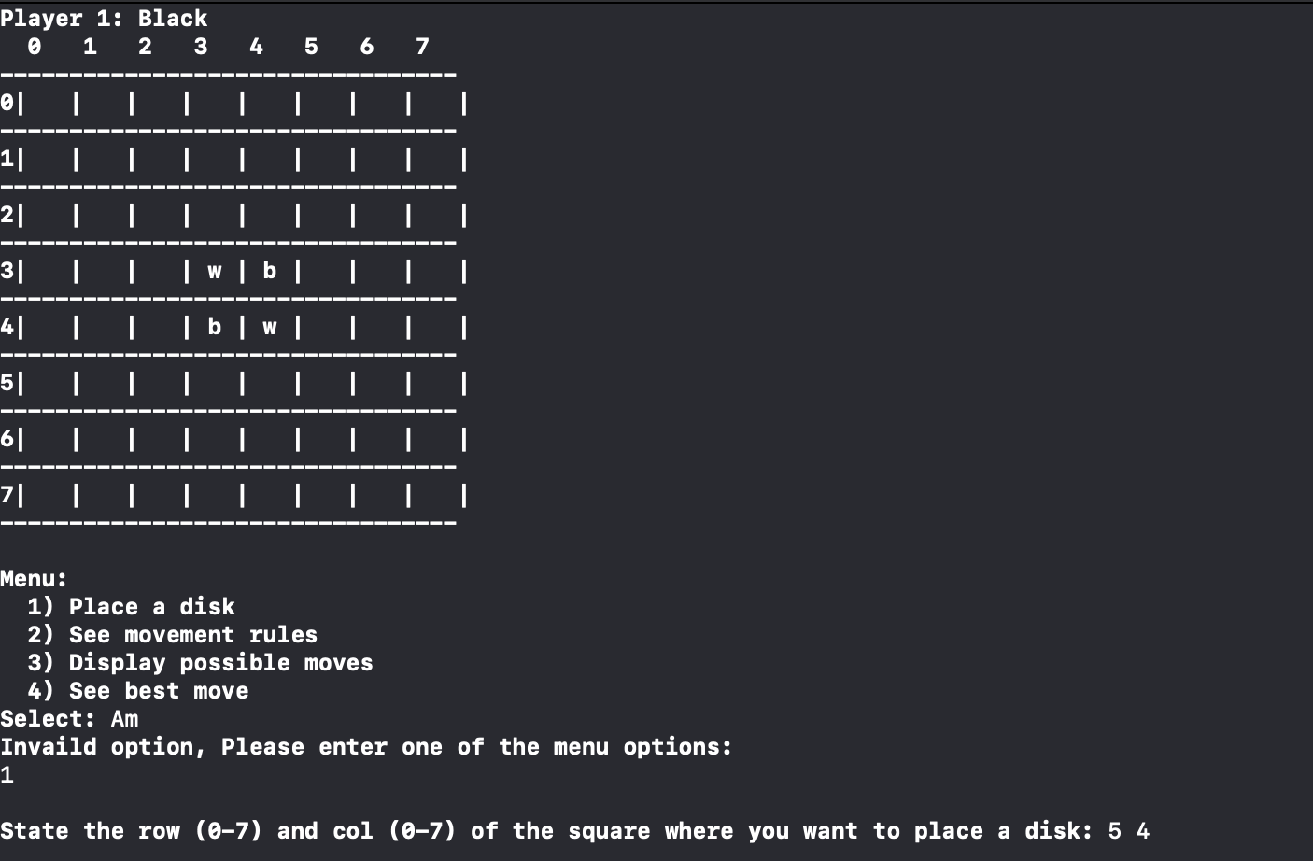

**Test#2**

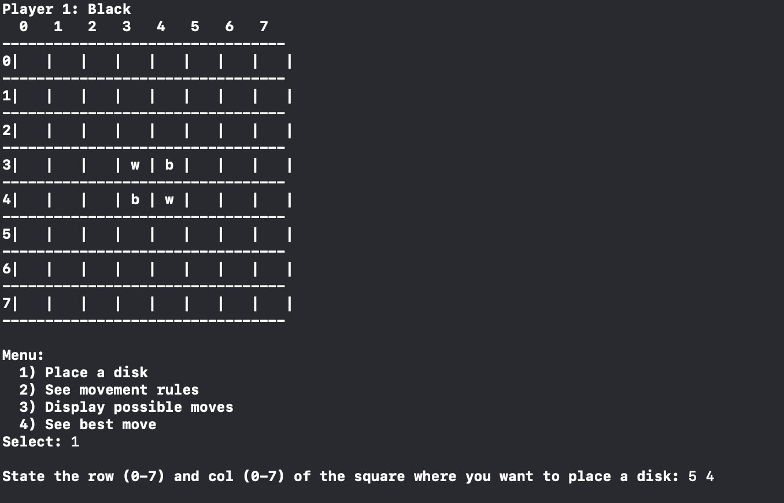

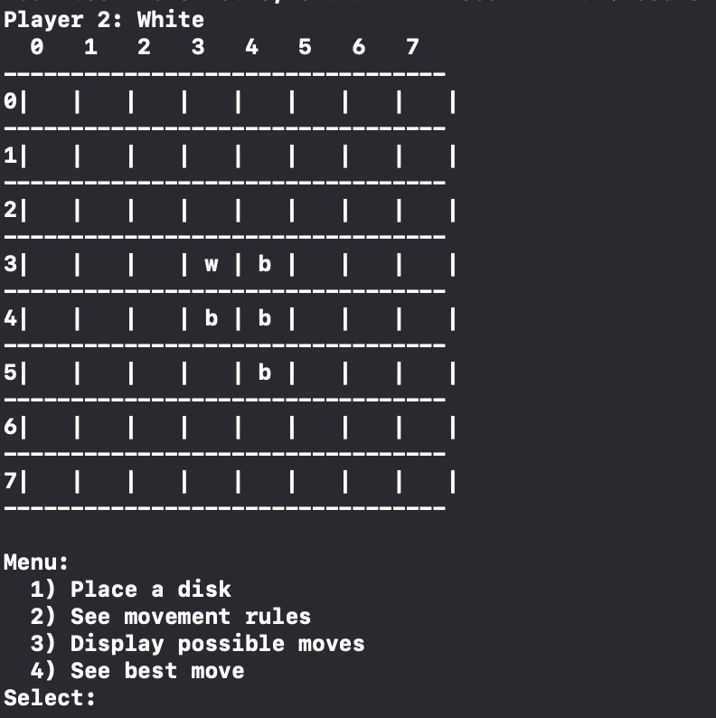

**Test#3**

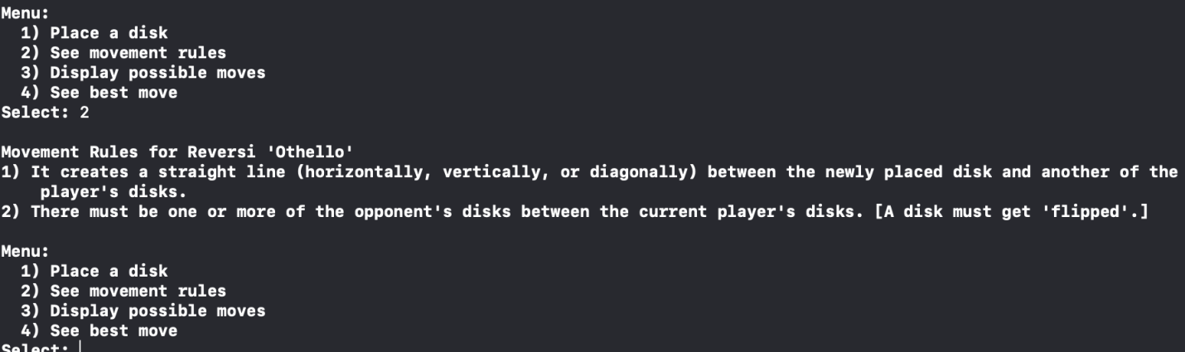

**Test#4**

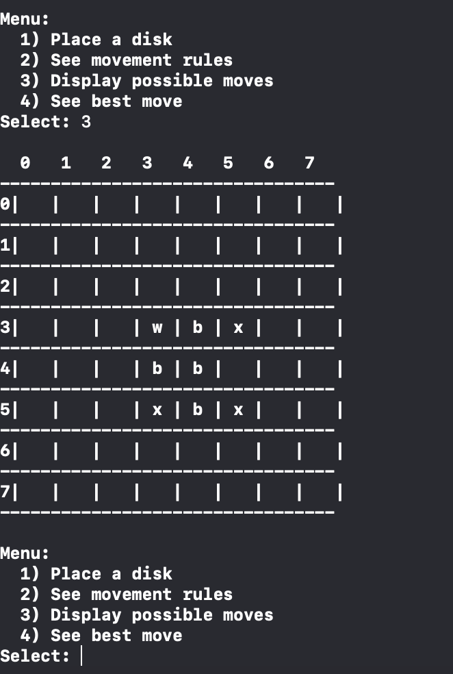

**Test#5**

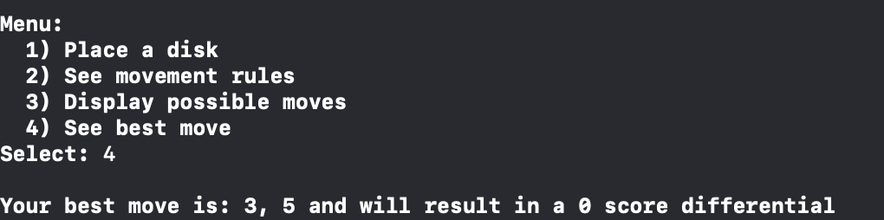

**Test#6**

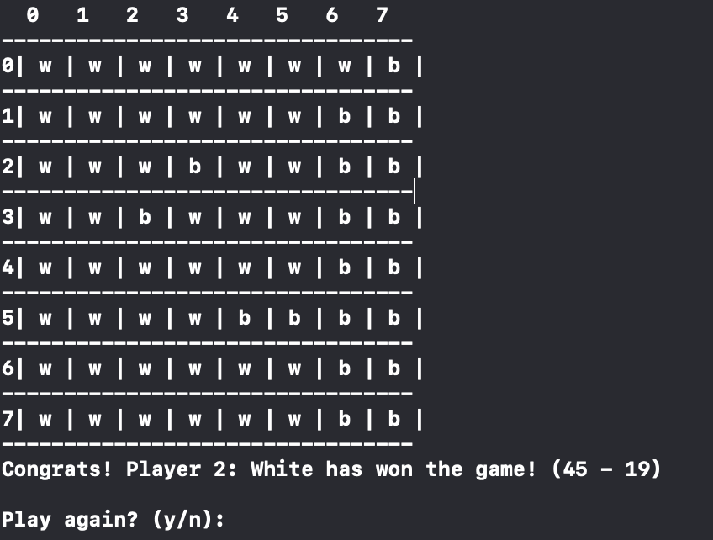

**Test#7**

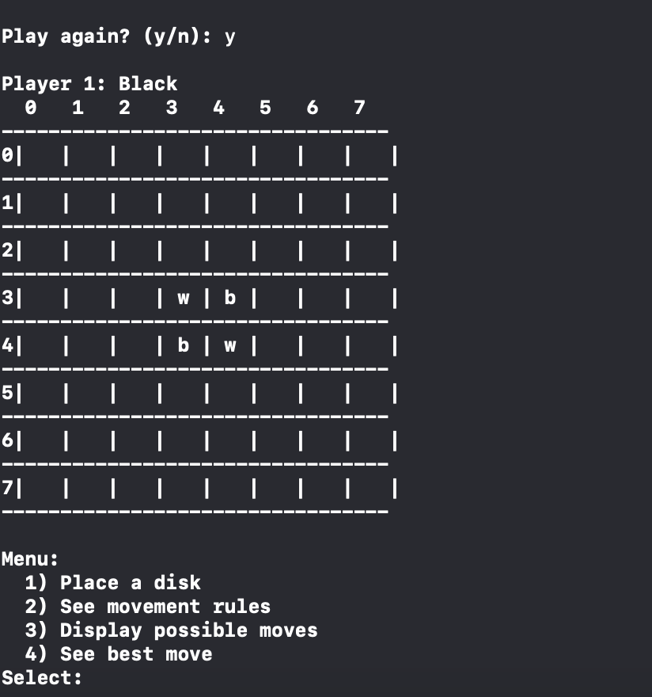

# 6.0 Program Status

The program works 100 percent but to display the winner you need to enter 4 to after there are no more moves to play.