**Name: Ahmed Tarek Mohamed EL-Meligy**

**Track: PHP**

**Lab1 Red Hat**

**2. What is the difference between cat and more command?**

**Cat**: It outputs the entire content of the file(s) to the terminal in one go, which can scroll past the screen too quickly if the file is long.

**More**: It displays the first page of the file and waits for user input to display subsequent pages. It stops after each page, showing **--More--** at the bottom, prompting the user to press the spacebar to continue or to use other navigation commands.

**3. What is the difference between rm and rmdir using man?**

**rm:** stands for "remove" and is used to delete files or directories.

rmdir: stands for "remove directory" and is specifically used to remove empty directories.

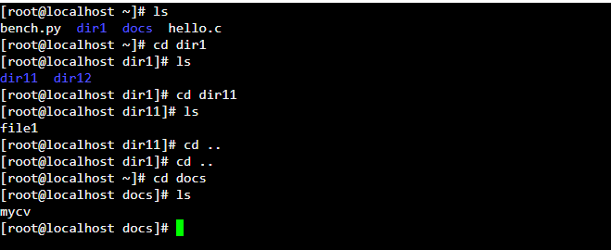4.

1. When attempting to remove dir11 using a single command like rmdir dir1/dir11, it result in an error because the directory contains files or other directories within it.

To over come this I used -r option (rm -r dir1/dir11)

1. the command will fail to remove **dir12 ,** it should be   
   (rmdir -p dir1/dir12)
2. absolute: /home/user/docs/mycv  
   relative docs/mycv

5**. Copy the /etc/passwd file to your home directory making its name is mypasswd**

(cp /etc/passwd ~/mypasswd)

7. **You are in /usr/bin, list four ways to go to your home directory**

**(cd) – (cd ~ ) – (cd $HOME) – ( cd ../root)**

**9. Display the first 4 lines of /etc/passwd**

head -n 4 /etc/passwd

**10. Display the first 7 lines of /etc/passwd**

**tail -n 7 /etc/passwd**

**11. Display the man pages of passwd the command and the file sequentially in one command.**

(man passwd && man 5 passwd)

**12. Display the man page of the passwd file.**

(man 5 passwd)

**13. Display a list of all the commands that contain the keyword passwd in their man page.**

Man -K passwd