1. **Using vi write your CV in the file mycv. Your CV should include your name, age, school, college, experience…**

**2. Open mycv file using vi command then: Without using arrows state how to:**

**a. Move the cursor down one line at time.**

**=> Key ( j )**

**b. Move the cursor up one line at time.**

**=> Key ( k )**

**c. Search for word age**

**=> :/Age OR :/age\C**

**d. Step to line 5 (assuming that you are in line 1 and file is more than 5 lines).**

**=> 5G in normal mode**

**e. Delete the line you are on and line 5.**

**=> dd for current line AND 5dd for line 5**

**f. How to step to the end of line and change to writing mode in one-step.**

**=> Key ( A )**

**3. List the available shells in your system**

**4. List the environment variables in your current shell.**

**5. List all of the environment variables for the bash shell.**

**6. What are the commands that list the value of a specific variable?**

**=> echo variable name**

**=> declare -p variable name**

**7. Display your current shell name.**

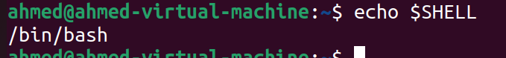

**8. State the initialization files of: sh, ksh, bash.**



**9. Edit in your profile to display date at login and change your prompt permanently.**

**=> vi .bashrc  
**

**10.Execute the following command :**

**echo \ then press enter**

**What is the purpose of \ ?**

**Notice the prompt ”>” what is that? and how can you change it from “>” to “:”.**

**=> “>” It's a secondary prompt that appears when a command is not completed on the initial line.**

**I can change it by edit PS2 in bashrc  
=> vi .bashrc  
**

**11.Create a Bash shell alias named ls for the “ls –l” command**

**I can make alias temporary like this   
=> alias ls=”ls-l”**

**OR I can edit it in bashrc to make it permanent**

