**Name: Ahmed Tarek Mohamed EL-Meligy**

**Track: PHP**

**Red Hat Lab(4)**

1. **List the user commands and redirect the output to /tmp/commands.list**



1. **Count the number of user commands**



1. **Get all the users names whose first character in their login is ‘g’.**

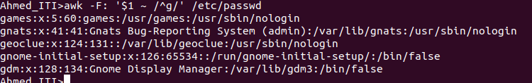

1. **Get the logins name and full names (comment) of logins starts with “g”**

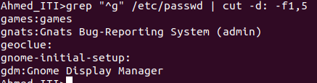

1. **Save the output of the last command sorted by their full names in a file.**

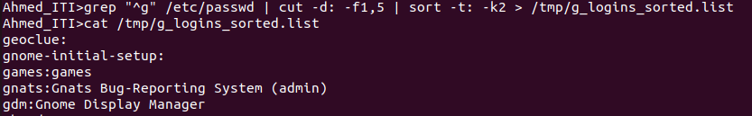

**6. Write two commands: first: to search for all files on the system that named**

**.bash_profile. Second: sorts the output of ls command on / recursively, Saving**

**their output and error in 2 different files and sending them to the background.**

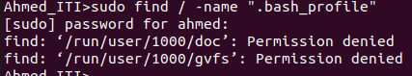



**7.Display the number of users who is logged now to the system.**

**8. Display lines 7 to line 10 of /etc/passwd file**

**9. What happens if you execute:**

**• cat filename1 | cat filename2**

**• ls | rm**

**• ls /etc/passwd | wc –l**

**10.Issue the command sleep 100.**



**11.Stop the last command.**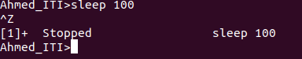

**12.Resume the last command in the background**



**13.Issue the jobs command and see its output**



**14.Send the sleep command to the foreground and send it again to the background.**

**15.Kill the sleep command.**



**16.Display your processes only**

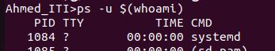

**17.Display all processes except yours**



**18.Use the pgrep command to list your processes only**

**19.Kill your processes only.**

* **( pkill -u $(whoami) )**