**Name: Ahmed Tarek Mohamed EL-Meligy**

**Track: PHP**

**Red Hat Lab(5)**

**1. Compress a file by compress, gzip, zip commands and decompress it again. State the**

**differences between compress and gzip commands.**

**File extension is different between compress and gzip**

**2. What is the command used to view the content of a compressed file.**

**3. Backup /etc directory using tar utility**





**4. Starting from your home directory, find all files that were modified in the last two day.**

**5. Starting from /etc, find files owned by root user**



**6. Find all directories in your home directory.**

**7. Write a command to search for all files on the system that, its name is “.profile”.**

**8. Identify the file types of the following: /etc/passwd, /dev/pts/0, /etc, /dev/sda**

**9. List the inode numbers of /, /etc, /etc/hosts.**

**10. Copy /etc/passwd to your home directory, use the commands diff and cmp, and Edit in the file you copied, and then use these commands again, and check the output.**

**11. Create a symbolic link of /etc/passwd in /boot.**



**12. Create a hard link of /etc/passwd in /boot. Could you? Why?**

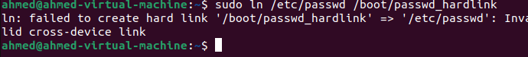

**Because of the different filesystem boundaries and security restrictions between these directories.**