**Algorithm Task**

**Project Idea: 1 (Climbing Stair)**

**Team Number: 12**

**GitHub Link:** [AhmedMetwaly12/algorithmtask (github.com)](https://github.com/AhmedMetwaly12/algorithmtask)

|  |  |
| --- | --- |
| ID | Name |
| 20210108 | أحمد محمد متولي بيومي |
| 20210102 | أحمد محمد عبدالسلام محمد |
| 20210115 | أحمد محمود رمضان محمد |
| 20210085 | أحمد عمر حسين محمد |
| 20210082 | أحمد علي سالمان أحمد |
| 20210026 | أحمد السيد السيد محمود |

**Code Number 1:**

**Pseudocode of Code Number 1**

f := 1

s := 1

Read integer n from the user

for I := 2 to n do {

tmp := f+s

f := s

s := tmp

}

If n < 1 then

s := 0

print s

**Analysis of Code Number 1**

$C\left(n\right) = \sum_{i=1}^{n}{1}=$ n-2 = O(n)

**Code Number 2**

**Pseudocode of Code Number 2**

function fibonacci(n)

if n < 1 then

return 0

if n <= 2 then

return n

return fibonacci(n-1) + fibonacci(n-2)

**Analysis of Code Number 2**

**Test Run of Codes**

**Code 1**

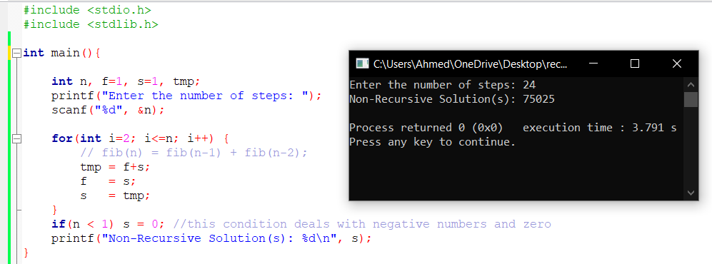

**Code 2**

**Comparison**

|  |  |
| --- | --- |
| Code No. | Time Complexity |
| 1 | O(n) |
| 2 | O(2^n) |

**Therefore:** Code number 1 is better, more time efficient.