We have list.h header file and it has all the function to create linked list.

Over here we also have Stack class. Besides the given functions, I added one more function that will help us to print a stack.

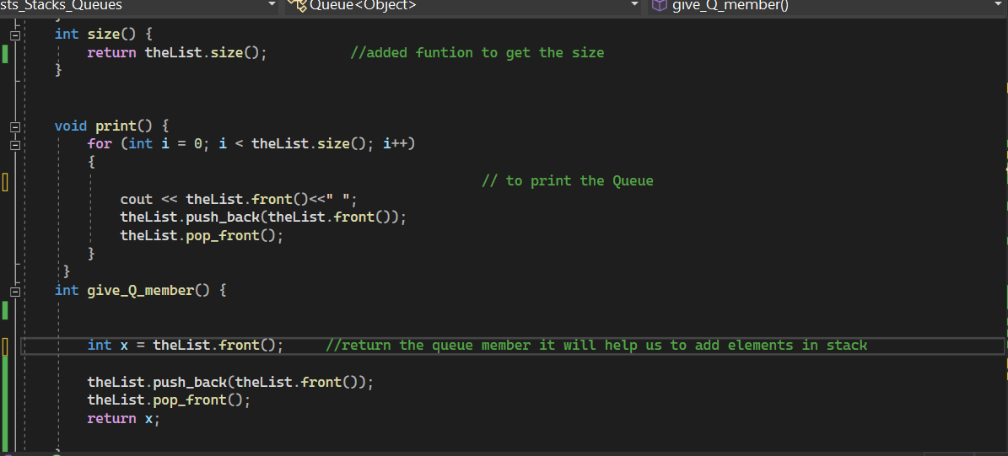

We also have a Queue class and besides the functions I added print and give queue member function. give_Q_member function will help us to access the member of the queue and also preserve the queue.

In the main function . We created 3 objects of list, queue and stack.

We created a list with in range 1.2.3.4.5…..10.Then print the list

Over here we are inserting a value for each elements.

And print out new l1.

Then we create l2 with the value of the l1. Then we print the lists. We can add a print list function that will help us to get a more cleaner code.

Then I added the elements of l1 in the queue. Print the queue. Then I add the l2 elements.

I print the queue.

Then I start the building our stack. I use the function (give_Q_member) to access the queue and add those in stack.

I print the stack and empty the stack(FIRST IN LAST OUT THEORY)