***WeRateDogs Insights***

After preparing and wrangling we rate dogs tweets data and cleaning it from most issues, now here we go discuss some insights about this data and how we can use it to answer questions.

WeRateDogs is a Twitter account that rates people's dogs with a humorous comment about the dog. These ratings almost always have a denominator of 10. The numerators, though? Almost always greater than 10. 11/10, 12/10, 13/10, etc. Why? Because "they're good dogs Brent." WeRateDogs has over 4 million followers and has received international media coverage.

Here some insights which we will discuss:

1. The most source of tweets

According to this statistic iphone is the most used source of tweets

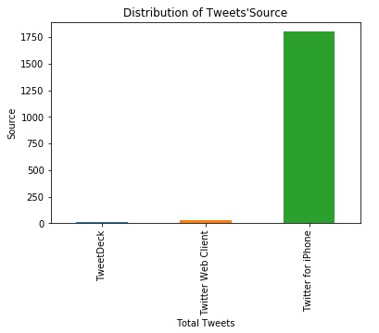

1. Quick overview

An overview about the dataset using “describe ()” method that shows a quick overview about the data like 5 number summary and other calculations from these statistics we can see that rating_numerator median is 11 and the values don't a large differ because std is somewhat small

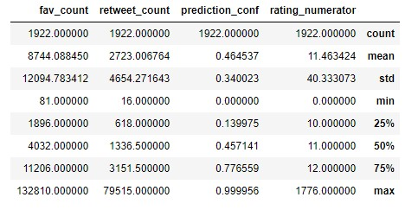

1. what is the common name of dogs

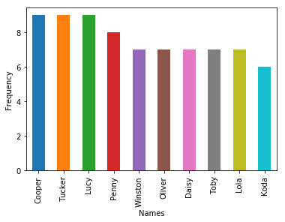Here we can see the most common name of dogs according to this statistics “Charlie & Tucker & Lucy” have the most high frequency among named dogs

1. what is the most common breed

Here we can see that “Golden retriever” is top rated that has a large frequency among the other breeds

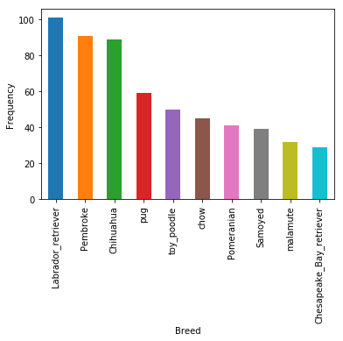

1. what is account statistics

From this analysis along 100 days we found that account performance and favorite counts are increasing although retweet counts are decreasing

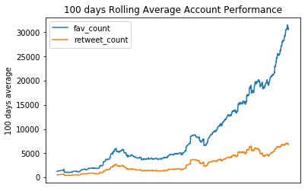

1. what are dog types that have max rate

According to these calculations “Puppo” is top rated type that scored values as follows:

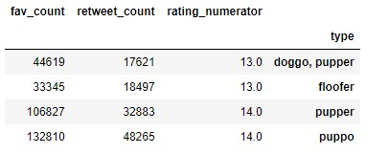

1. what are dog types that have min rate

On the other hand, “pupper” type is the lowest rated type that scored as follows:

