**Question 1**

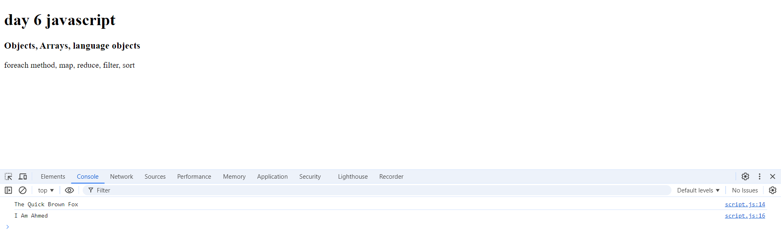

**Question 2**

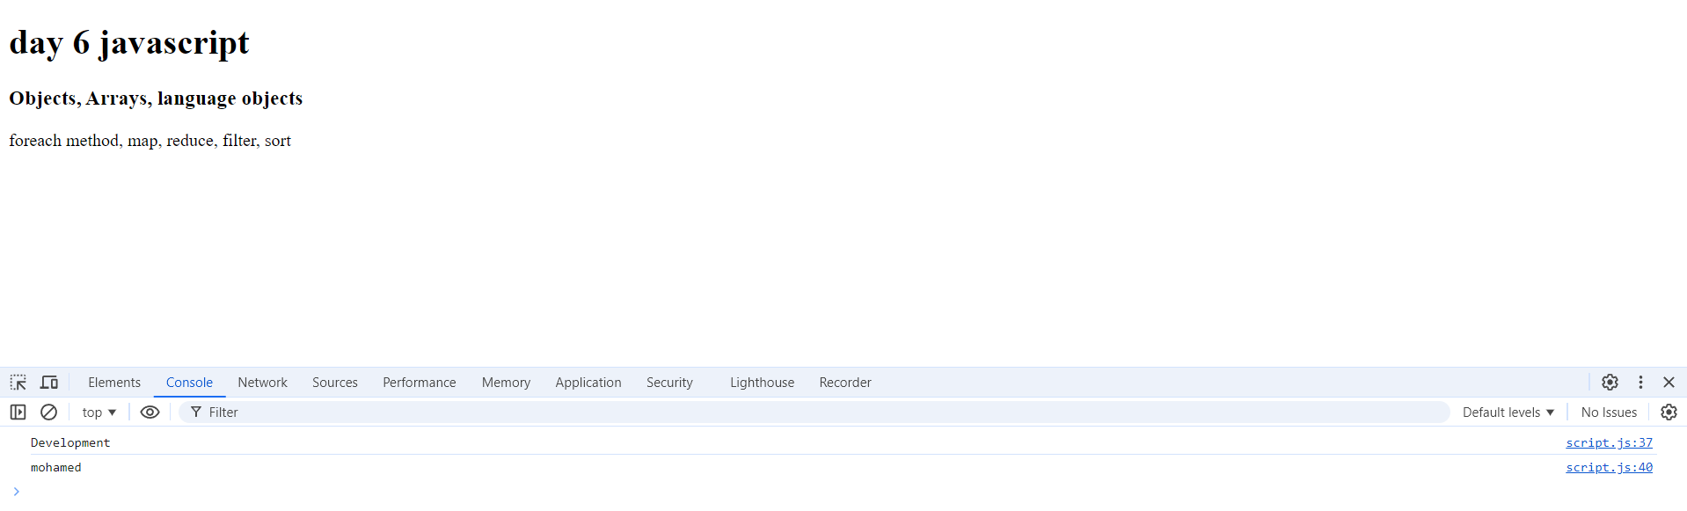

**Question 3**

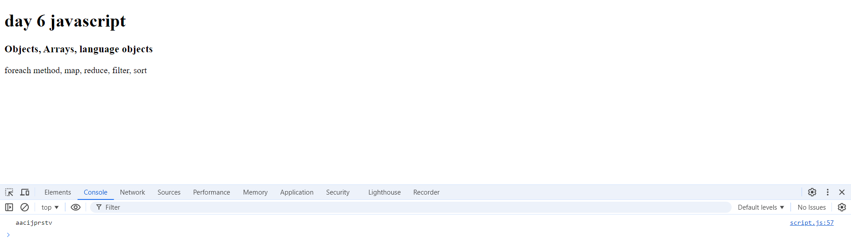

**Question 4**

**Q4.1**

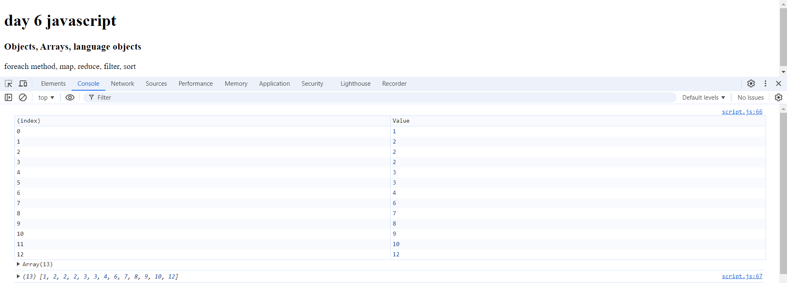

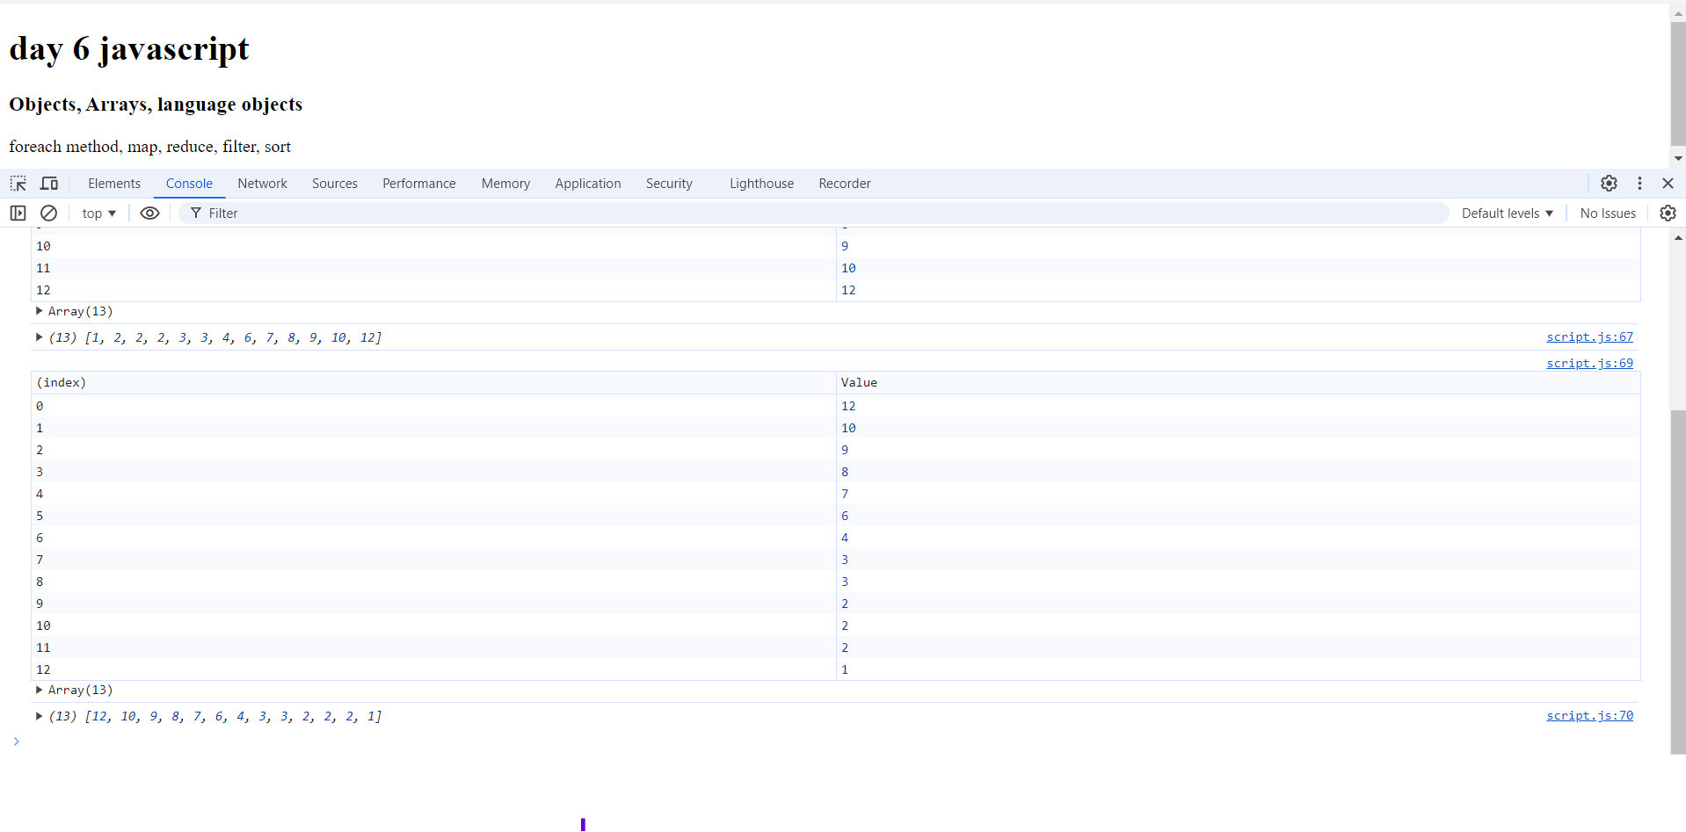

**Q4.2**

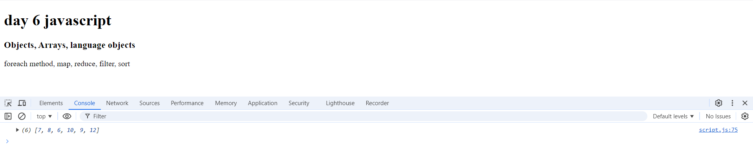

**Q4.3**

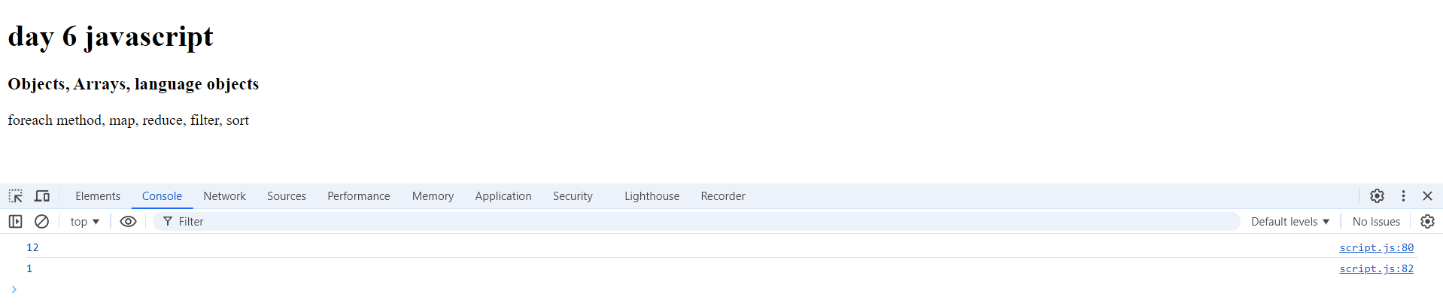

**Q4.4 mapped array .. multiply element by 5**

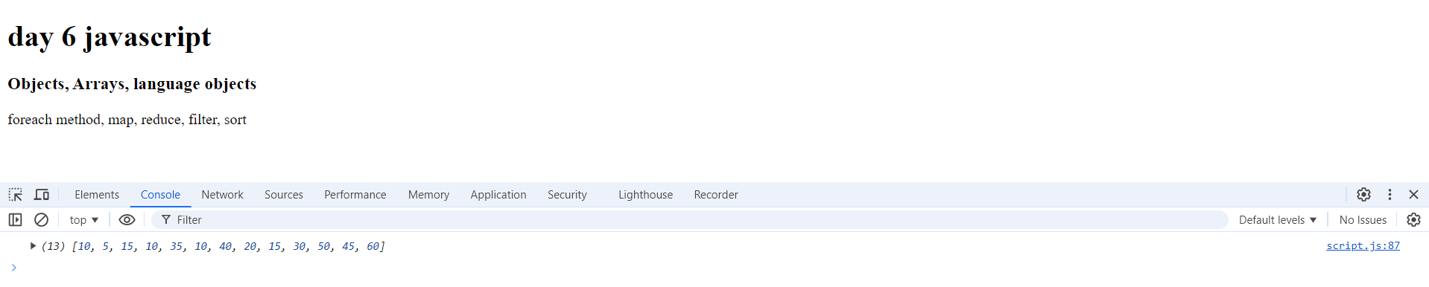

**Q4.5 unique numbers**

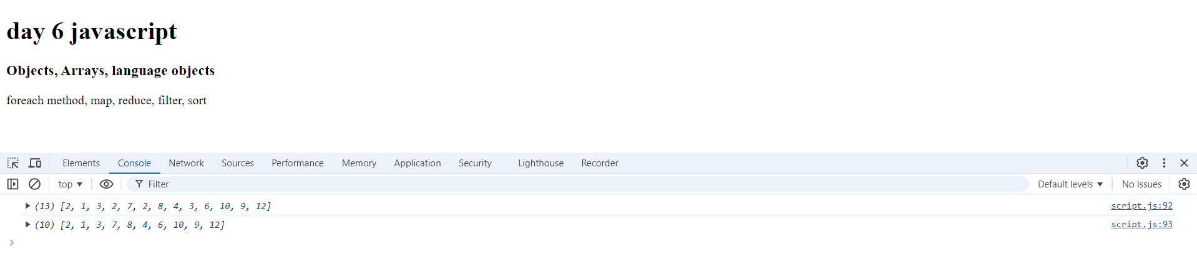

**Q4.6**

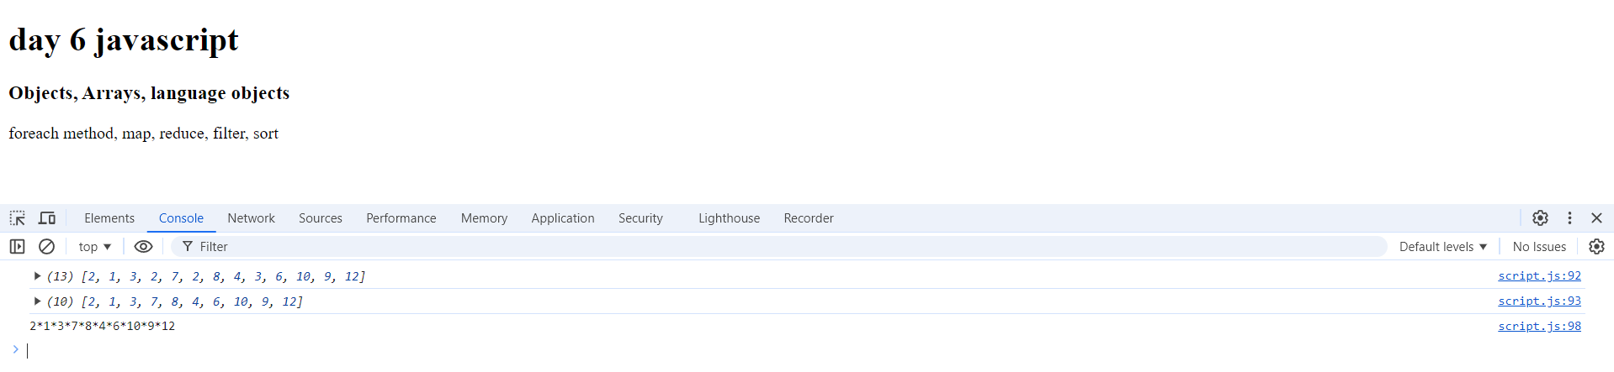

**Question 5**

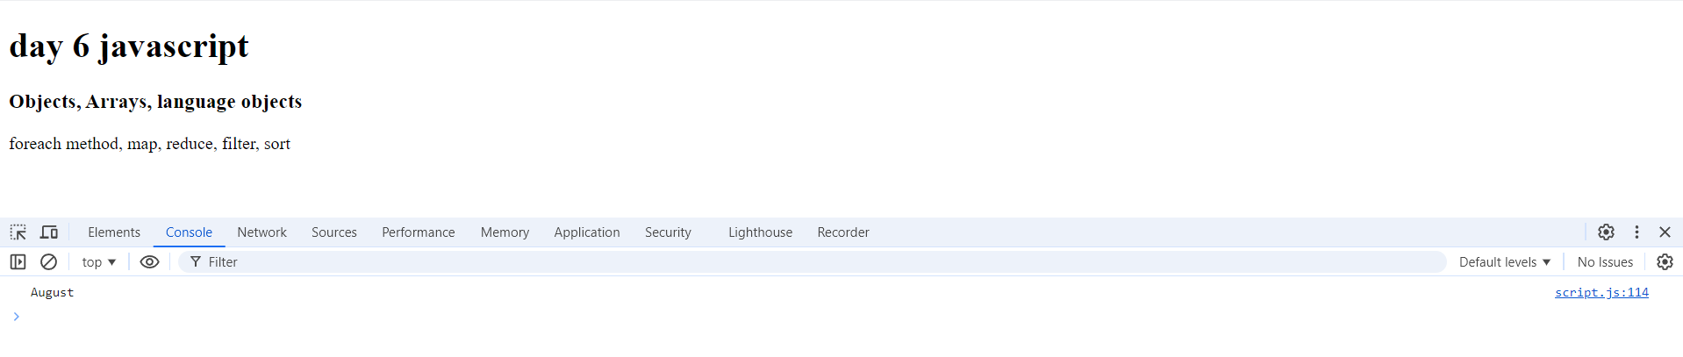

* **Get month name automatically**

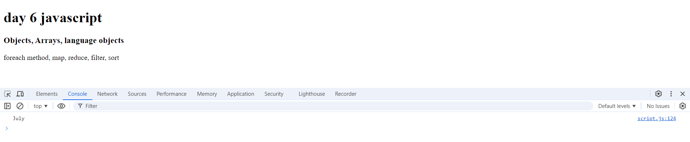

* **Get month name manually**