- What is the difference between Em and Rem units?

Em -> is a relative unit for the direct parent of the element

Rem -> is a relative unit for the root element of the page .. html

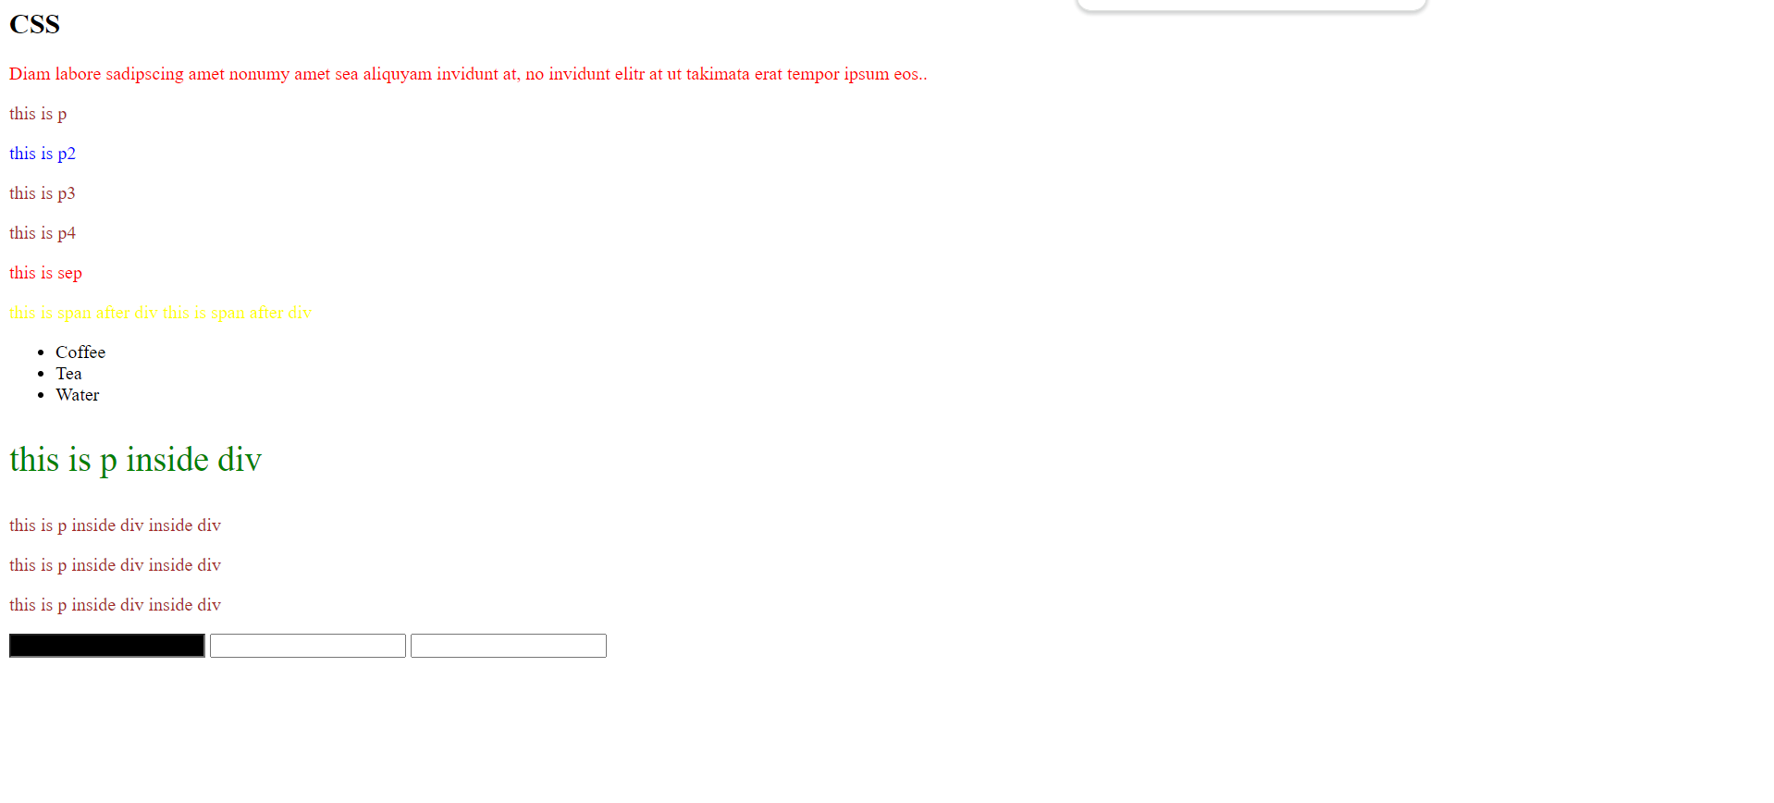**Selector Task**

Figure 1 selector task

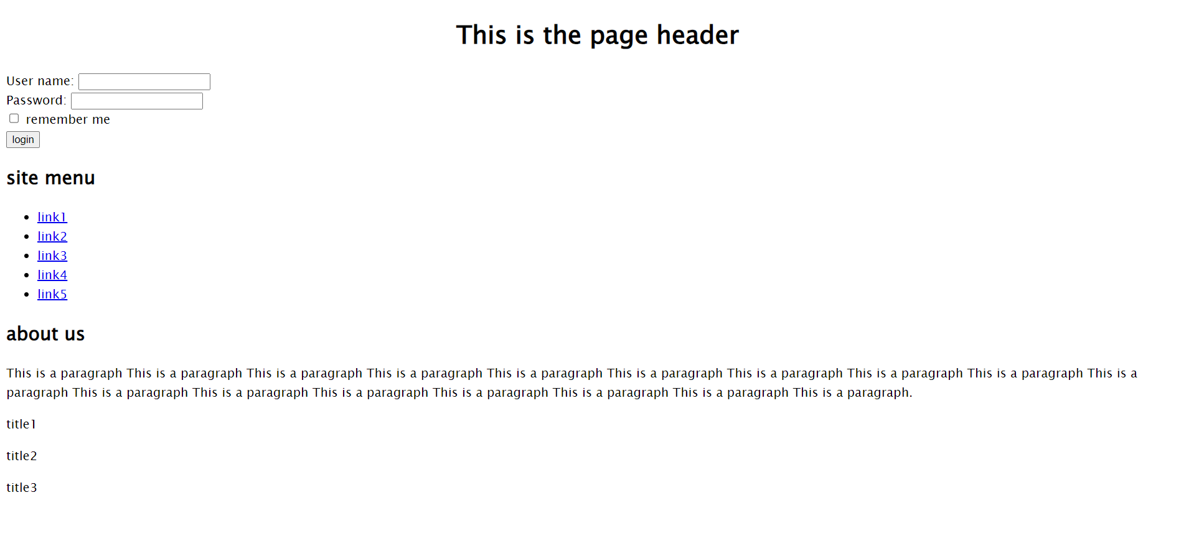**HTML Page Task**

Figure 2 html page task.... point 1

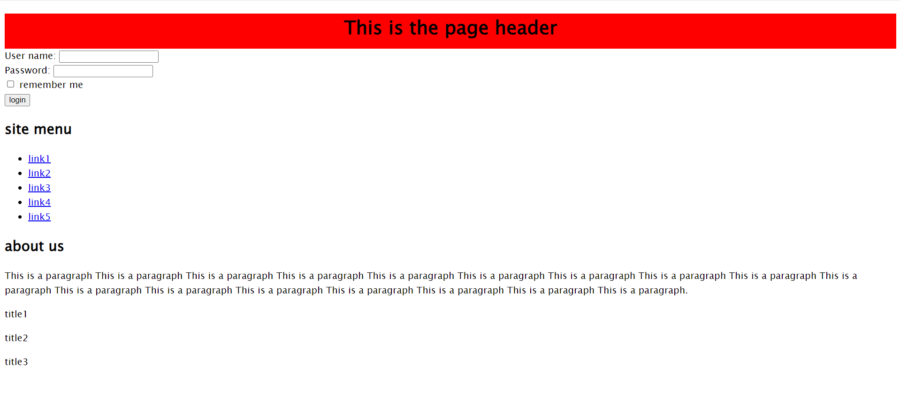

Figure 3 html page task.... point 2

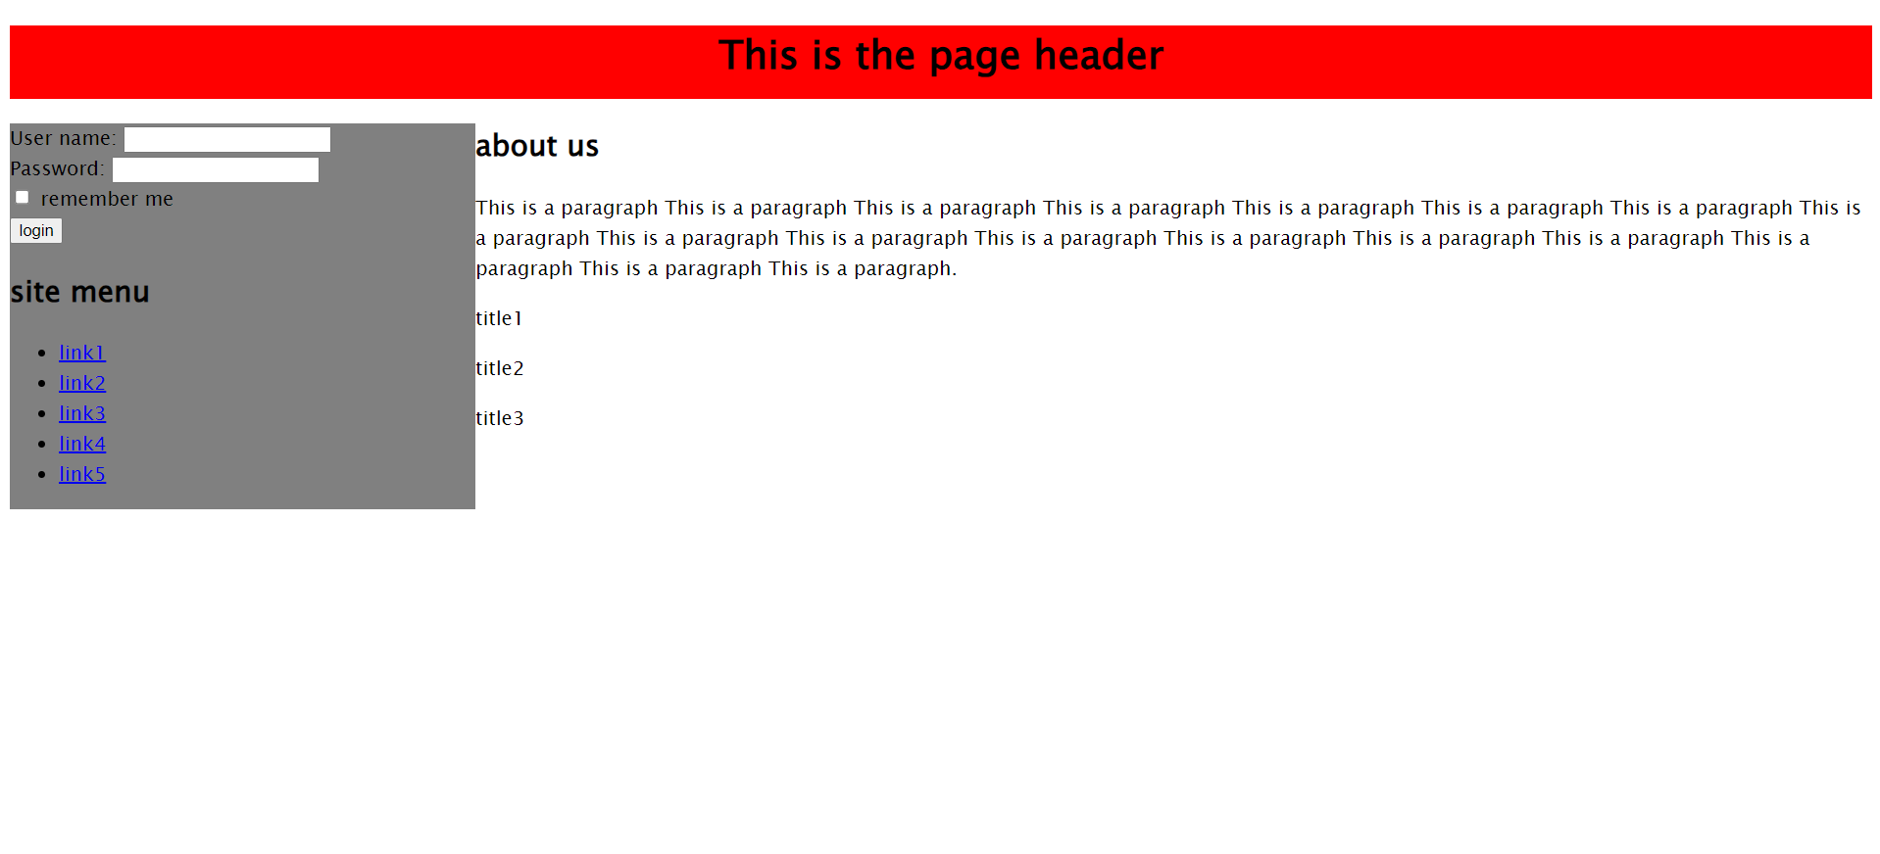

Figure 4 html page task.... point 3

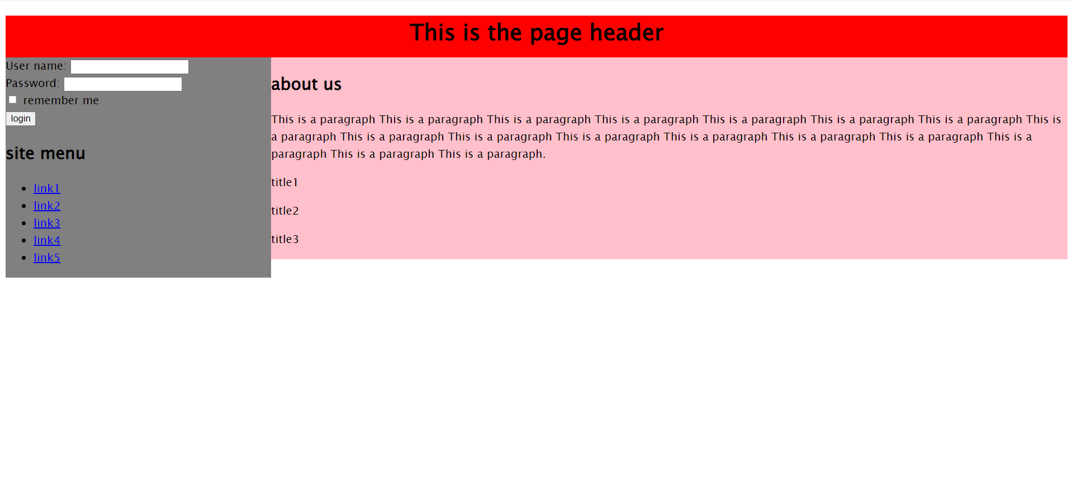

Figure 5 html page task.... point 4

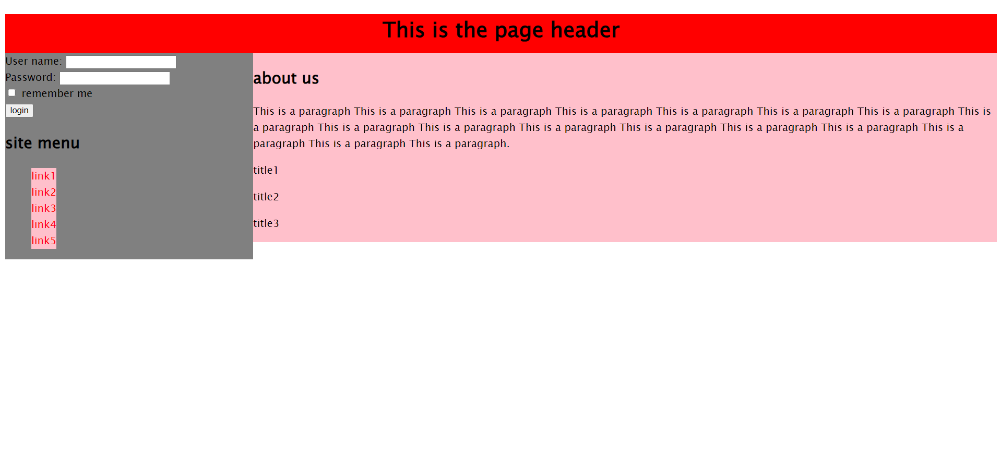

Figure 6 html page task ... point 5a-b

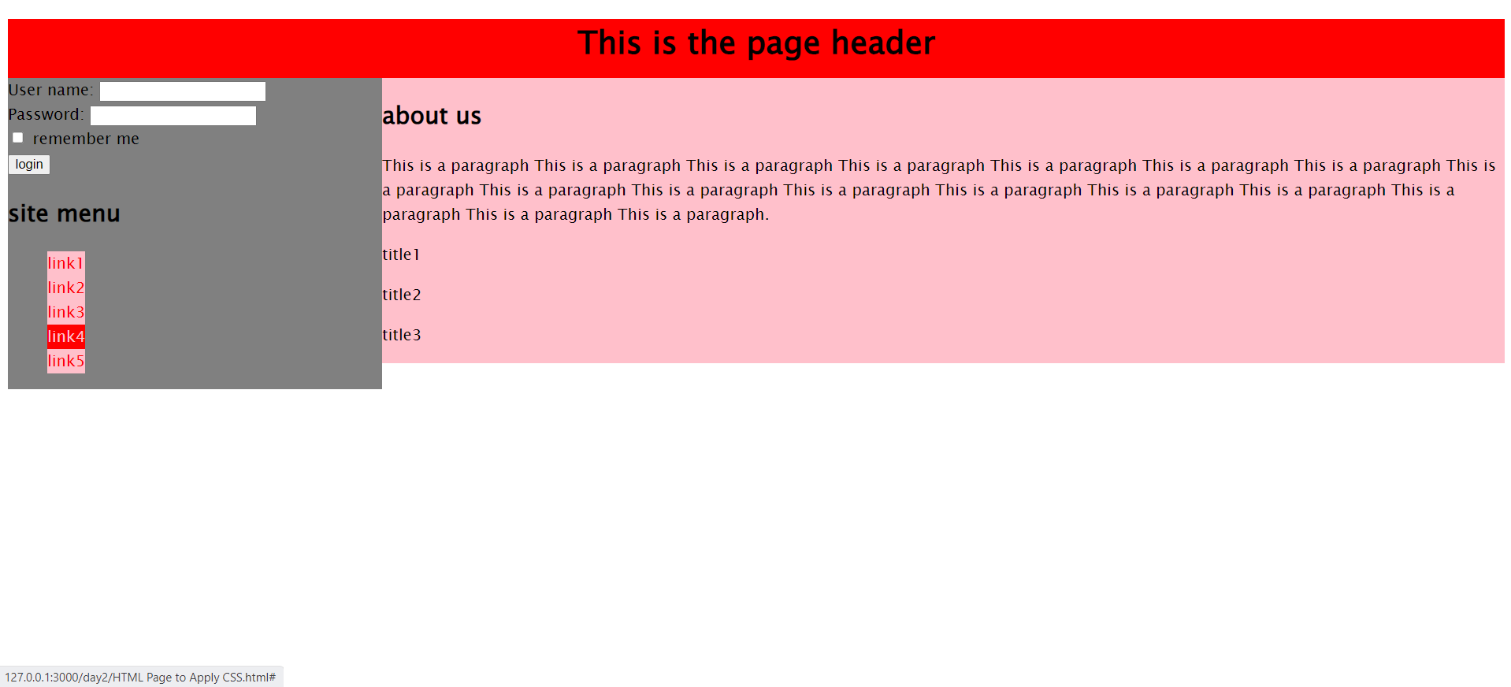

Figure 7 html page task .. point 5c

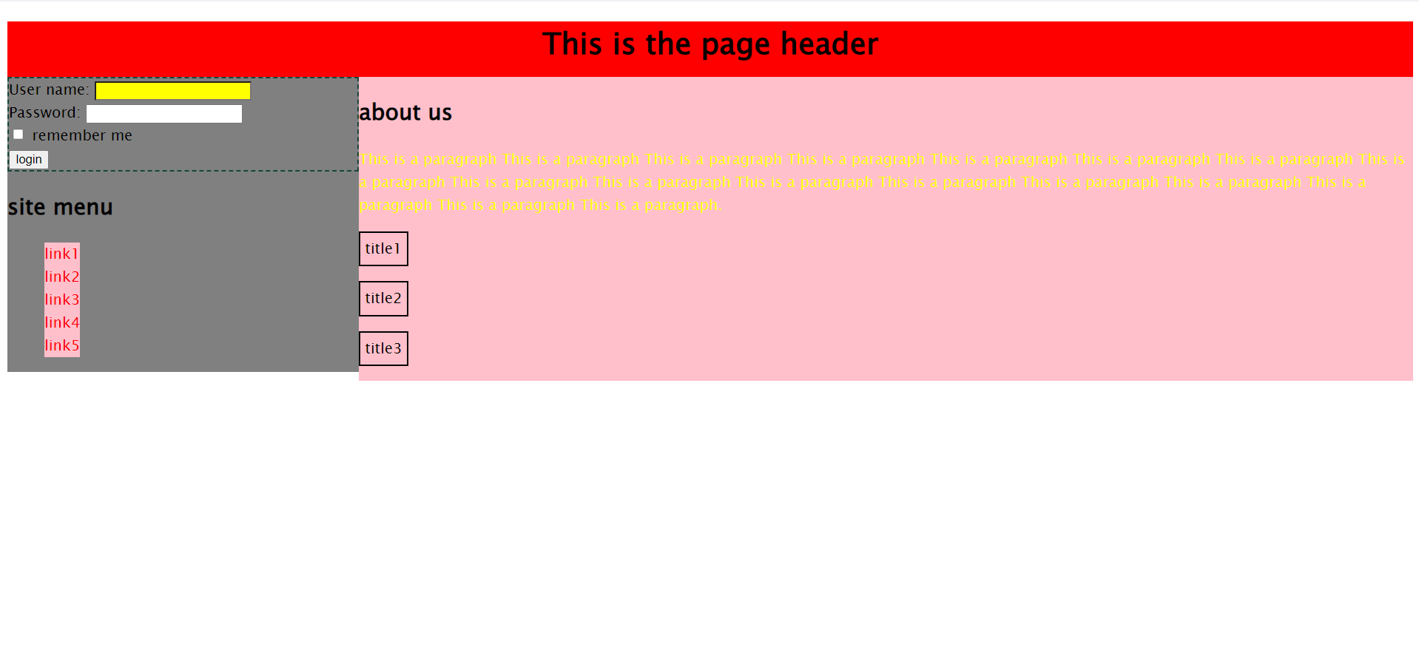

Figure 8 html page task .. point 5def

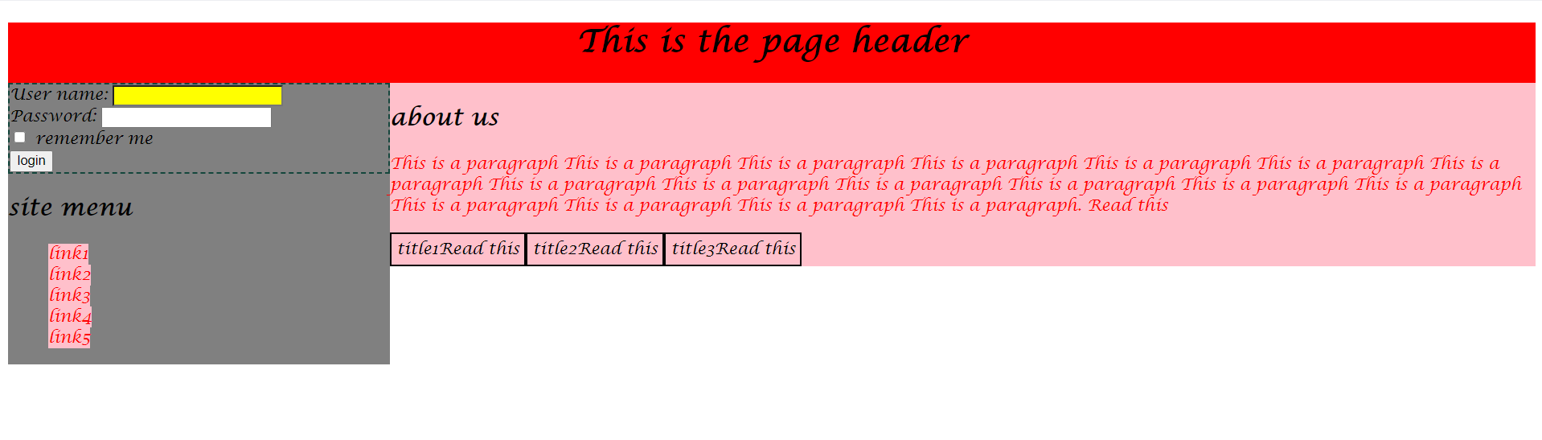

Figure 9 html page task ... point 5g ... paragraph

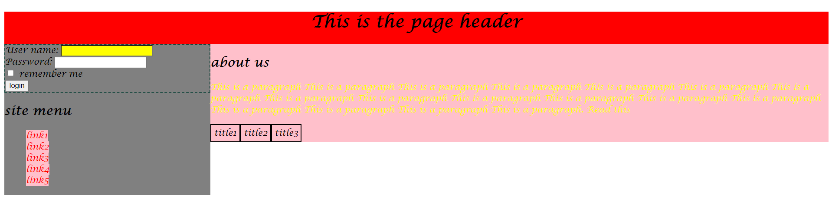

Figure 10 html page task ... point 5g …. span

**Try to change the <p> tags inside the div with id "titles" to spans, is there any difference?**

* When change the p into span, nothing will change except the after statement after paragraph

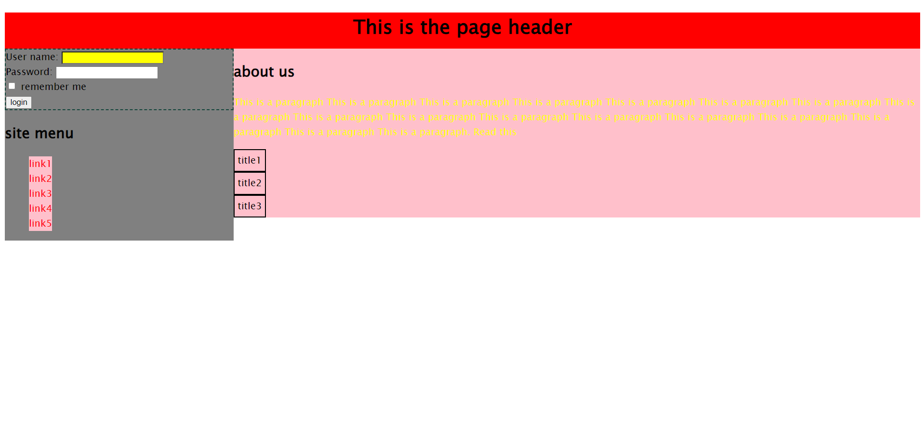

Figure 11 html page task ... point 5h

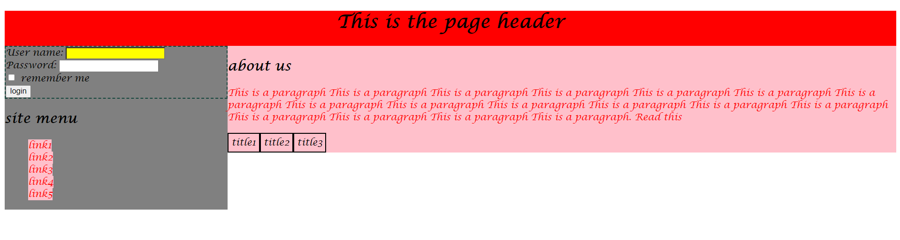

Figure 12 html page task ... point 6-7

**Which style will be applied to the paragraph? And why?**

* The second style applied because it has higher specificity, span#content p#aboutus has a specificity of (2, 0 , 2) while p#aboutus has a specificity of (1, 0 ,1)

When using !important the style of the lower specificity is applied instead of the higher specificity and the color will be red