**Question 2**

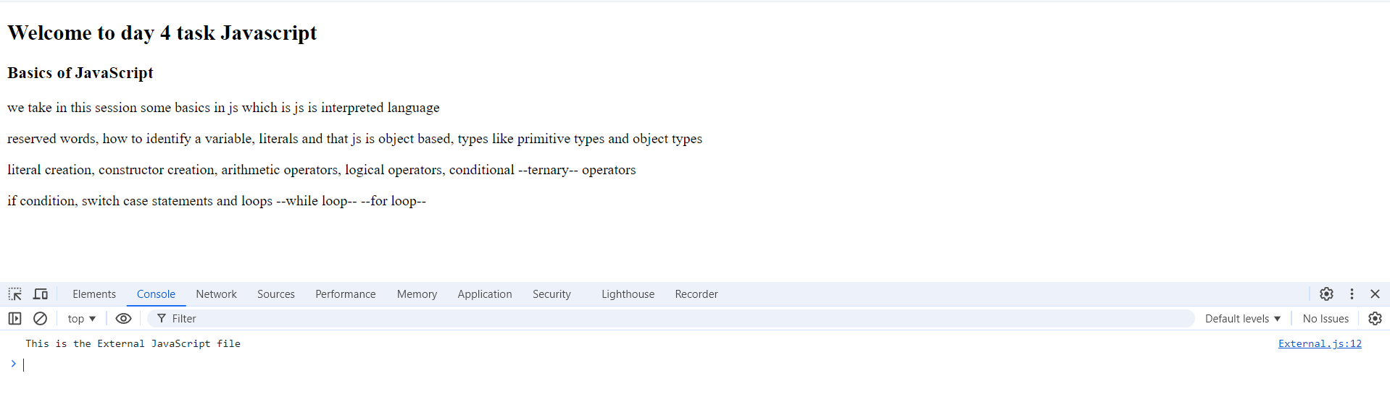

**Question 3**

1. **print the value of number1 on console before number1 definition line**

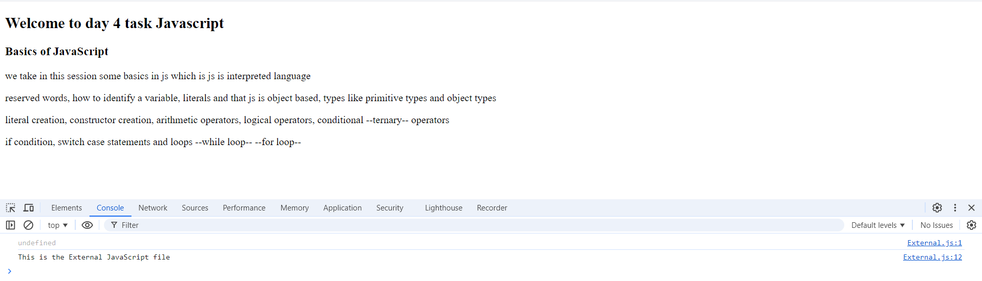

1. **Try to change the value of number1, number2 or number 3 on developer tool console what will happen**

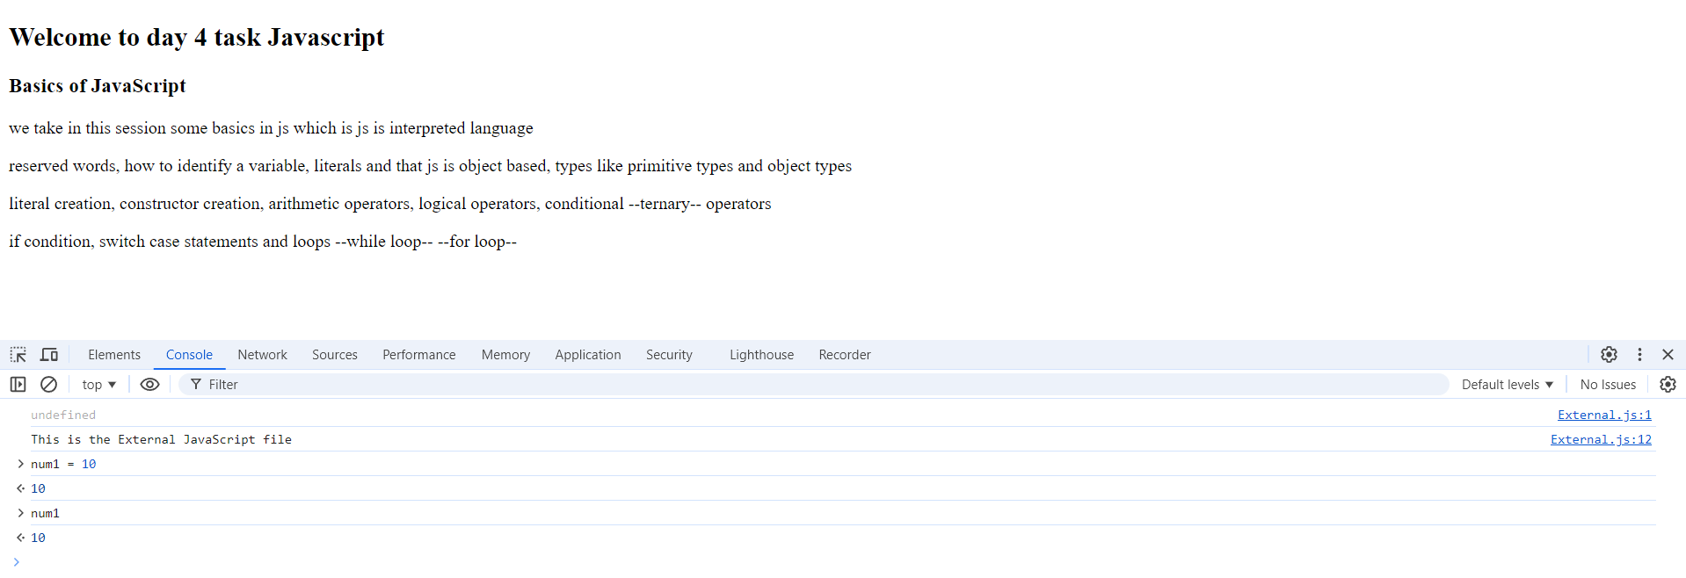

* **The value will change without problems but it not be saved, if the page is refreshed the previous value will return**

1. Try to change your firstName character at index 3, firstName[3]=’A’

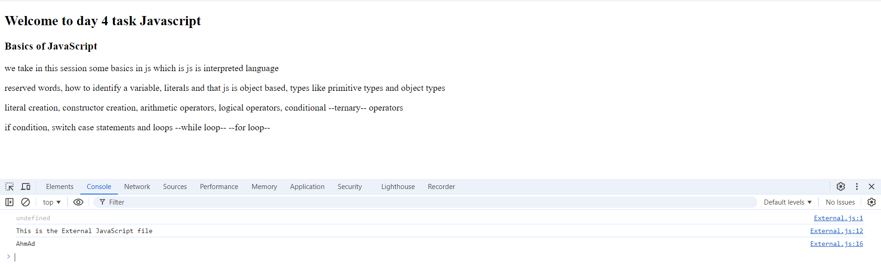

1. Print typeof all your variables

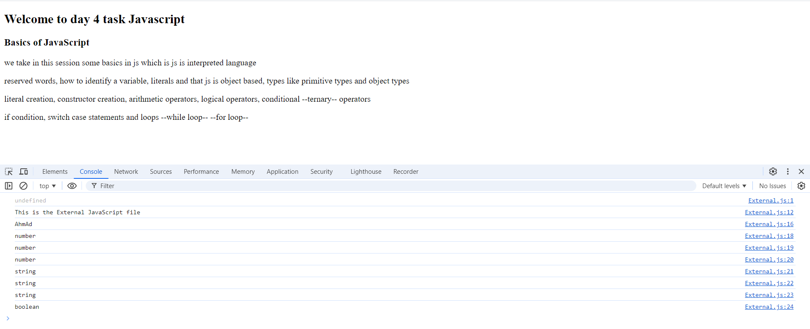

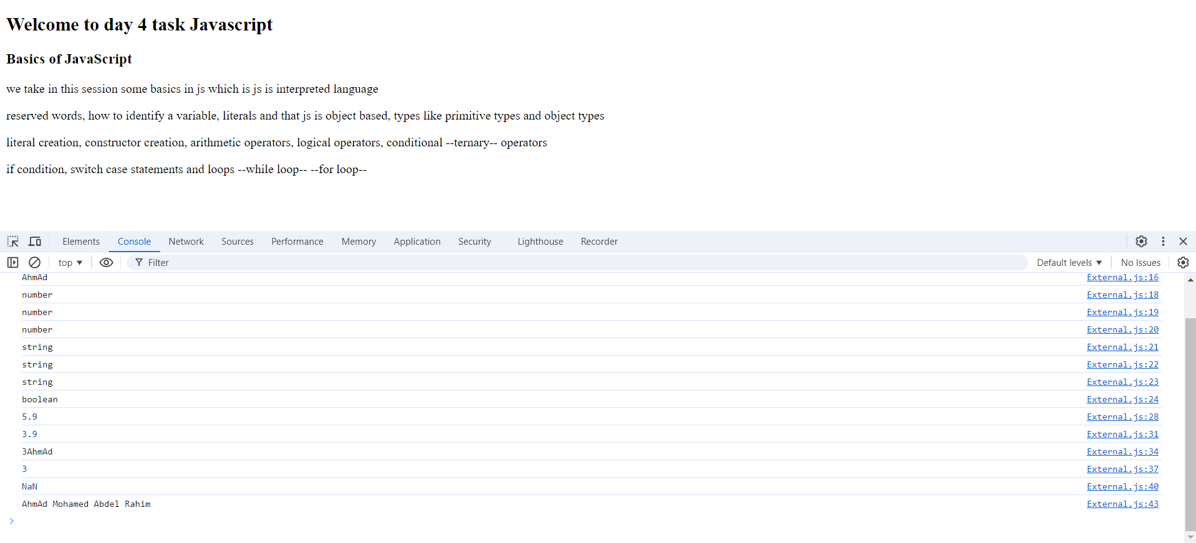Question 4