**Assignment 1**

**Question 1 using Function Statement**

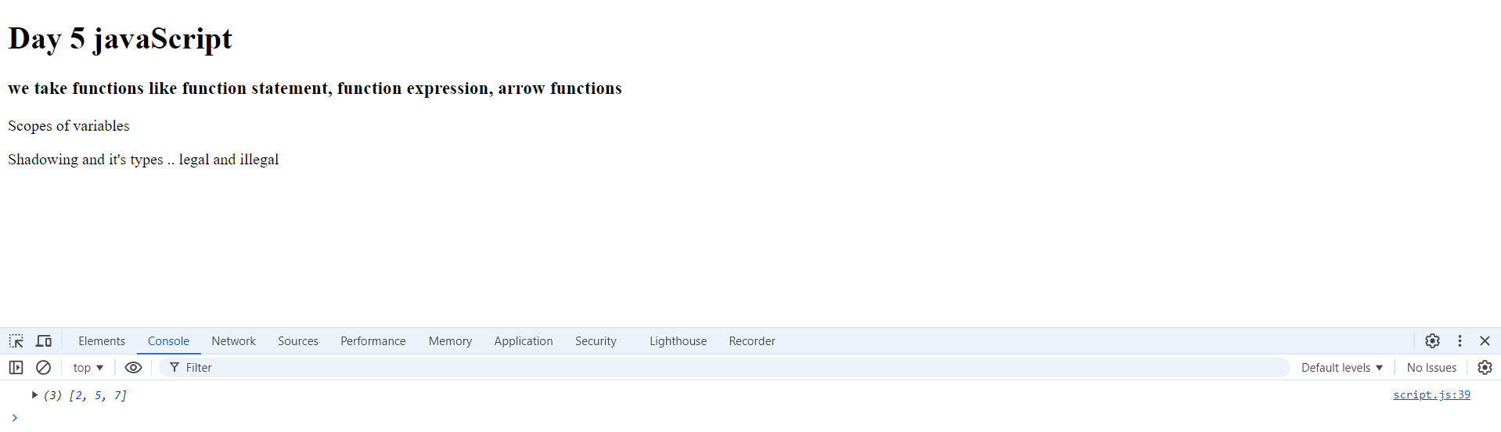

**Q1.a try to console.log the values of value1,value2,value3**

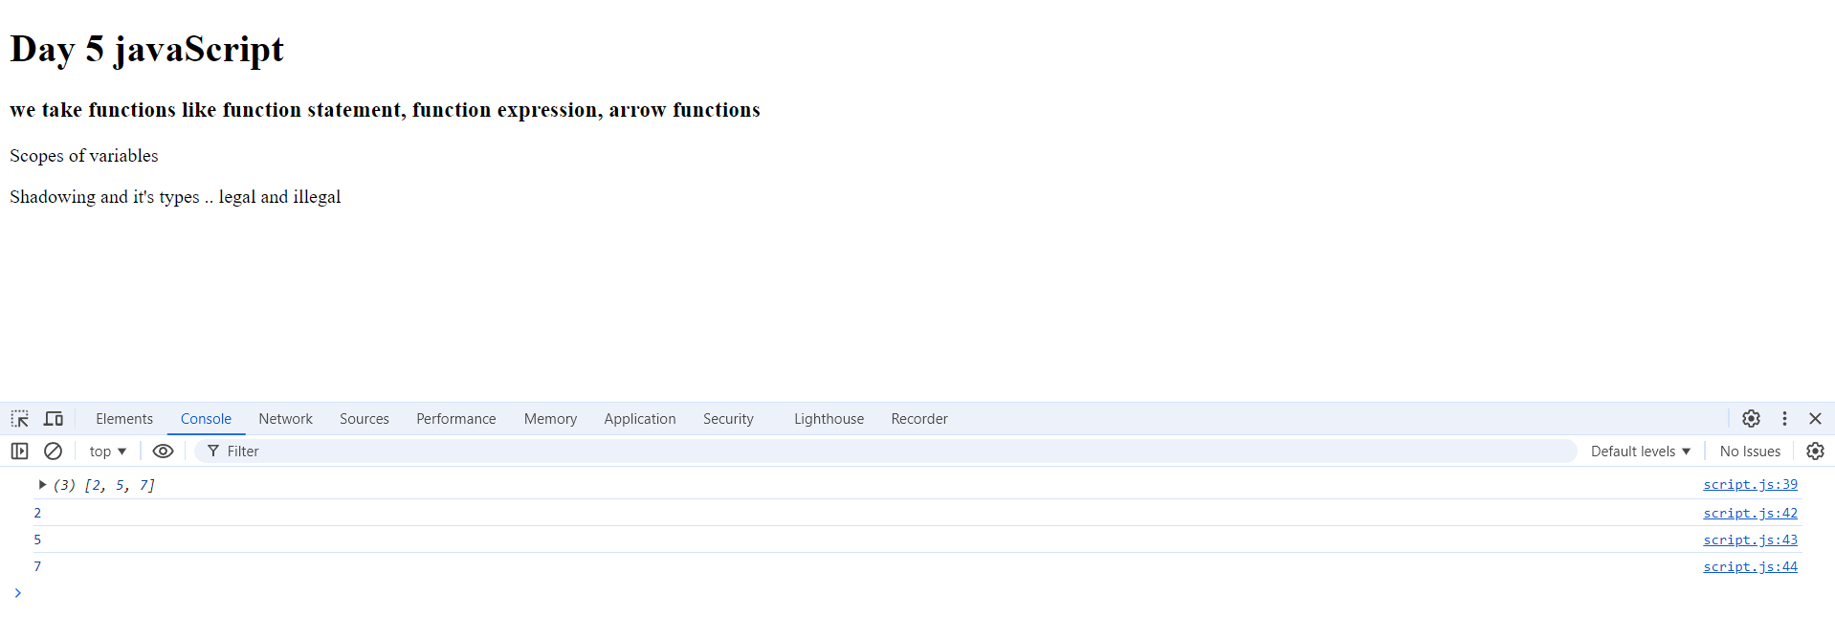

**Q1.b Try to call the function before definition line?**

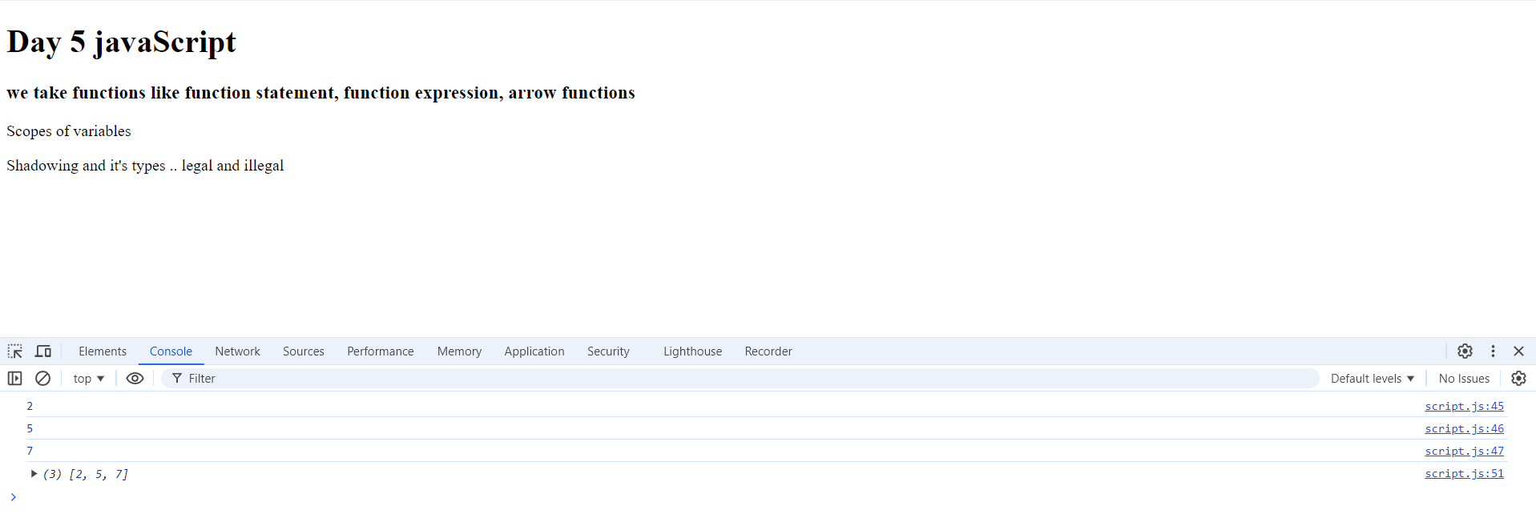

* **Nothing will change as the function statement is hoisted so the function is declared in the top of the page**

**Q1.c Call the function with 3 values then print the return**



**Q1.d Try to call the function with less than 3 parameters printVariables(3,5)**

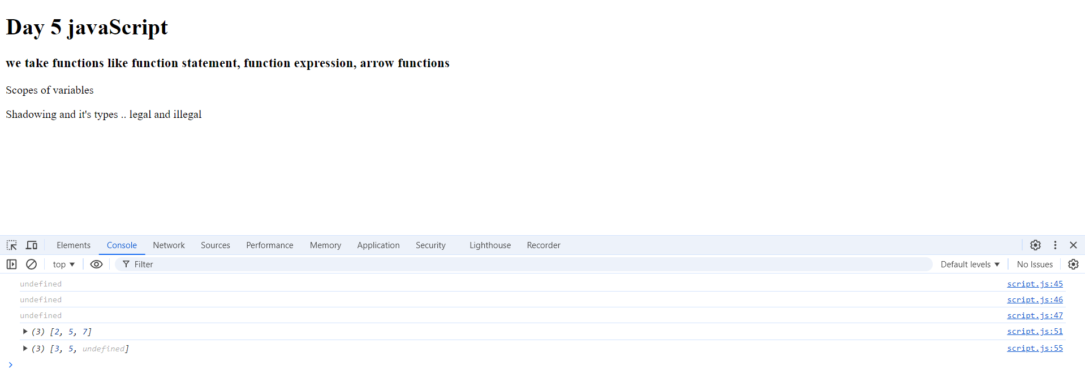

* I can solve the problem of undefined variables by using default value for the parameter

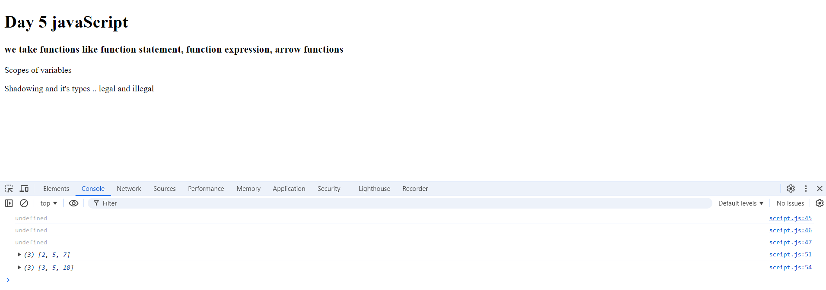

**Q1.e What if you call the function with too many parameters ?**

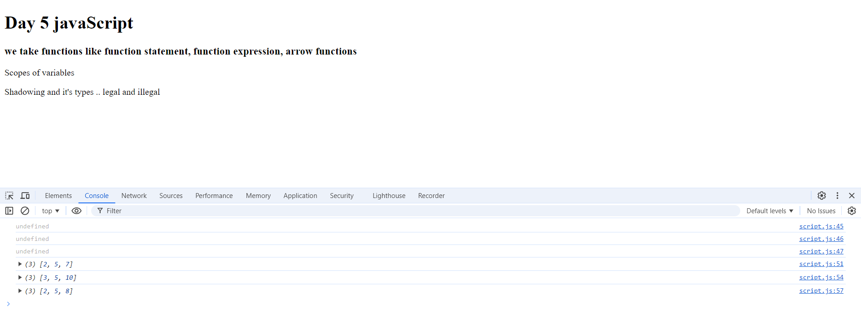

* It takes only the first 3 parameters and ignore the others

**Q1.f Define var localVar=3; testingVar=5; inside the function’s block**

**Before calling the function try to console.log the values localVar**

**and testingVar.??**

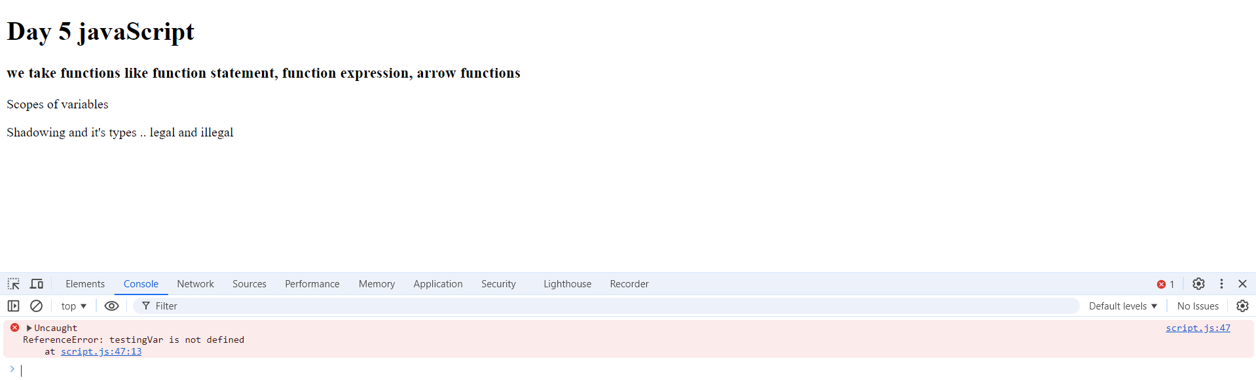

* It gives me reference error as the variable still not declared so the console can’t see it, if I call the function the testingVar will be declared and will print the value of the variable

**Q1.g call the function and try to print localVar and testingVar?**

* It still show reference error for localVar but testingVar give me a value

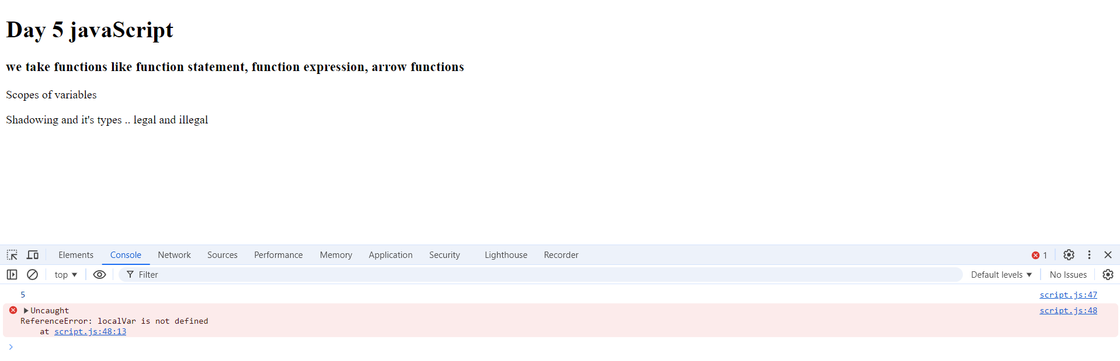

**Q1.h Define the following variable on your script outside the function**

Q1.h a. Before calling the function try to console.log the value of localVar

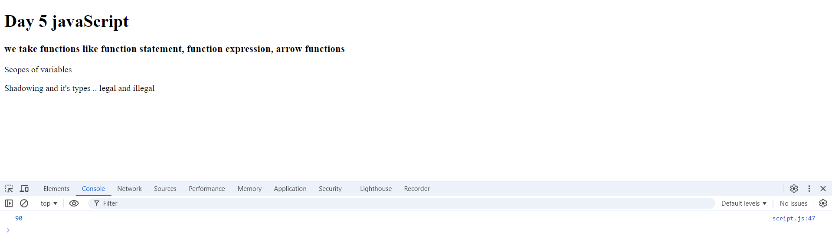

Q1.h b. then try to console.log localVar after calling the function



* Still the answer is 90

Q1.h c. Now try to console.log the value of localVar inside the function but before variable’s definition line.

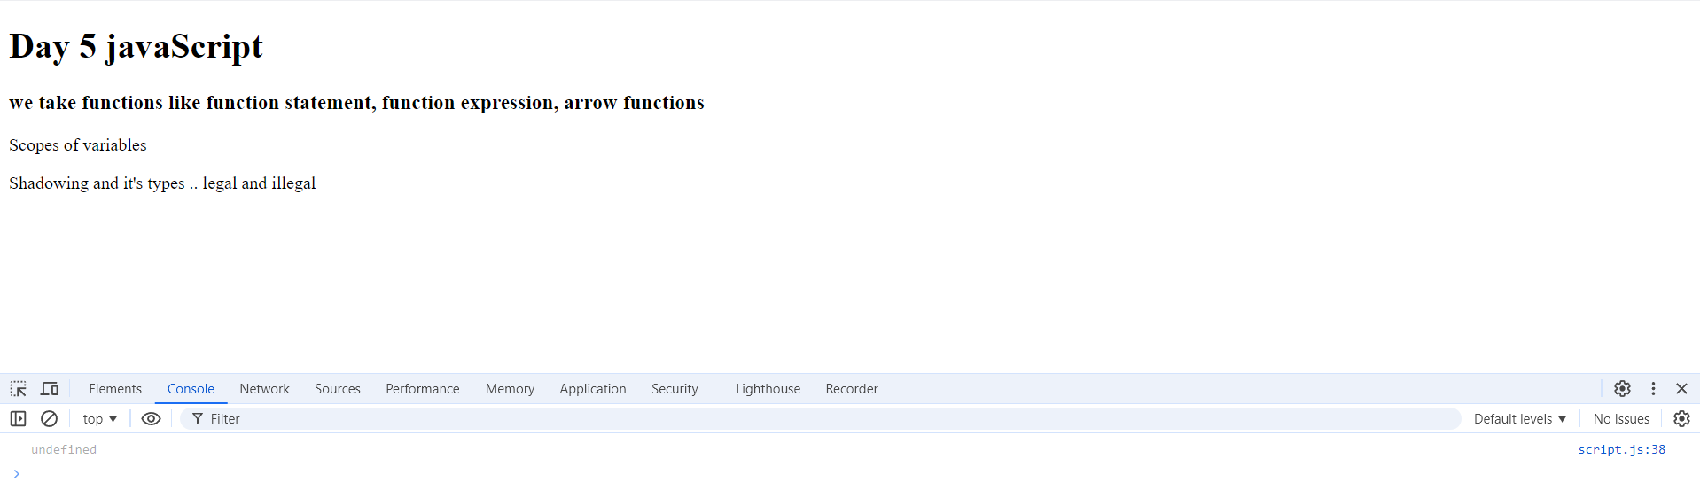

* It shows undefined because the variable is declared but it was before the original initialization so it hoisted the declaration of variable

Q1.h d. Now inside the function what if you remove let from localVar and repeat the pervious Steps again?

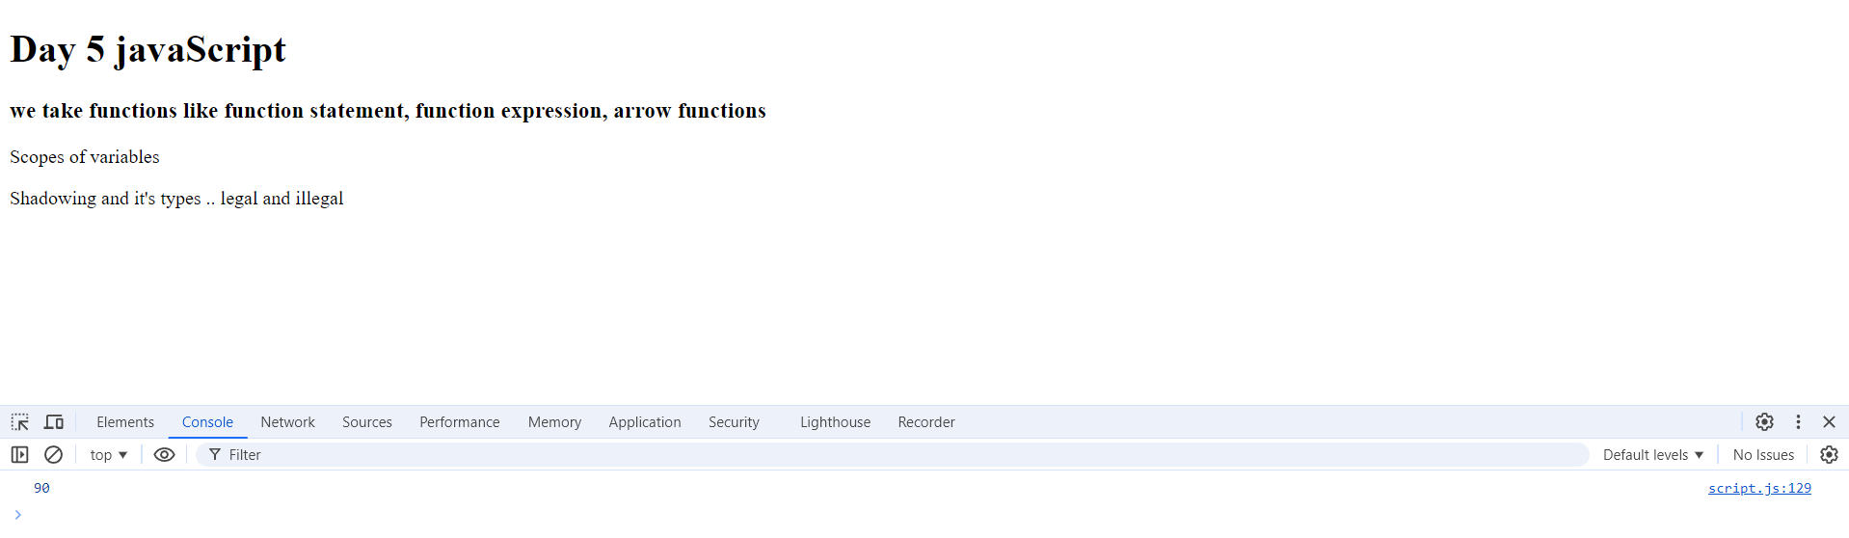

* If print localVar before call the function it will appear the value that I initialize before the function declaration

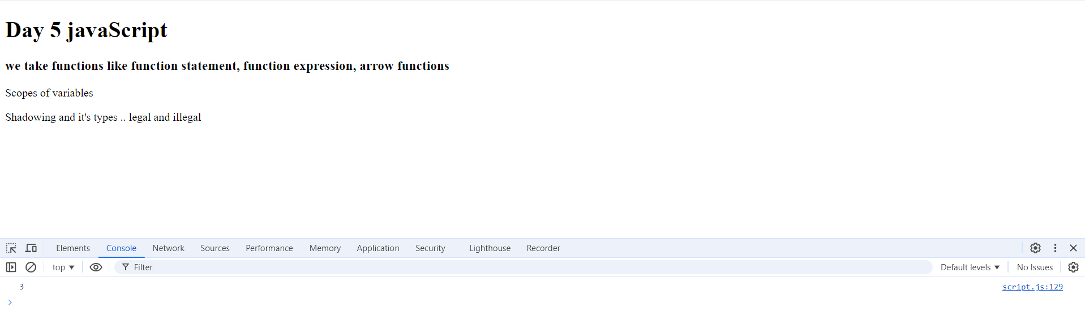

* After calling the function the localVar is updated with the new value



* It takes the value of the outer variable because it print before the change of the value

**Question 2 using Function Expression**

**Q2.a**

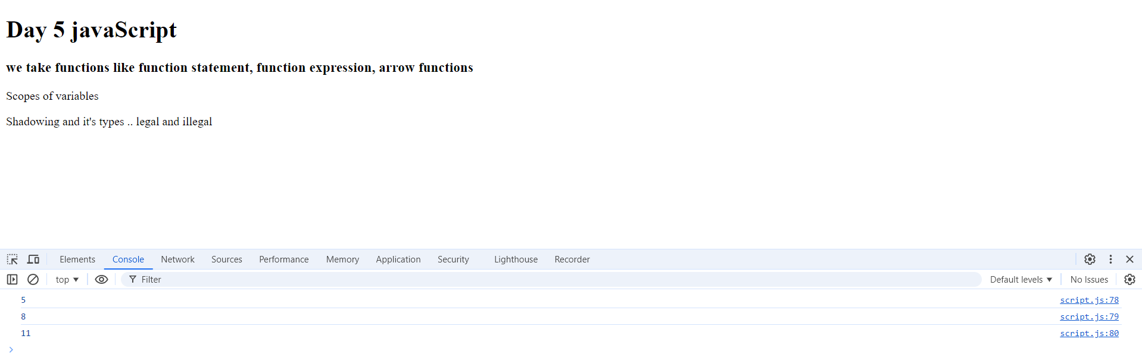

**Q2.b**

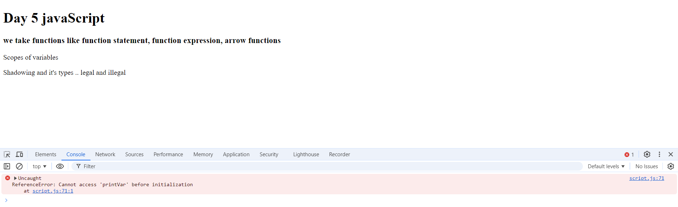

* **Error because the function expression is not hoisted**

**Q2.c**

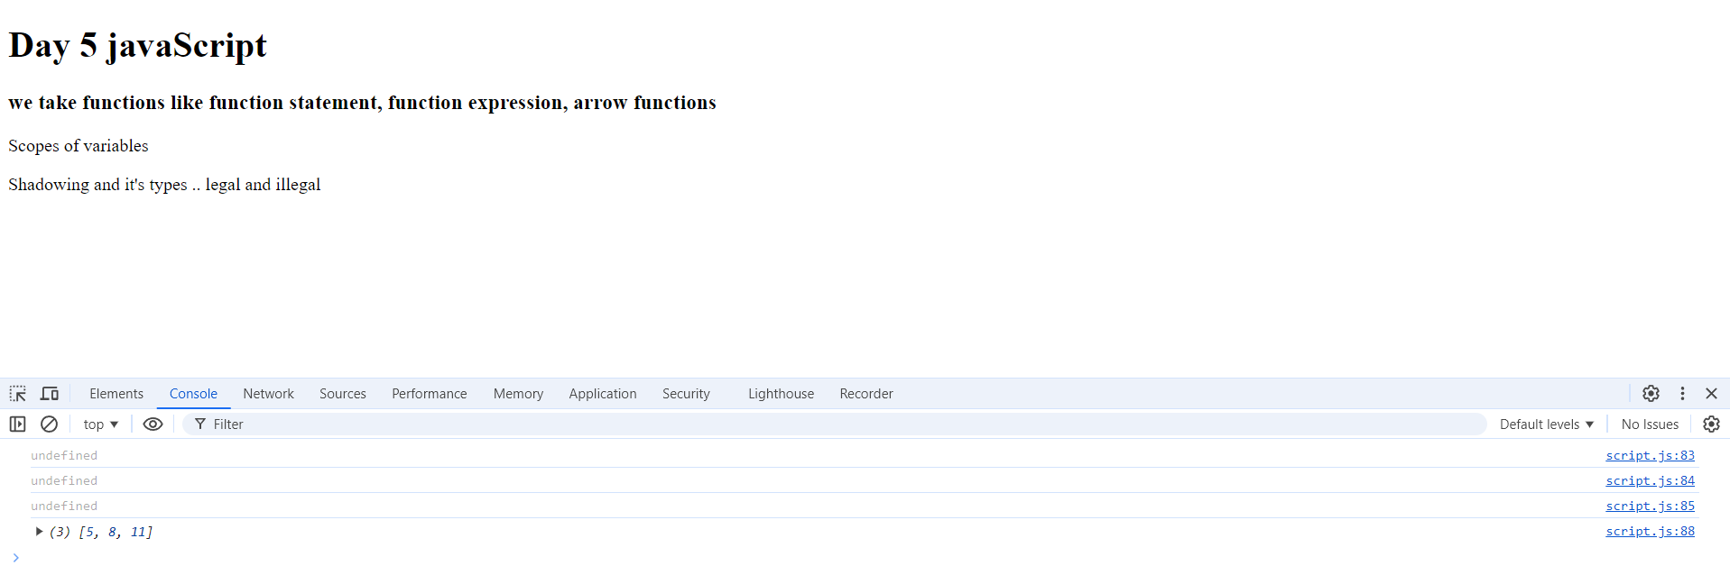

**Q2.d**

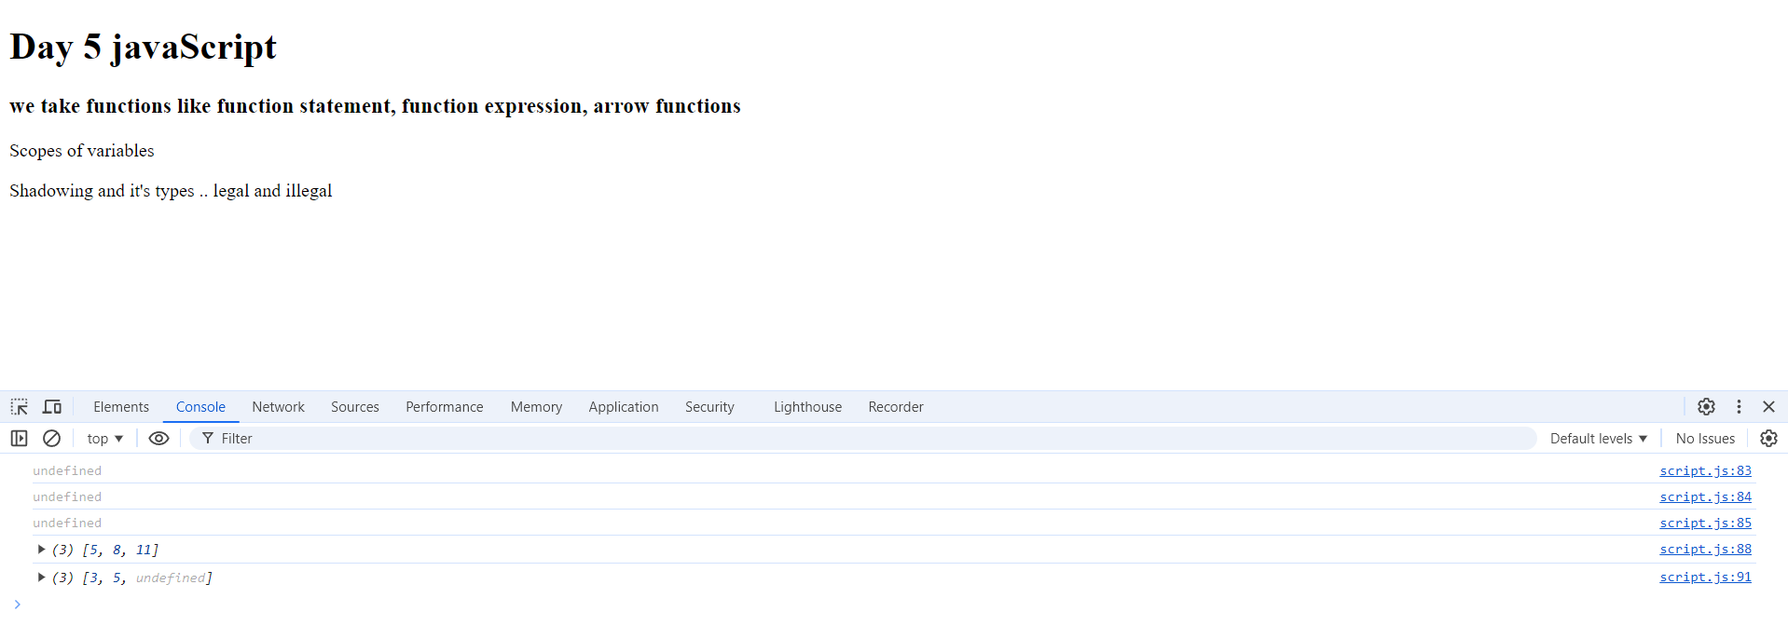

* **Give a default value to the function parameters**

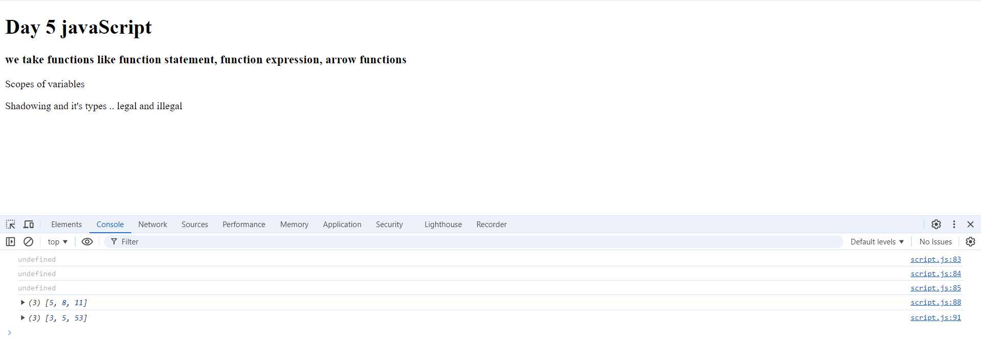

**Q2.e**

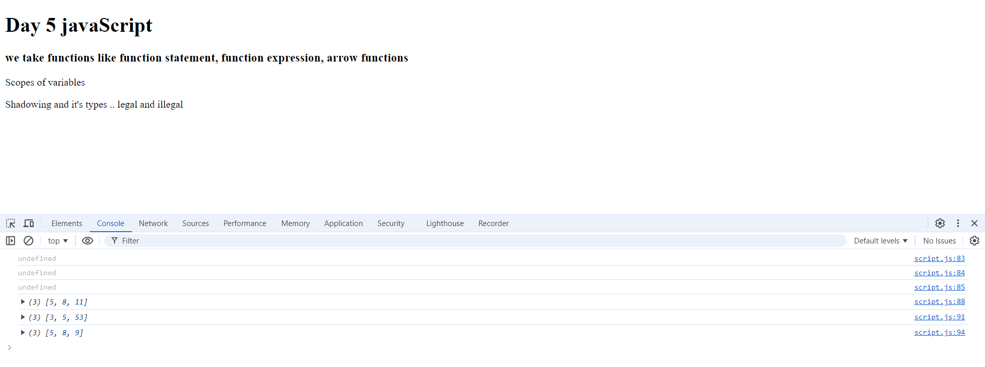

* It takes only the first 3 parameters and ignore the others

**Q2.f**

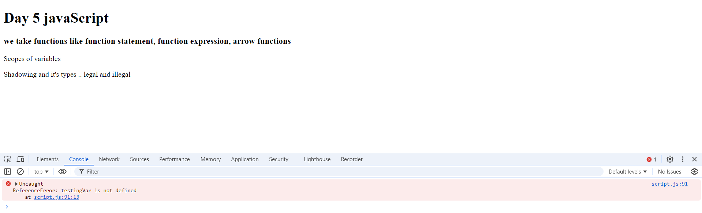

**Q2.g**

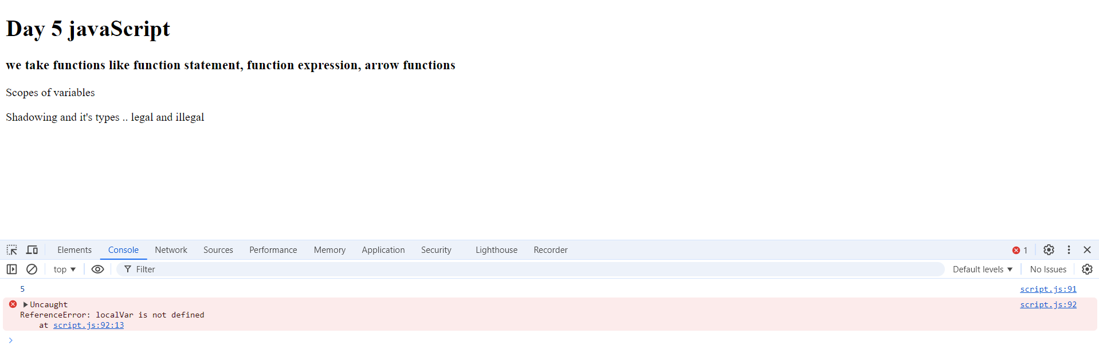

* **Same as above**

**Q2.h.1**

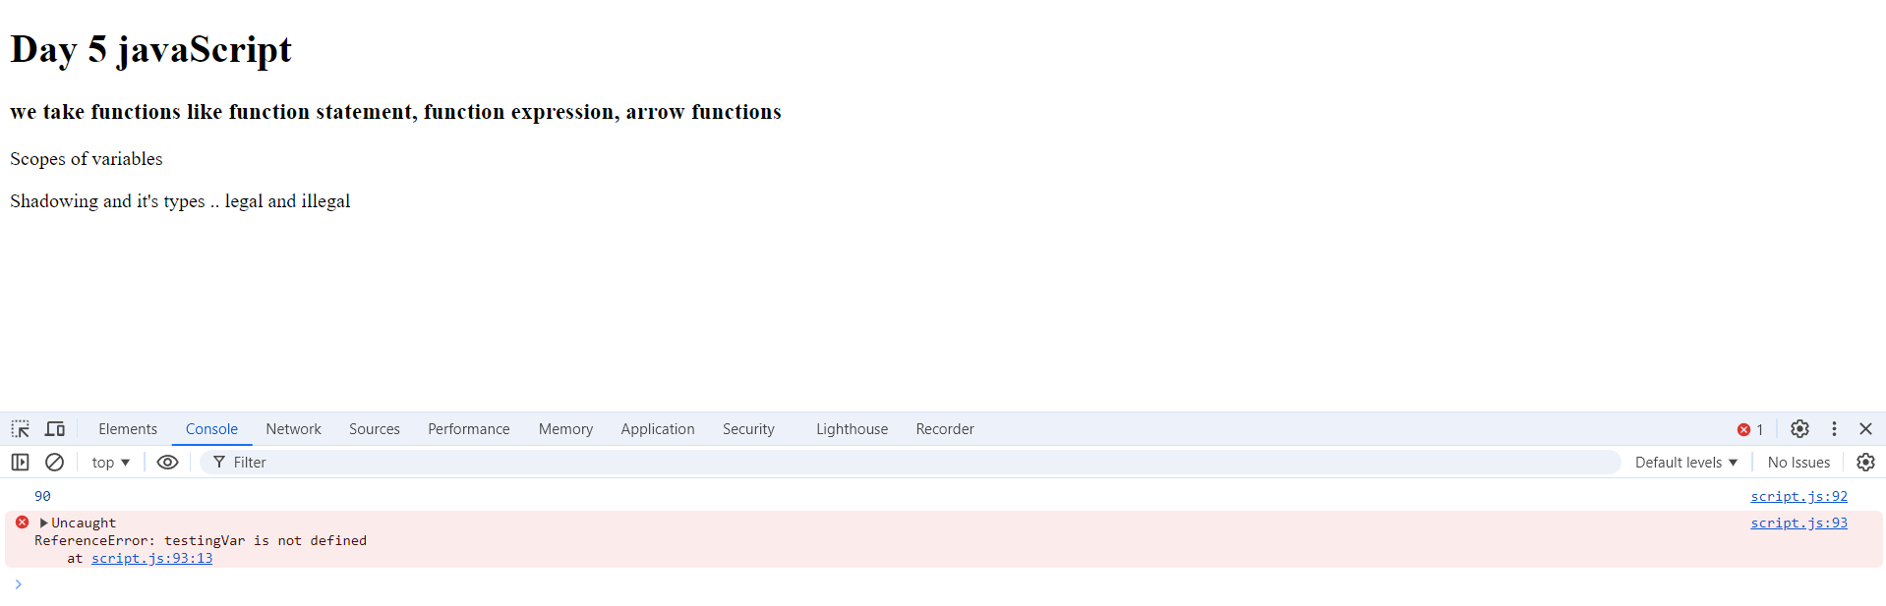

**Q2.h.2**

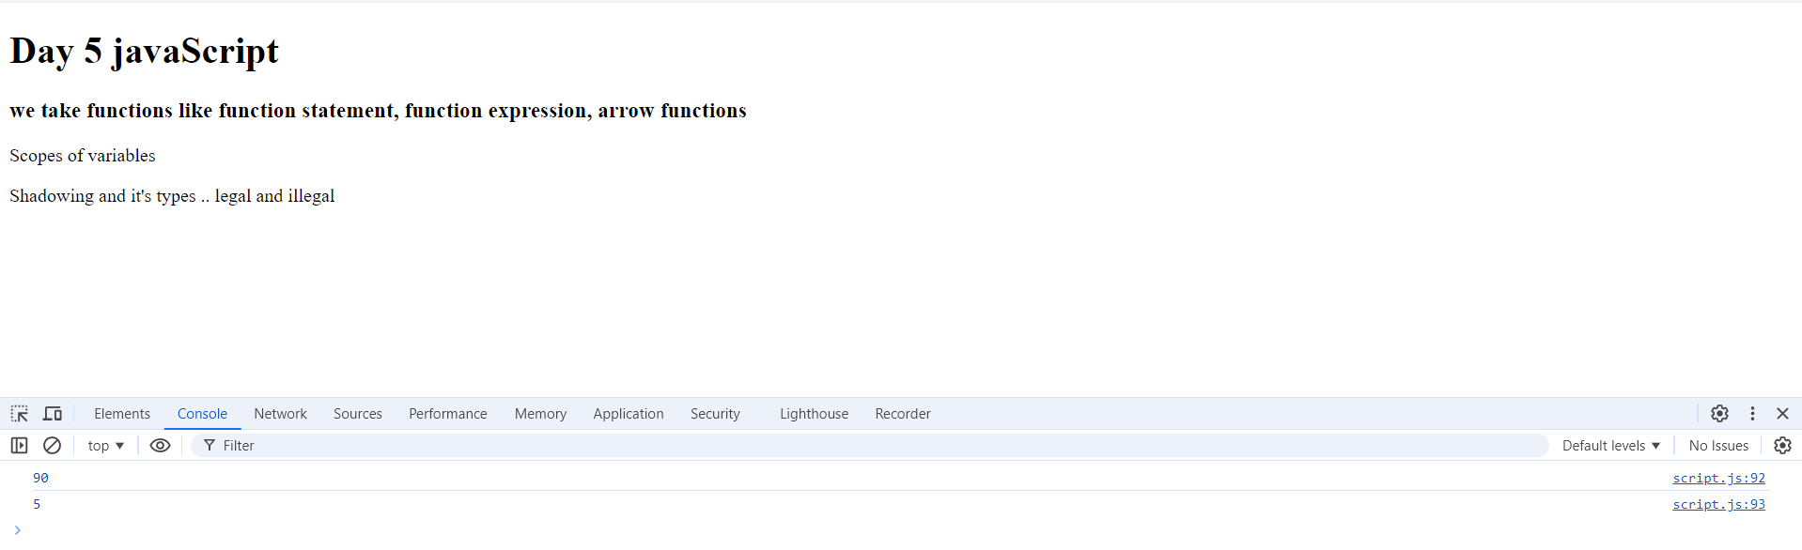

**Q2.h.3**

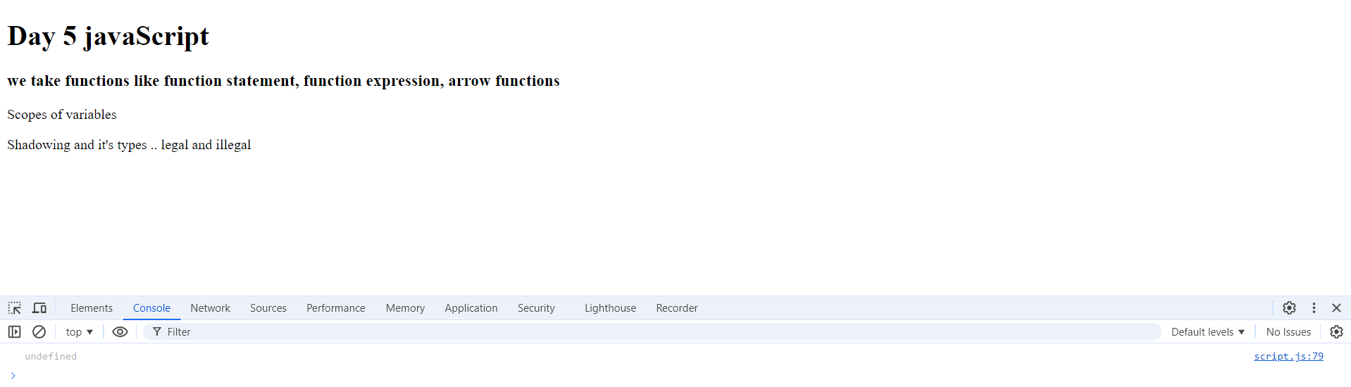

**Q2.h.4 Same as Above**

**Question 3 using arrow function**

**Q3.a**

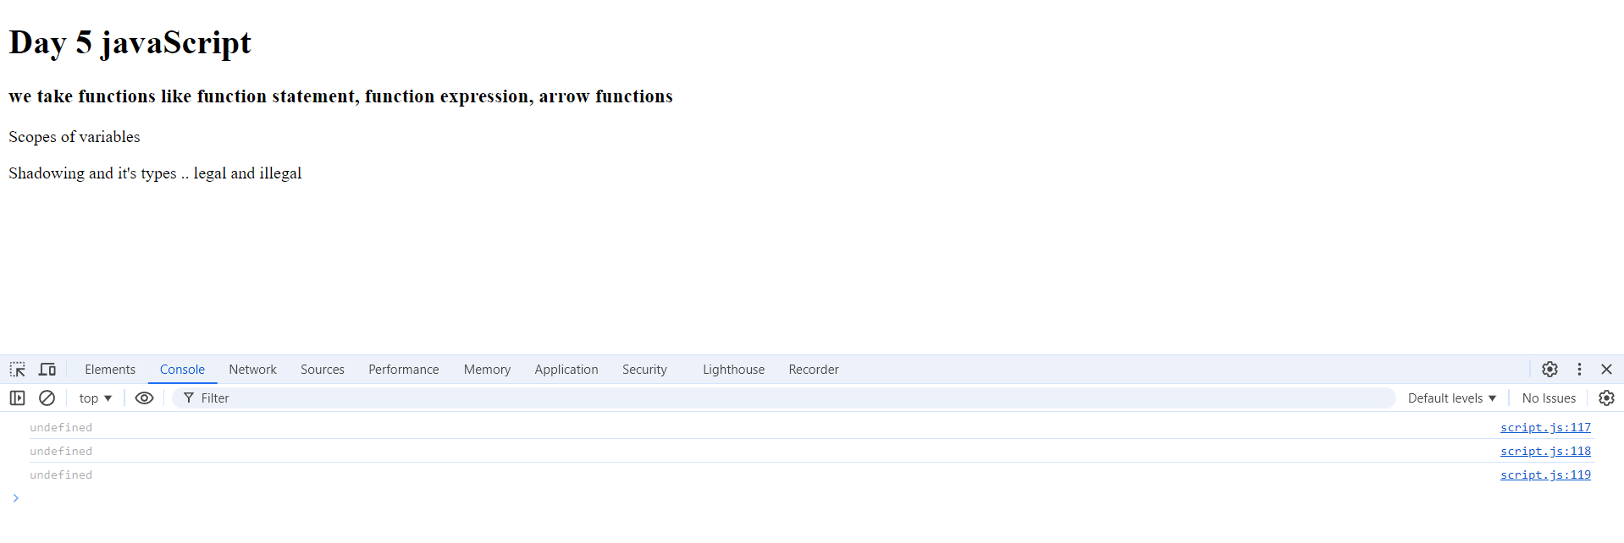

**Q3.b**

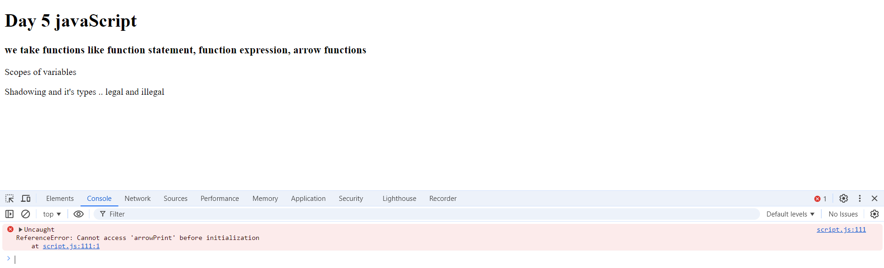

**Q3.c**

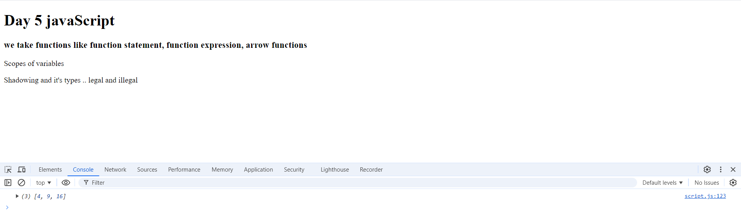

**Q3.d**

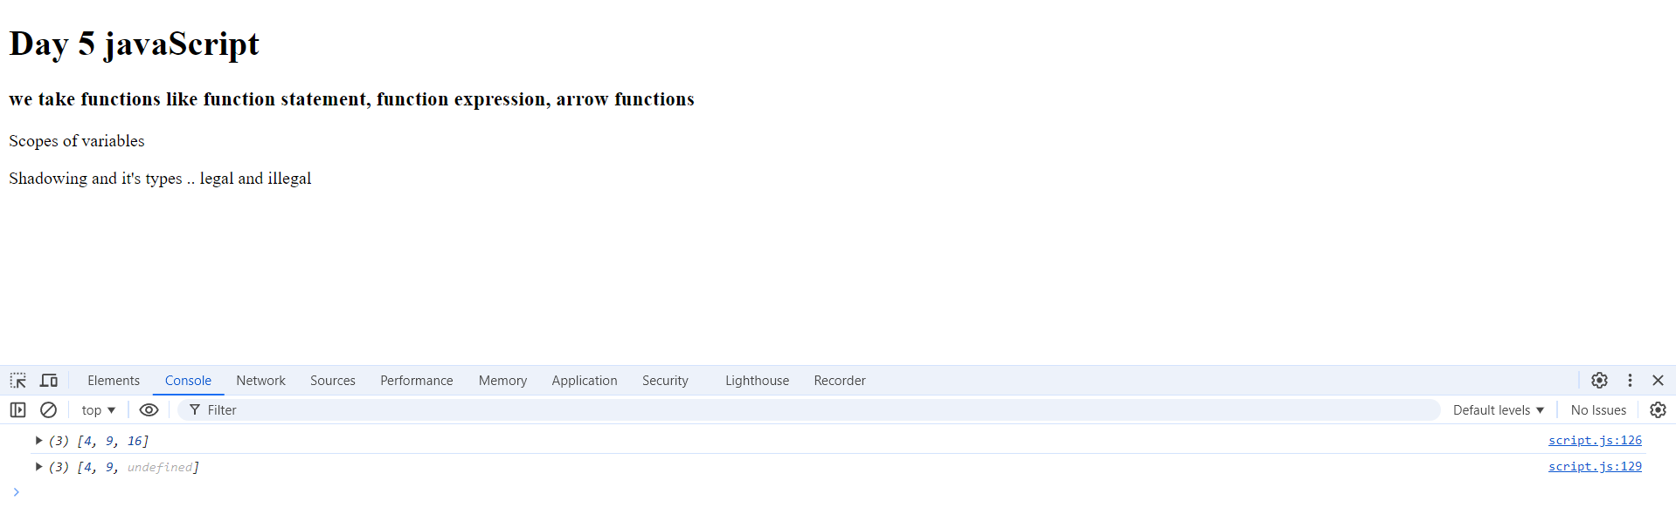

* **Give a default value to the function parameters**

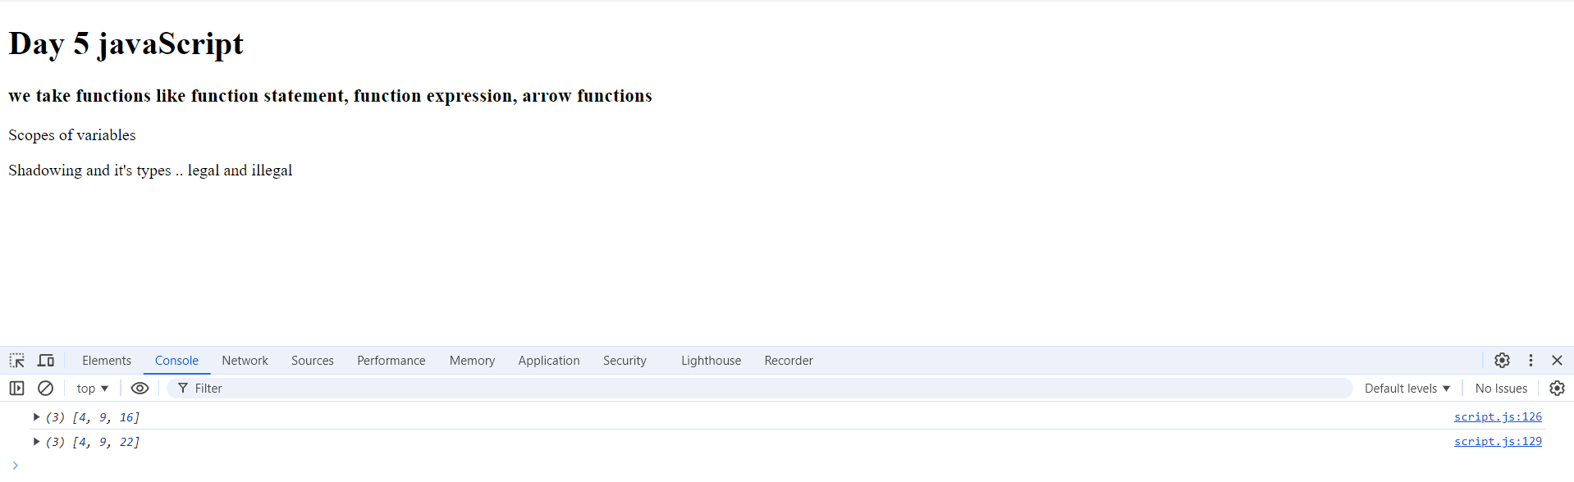

**Q3.e**

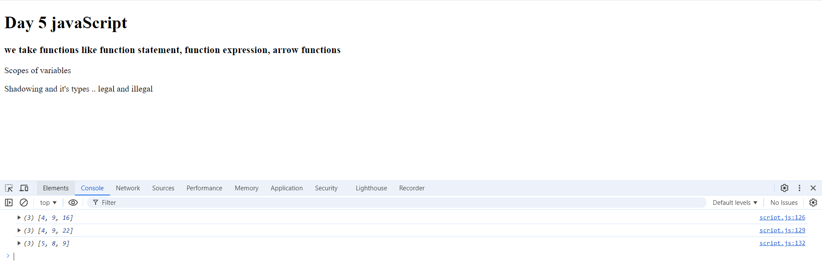

* It takes only the first 3 parameters and ignore the others

**Q3.f**

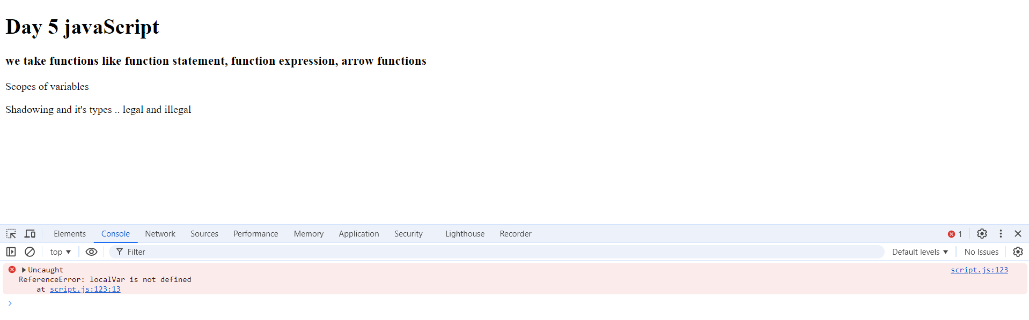

**Q3.g**

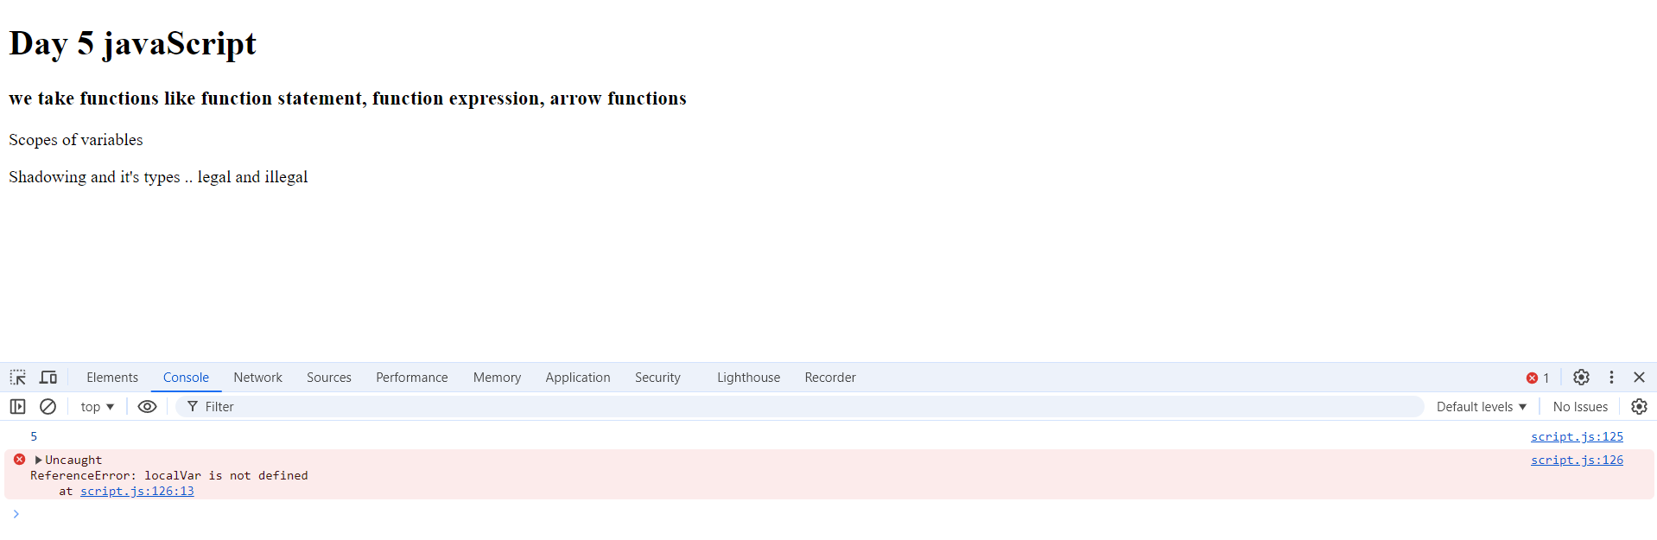

**Q3.h.1**

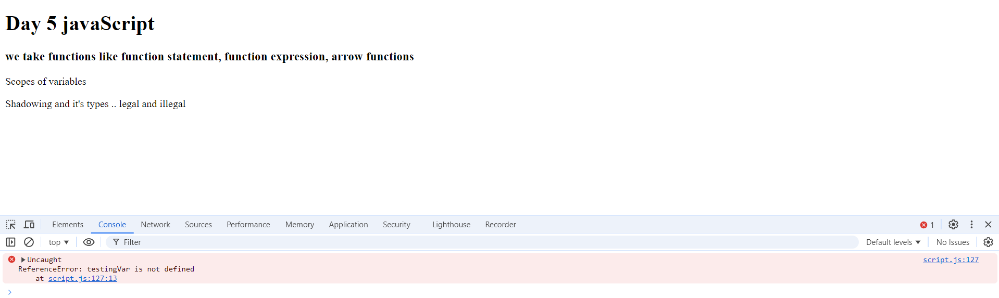

**Q3.h.2**

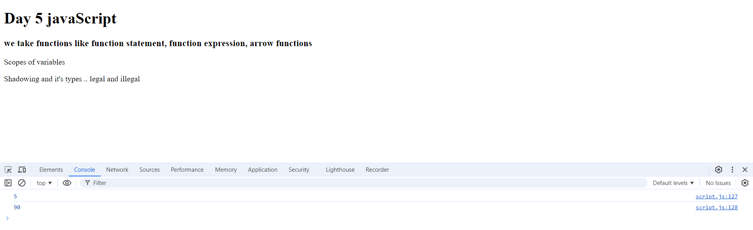

**Q3.h.3**

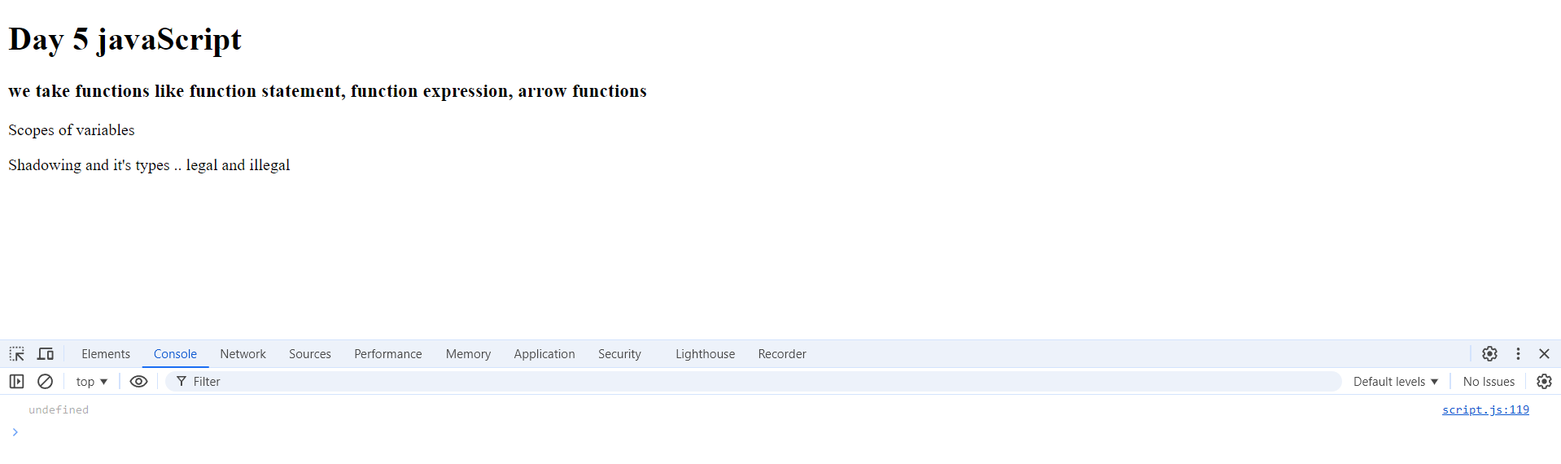

**Q3.h.4**



* If print localVar before call the function it will appear the value that I initialize before the function declaration



* After calling the function the localVar is updated with the new value



* It takes the value of the outer variable because it print before the change of the value

**Assignment 2**

**Question 4**

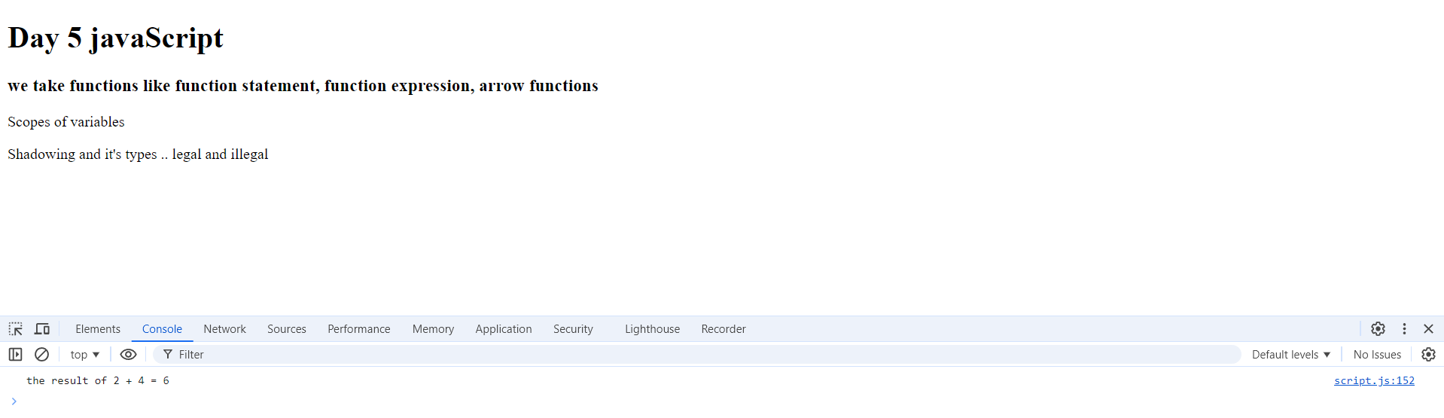

**Q4.1**

The result is NaN .. Not a Number as it add the value of number and a value of declared variable but not initialized .. can solve it by give default value to the variable

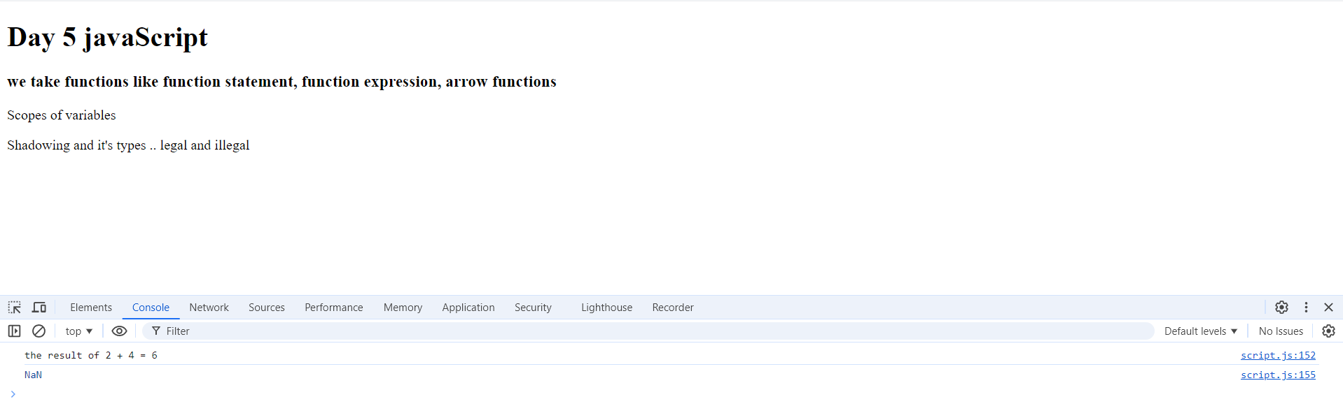

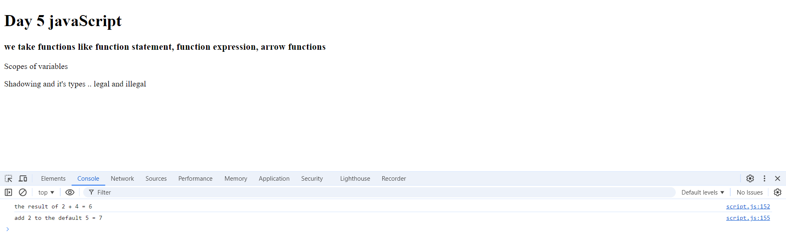

**Q4.2**

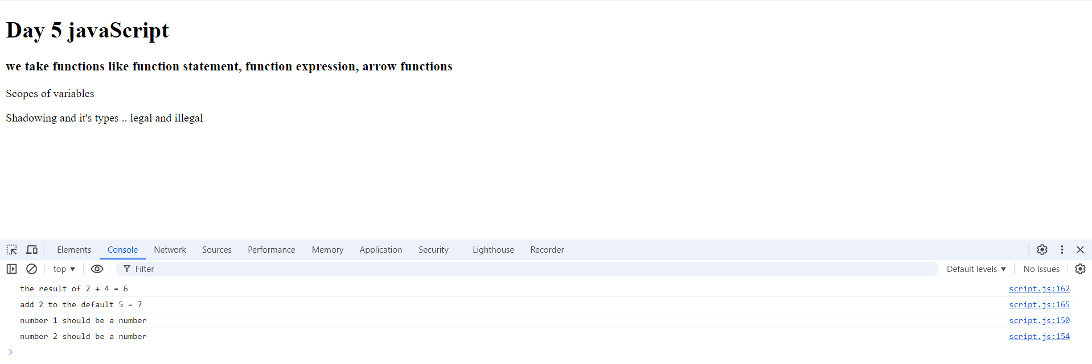

**Question 5**

