**Question 1**

create a web page that open existing small window and scroll it’s content to the end .

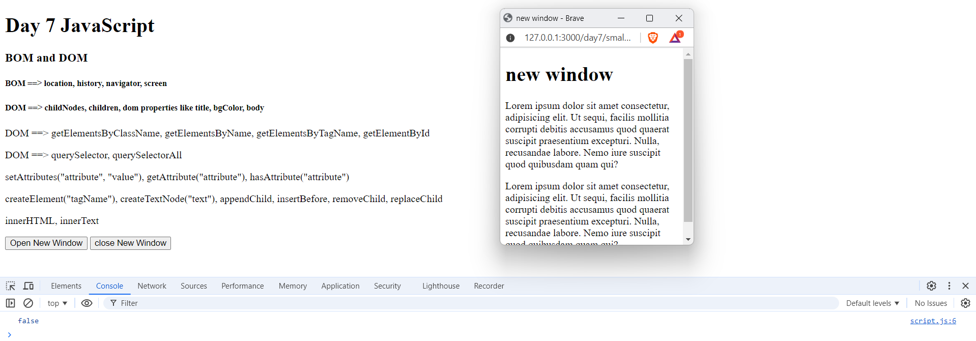

Q1.a check if the small window still opened, close it.

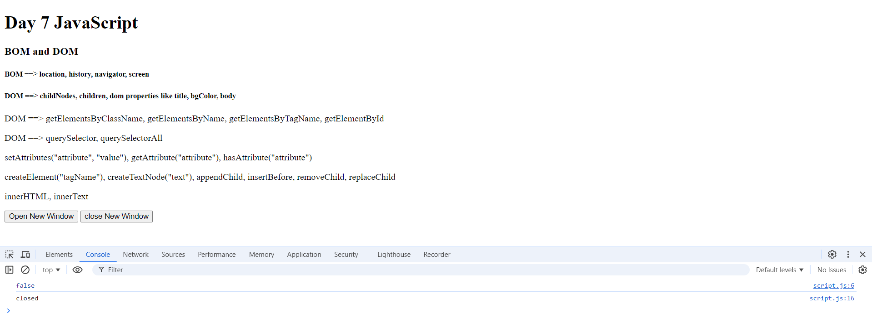

Q1.b Try to write your name on the small window document using document.write (what is the problem).

* It removes all the text from html and put my name only, but if I add a new js file and do document.write it will append my name in the bottom of the new window page

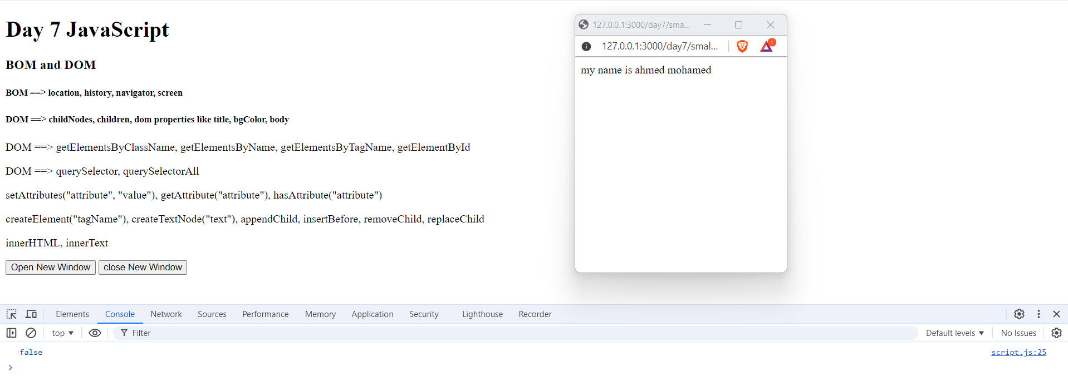

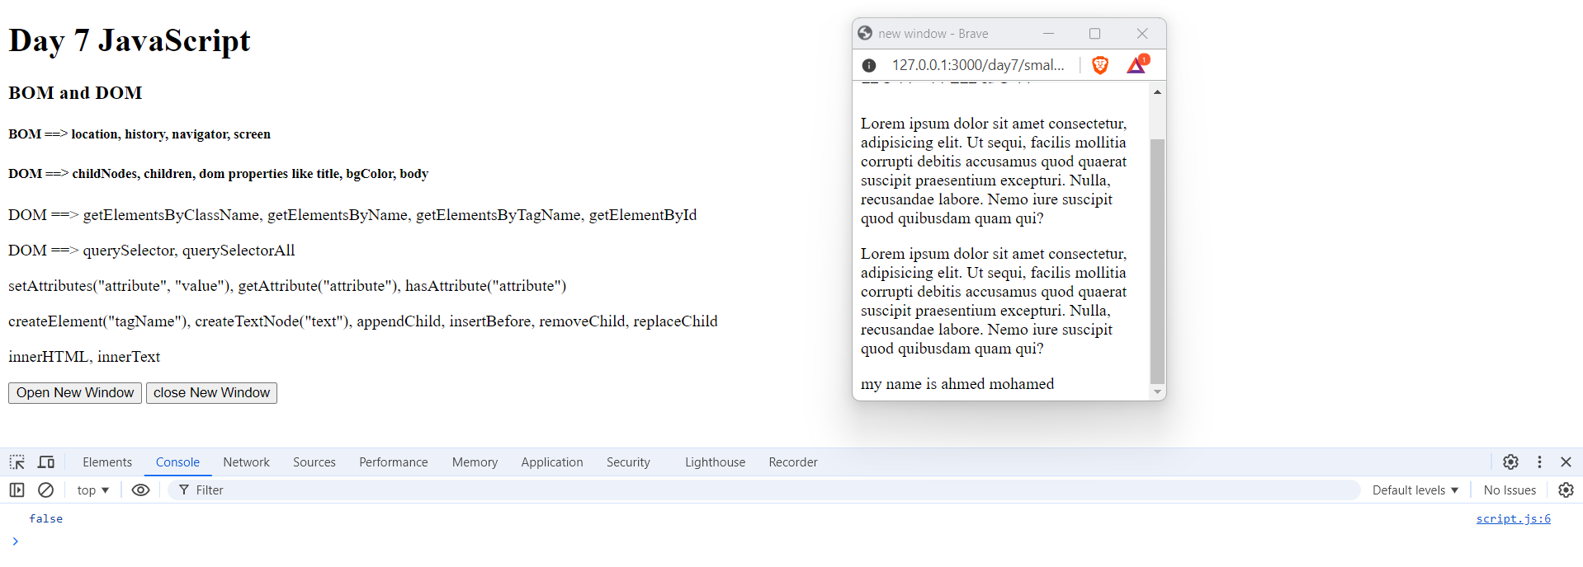

**Q1.c**

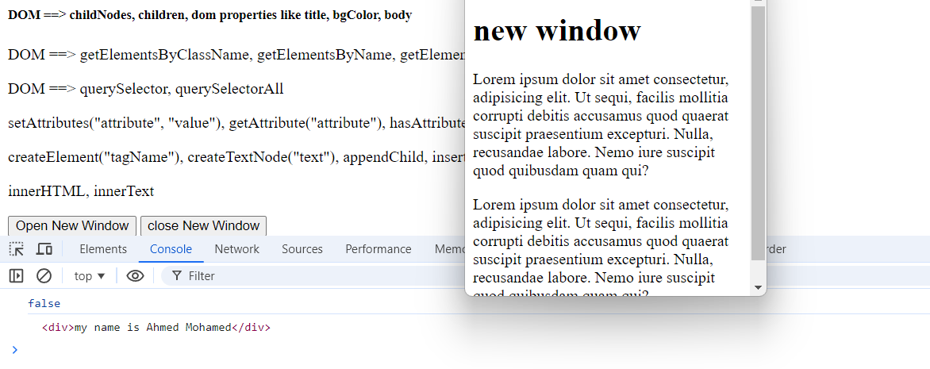

* **It did not want to append the div in the body of newWindow but it append the text with the div element.**

**Q2 a. Find all images in page by two ways (document default collection and document methods).**

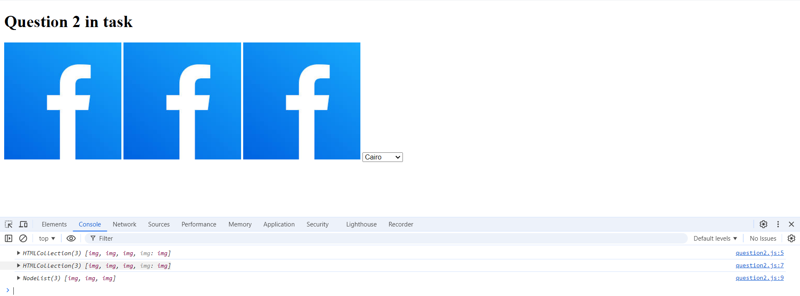

**Q2.b Find all options for City drop down list.**

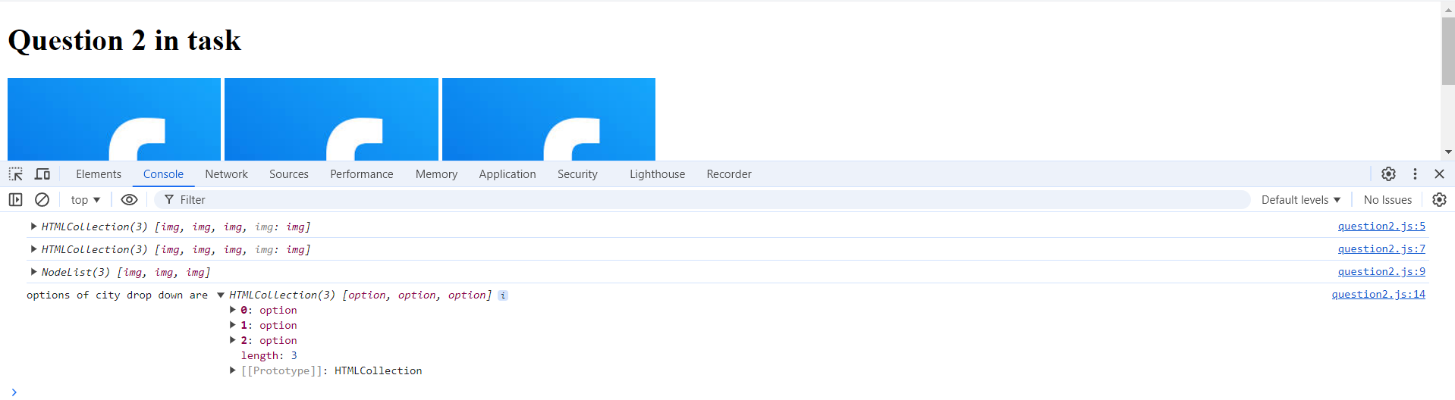

**Q2.c**

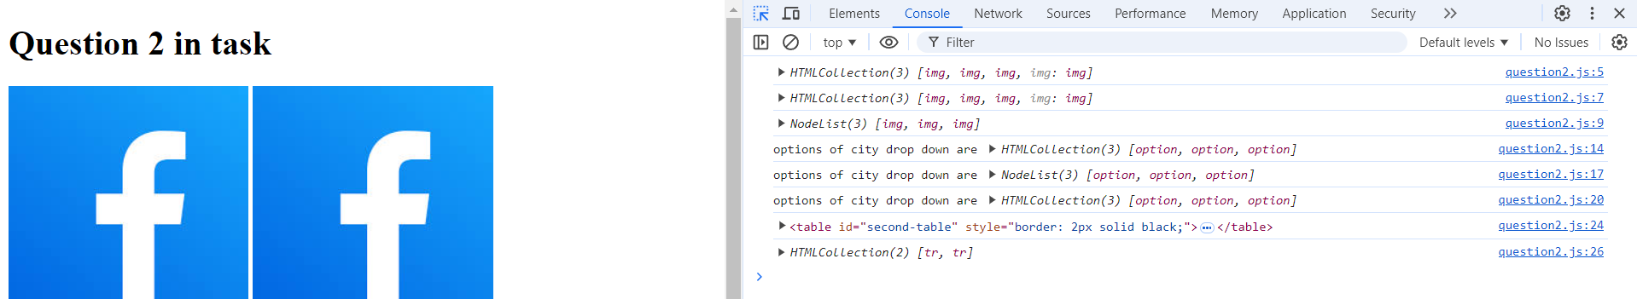

**Q2.d**



**Question 3**

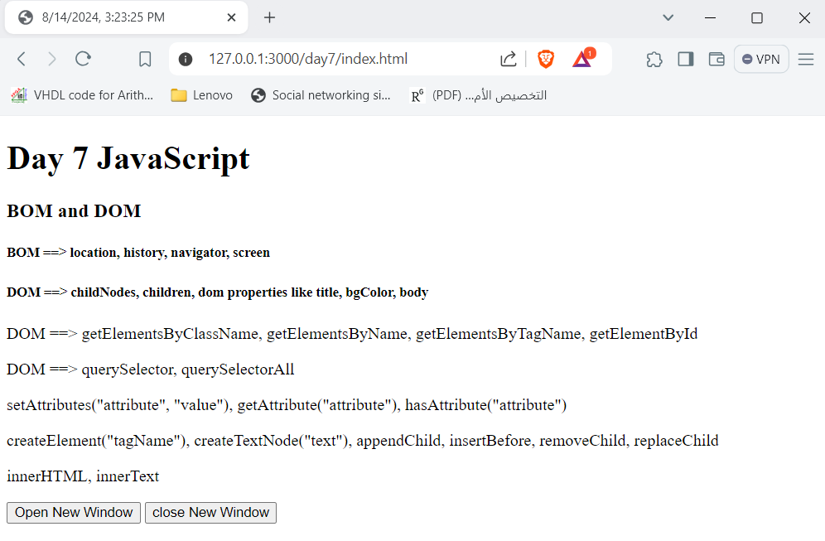

**Q4**

