**WeRateDogs Data Analysis Report**

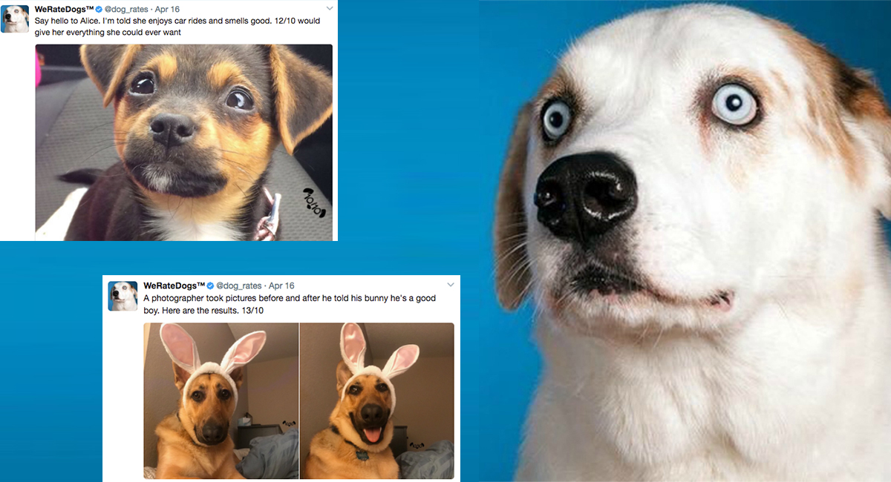

[**WeRateDogs**](https://twitter.com/dog_rates) is a Twitter account that rates people's dogs with a humorous

comment about the dog. It was started in 2015 by college student Matt Nelson, and

has received international media coverage both for its popularity. Data used in this

project is grabbed from inception up to and excluding August, 2017 about 2400

tweets initially. In particular number of retweets and favorite counts are analyzed

and are drafted in this report

|  |  |
| --- | --- |
|  | One interesting result is the maximum numerator  rating of 1776.  This rating may be given by the user to celebrate  U.S independence. The year 1776 is celebrated in  the United States as the official beginning of its  nationhood, with the Declaration of  Independence issued on July 4.  The tweet was posted on 4th July, 2016 stating  “This is Atticus. He's quite simply America af.”  The tweet image prediction could not tell which  breed of dog it is and predicted it as sunglasses and  bow tie (because this is what he wears!) |
|  | This tweet at WeRateDogs has received the  maximum likes as on August 1, 2017. The  tweet was posted on 21ST January, 2017 when  the largest single-day protest in U.S history  took place, stating “Here’s a super supportive  puppo participating in the Toronto  #WomensMarch today.”  The maximum number of likes are may be due  to the board which the dog is wearing to  support the Women's March.  The Women’s March was a worldwide protest  on January 21, 2017, to advocate legislation  and policies regarding human rights. Most of  the rallies were aimed at Donald Trump,  largely due to statements that he had made  which were regarded by many as antiwomen  or otherwise offensive. |

**Analyses questions:**

Which stage has the highest number of posts?

In the data there are specifically four stages of dogs are mentioned, so having these four stages, which stage has got highest number of posts is analyzed

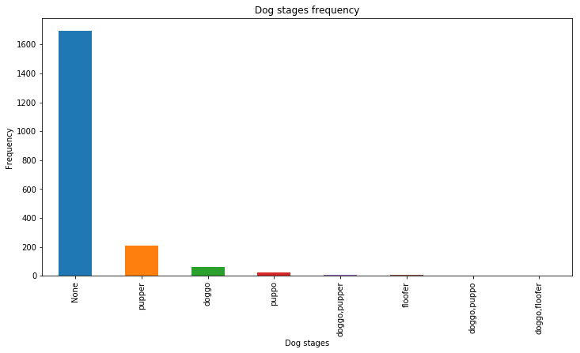

**Conclusion**

Given four stages of dogs are Pupper, Doggo, Puppo, Floofer and other mixed stages as in the plot. Out of these 4,

Pupper has the highest number of posts.

**Does dog_stage has any influence on favorite_count and**

**retweet_count?**

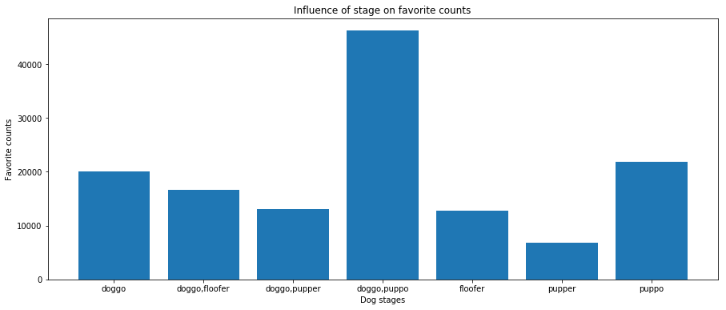

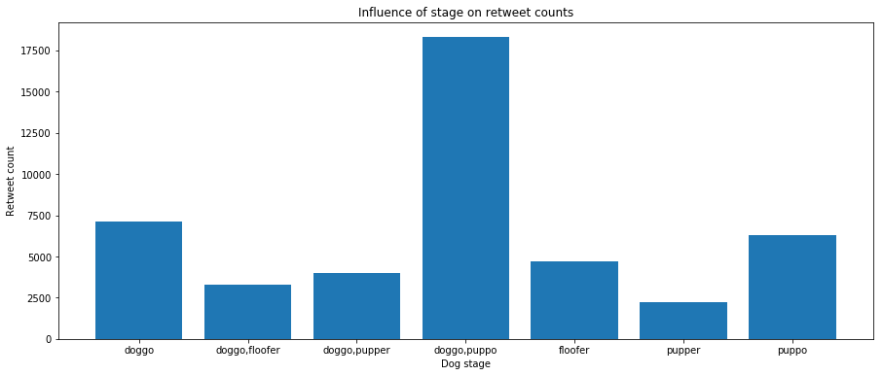

**Conclusion**

Besides pupper having the highest frequency, Puppo gets the highest number of favorite

counts followed by Doggo, Floofer, Pupper and Doggo gets the highest number of

retweet counts followed by Puppo, Floofer, Pupper.

**Is there any correlation between favorite and retweet counts?**

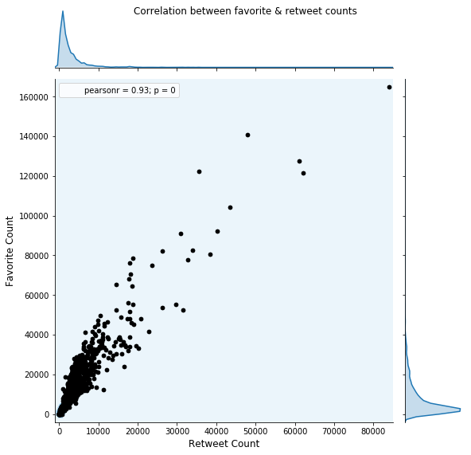

**Conclusion**

There exists a positive correlation between favorite count and retweet count. The

relation is too strong when there are less number of likes or retweets and as they

increase, the relation becomes weak.

**Most frequent dog names:**

Here’s a bar plot showing the most common dog names used in tweets at WeRateDogs.

The most common dog names are Oliver, Cooper, Charlie and Lucy.

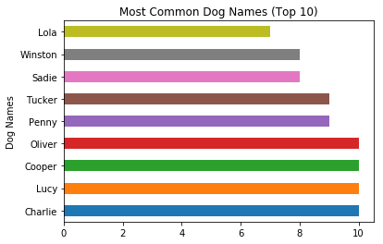

**Tweets per Month Over Time**

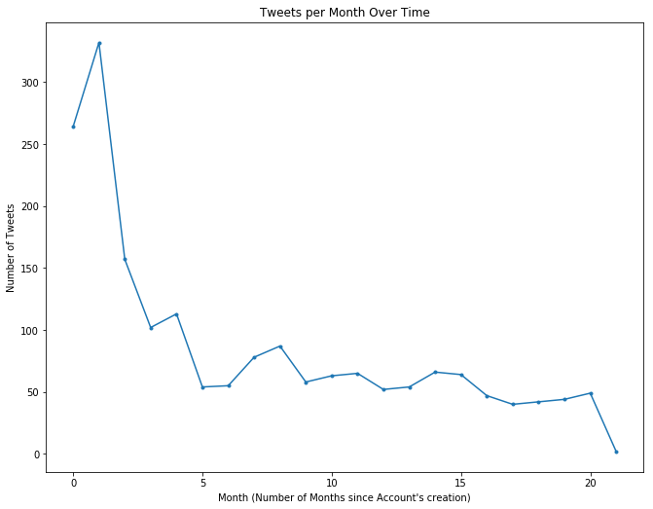

The graph clearly illustrates that @dog_rates post rate has declined significantly since it’s creation. The slight dip at the end is less dramatic than it seems, since the data for August only

includes the first of the month. The increase around 7.5 months corresponds with the summer

months. Hinting the person running the twitter account was a student.