1. Introduction

We are dealing with a photography studio that focuses on producing photos for advertisements. The studio is owned by three men who conduct the work themselves. Meaning they have no employees. They use Photoshop and other photo editing software. Enhancing and altering the colors of images with the assistance of color presets. Color presets can be bought or made using a program named Lightroom. they are saved as files with the format XMP. color presets can be used in various programs. They use a single computer to store all the presets and images. They have repeating customers and occasionally get new ones. Writing information on paper is their main way of keeping track of the transactions. They don’t have a database on their main computer.

1. Problem definition

repeating customers almost always wish to keep the theme of their menu and accounts consistent. Which requires the photographers to use the same color preset they used editing the customers products previously. Their main computer contains two files. In one file they store all their presets. And in the other they store all the images they worked on previously. And with no sure way of knowing which preset they used. they have to open the folder containing the images they worked on previously and search through hundreds of images for the latest image belonging to the customer that is currently requiring their services. And when they find the image. they have to use photo editing programs to identify the color preset that has been used. Here lies the problem. This method is time consuming and not optimal. They can’t fix the problem by naming the color preset after the customer or their franchises name. for the particular reason that a single color preset is usually used with multiple other customers. There is also the fact that depending on the product from the same customer. they may need to edit the preset and slightly alter the colors. So that the product appears in the best way possible while maintaining the original theme. This leads them to save the color preset as a new separate file. All that leads to multiple color presets which leads to further time consumed on just figuring out which color presets were used previously with a certain customer.

1. Current status

Currently the photography studio has yet to establish a way to deal with their problem. Their services continue to be delayed due to their current predicament. Lacking any way to store their data other than writing it on paper. Their method of acquiring the data they need becomes more and more time consuming with every customer. And with every new photo or color preset.

1. Proposed solution

We believe that the best way to sort these problems is by creating a database that can provide quick access to the customers information. Designing and creating the database in way that provide sufficient information in a quick and easy manner. This is done by making the database store the customers information (name, phone number, company name) and past transactions with the addition of a list of color presets that have been used with the client previously. Furthermore, this solution would require the database to have a receipt system. In which case their efficiency will greatly benefit. This way they can quickly identify the color preset needed and easily implement it to any new photo. We will also try to make it as user friendly as possible. This will result in the benefits previously mentioned and will also insure that any future employee will not need any excessive training on how to use the system.

1. Interview/ questionnaire questions
2. 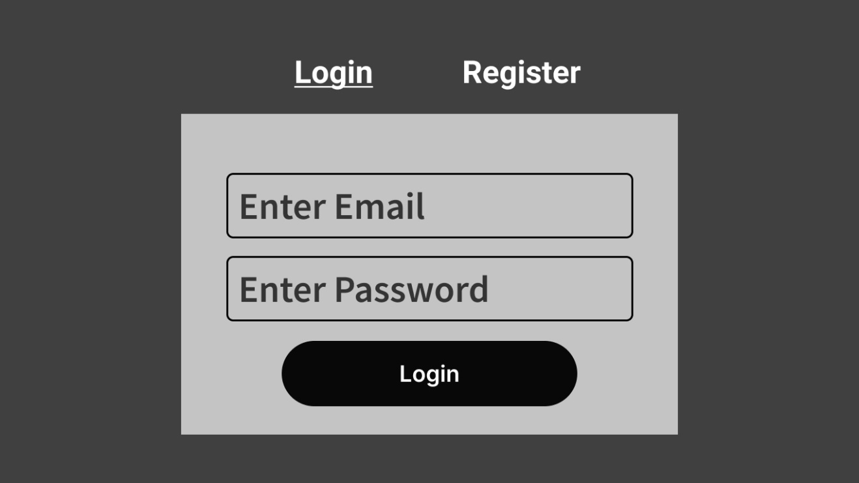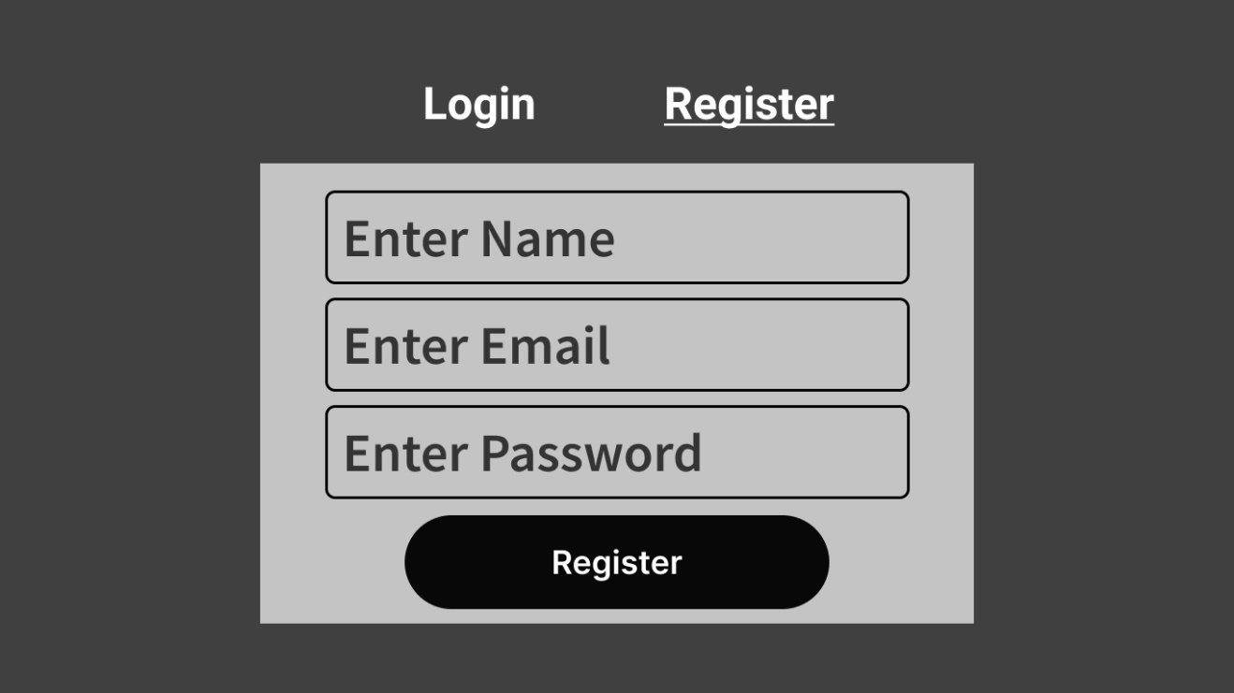Screen Design

Figure : Login Page

Figure : Register Page

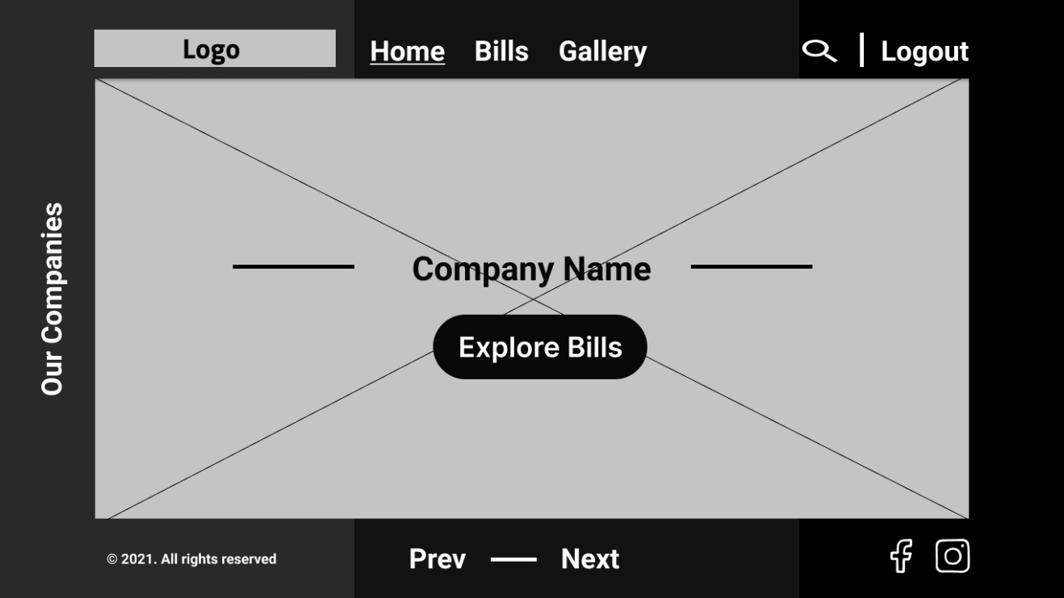

Figure : Home Page

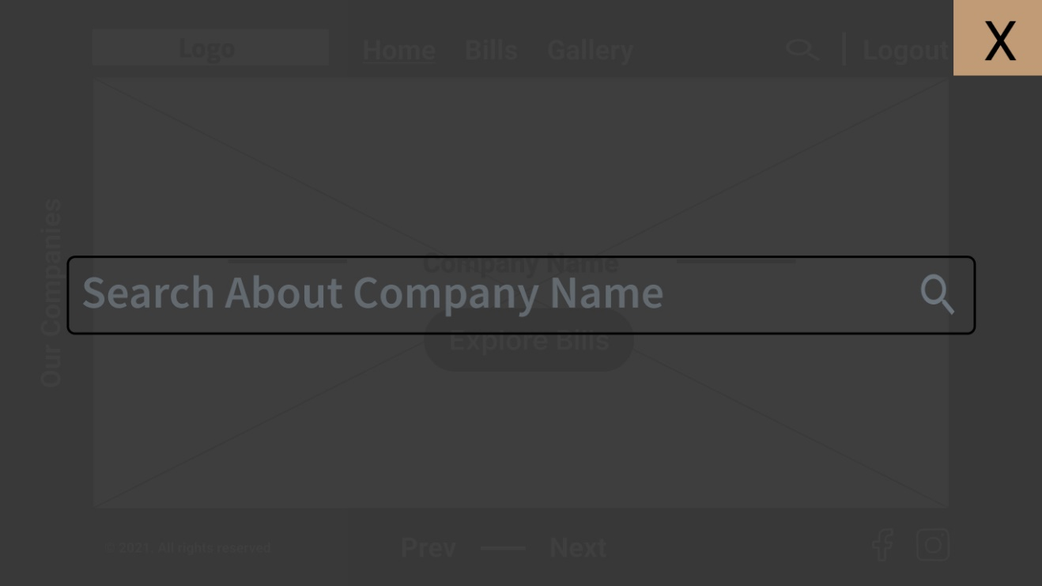

Figure : Search Page

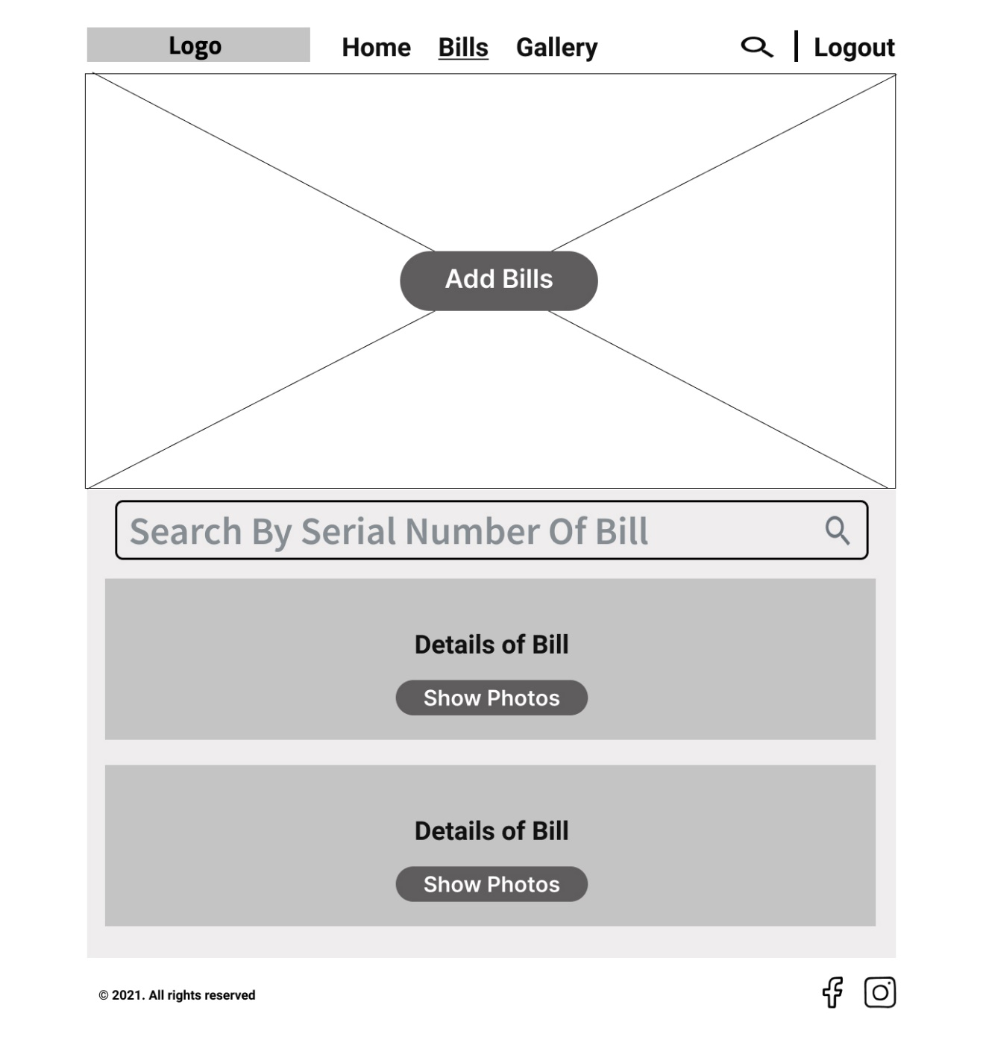

Figure : Bills Page

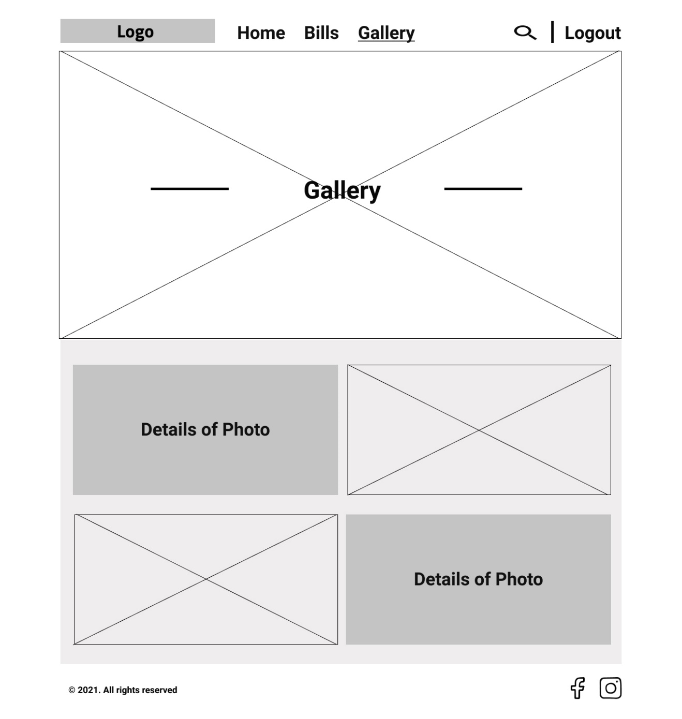

Figure : Gallery Page

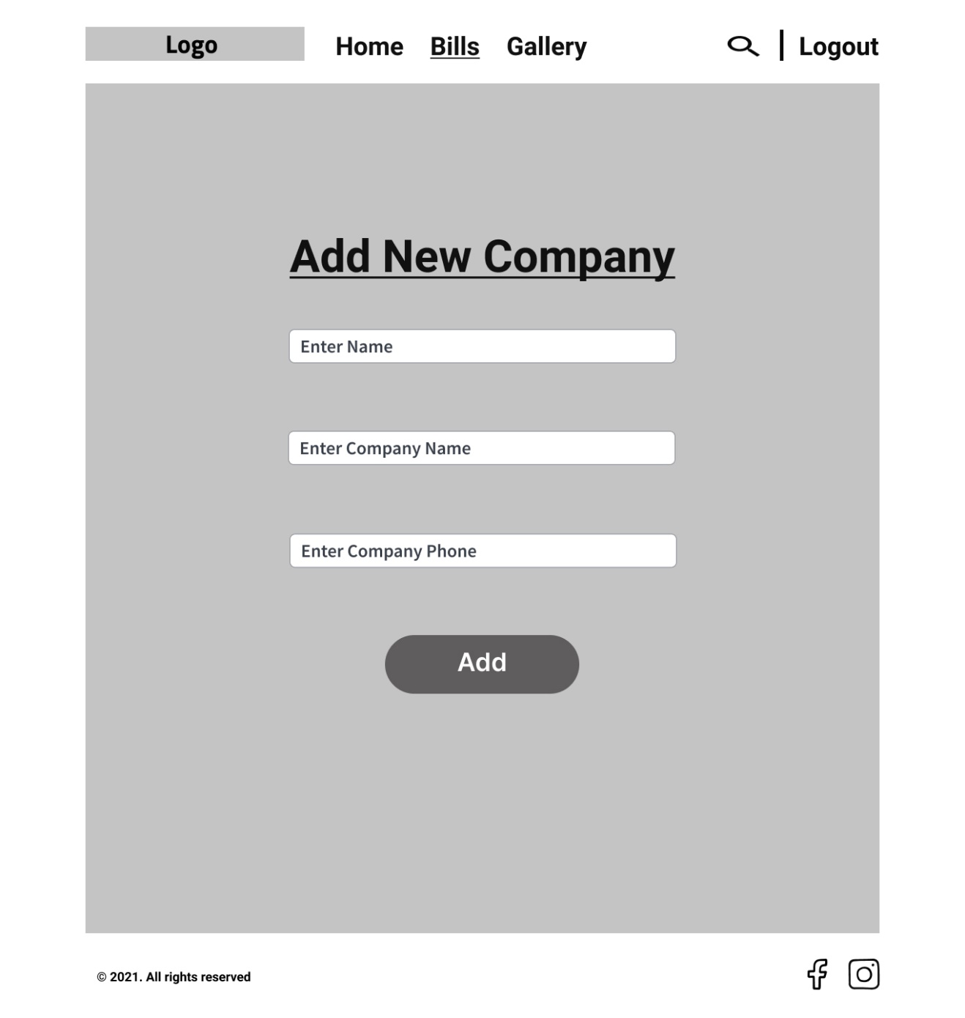

Figure : Add Company Page

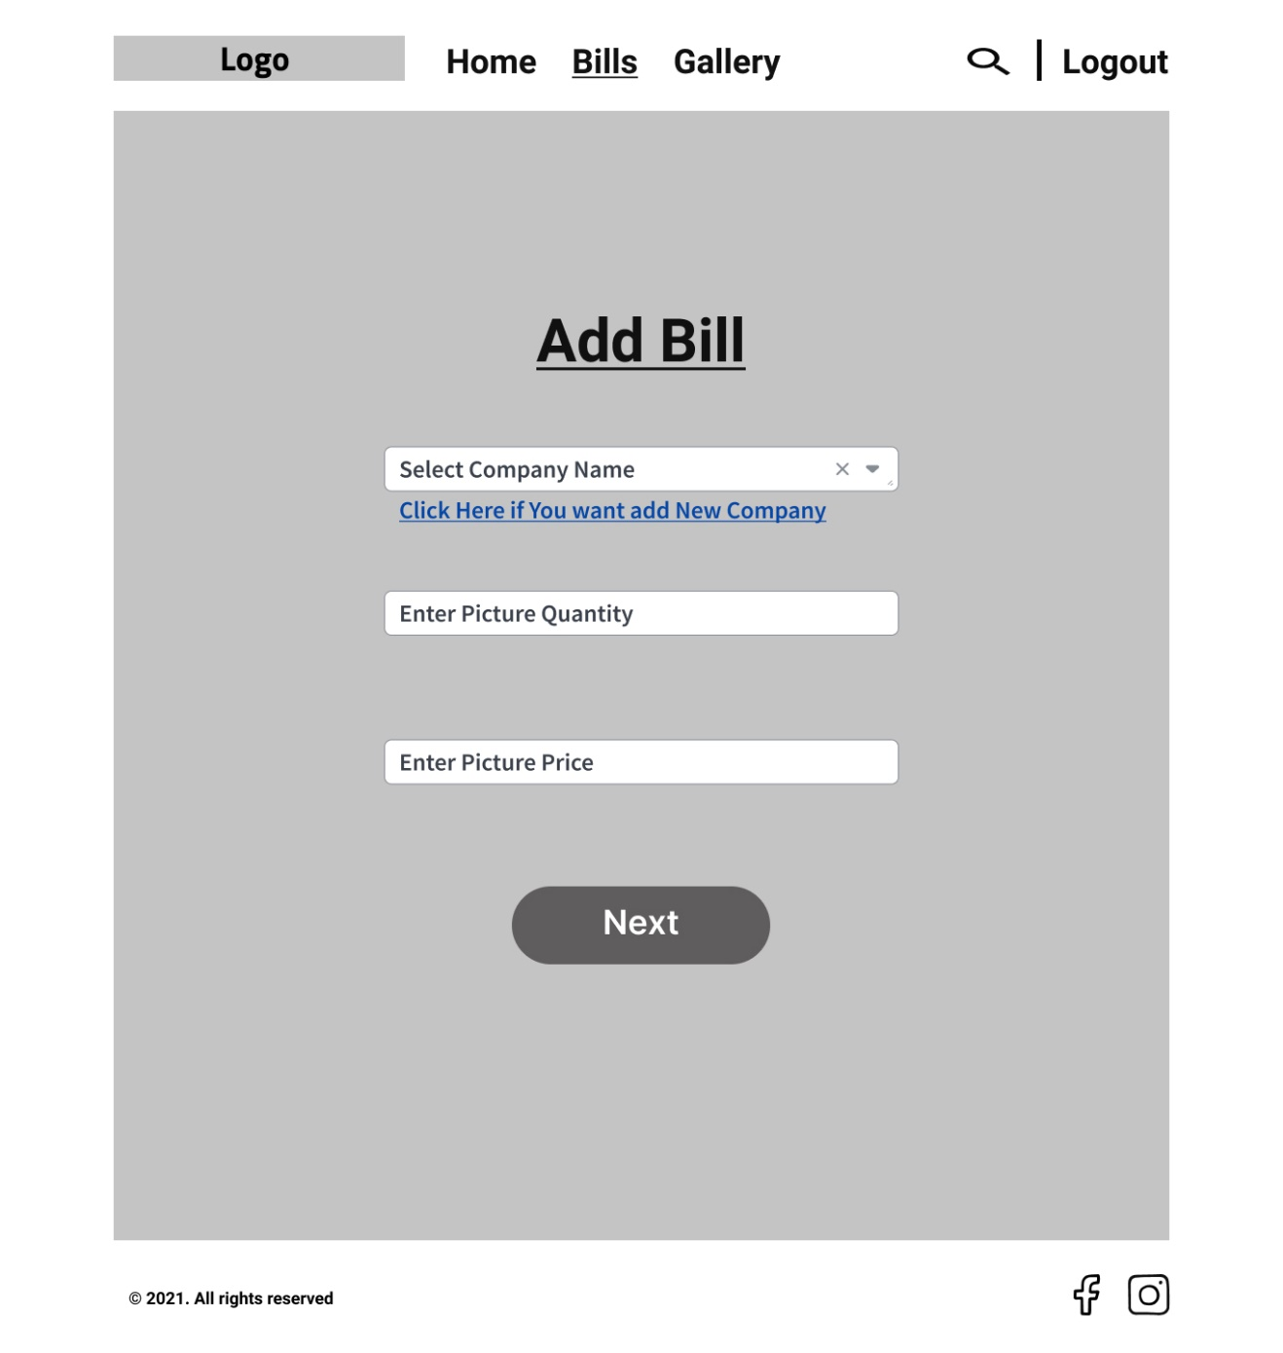

Figure : Add Bill Page

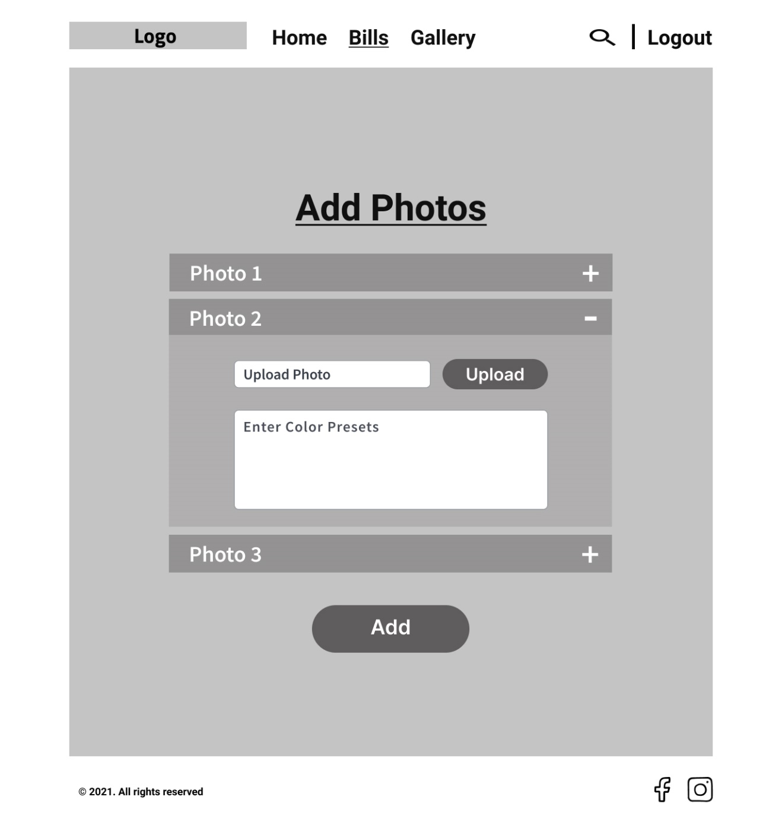

Figure : Add Photos For Bill

1. Report Design

* Show All Bills.
* Show All Details about photos.
* Show All Companies with Bills

1. Data Flow Diagram
   1. Context Diagram

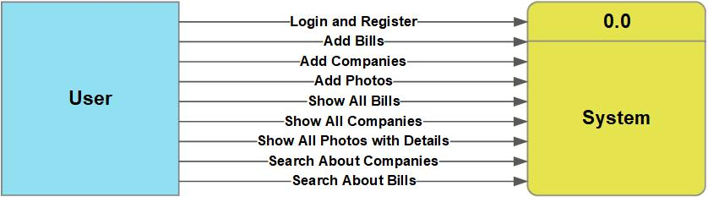

Figure : Context Diagram

* 1. 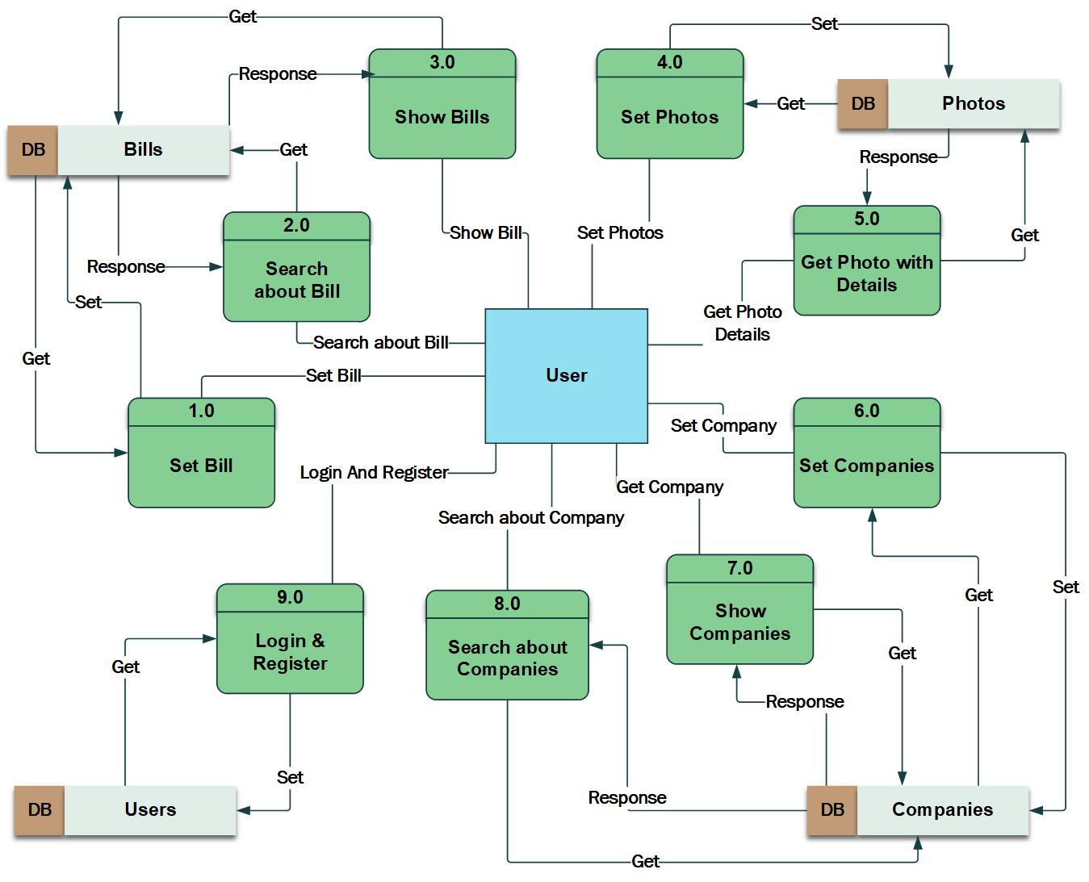Data Flow Diagram Level 1

Figure : Data Flow Diagram Level 1

1. Pert Chart

Table : Pert Table

|  |  |  |  |
| --- | --- | --- | --- |
| Task Mode | Task Name | Duration | Predecessors |
| 1 | Requirement Gathering | 2 days | None |
| 2 | Database Design | 3 days | 1 |
| 3 | Developing back-end | 4 days | 2 |
| 4 | Screen design | 4 days | 3 |
| 5 | server setup & preparation | 3 days | 4 |
| 6 | Deploying back-end to server | 6 days | 5 |
| 7 | Graphics Design | 5 days | 6 |
| 8 | website Development | 6 days | 7 |
| 9 | Deploy website | 5 days | 8 |

Figure : Pert Diagram

* 1. Pert Diagram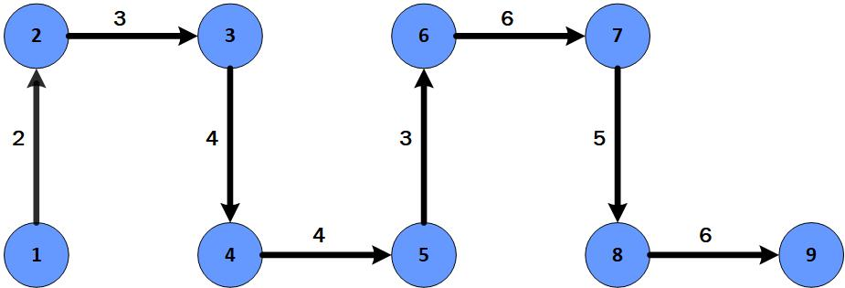

1. 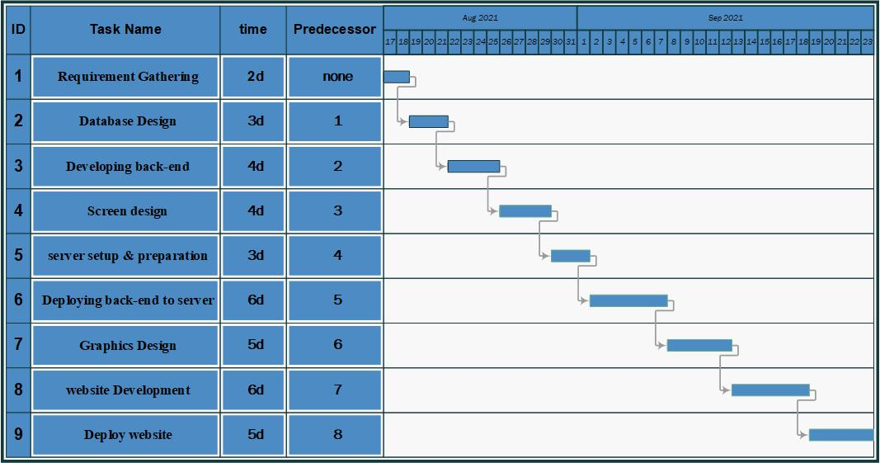Gantt Chart

Figure : Gantt Chart

1. 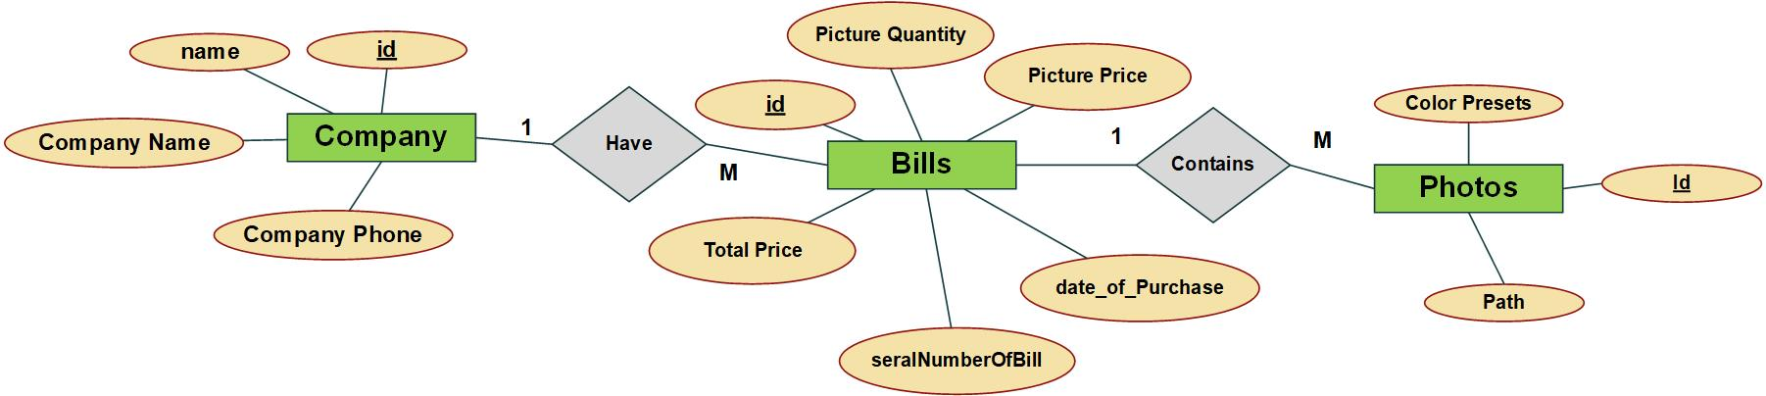ER Diagram

Figure : ER Diagram