- Fire Team:
- Ahmed Mousa Mousa ( Product Manager )

- The problem statement relates to a GCGO:
Job creation (“Youth Unemployment and Weak School-to-Work Transition”)

- Define:
This issue limits Egypt’s economic growth and wastes the potential of an
educated generation unable to find stable, decent jobs. Strengthening the
connection between education and employment is vital to reduce poverty, boost
productivity, and ensure sustainable economic development.

- The Problem can potentially be addressed with technology
1. Bridging the Education–Employment Gap
AI-powered job platforms can match graduates with employers based on skills, not degrees. Career guidance apps help students choose in-demand fields. (e.g., LinkedIn Learning, Wuzzuf)
2. Upskilling and Reskilling through E-Learning
Platforms like Coursera, Udemy, and Edraak offer flexible, affordable training in digital and soft skills. Micro-credentials prove competence and keep graduates market-ready.
3. Using Data and AI to Inform Policy
Governments can analyze labor market data to align education with demand and use predictive analytics to anticipate future job trends.
4. Digital Internships and Remote Work
Technology enables virtual internships and remote jobs, allowing Egyptian youth to gain experience and income from global opportunities.

- Problem Statement:
Youth unemployment and the weak school-to-work transition remain major challenges in Egypt, limiting economic growth and wasting the potential of a well-educated generation. Many graduates struggle to find stable, decent jobs that match their skills, leading to underemployment and frustration. This disconnect between education outcomes and labor market needs contributes to poverty and reduced productivity. Strengthening the link between education and employment is therefore essential to empower youth, boost national productivity, and drive sustainable economic development.

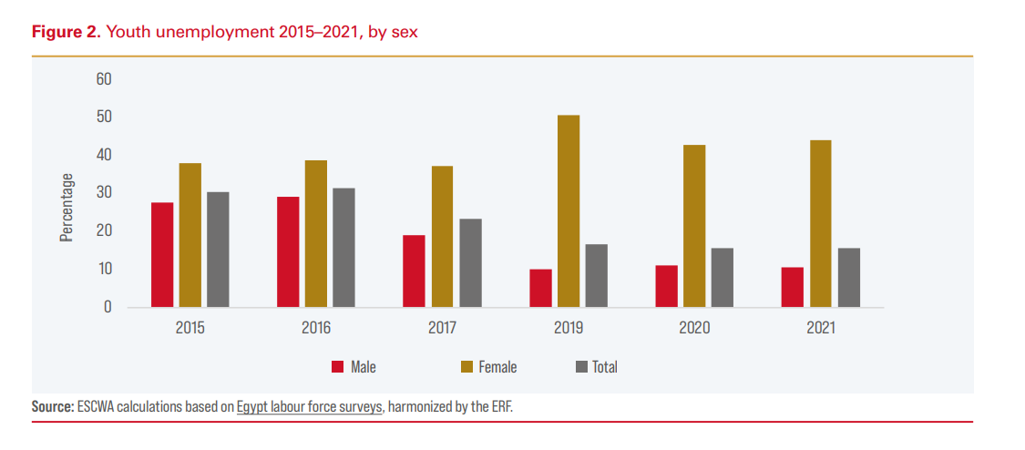 In Egypt, young women face much higher unemployment and exclusion from the labor market than men.

Female youth unemployment rose from 38% in 2015 to over 50% in 2019, before slightly improving to 44% in 2021.

Their labour force participation dropped sharply from 21% to 8% during the same period.

At the same time, the quality of youth employment has worsened:

Most young workers (about 89%) have no contracts, and 91% lack social security.

Underemployment increased from 8% in 2015 to 26% in 2020, improving slightly to 22% in 2021.

Overall, Egyptian youth—especially women—face high unemployment, job insecurity, and limited stable work opportunities, reflecting persistent inequality and economic vulnerability.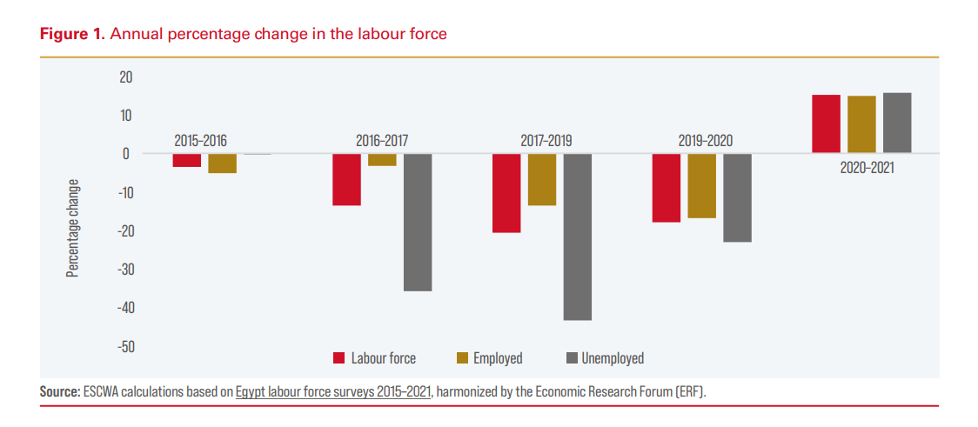

- One good thing that happened during our team meeting was that everyone actively participated and shared useful ideas, which helped us clearly define our next steps and improve collaboration.

- What’s working well with our team is the strong communication and collaboration — everyone stays engaged, meets deadlines, and supports each other to reach our shared goals efficiently.

- One thing our team could do better in the next meeting is to stay more focused on the agenda and manage time more effectively so we can cover all topics without rushing at the end

- Yes, sometimes it’s frustrating when tasks aren’t clearly assigned or updates come in late. To lessen this frustration, I can take the initiative to communicate more proactively, clarify responsibilities early, and offer help to keep everyone on track.

- 4

- My biggest concern about working with the team during Month 2 is keeping up with deadlines as our workload increases. To address this, I plan to stay organized, communicate early about any challenges, and help the team prioritize tasks effectively.

- As a team, we can address that concern by setting clear weekly goals, tracking our progress regularly, and communicating openly about any delays or obstacles. This way, we can support each other, stay accountable, and ensure we meet all our deadlines on time.

- To address that concern as a team, we can create a shared task tracker to monitor deadlines, assign clear responsibilities to each member, and hold short weekly check-ins to review progress and resolve issues early. This will keep everyone aligned and ensure consistent progress throughout the month.

- One hope I have for our team during Month 2 is that we continue to build stronger collaboration and communication so we can work more efficiently and achieve our project goals with confidence and teamwork.

- 4

