# Scrambling:

The block of bits b(0),...,b(M bit −1 ) , where M bit is the number of bits transmitted on the physical uplink shared

channel in one subframe, shall be scrambled with a UE-specific scrambling sequence prior to modulation, resulting in a block of scrambled bits b ~(0),...,b ~(M bit −1) according to the following pseudo code.

Set *i* = 0

while *i* < *Mbit*

if  // ACK/NAK or Rank Indication placeholder bits



else

if  // ACK/NAK or Rank Indication repetition placeholder bits



Else // Data or channel quality coded bits, Rank Indication coded bits or ACK/NAK coded bits



end if

end if

*i* = *i* + 1

end while

Control data arrives at the coding unit in the form of channel quality information (CQI and/or PMI), HARQ-ACK and rank indication. Different coding rates for the control information are achieved by allocating different number of coded symbols for its transmission. When control data are transmitted in the PUSCH, the channel coding for HARQ-ACK, rank indication and channel quality information is done independently.

**So we ignore ACK/NAK or Rank Indication repetition placeholder bits for simplicity.**

**The new pseudo code is :**

Set *i* = 0

while *i* < *Mbit*



*i* = *i* + 1

end while

**Where :**

.

nRNTI Radio network temporary identifier

nID Physical layer cell identity

ns Slot number within a radio frame

## * RNTI ( Radio network temporary identifier ) :

( <http://www.sharetechnote.com/html/Handbook_LTE_RNTI.html> )

( <http://howltestuffworks.blogspot.com.eg/2014/06/rntis-in-lte.html> )

this RNTI is used to identify one specific radio channel from other radio channel and one user from another user.

Putting it very simply, you can think of RNTI as a kind of UE ID for the traffic between UE and eNB lower layer. But it would be more accurate to think of it as 'UE ID + Channel ID' since each type of channel has its own range of RNTI value.

Who issues these RNTI ?

Network issues RNTI.

If a UE is configured by higher layers to decode PDCCHs with the CRC scrambled by the C-RNTI, the UE shall decode the PDCCH according to the combination defined in table 8-3 and transmit the corresponding PUSCH. The scrambling initialization of this PUSCH corresponding to these PDCCHs and the PUSCH re-transmission for the same transport block is by C-RNTI.

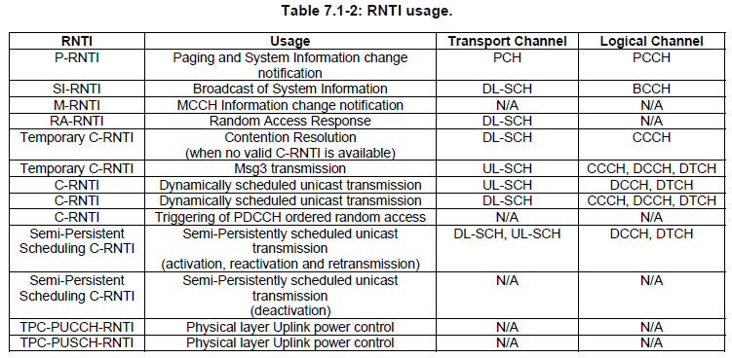

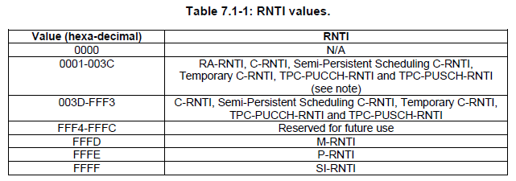

**How/Who determines each types of RNTI ?**

RA-RNTI : UE determines RA-RNTI as explained in [here in the RACH page](http://www.sharetechnote.com/html/RACH_LTE.html#How_can_we_get_RA_RNTI).

T-CRNTI : Network allocate T-CRNTI via RAR as shown in [here in the RACH page.](http://www.sharetechnote.com/html/RACH_LTE.html#RACH_Procedure_for_Initial_Registration)

C-RNTI : T-CRNTI becomes C-RNTI once Contention Resolution gets passed.

## * Physical layer cell identity

As the terminology implies, Physical Cell ID is an indentification of a cell at physical layer. It has similar role as Primary Scrambling Code of UMTS cell.

This physical cell ID is determined by [Primary Sync Signal and Secondary Sync Signal](http://www.sharetechnote.com/html/Handbook_LTE_Synchronization_Signal.html) as described below.

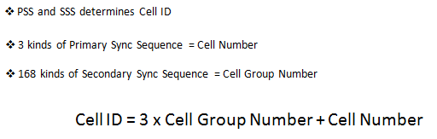

## * Pseudo-random sequence generation

Pseudo-random sequences are defined by a length-31 Gold sequence. The output sequence  of length, where, is defined by



where and the first m-sequence shall be initialized with. The initialization of the second m-sequence is denoted by  with the value depending on the application of the sequence.

## **Modulation**

The block of scrambled bits shall be modulated as described in Section 7.1, resulting in a block of complex-valued symbols. Table 5.3.2-1 specifies the modulation mappings applicable for the physical uplink shared channel.

Table 5.3.2-1: Uplink modulation schemes

|  |  |
| --- | --- |
| Physical channel | Modulation schemes |
| PUSCH | QPSK, 16QAM, 64QAM |

## **Transform precoding**

The block of complex-valued symbols  is divided into  sets, each corresponding to one SC-FDMA symbol. Transform precoding shall be applied according to



resulting in a block of complex-valued symbols . The variable, where  represents the bandwidth of the PUSCH in terms of resource blocks, and shall fulfil



where  is a set of non-negative integers.

## SC-FDMA baseband signal generation

This section applies to all uplink physical signals and physical channels except the physical random access channel.

The time-continuous signal  in SC-FDMA symbol  in an uplink slot is defined by



for where , ,  and  is the content of resource element .

The SC-FDMA symbols in a slot shall be transmitted in increasing order of , starting with , where SC-FDMA symbol starts at time  within the slot.

Table 5.6-1lists the values of that shall be used. Note that different SC-FDMA symbols within a slot may have different cyclic prefix lengths.

Table 5.6-1: SC-FDMA parameters.

|  |  |
| --- | --- |
| Configuration | Cyclic prefix length |
| Normal cyclic prefix |  |
| Extended cyclic prefix |  |