Freight rate prediction: validation approach, model and December forecast

1. Summary
Split approach: expanding-window temporal cross-validation with 2-month test windows (matching the Nov-Dec validation horizon), plus a one-month-gap check (Oct only) and an unseen-city check. Random K-fold is reported only to show how optimistic it is. All transforms are fitted inside each fold's fit window, and the number of boosting rounds is chosen on an inner holdout (the last fit month), never on a test window.
Final model: LightGBM on log(rate per mile), back-transformed to dollars. Mean temporal-CV MAE $129 (MAPE 5.4%, WAPE 5.3%), against $183 for the lane+equipment median baseline (29.6% lower), $157 for equipment x distance-band median (18.0% lower) and $249 for a global rate-per-mile (48.4% lower). The selection fold F3 (Sep-Oct) MAE is $98; the gap fold (Oct) $99.
model | F1 | F2 | F3 (selection) | mean MAE | gap (Oct) | mean MAPE %
b0_global_rpm | 242 | 249 | 257 | 249 | 253 | 11.6
b1_equip_distband_rpm | 201 | 135 | 135 | 157 | 139 | 6.8
b2_lane_equip_rpm | 222 | 175 | 151 | 183 | 155 | 7.9
ridge_loglog | 200 | 113 | 110 | 141 | 112 | 5.9
lgbm | 181 | 107 | 98 | 129 | 99 | 5.4

December forecast (Lexington to Fort Wayne, 360 mi, Dry Van, 32,000 lb): mean $836, range $827 to $843, correlation with the daily market index 0.96 (the chosen model has no market inputs: the shape comes from day of week, and the December market index happens to share a weekly pattern; see section 7).
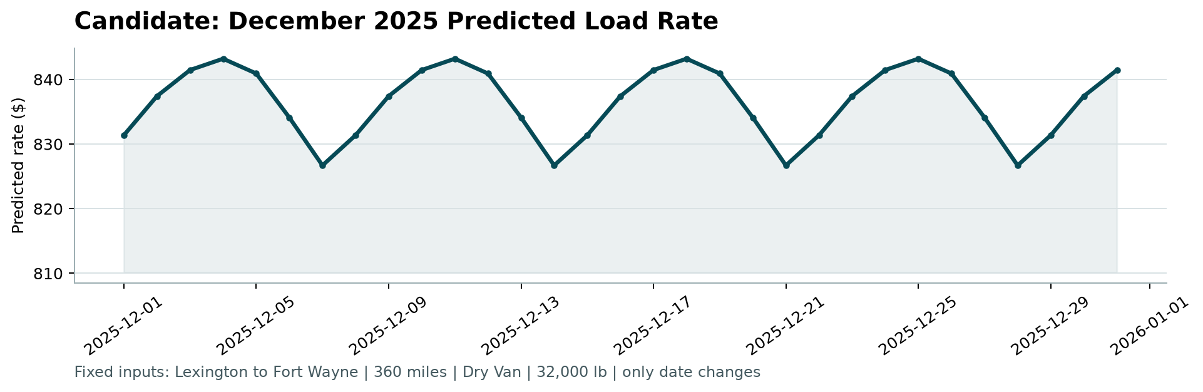
score.py December chart (candidate_december.png)

2. Data and EDA
Train has 48,000 loads (2025-01-01 to 10-31) and validation 12,000 (Nov-Dec). Distance dominates: corr(log rate, log distance) = 0.967. Median rate per mile by equipment: Dry Van 2.05, Flatbed 2.22, Reefer 2.31. The market index is effectively one value per day (sd within a date 0.025 vs 0.165 between dates, lag-1 autocorrelation 0.93). quote_signal is row-level, weakly and non-monotonically related to price (U-shape) and its linear relation with the residual flips sign by month.
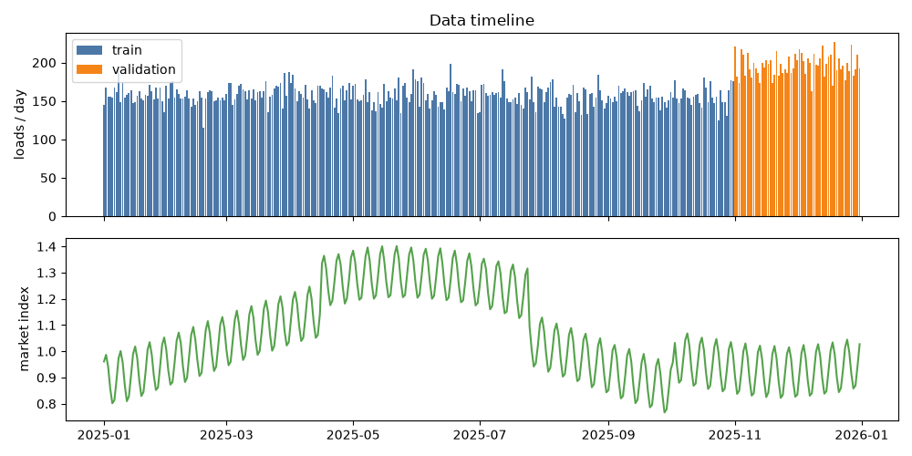
Loads per day and daily market index
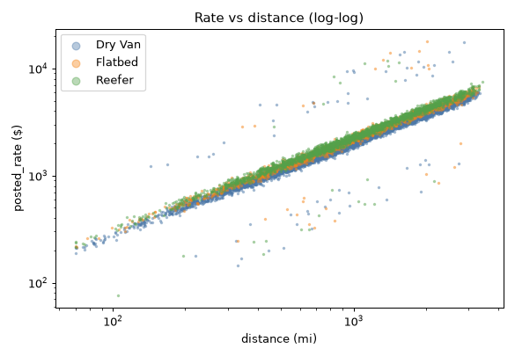
Rate vs distance (log-log)
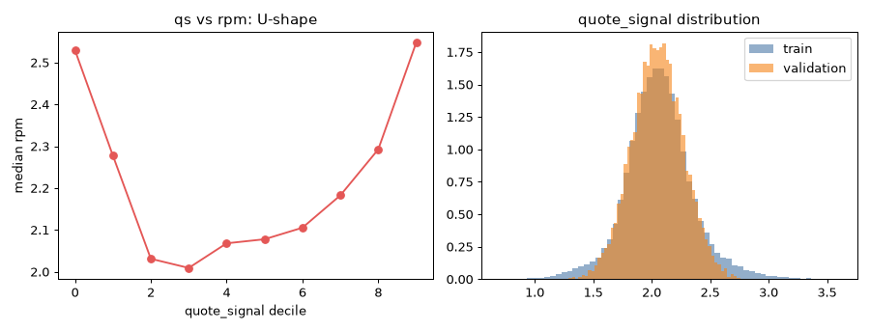
quote_signal: U-shaped relation with rate per mile
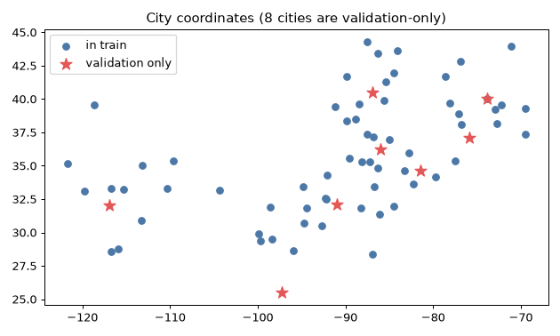
Validation contains cities never seen in train

3. Data quality
issue | train | validation | fix
negative weight (sign error) | 292 | 145 | abs(); flag kept
missing weight | 300 | 165 | median per equipment (fit rows); flag
weight exactly 47,500 (cap) | 1191 | 297 | kept as is; flag
missing market_index | 374 | 249 | mean of other rows same date; flag
label outliers (rate vs lane-equipment median beyond 3x or 1/3) | 451 (0.94%) | n/a | mode 'drop' (CV decision); always kept in evaluation
coordinates clipped (lon -69.5 / lat 25.5 rows) | 2062 / 0 | - | left unchanged, reported
cities not in train | - | 8 cities, 1447 rows (12.06%) | use coordinates, not city IDs
file names | hyphenated in raw/ |  | prepare-data creates the data/ names used by the brief

4. Validation and split approach
Validation is the two months after the training data, so a random split would leak market regime information (neighbouring days share a market index and lane rates) and overstate accuracy. Folds: F1 fit Jan-Apr / test May-Jun; F2 fit Jan-Jun / test Jul-Aug; F3 fit Jan-Aug / test Sep-Oct; gap fold: same fit as F3, test October only (proxy for forecasting a month ahead); unseen-city fold: F3 with 8 train cities removed from the fit set and scored on the test rows touching them (3 seeds). Early stopping uses the last fit month as inner holdout, then the model is refit on the whole fit window with that iteration count.
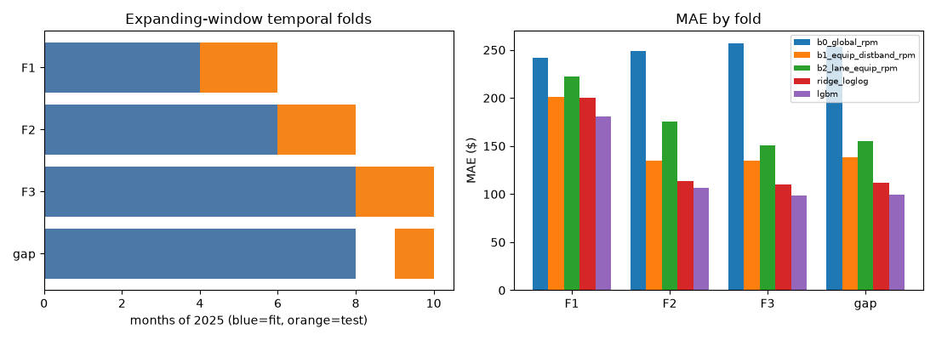
Fold layout and MAE by model
Random 5-fold on all train gives LightGBM MAE $118 against $129 under temporal CV: 9% too optimistic. Unseen-city MAE: LightGBM $93 vs lane+equipment baseline $159.
Stability: the linear residual correlation with quote_signal is positive in 6 and negative in 4 of 10 months; market_index is positive in 10 of 10. Adversarial AUC (Aug-Oct train vs validation) = 0.807 with all features and 0.560 without market columns (coordinates reveal the new cities).
Caveat: decisions were made sequentially on F3 and the gap fold, so F3 is a selection fold, not an untouched holdout. The only untouched evaluation is the scoring of the validation set itself.

5. Features and model
Features: distance, equipment, cleaned weight and its missing flag, market_index, pickup/delivery coordinates, circuity (distance / haversine) and day of week. No month or time index (December is out of the training range). City IDs and lane target-encodings are deliberately absent: coordinates generalise to new cities.
Target: log_rpm; outlier handling: drop; recency half-life: 3 months; final boosting rounds n_final = 315; seed noise sd = 0.7437% of MAE, so the adoption gate is 1.4874%.
Decision rule: adopt the more complex option only if mean MAE improves by at least the gate and neither F3 nor the gap fold gets worse. Decisions and evidence (from config/decisions.json):
setting | value | evidence
outlier_mode | drop | outlier_target sweep (gate 1.49%): winner drop|log_rpm. keep|log_rate vs keep|log_rpm: gain -8.07% (gate 1.49%), F3 117.0 vs 105.9, gap 118.4 vs 106.7 -> reject | drop|log_rpm vs keep|log_rpm: gain +1.79% (gate 1.49%), F3 100.6 vs 105.9, gap 102.2 vs 106.7 -> ADOPT | drop|log_rate vs drop|log_rpm: gain -3.78% (gate 1.49%), F3 106.7 vs 100.6, gap 108.2 vs 102.2 -> reject | weight|log_rpm vs drop|log_rpm: gain +0.22% (
target | log_rpm | outlier_target sweep (gate 1.49%): winner drop|log_rpm. keep|log_rate vs keep|log_rpm: gain -8.07% (gate 1.49%), F3 117.0 vs 105.9, gap 118.4 vs 106.7 -> reject | drop|log_rpm vs keep|log_rpm: gain +1.79% (gate 1.49%), F3 100.6 vs 105.9, gap 102.2 vs 106.7 -> ADOPT | drop|log_rate vs drop|log_rpm: gain -3.78% (gate 1.49%), F3 106.7 vs 100.6, gap 108.2 vs 102.2 -> reject | weight|log_rpm vs drop|log_rpm: gain +0.22% (
qs_variant | none | market sweep (gate 1.49%): winner no_qs_no_mi. no_qs vs no_qs_no_mi: gain +5.19% (gate 1.49%), F3 145.0 vs 106.3, gap 143.7 vs 108.2 -> reject | no_mi vs no_qs_no_mi: gain -14.50% (gate 1.49%), F3 96.7 vs 106.3, gap 103.2 vs 108.2 -> reject | full vs no_qs_no_mi: gain -19.44% (gate 1.49%), F3 124.3 vs 106.3, gap 129.0 vs 108.2 -> reject | qs_dev vs no_qs_no_mi: gain -24.10% (gate 1.49%), F3 148.3 vs 106.3, gap 136.1
use_mi | false | market sweep (gate 1.49%): winner no_qs_no_mi. no_qs vs no_qs_no_mi: gain +5.19% (gate 1.49%), F3 145.0 vs 106.3, gap 143.7 vs 108.2 -> reject | no_mi vs no_qs_no_mi: gain -14.50% (gate 1.49%), F3 96.7 vs 106.3, gap 103.2 vs 108.2 -> reject | full vs no_qs_no_mi: gain -19.44% (gate 1.49%), F3 124.3 vs 106.3, gap 129.0 vs 108.2 -> reject | qs_dev vs no_qs_no_mi: gain -24.10% (gate 1.49%), F3 148.3 vs 106.3, gap 136.1
mi_date_mean | false | default
recency_halflife | 3 | recency sweep (gate 1.49%): winner h=3. h=3 vs h=0: gain +2.56% (gate 1.49%), F3 101.4 vs 101.4, gap 102.1 vs 104.0 -> ADOPT | h=6 vs h=3: gain -0.80% (gate 1.49%), F3 100.6 vs 101.4, gap 102.2 vs 102.1 -> reject
lgbm_params | {"learning_rate": 0.03, "num_leaves": 31, "min_child_samples": 80, "feature_fraction": 0.8, "bagging_fraction": 0.8, "bagging_freq": 1, "lambda_l2": 1.0, "objective": "huber"} | tune: incumbent nl63_mcs40_l2 mean 130.84; best grid nl31_mcs80_huber mean 128.72 (gain +1.62%, gate 1.49%, F3 98.4 vs 101.4, gap 99.3 vs 102.1) -> ADOPT; n_final = round(1.1 * median inner iters [286, 160, 1980]) = 315
n_final | 315 | tune: incumbent nl63_mcs40_l2 mean 130.84; best grid nl31_mcs80_huber mean 128.72 (gain +1.62%, gate 1.49%, F3 98.4 vs 101.4, gap 99.3 vs 102.1) -> ADOPT; n_final = round(1.1 * median inner iters [286, 160, 1980]) = 315

Market-feature ablation (mean MAE over F1-F3, F3, gap):
variant | mean MAE | F3 | gap | decision
no_qs_no_mi | 137 | 106 | 108 | baseline
no_qs | 130 | 145 | 144 | reject
no_mi | 157 | 97 | 103 | reject
full | 164 | 124 | 129 | reject
qs_dev | 170 | 148 | 136 | reject

Market-index audit (scripts/mi_audit.py, final configuration, mean over seeds). Because market_index is positively related to the residual in every month, its rejection was re-tested in several forms, adding fold 'oct1' (fit Jan-Sep, test Oct), the closest proxy for fitting through October and predicting Nov-Dec. Variants: raw MI, date-mean MI, MI with a monotone (+) constraint, a fixed log-rate offset beta*log(MI) with beta estimated inside each fit window from within-month daily residuals (about 0.13-0.15), and offsets on short-run MI moves only (log MI minus its trailing 7/14/28-day mean).
variant | seeds | F1 | F2 | F3 | gap | oct1 | mean
base | 3 | 181.0 | 107.5 | 98.0 | 99.0 | 97.7 | 128.8
mi | 3 | 123.0 | 105.3 | 124.1 | 124.6 | 112.1 | 117.4
mi_datemean | 3 | 124.8 | 107.6 | 124.8 | 123.9 | 112.9 | 119.1
mi_mono | 3 | 121.8 | 107.3 | 124.7 | 125.2 | 111.4 | 117.9
offset_est | 3 | 125.2 | 89.8 | 126.3 | 122.9 | 108.3 | 113.8
mi_dev28 | 3 | 193.0 | 126.6 | 106.3 | 109.4 | 107.4 | 141.9
offset_est_dev28 | 3 | 125.4 | 95.4 | 128.1 | 134.3 | 131.2 | 116.3
off_dev28 | 1 | 193.9 | 100.2 | 97.8 | 99.8 | 99.8 | 130.6
off_dev14 | 1 | 187.8 | 101.3 | 98.3 | 100.0 | 99.3 | 129.1
off_dev7 | 3 | 184.0 | 102.6 | 98.2 | 99.6 | 98.8 | 128.3
Every MI-level variant wins on F1 and F2 (test windows where MI rose or stayed high) but is 26-30% worse on F3 and 11-15% worse on oct1. The reason is a confound: after removing an MI elasticity of about 0.14, rates still drift upward by about 6% from January to October, so when MI falls (Aug to Sep-Oct) an MI-driven model predicts a drop that did not happen. The short-run-only offsets avoid this but are neutral (mean within 0.4%, below the gate; oct1 about 1% worse), because day of week already captures MI's weekly cycle. Nov-Dec MI (0.92-0.93) is at the Sep-Oct level, so an MI feature would mostly add risk rather than signal. The no-market model is kept.
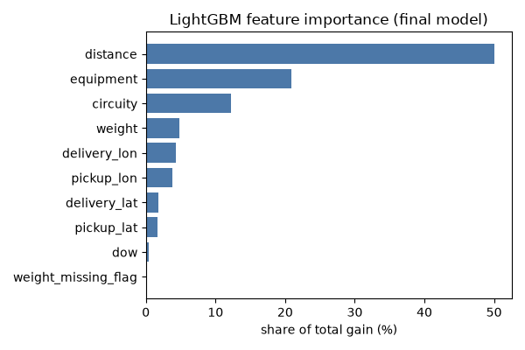
Feature importance (gain share)

6. Results
model | RMSE | MAPE % | MedAPE % | WAPE % | R2 | MAE sd across folds
b0_global_rpm | 677 | 11.6 | 8.0 | 10.3 | 0.802 | 6
b1_equip_distband_rpm | 645 | 6.8 | 4.1 | 6.5 | 0.820 | 31
b2_lane_equip_rpm | 720 | 7.9 | 4.2 | 7.6 | 0.775 | 30
ridge_loglog | 642 | 5.9 | 3.3 | 5.8 | 0.822 | 42
lgbm | 636 | 5.4 | 2.9 | 5.3 | 0.825 | 37

F3 segments (MAE in dollars):
segment | level | n | LightGBM MAE | b2 MAE
equipment | Dry Van | 5360 | 98 | 136
equipment | Flatbed | 1770 | 93 | 171
equipment | Reefer | 2393 | 102 | 171
distance_band | <300 | 780 | 21 | 37
distance_band | 300-800 | 3126 | 51 | 82
distance_band | 800-1500 | 2916 | 103 | 153
distance_band | >1500 | 2701 | 171 | 261
city | seen | 9523 | 98 | 151
label | clean | 9425 | 54 | 107
label | outlier | 98 | 4,369 | 4,416
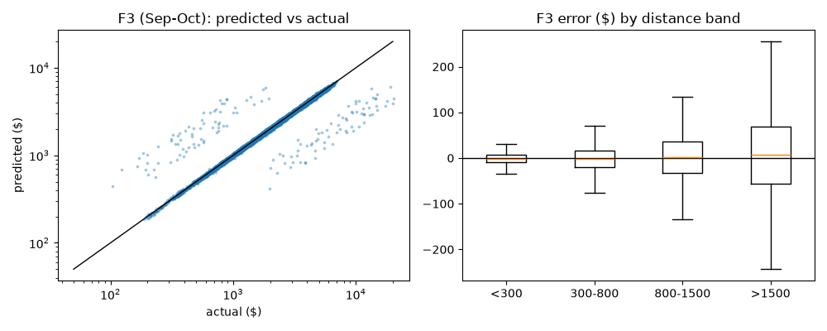
F3 predictions vs actual and error by distance band

7. December forecast
The chart file only gives the lane, distance, equipment, weight and date. The full feature rows are rebuilt for each December date with the same code path as training: coordinates from the city table, the fixed load attributes, day of week, and the market index for that date taken from validation.csv (it is a daily series that exists for every December date). The December MI day-to-day volatility is 0.99x the training volatility, so raw daily values are used (smoothing rule: only if > 2x).
The sequential CV ablation rejected both market_index and quote_signal as model inputs (they improved some folds but made the selection fold and the gap fold worse; see section 5), so the chosen model's December curve is driven by distance, equipment, weight, lane geography and day of week only. In the sensitivity table the first six rows are therefore identical by construction; the two 'alt model' rows show what a market-aware model would predict.
score.py candidate_december.png
variant | mean $ | min $ | max $ | corr with primary
primary (marginalise qs over day's <600mi loads) | 836 | 827 | 843 | 1.00
qs: train-median plug-in | 836 | 827 | 843 | 1.00
qs: daily band-median plug-in | 836 | 827 | 843 | 1.00
qs: train 5-95pct grid mean | 836 | 827 | 843 | 1.00
MI: October mean | 836 | 827 | 843 | 1.00
MI: 7-day rolling mean | 836 | 827 | 843 | 1.00
no-market model | 836 | 827 | 843 | 1.00
alt model: MI only | 827 | 820 | 833 | 0.95
alt model: MI + qs | 825 | 815 | 835 | 0.80
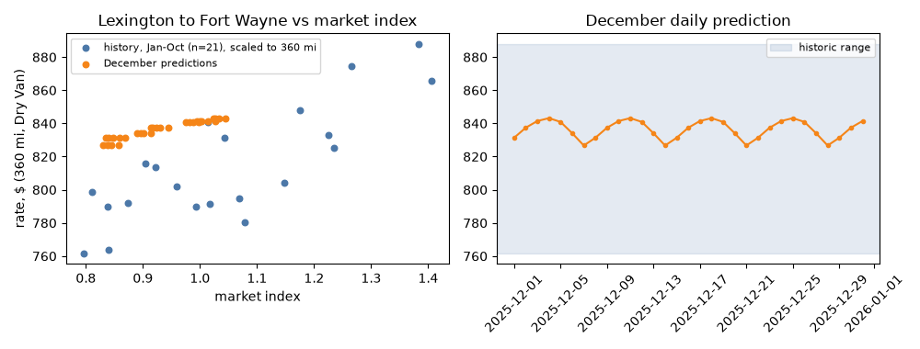
December predictions vs historic Lexington-Fort Wayne Dry Van rates (scaled to 360 mi)

8. Limitations
- Train has no Nov/Dec data, so holiday effects (Dec 24-26, 31) cannot be learned; the December curve only moves with day of week (it tracks the market index's weekly cycle, corr 0.96, but not its level).
- The model has no time trend; the January-October upward drift (about 6% after the market effect) is only partly carried into Nov-Dec through the 3-month recency weighting, so a small downward bias is possible.
- quote_signal is weak and unstable; its inclusion was decided by the CV rule and its contribution is small.
- Label outliers are assumed to be entry errors; this is an assumption.
- F3 is a selection fold; the real out-of-sample result is the external scoring.
- Future work: lane-level shrinkage, quantile models for uncertainty bands, a market-index forecaster.

